WEEK 23
Period 90
Monday, February, 24th 2025 Class: 4A
English
Unit: REVIEW 4 - Part 2

I. OBJECTIVES:
1. Knowledge:
-Students will review the words, phrases and structures related to the topic Technology:
+ smartphone, make phone calls, make videos, write emails, use the tablet, surf the internet, work in groups, work in pairs, change the password, use the computer lab, use the projector, use the speaker
+ talk about what someone does with a smartphone every day
She sometimes makes videos on her smartphone.
He always learns English on his computer.
+ ask and answer questions about who can use a certain technology device in class
Who can use the computer lab? - Teachers and students can.
Who can change the password? - Teachers can.
2. Competences:
- English competences: Students will be able to talk about some activities in class using technology
- Common competences: Students will have the opportunity to develop communication among friends.
3. Qualities:
- Students will be responsible and well-behaved in communicating in the classroom with friends and others.

II. EQUIPMENT AND MATERIALS:
- Basic things: Student’s book, flashcards.
- Advanced things: PPT, projector/interactive whiteboard/laptop/TV.

III. LESSON PROCEDURE:
Warm up (5 minutes)
Aims: Review the vocabulary and grammar of the unit 7 and 8
Teacher’s activities | Student’s activities
- Greet students  -Ask students to sing a warm up song.  https://www.youtube.com/watch?v=2nesqKP9-5c  Game: Spelling game  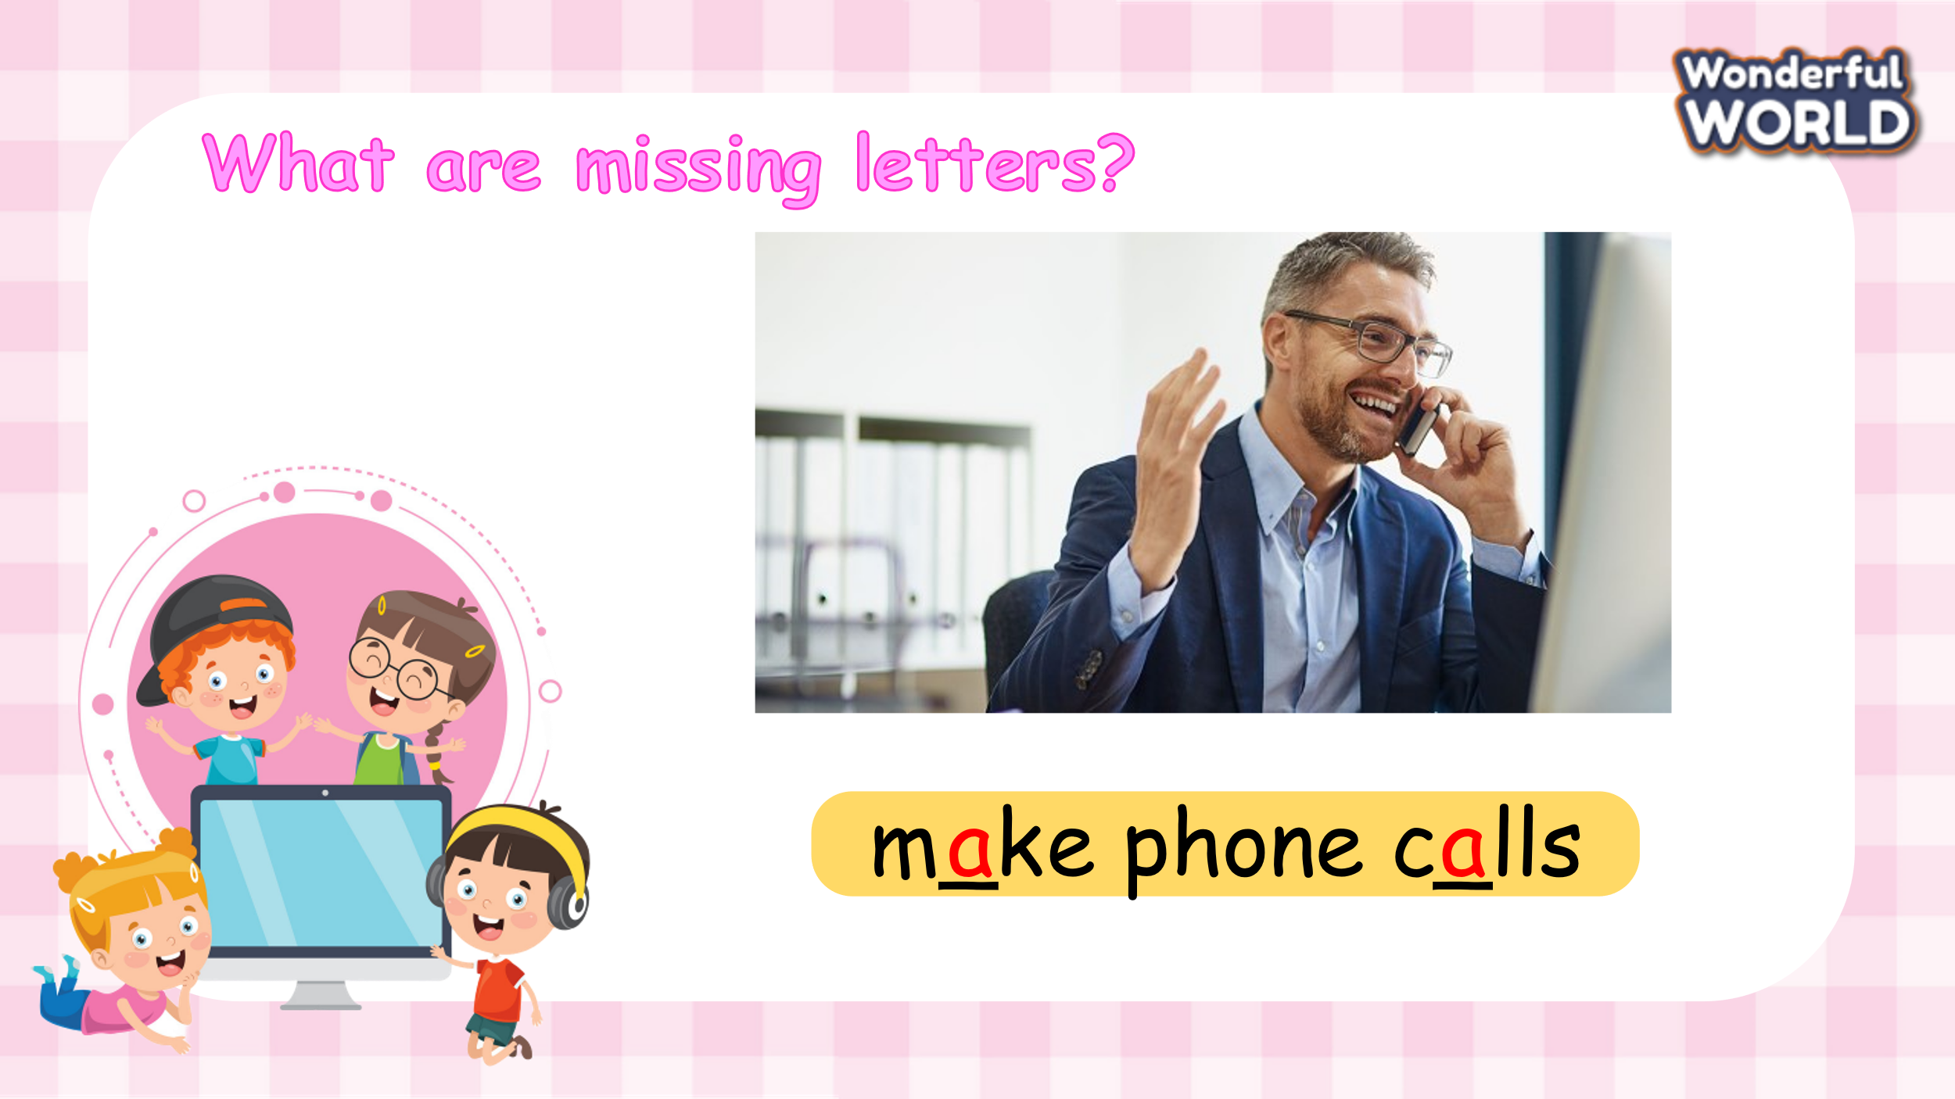  (Students find the missing letters)  - Divide the class into 4 groups  - Set the game rules.  - Ask students to fill the blanks  - Award the best groups  Lead in: Use the pictures of game to review. | - Greet teacher  - Sit in 4 groups.  - Listen to the game rules carefully  - Play game
Review (20 minutes)
Aim: Practice words and phrases that they have learnt in the unit 8 via matching and word rehearsing tasks.
Teacher’s activities | Student’s activities
Task 1: Match  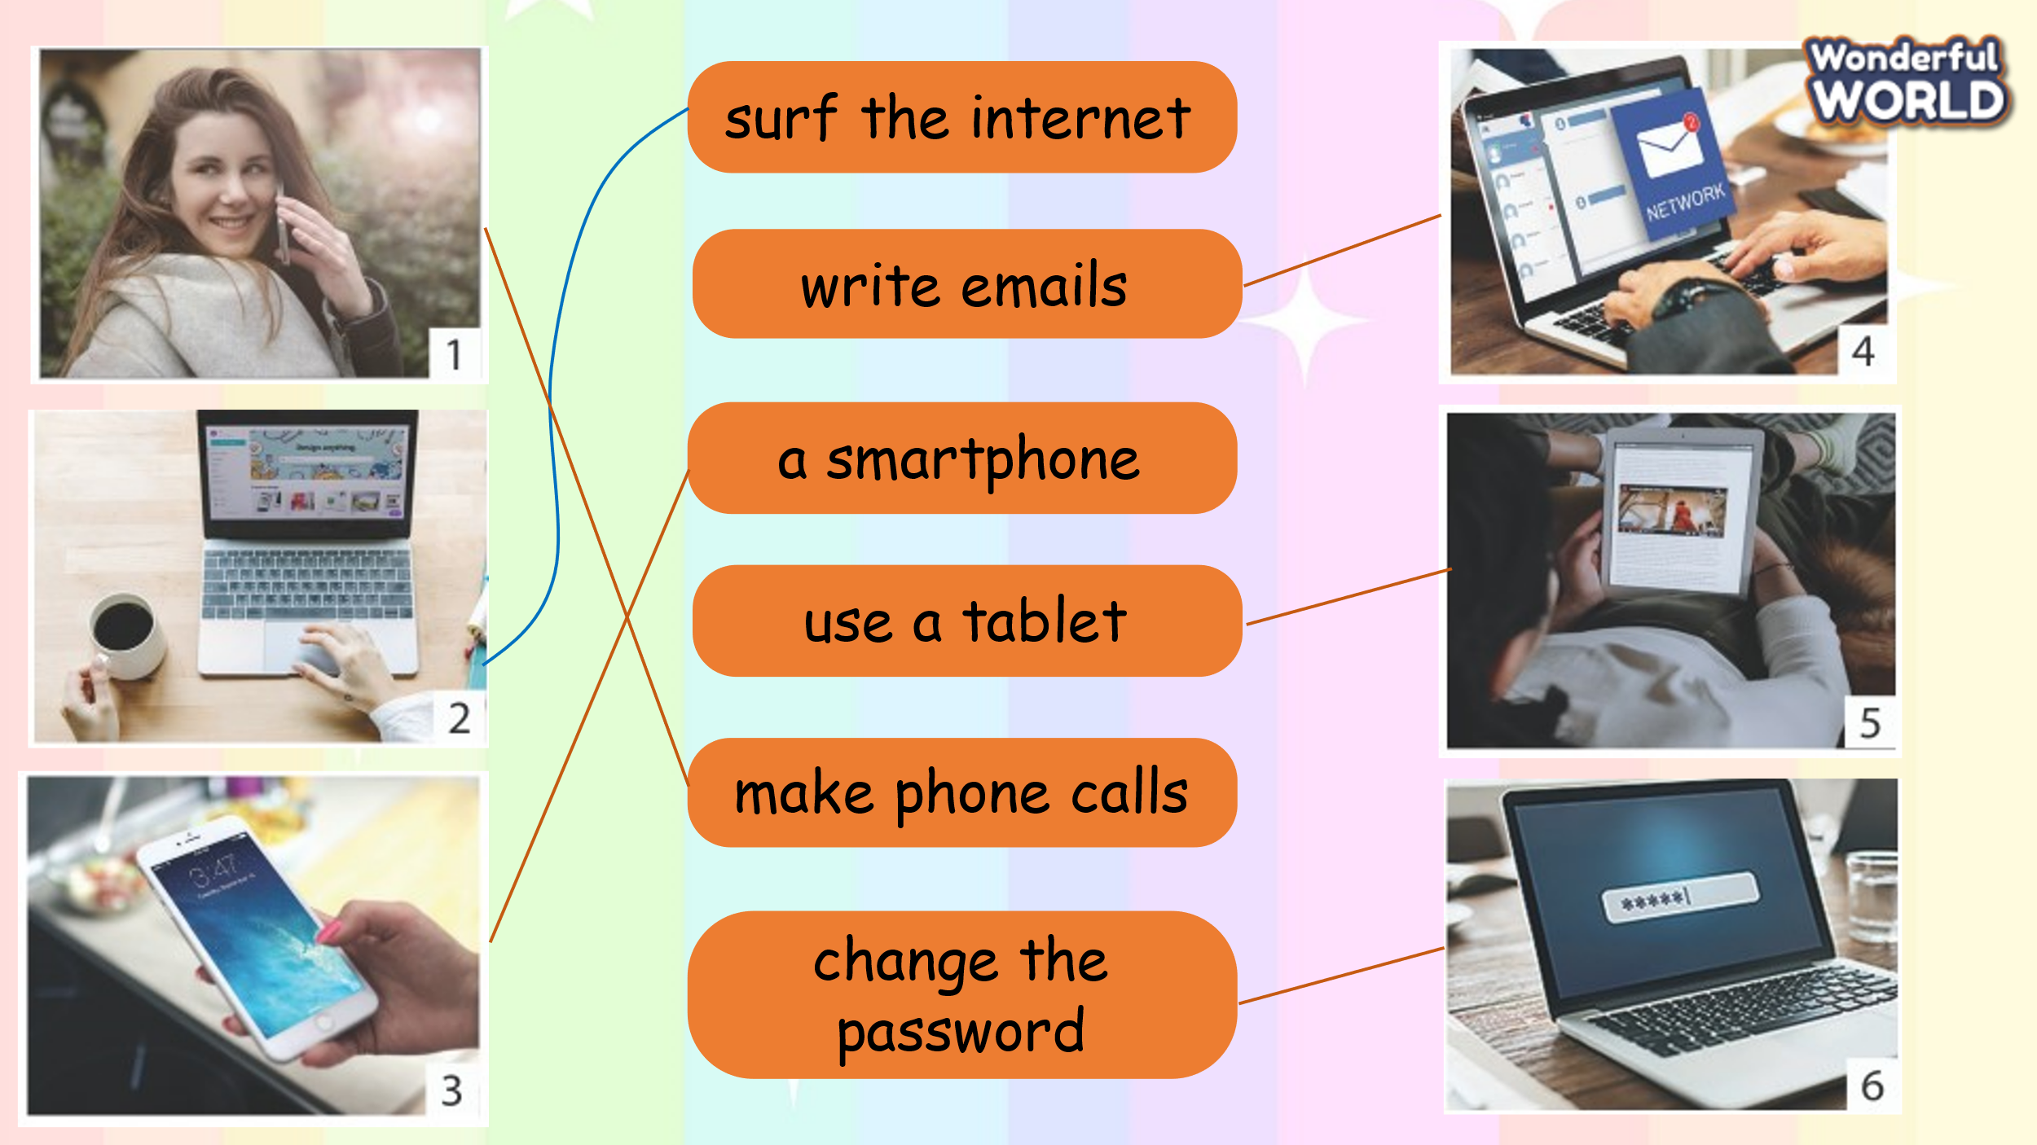  -Tell students to look at the photos 1–6.  -Ask them to tell you what they show. Elicit the words. Tell students to look at the words and match them to correct picture with a line. Do the first one as a class and make sure students understand the task.  -Allow time to complete the task, alone or with a partner.  -Check answers as a class.  Game: “Go to the Island game”  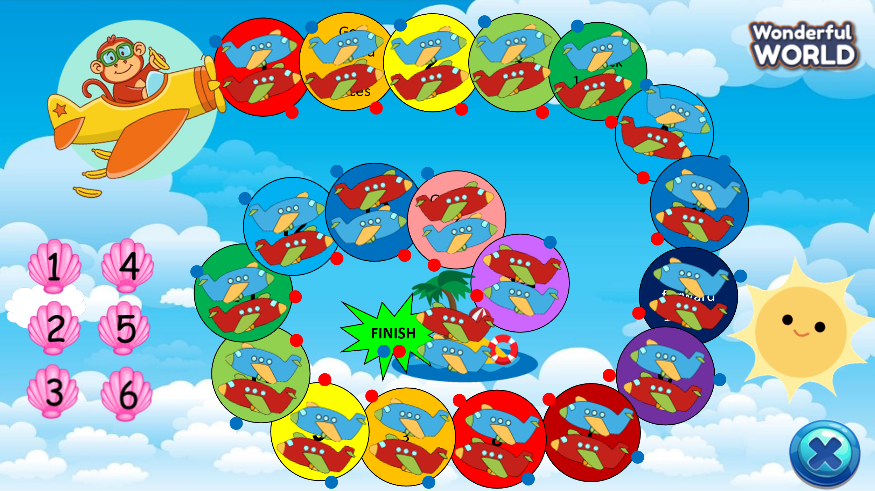  (There are 6 questions. The two teams take turns choosing a question and answer. Teacher prepares a dice. For each correct answer, students roll the dice and move their team's plane. The team that goes to the island first is the winner)  - Introduce and set game rules.  - Call Ss to choose a number and answer the questions.  - Check answers and give feedback.  1 Cαn students use their phones in clαss?  2 Who cαn chαnge the pαss word?  3 Cαn Mr. John use the computer lαb?  4 Cαn I tαke photos in clαss?  5 Cαn Kαte mαke videos on α tαblet?  6 Cαn students surf the internet in clαss?  Task 2: Match and say  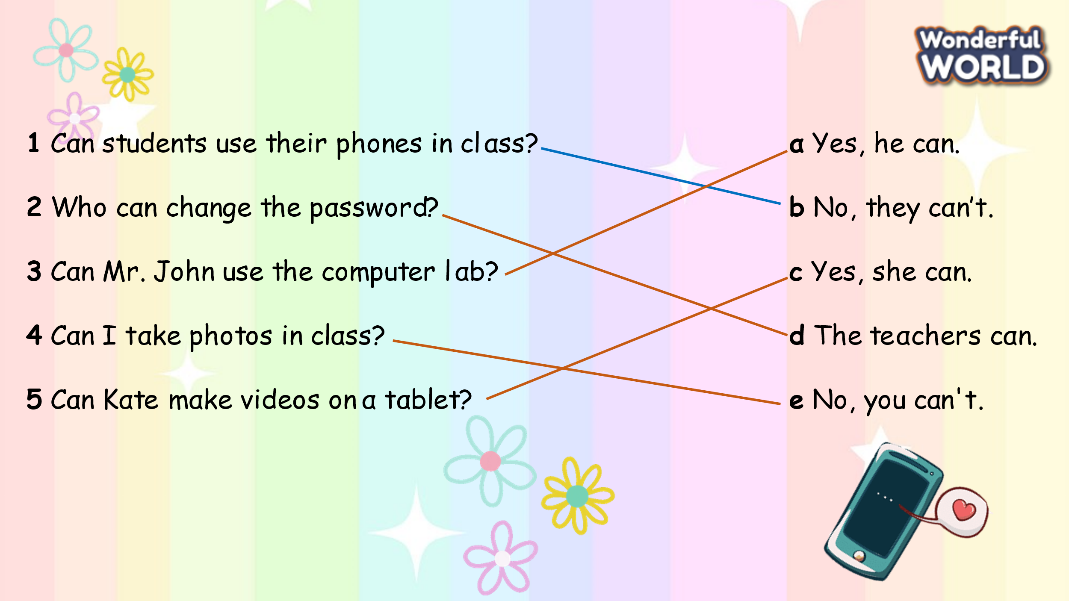  - Tell students to look at the questions 1-5 and the answers a-e and tell them they have to match the questions with the correct answers.  - Tell them to look at the first question and the example answer.  - Ask them to do the same with the other questions.  - Allow enough time for students to complete the task. Check answers in class. | -Look  -Answer  -Listen  -Do the crossword  -Check answers  -Look and listen  -Circle and check the answers.  Yes, he cαn.  No, they cαn’t.  Yes, she cαn.  The teαchers cαn.  No, you cαn't.  No, they cαn’t.  -Look and read the example.  -Repeat  -Match  -Check answers with friends
Extra activity (10 minutes)
Aims: Consolidate the content of the lesson.
Teacher’s activities | Student’s activities
- Talk about technology in your school.  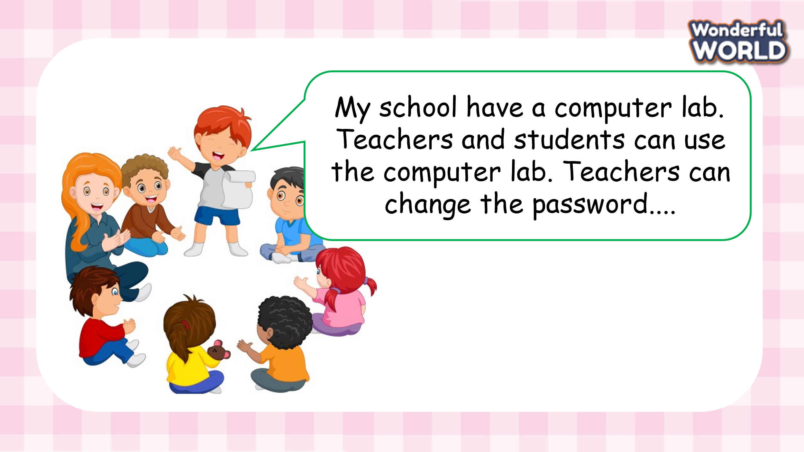  - Work in groups and talk about their family and friends  - Call some students to present in front of the class.  - Give feedback to them.  -Ask students to sing the goodbye song. | - Work in groups  - Present.  - Listen to T.  -Sing

