WEEK 22
Period: 86
Monday, February, 17th 2025 Class: 5C
English
UNIT 8: PEOPLE AND PLACES
Lesson 3: Parts 7, 8, 9
I. OBJECTIVES:
1. Knowledge:
- Students learn about sentence stress and how to indicate the word or words that are important, or the word that he/she wants the listener to pay attention to.
- Students are able to speak with natural intonation.
2. Competences:
- English competences: Students are able to speak with intonation to make conversation/speech natural and draw listeners’ attention to important information.
- Common competences: Ss are able to communicate naturally.
3. Qualities:
- Students will
+ have a strong confidence while speaking.
+ Be able to draw listeners’ attention and correct information by using intonation.
II. EQUIPMENT AND MATERIALS:
- Basic things: Student’s book, flashcards, photos, papers.
- Advanced things: PPT, laptop, TV.
III. LESSON PROCEDURE:
Activity 1: Warm-up
Activity 2: Presentation
Activity 3: Practice
Activity 4: Production
Activity 5: Wrap-up & Assessment
Activity 1: Warm-up (5 minutes)
A guessing game “Clap the rhythm!”
 | Aims: Welcome students. Engage the class (or warm the class up) with an activity to make a relaxing environment and lead in to the new lesson.
 | Teacher’s Activities | Students’ Activities
 | Procedure
 | 1. Greet students. Chatting…Do you like listening to music? Do you often listen to instrumental music or the song with lyrics? Etc.  2. Introduce the activity: Clap the rhythm!  - Ask Ss about the beat of a song. Show them an example.  - Explain the rules of the activity: T plays the video, when it comes to the orange button, Ss will tap their fingers on the table gently without making noise. And when it comes to the blue button, Ss will clap their hands along the beat.  - Play a part of the video to show them an example.  - Play the video and ask Ss to follow.    Lead in:  - Ask Ss if they find the beat of the song similar to the rhythm of words when we say a sentence (in the song, some beats are emphasized (clap), and there are ones that are not (touch the table without making noise)).  - Lead in the sentences we speak also have beats, which is called sentence stress. It makes the sentences specific, and the conversation in general, sound natural.  - T writes the topic “Sentence stress”. | - Greet the T.  - Listen to the rules of the activity.  - Listen to the video and try a short verse.  - Listen and clap the rhythm.  - Think of the similarity between the beat of a song and the rhythm when we speak.
Activity 2: Presentation (12 minutes)
a. Aims:
- Learn about sentence stress and how to stress in a sentence.
- Analyze the examples of stresses in sentences.
- Finish task 7
b. Procedure
Teacher’s Activities |  | Students’ Activities
PRESENTATION  - Show the questions about stresses in sentences and invite some Ss to answer.  - Show the definition of sentence stress and explain why we need to stress in a sentence.  - Show the examples, and ask Ss to guess the words that can be stressed.  - Play the audio and check.  - Play again and ask Ss to repeat.  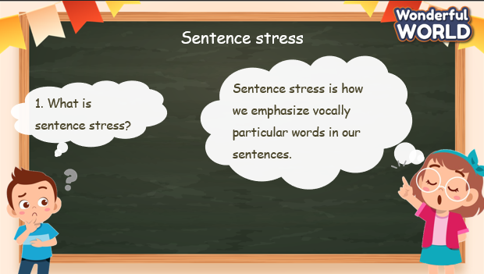  Task 7: Listen and repeat.  - Tell students to look at sentences on the screen.  - Ask Ss to point out which words should be stressed.  - Show the stressed words on the screen.  - Play the audio recording.  - Instruct students to listen carefully and pay attention to the words in bold in each sentence as they hear them.  - After playing the recording once, play it again and ask students to repeat each sentence after the audio.  - Guide identifying stressed words, such as  emphasizing the natural rhythm of spoken English and the emphasis on certain syllables. 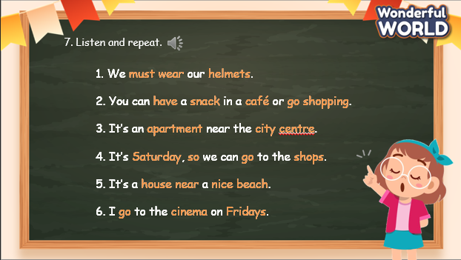 |  | - Look at the questions and answer.  - Look at the example and guess the words that are stressed.  - Listen to the audio and check.  - Listen to the audio and repeat.  - Look at the screen and identify which words should be stressed.  - Listen to the audio and pay attention to the bold words.  - Listen again and repeat. Try to make the bold words louder, higher, and longer.
Activity 3: Practice – Controlled practice (8 minutes)
a. Aims:
- Complete task 8 to practice sentence stress.
- Join the game “Correct me” to make it fun and practice sentence stress.
b. Procedure
Teacher’s Activities |  | Students’ Activities
Task 8: Read and underline the stressed words in the sentences. Then listen and repeat.  - Instruct students to read each sentence silently and underline the  stressed words they identify.  - Play the audio recording for Track 8.10.  - While listening, students should pay attention to the stressed words in each sentence.  - After playing the recording, ask students to repeat each sentence  after the audio, focusing on pronouncing the stressed words  with emphasis.  - Tell students that when stressing confirmative in English, such  as emphasizing agreement or confirmation, the stress is placed  on the main content words in the sentence, particularly on verbs and important nouns.  - Encourage students to practice stress and intonation in their spoken English during conversations and activities.  - Provide positive feedback and corrections as necessary  to help students improve their pronunciation and stress  patterns.  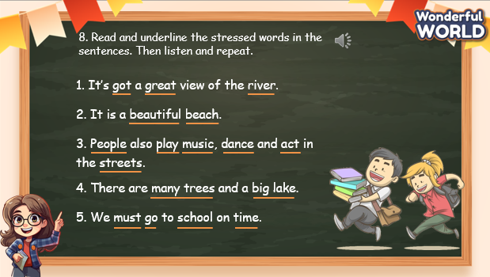  Correct me! game  - Divide the class into groups of 2.  - Invite groups randomly to practice conversations. Remind Ss to pay attention to the bold words. Make the word louder, higher, and longer.  - After each group’s practicing, ask for comments from other groups. If they find that the conversation is not stressed correctly, ask them to correct it.  - The pairs that do not make the correct stresses will do an exercise (jumping, dancing, singing, etc.)  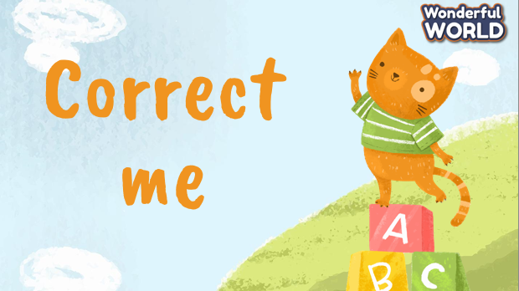 |  | - Read the sentence individually and underline the stressed words.  - Listen to the audio and check.  - Listen again and repeat after the audio. Try to make the stressed words louder, higher, and longer.  - Listen to the rules of the game.  - Sit in pairs and read the conversation. Remember to say the bold words louder, higher, and longer.  - Other groups: listen and make comments.  - The pairs who do not make it right will do an exercise.
Activity 4: Production – Speaking (6 minutes)
a. Aims:
- Practice stress with a chant
- Build the confidence to perform a chant in front of the class
b. Procedure
Teacher’s Activities |  | Students’ Activities
Task 9: Listen and chant.  - Ask Ss to look at the chant and identify the stressed words.  - Tell students they are going to learn a chant. Explain to students that the chant uses the sounds they have just learnt.  - Play the recording and tell students to listen and follow the words with their fingers.  - Read out the chant one line at a time and ask students to repeat after you.  - Play the recording again. Encourage students to chant along. Practice several times until students are familiar with the words and sounds.  - Ask students to practice the chant individually, and then in pairs or groups. For example, one group chants the first verse, and the other group chants the second verse.  Optional activity:  - Ask some volunteers to say the whole chant. 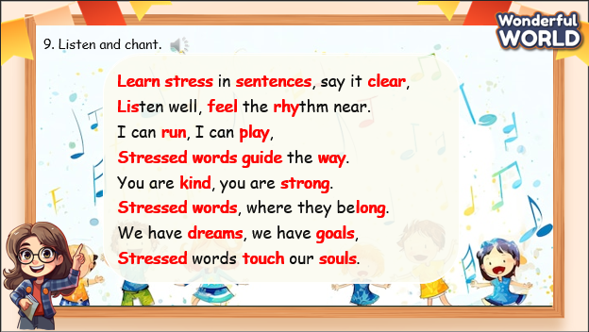 |  | - Look at the chant and identify the stressed word.  - Listen to the chant the first time and pay attention to the bold words.  - Listen again and chant along.  - Practice chanting sentence by sentence.  - Practice individually, then in pairs or groups.  - Perform in front of the class.
Activity 5: Wrap up & Assessment (4 minutes)
Teacher’s Activities |  | Students’ Activities
a, Aims:
- Check Ss’s understanding of what they have learned.
- Students rehearse what they have learned in the lesson.
- Ask Ss to do the assessment.  - Give the assessment to the class and some Ss.  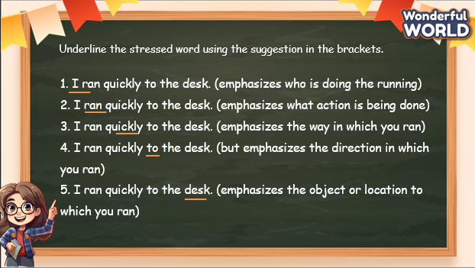  - Check with the class.  - T asks Ss about what they have learnt in today’s lesson.  - T shows the wrap-up slide and concludes the lesson.  * Remember  GRAMMAR  1. Sentence stress  We use it to indicate which word or words are the most important, and which word we want the listener to pay attention to.  Eg: He bought a red car for his daughter. (emphasis on who bought a red car) |  | - Do the assessment.  - Check with the teacher.  - Answer T’s question of what they have learnt in today’s lesson.  - Ss read the wrap-up.  - Stand up and say goodbye to the teacher.

