WEEK 21 Monday, February, 10th 2025 Class: 4C
Period 81
English
Unit 8: TECHNOLOGY
Lesson 2: 4, 5, 6
I. OBJECTIVES:
1. Knowledge:
- Students will review words and phrases related to the topic Technology: smartphone, make videos, make phone calls, learn English, play video games, write emails.
- Students will learn about frequency adverbs: sometimes, always.
- Students will learn about new structure:
I always learn English on my computer.
He sometimes makes phone calls.
2. Competences:
- English competences: Students will be able to talk about what they can do on smartphone and computer, as well as how often they use them.
- Common competences: Students will have the opportunity to develop the creativeness by participating in games and developing communication among friends.
3. Qualities:
- Students develop topic related to technology skills.
II. EQUIPMENT AND MATERIALS:
- For Teacher: PP, flashcards, handout, track 8.3.
- For students: pens, books, crayons, paper.
III. LESSON PROCEDURE:

Activity 1: Warm up (5 minutes)
Teacher’s Activities | Students’ Activities
a, Aims: Review the words of Technology and previous structure which they have learned before.
b, Procedure  - Greet students and divide class into 4 teams.  Warm up: Crossword.  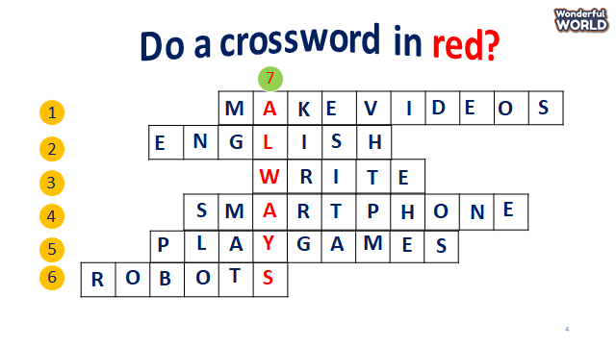  - The T shows the crosswords and asks sts to choose the numbers, then guess the answers.    - Sts can find out all words to get stars. If they find out the crossword in red, they can get double points for their team. | - Great teacher and choose the team name.  -Join the game.  - Choose the numbers and find out the words.  - Get double stars if sts figure out the key.
Activity 2: Presentation (8 minutes)
Teacher’s Activities | Students’ Activities
a, Aims: Present new grammar: Frequency adverbs.
b, Procedure  Task 4. Listen and repeat.  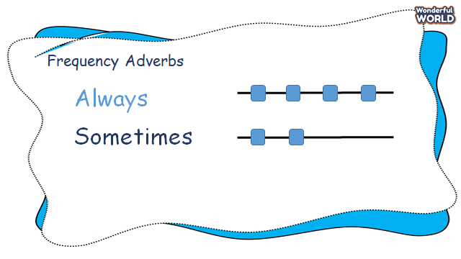  - T introduces frequency adverbs and how to use them.  - Say the words/sentences for students to repeat in the chorus.  - T explains the meaning of adverbs.  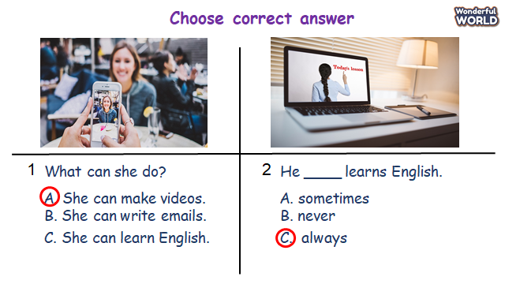  - Let sts answer the questions before listening to the task. 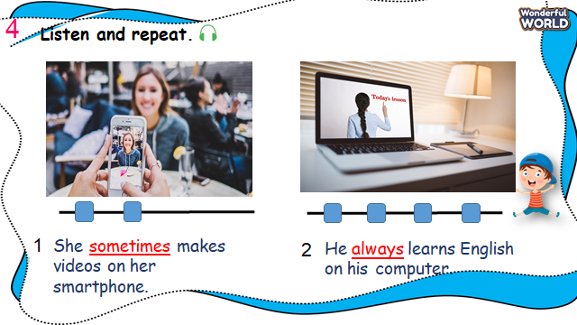  - Ask Sts to look at pictures and answer the questions.  - Say a word/sentence for students to repeat then point.  - Play track 8.3 for the students to listen to and repeat in chorus, and groups.  - Ask sts to notice the frequency adverbs in each sentence. | -Repeat after the teacher.  - Say the adverbs loudly.  -Sts listen and practice the words.  -Sts join the game and get stars.  -Sts look and answer about the pictures  -Repeat the sentences individually and in groups.
Activity 3: Practice (14 minutes)
Teacher’s Activities | Students’ Activities
Aims: Make sentences based on the structure they have learned using frequency adverbs.
Encourage sts to talk about what can they do when using technology.
Task 5: Look and say.  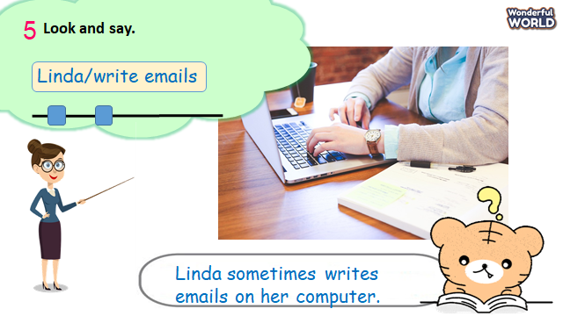  - Look at the picture and ask sts to read out the prompts.  - Tell sts the example and ask them to repeat.  - Explain the rest of the task.  - Let Sts make some sentences through some pictures and practice them in pairs.  - Require some pairs present in front of the class. | -Read out prompts.  -Read some sentences.  -Make and practice some sentences in pairs and present them to the class.
Activity 4: Production (9 minutes)
Teacher’s Activities | Students’ Activities
a, Aims: Apply words and grammar to make correct answers using frequency adverbs.
Encourage sts to read out what they can do on the phone.
b, Procedure  Task 6: Let’s talk  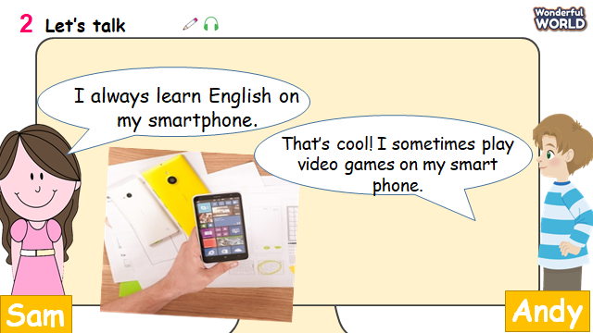  -T shows the picture of the phone and the examples.  -Read out some sentences and ask sts to repeat.  -Then let sts practice sentences through the game:  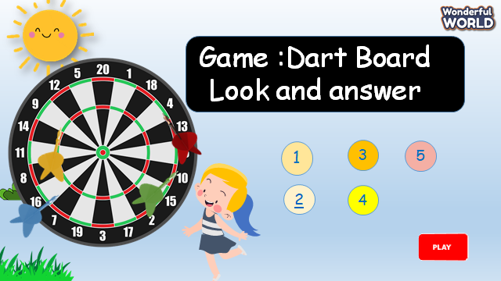  -T shows the game and asks to choose the numbers  - Answer some questions and get stars for their teams.  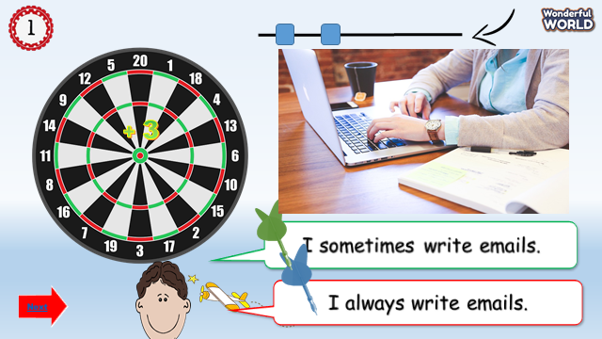  - Ask sts to make their own sentences through a game using activities and frequency adverbs.  - Allow sts some minutes and ask some volunteers read out their sentences.  - Check their answers. | -Sts read out sentences.  - Join the game to get stars.  - Make their own sentences.  - Some sts read loudly.
Activity 5: Assessment (3 minutes)
Teacher’s Activities | Students’ Activities
a, Aims: Consolidate the content of the lesson.
-Ask sts to do the assessment.  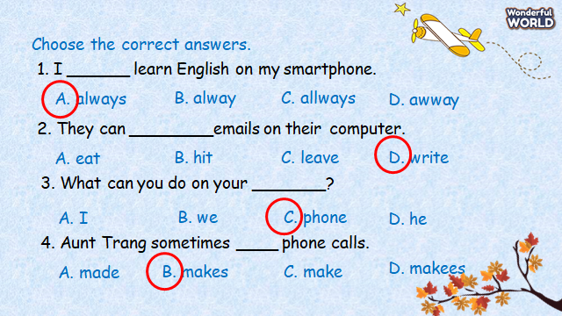  - Check with the class.  - Wrap up the vocabulary and structure  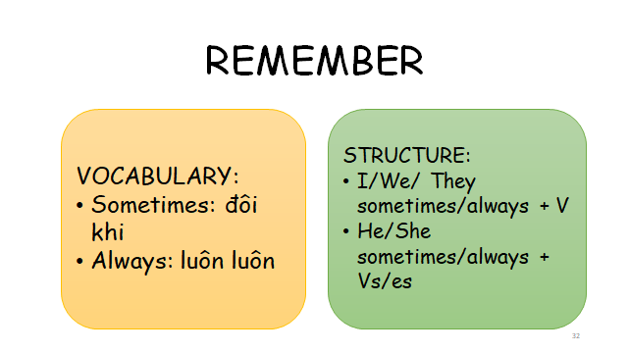 | -Do the assessment.  -Check with the teacher  - Read the wrap-up.  - Stand up and say goodbye to the teacher.

