WEEK 20
Period: 79
Wednesday, February, 5th 2025 Class: 5A
English
UNIT 7: Sports
FUN TIME & PROJECT PART 2
I. OBJECTIVES:
1. Knowledge:- To review all target vocabularies and structures of Unit 7 and some fun activities.
- Making instructions on how to keep safe when playing sports.
2. Competences:
English competences:- Students will be able to think and talk about topics.
related to sports.
Common competences: - students will be able to develop collaborative skills through teamwork and logical thinking.

3. Qualities:
- Be confident and active in communication with friends and teachers.
- Show their love and passion for sports.
II. EQUIPMENT AND MATERIALS:
- Basic things: Student’s book, flashcards.
- Advanced things: PPT, laptop, TV.
III. LESSON PROCEDURE:
Activity 1: Wram- up & Review
Activity 2: Practice
Activity 3: Production
Activity 4: Wrap-up & Assessment

 | Activity 1:Warm-up & Review (7minutes)
 | Teacher’s Activities | Students’ Activities
 | Aims:- Welcome students and engage the class with a funny song to warm up the class’s atmosphere.
 | b, Procedure  - Greet students.  -Divide the class into many teams. Each team chooses their team names.  -Ask students to stand up and follow the actions in the video.  - Give stars to the team that dances the most beautifully.    -Review some sports for students and then play the game “What sports are missing”.  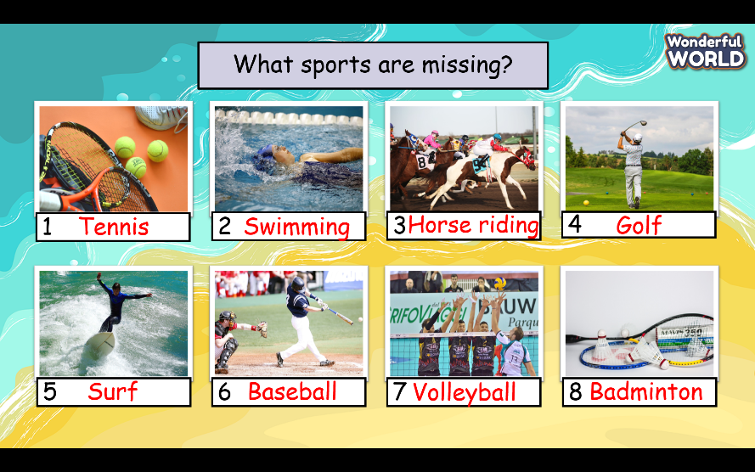  -Give students 30 seconds to remember the position of each picture.  -Click to hide pictures at once and ask students to recognize which pictures have disappeared.  -Give stars for the correct answer  -Check students’pronunciation. | - Greet Teacher  -choose a team name  - Join the activity.  - be active and happy  - remember the position of each picture.  -raise the hand to recognize which pictures are disappeared.  - Read in the whole class, team, and individual.
Activity 2: Practice (8 minutes)
Teacher’s Activities |  | Students’ Activities
- Aim: Control the whole class and help students have a chance to play games to review vocabulary structures and phonetics.
b, Procedure  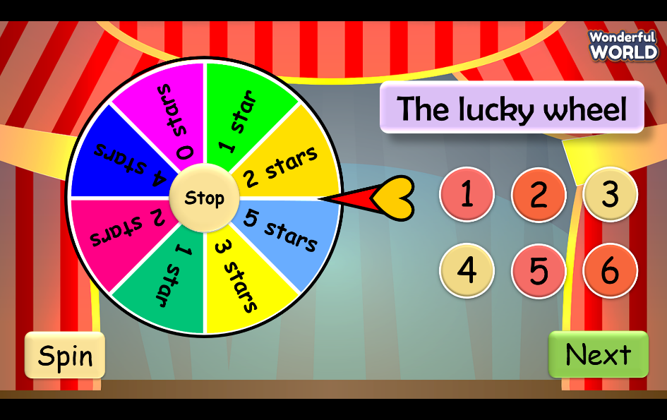  - Create 6 questions about structures and phonetics that students learn in Unit 7  +Question1: their/much/shouldn’t/use/People/smartphones/too  People shouldn’t use their smartphones too much.  +Question 2:  You/helmet/when/a/motorbikes/wear/should/riding/your  You should wear a helmet when riding your motorbike.  +Question 3: She ____________ at the moment. (run)  is running  Question 4: They ___________________ at present. (ride the horses) are riding horses  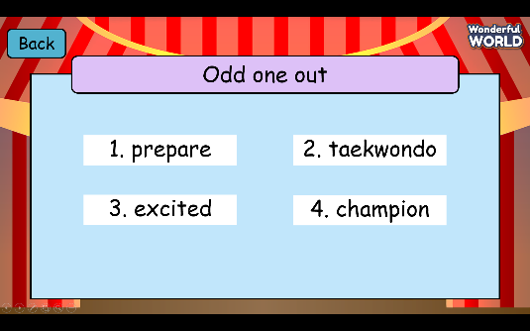  Question 5:  Champion  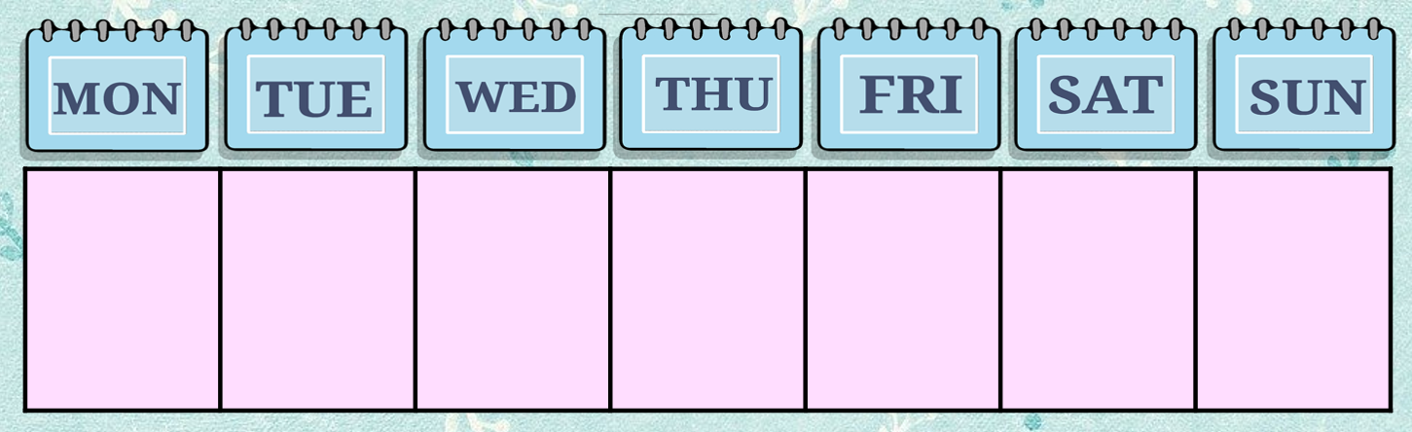  +Question 6:  My family has outdoor activities__ __. twice a week  -Click the spin button to spin and click the stop button if the student wants to stop. |  | -Choose the question and read it carefully.  - Have a chance to spin the wheel if they answer correctly.
Activity 3: Production (115 minutes)
Teacher’s Activities |  | Students’ Activities
Aims: Develop speaking skills and teamwork skills.

Task 3 Project: How to stay safe when playing a sport  -Explain to students that they will work in groups of four. Each group will write four instructions on how to stay safe when playing sports.  - Ask students to read the example sentences.  -Allow students time to work in their groups.  - Have each group write their sentences on a poster.  -Ask students to choose the sport they like.  ( use should and shouldn’t in each sentence)  - Have each group put up their poster on the classroom wall for a walking exhibition.  Task4 Show and tell.  - Show your poster. Tell your class about it.  -T will read the sample first and ask some students to read it several times.  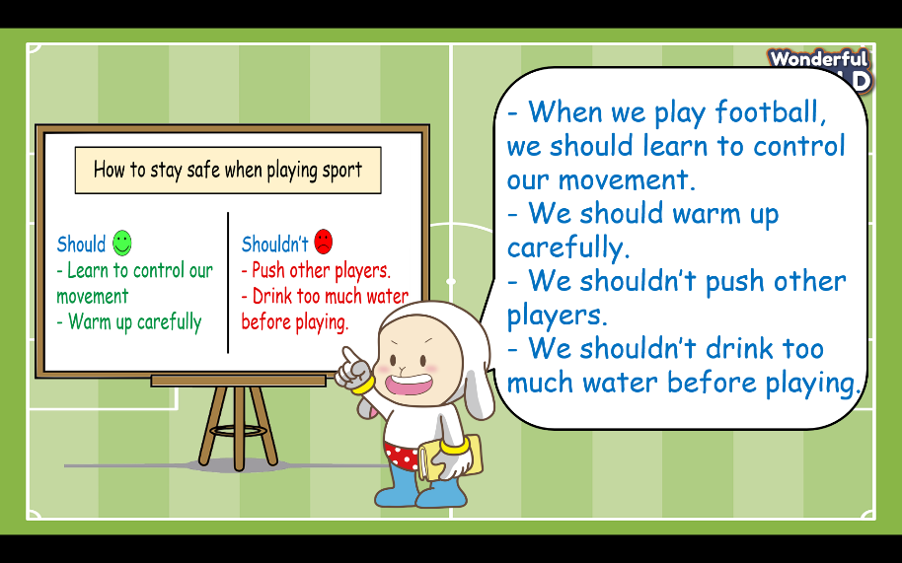  -Give some comments for each team after the leader of each team has finished his/her task. |  | -Read the example sentences.  - Choose a sport to write four instructions on how to stay safe when playing it.  -work in groups.  - The leader of each group will go to to board to present his/her group’s production.  - Give comments for each team.
Activity 4:Wrap-up & Assessment ( 5minutes)
Teacher’s Activities |  | Students’ Activities
a, Aim:
- Check students’s understanding of what they have learned.
- Students rehearse what they have learned in the lesson.
-T asks sts to do the assessment (Read and write)  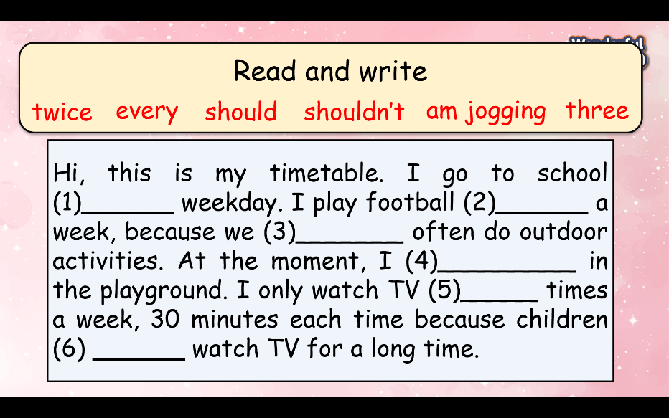  - Check with the class.  Answer key: 1-every, 2- twice, 3- should, 4-am jogging, 5-three, 6- shouldn’t  - Wrap-up  * Remember: To review all target vocabularies and structures of Unit 7. |  | -Do the assessment.  -Check with the teacher  - Sts read the wrap-up  - Stand up and say goodbye to the teacher.

