WEEK 19 Monday, January, 20th 2025 Class: 4C
Period 73
English
Unit 7: JOBS
Lesson 2: 1, 2, 3

I. OBJECTIVES:
1. Knowledge:
- Students will review words related to the topic Jobs: in a hospital, in a restaurant, in a studio, in a clinic
- Learn and use new grammar: Where does he/she work?
2. Competences:
- English competences: Students will be able to use adverbs and nouns to describe the places of work.
- Common competences: Students will have the opportunity to develop logical thinking and develop communication among friends.
3. Qualities:
- Students develop thinking of the jobs and future and the adverbs in English.
- Be confident and active in communicating with friends and teachers.
II. EQUIPMENT AND MATERIALS:
- For Teacher: PPT, flashcards, blank papers, crayons, track 7.4, track 7.5.
- For students: textbook
III. LESSON PROCEDURE:

Activity 1: Warm-up (5 minutes)
Aim: warm-up activity to review the word and ways to introduce someone’s job from the previous lesson and introduce new lesson.
Teacher’s Activities | Students’ Activities
- Greet the Ss  - Asks Ss to join a small game to review the word in previous lesson.  Warm-up: Play a small game “Catch the word”  T divides the class into 4 teams.  T introduces the rule of game:  (Game: Catch the word  - Each team stands in lines. The first SS will be given a word and they must draw a picture according to that word.  After finishing, the picture will be passed down to the next one to re-draw. The last SS will write down the answer on the paper.  Each turn will last for 1’30s.)  T asks Ss to repeat after checking.    Lead in:  - T introduces vocabulary about “Jobs” in English.  - Write on the board “Jobs” and introduce the lesson. | - Greet the teacher  - Listen and choose a team name  - Listen and play game in groups.  - Look at the images and guess the words  - Repeat.  - Listen to T.
Activity 2: Presentation (10 minutes)
Aim: Controlled practice: Help Ss to review and practice the vocabulary of Jobs.
Encourage Ss to make full sentences relating to Jobs.
Teacher’s Activities | Students’ Activities
Lead-in:  - Asks Ss about some jobs they know. Ask if they know what their family members’ do.  Presentation:  - T shows the 4 words in Lesson 1 and asks SS to listen and repeat.  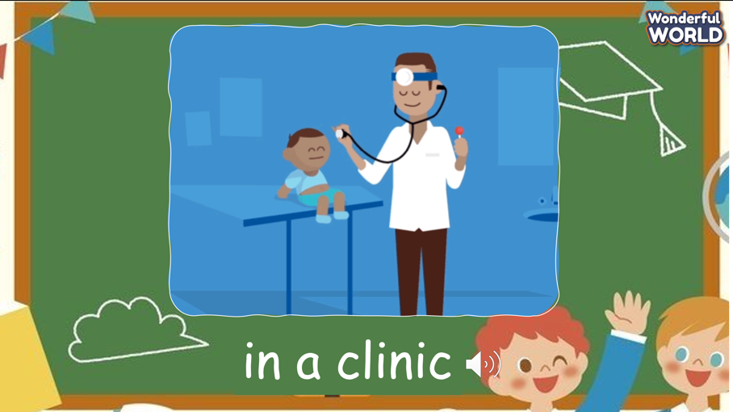 | - Discuss in groups  - Listen and answer.  - Repeat after the teacher.
Activity 3: Practice (12 minutes)
Aim: Practise new words, ask and answer using structure:
- What does he do?
- He’s a chef.
Encourage Ss to use long sentences while describing their activities.
Teacher’s Activities | Students’ Activities
Based on each tasks, T asks Ss to work individually, in pairs, or in groups  Task 1: Listen and point. Repeat. Track 7.4  - Tell students to look at the vocabulary box on page 80. Find out if they know any of the words.  - Play the recording for students to listen and point to the correct pictures.  - Play the recording again, pausing after each word for students to say  the word. Ask which people work inside, outside or both.  - Invite pairs of SS to read the words aloud.  - Give their feedback.  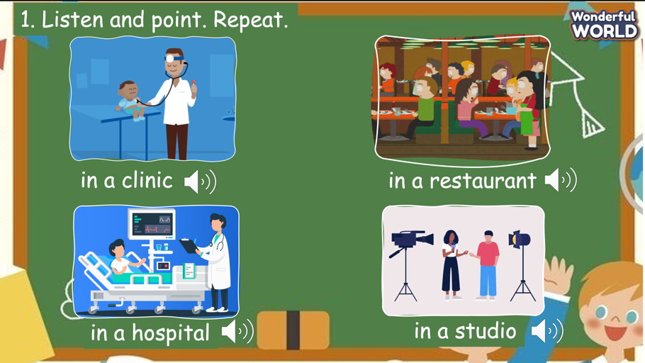  Task 2: Listen and read.  - Ask students to look at the photo and elicit what they can see.  - Point to the new words in the text. Read them out loud and ask students to repeat.  - Play the recording. Tell students to look at the picture and follow the  text with their fingers.  - Play the recording again, pause after each sentence and ask students to repeat.  - Give their feedback.  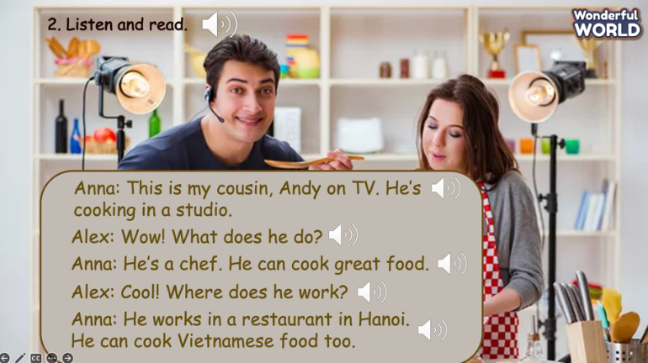  - Tell students to look at the sentences and the text and ask them what should be filled in the gap. Instruct them to look for similar sentences in the text. Elicit the correct answers.  - Ask students to practice reading the text in pairs and then ask volunteers to read the text aloud in front of the class.  Task 3: Match and say.  - Ask students to look at the pictures and elicit the job that the pictures show.  - Tell students to look at picture 1 and the example. Elicit that the man in the picture is a vet. Then read the example aloud and ask students to repeat after you.  Ask students to match the pictures with the places. Allow them enough time to complete the task. Check answer as the whole class.  - Put students in pairs and ask them to practice saying the sentences. Walk around and give help if necessary. Ask some volunteers to say the sentences in front of the class.  - Suggested answers:  1. He’s a vet. He works in a clinic.  2. He’s a chef. He works in a restaurant.  3. He’s a photographer. He works in a studio.  4. She’s a farmer. She works on a farm.  5. He’s a doctor. He works in a hospital  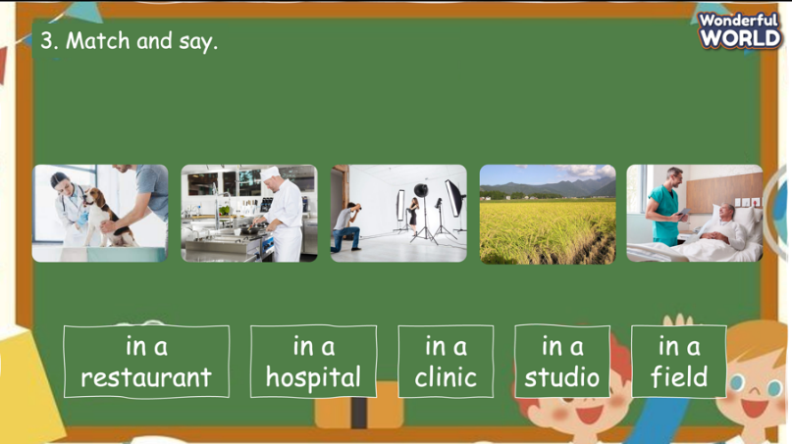 | - Look at the pictures and practice speaking in pairs.  - Work in pairs.  - Speak in front of the class.  - Look at the screen and listen to the whole conversation.  - Listen to each sentence and repeat.  - Practice the conversation in pairs.  - Speak in front of the class.  - Look at the pictures and elicit the job that the pictures show.  - Match the phrases with the pictures and create the full sentences.  - Speaking in front of the class.
Activity 4: Production (9 minutes)
Aim: Join the game to review the words and structure
Teacher’s Activities | Students’ Activities
Let’s talk  - Ask SS to play a game “Who wants to be a millionaire”.  - Introduce the rule of game.  (the rule of game: Who wants to be a millionaire  T divides the class into 4 groups. Each group will have a bell.  When the question is opened, each group will ring the bell to answer.  If the answer is correct, that group will get 1 point. If not, the chance is given to the other team.  When the game finishes, the group with higher score will win.)   | - Listen.  - Play the game.  - Take turn to answer the questions until the last ones.  - Check the final result.
Activity 5: Assessment (3 minutes)
Aim: Do the exercise to review and remember the words.
Consolidate the content of the lesson.
Teacher’s Activities | Students’ Activities
- Review the words that have learnt in the lesson without looking at the book.  - Ask sts to do the assessment.  - Check with the class.  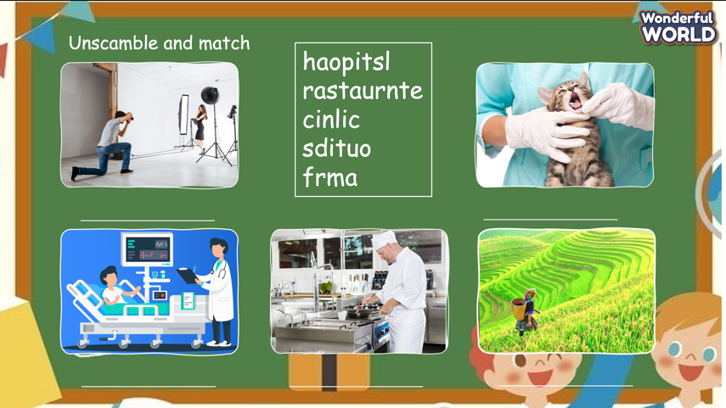 | - Do the assessment individually.  - Check with the teacher.

