WEEK 17
Period: 65
Monday, December, 30^{th,} 2024 Class: 5A
English
REVIEW 3
Part 3
I. OBJECTIVES:
1. Knowledge:
- Students learn about the largest hot-air balloon festival in the world and the related vocabulary: pilot, cloth, hot-air balloon, size
- Students know how to describe a festival
2. Competences:
- English competences: Students can talk about a festival in the world.
- Common competences: Students can describe the purposes, events, activities, and visitors in an event.
3. Qualities:
- Students will
+ have a strong curiosity in exploring a specific festival in the world.
II. EQUIPMENT AND MATERIALS:
- Basic things: Student’s book, flashcards, photos, papers.
- Advanced things: PPT, laptop, TV.
III. LESSON PROCEDURE:
Activity 1: Warm-up
Activity 2: Presentation
Activity 3: Production
Activity 4: Wrap-up & Assessment
Activity 1: Warm-up (5 minutes)
A guessing game “Memory game?”
 | Aims: Welcome students. Engage the class (or warm the class up) with a guessing word game to revive the vocabulary (write the words here….) and lead in the new lesson.
 | Teacher’s Activities | Students’ Activities
 | Procedure
 | 1. Greet students. Chatting…Do you like playing games…  2. Introduce the game: Memory game  - Ask Ss to think of the food learnt in the previous lesson.  - Put students in two groups and each group will take turns play.  - Each turn, a group will open two numbers. If the picture and the text match, click on the picture to clear and that team will get a point.  - If not, click on the red circle button to hide the picture and move to the next turn.  - When all pictures are clear, the team with higher scores will win the game.  - T can open the slide again and show all pictures and words to review  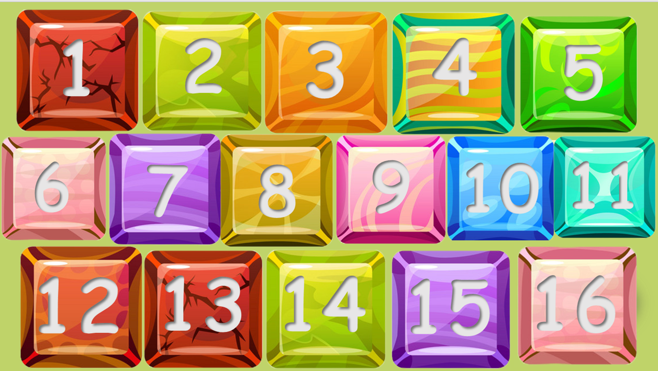  Lead in:  - T raises some pictures and ask Ss to guess the topic of the lesson.  - T introduces the topic “hot-air balloon festival”.  - T writes on the board “Review 3” and leads in the lesson. | - Greet the T.  - Listen to the rules of the game.  - Listen and play a game.  - Sit in groups and take turns to open the pictures.  - Check the result.  - Repeat after T.  - Look at the pictures and guess the topic.
Activity 2: Presentation (20 minutes)
a. Aims:
- Introduce the vocabulary about the hot-air balloon festival: pilot, cloth, hot-air balloon, size.
+ Ss know how to describe a festival
+ Finish Task 1, 2, 3, 4
b. Procedure
Teacher’s Activities |  | Students’ Activities
- Show the words on the screen.  - Ask students to look at the screen and guess the word.  - Show the text and audio for each word.  - Ask Ss to listen and repeat after the audio.  - Play twice or three times so that Ss can practice the words.  - Asks some students to read the words or phrases individually.  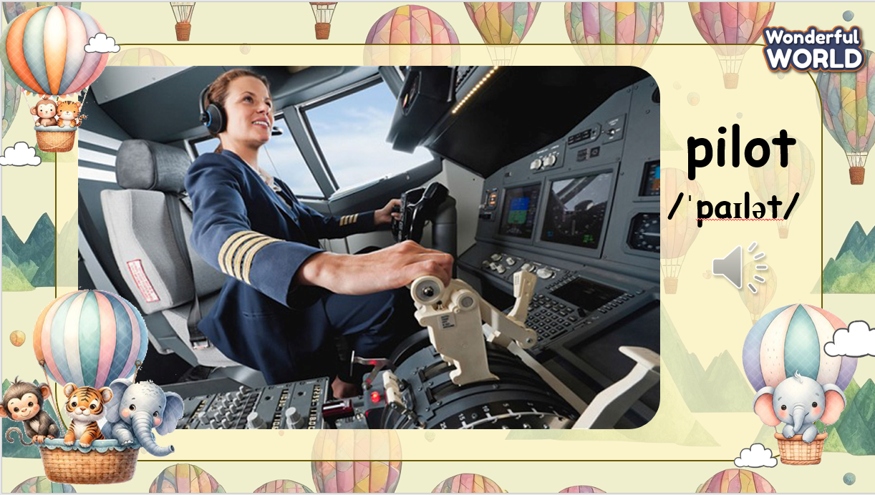  Task 1: Before you watch.  - Show the items on the screen.  - Tell students to look at the screen and tell you what they can see. If necessary, teach hot-air balloons.  - Ask students to tell you what colours they can see.  - Ask students if they have ever been in a hot-air balloon. If not, would they like to go in one? Why / Why not?  - Briefly explain how the hot-air balloon works: people stand in a basket beneath the balloon. The air inside the balloon is heated by a burner. This causes the balloon to rise. When the air inside  the balloon cools down, the hot-air balloon floats back down to  Earth.  - Ask if they are on a hot-air balloon ride, what they would take with them.  - Click on the box to show the checkmark, click on the checkmark to clear.  - Make a discussion to see what we should take with when we’re on a hot-air balloon ride and check the final answer.  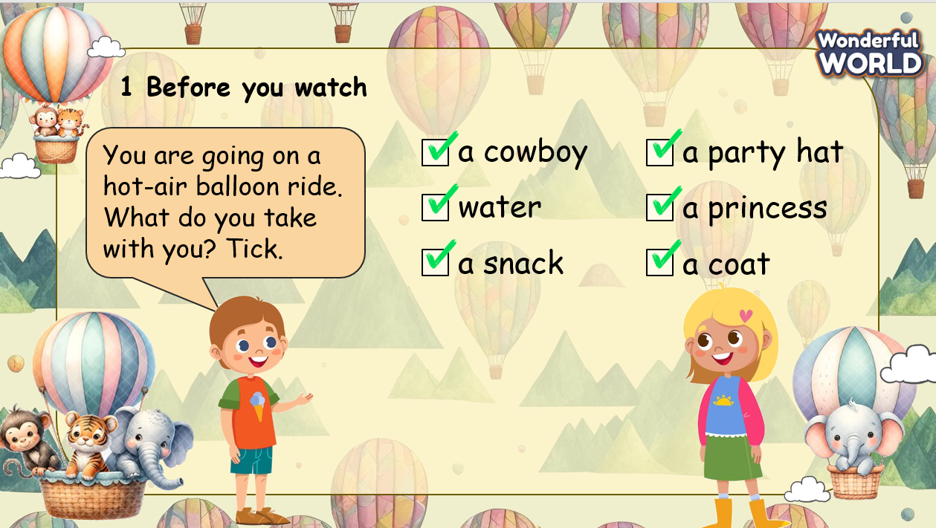  While you watch  Remind Ss of the question before watching.  After watching  - Ask and answer the question: Say the colours and shapes of the balloon you can see in the video.  - Play the video again and pause to check the answer.  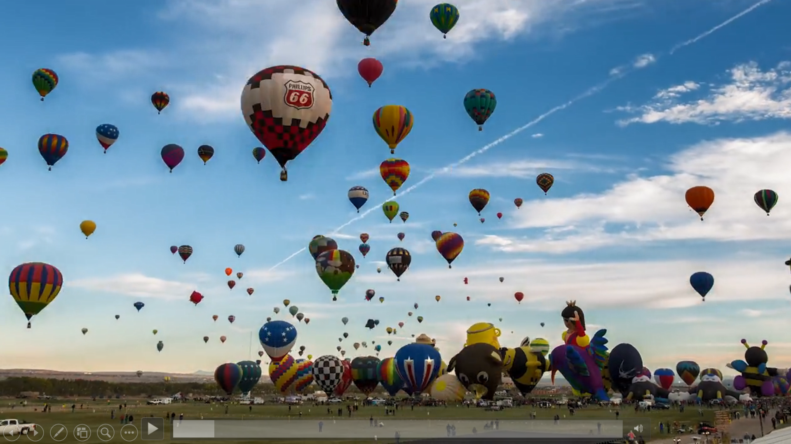  Task 4. After watching.  - Show the statements on the screen. Ask if Ss remember the content of the video.  - Ask Ss if it is necessary to play the video again.  - If yes, play the video and give Ss some minutes to finish the task.  - Invite some Ss to write their answers on the board.  - Play the video and check each Ss.  - Show the answers on the screen and check.  Let’s check.  T divides the class into 2 groups. Each group will choose a name and play rock, scissors, and paper to decide which group goes first.  Two groups will take turns to choose a number and answer the corresponding questions to review what they have seen in the video.  T checks the answer. If it is correct, T clicks the “spin” button to rotate the wheel, and then clicks on the wheel to stop and check the points.  If the answer is incorrect, T asks the next team to choose the number.  When all the questions are answered, the team with the higher score will win the game.  When the game is finished, click on the next button on the right bottom edge to move to the next slide. |  | - Look at the screen and say the words.  - Check the words and listen to the audio.  - Listen and repeat.  - Look at the screen and listen to the explanation.  - Look at the task on the screen and discuss with T  - Discuss with the class, explain why we should take the items  - Check the answer.  - Remember / take a note of the question  - Watch the video  - Answer the question  - Watch the video again and check the answer  - Check the statements on the screen  - Ask T to play the video again before starting task 4  - Fill T / F in the box  - Write the answer on the board  - Watch the video again and check the answers  - Listen to the rules of game  - Appoint a representative to do rock, scissors, and paper to decide who goes first  - Choose the number and pay attention to the questions, and then answer  - If the answer is correct, spin the wheel to get the points  - If not, the next team will choose another number to continue the game  - Check the results
Activity 3: Production – Crafting (6 minutes)
a. Aims:
- Guide Ss to make a paper hot-air balloon to decorate the class room
- Encourage Ss’ creativity and develop teamwork skills
b. Procedure
Teacher’s Activities |  | Students’ Activities
- Show the instruction on the screen  - Ask Ss about the items needed  - Divide Ss into groups of 6, guide Ss to make a hot-air balloon step-by-step  - Give them some minutes to finish their products  - Invite some Ss to make quick introductions about their product (what is this? What colour is this? How many ___ are there? Etc.)  - Ask for comment from classmate  - Give them feedback  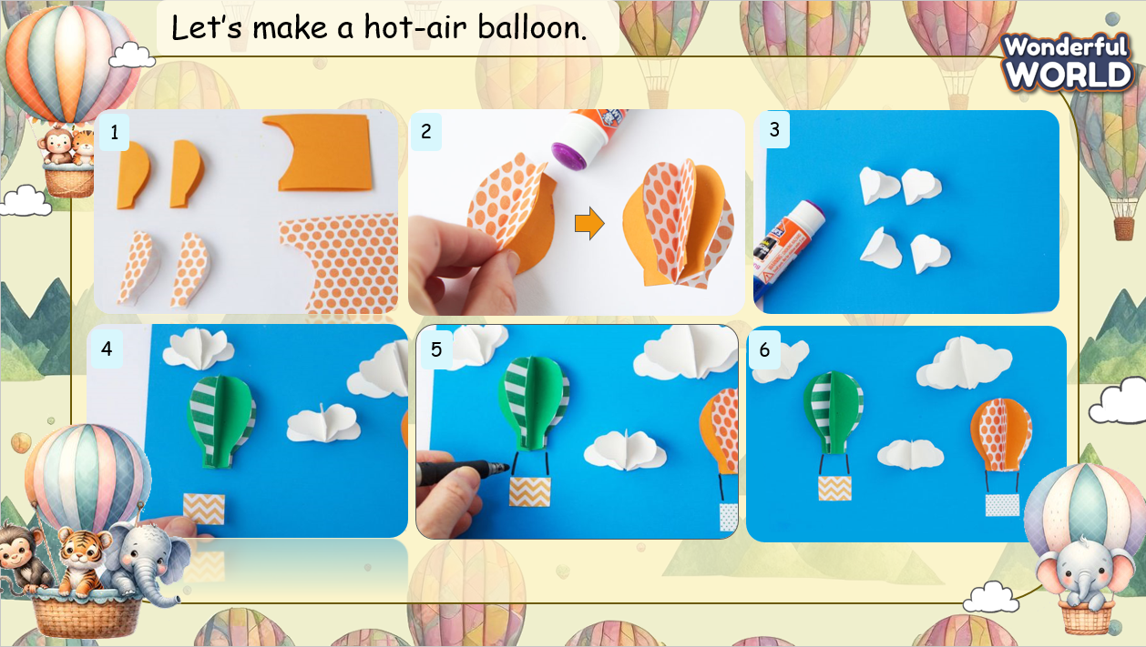 |  | - Look at the screen and identify the items needed  - Sit in groups and listen to the instruction  - Create their products  - Make a short introduction about their product  - Receive feedback.
Activity 4: Wrap up & Assessment (4 minutes)
Teacher’s Activities |  | Students’ Activities
a, Aims:
- Check Ss’s understanding of what they have learned.
- Students rehearse what they have learned in the lesson.
- Ask Ss to do the assessment.  - Give the assessment to class and some Ss.  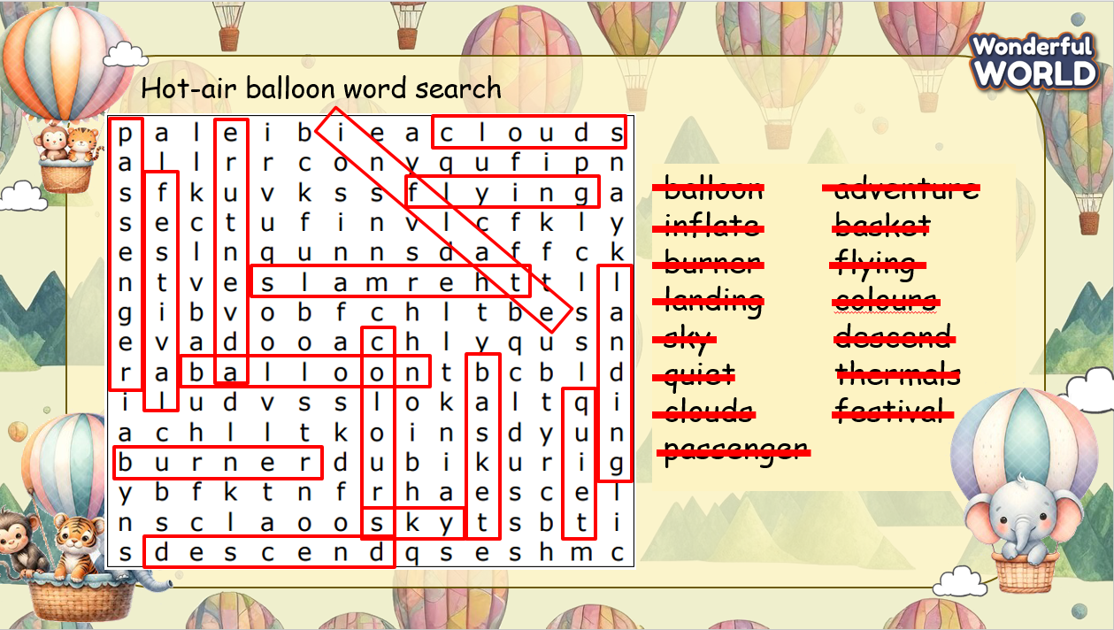  - Check with the class.  - T asks Ss about what they have learnt in today’s lesson.  - T show the wrap-up slide and conclude the lesson.  * Remember  VOCABULARY  Pilot, cloth, hot-air balloon, size |  | - Do the assessment.  - Check with the teacher.  - Answer T’s question of what they have learnt in today’s lesson.  - Ss read the wrap-up.  - Stand up and say goodbye to the teacher.

