WEEK 16
Period 62
Monday, December, 23th 2024 Class: 4C
Tuesday, December 24th 2024 Class : 4A, 4B
English
Unit 6: Outdoor Activities
Fun Time and Project
I. OBJECTIVES:
1. Knowledge:
- Students will review Outdoor Activities vocabulary and unit grammar.
2. Competences:
- English competences: Students will be able to remember the words and structures they have learnt.
- Common competences: Students will have the opportunity to develop logical thinking and develop communication among friends.
3. Qualities:
- Students develop love for different leisure activities and be friendly to their friends in the class.
II. EQUIPMENT AND MATERIALS:
- For Teacher: PP, TV, boards, markers, sweets.
- For students: A4 paper, books, pens, notebook/paper.
III. LESSON PROCEDURE:

Activity 1: Fun Time (10 minutes)
Aims: Elicit the words from the vocabulary about the outdoor activities.
Teacher’s Activities | Students’ Activities
WARM-UP : (3 MINUTES)  Clothes song  - Introduce the song  - Ask sts to review some vocabulary and do action  - Play the song: Ten Little Indians  Task 1: Unscramble (7 MINUTES)  Before unscrambling: Game  Ask sts to look at the screen and choose the characters they want. Then, answer all the questions and get stars  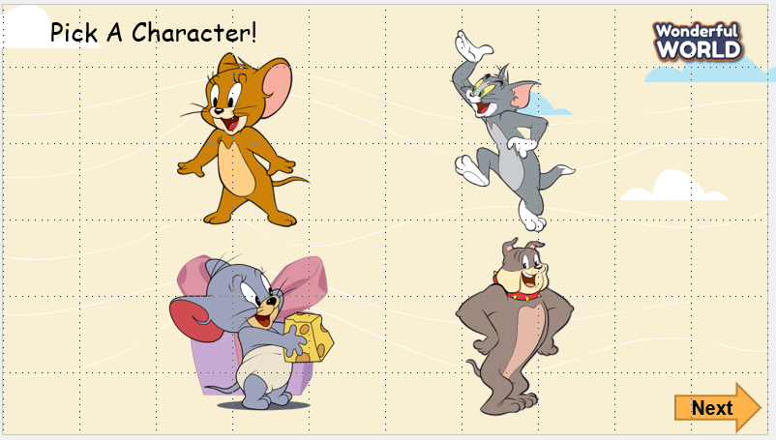  While gaming  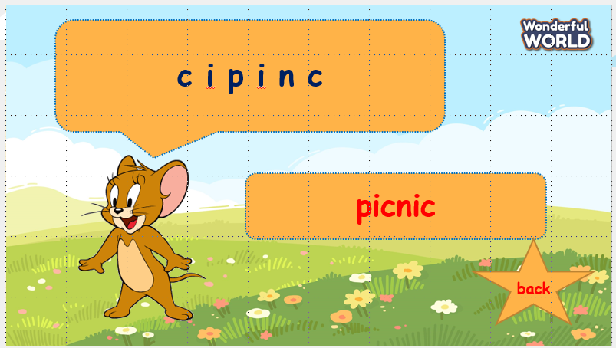  - Ask sts to work in groups  - Hand each group a print of task 1  - The sts will unscramble the words and get stars.  - The team, who gets the highest scores, will be the winner. | -Listen to the teacher  - Repeat and do the action  - Sing along and repeat the song.  Speak out correctly, paying attention to the pronunciation.  Do the game and get stars
Activity 2: Project (20 minutes)
Aims: Review phonics and words learned in the unit via fun activities (drawing) and quiz.
Teacher’s Activities | Students’ Activities
Project: Hobbies  Outdoor activities quiz  - Guides sts to play with the game and match the correct pictures with the correct words  - Anyone who can answer correctly will be given a star.  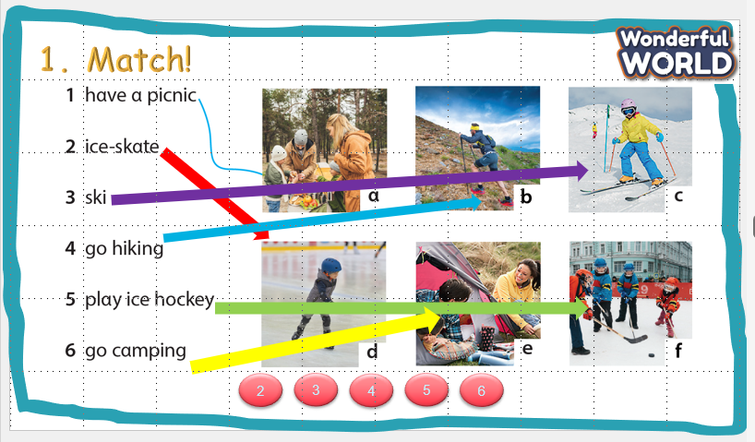  Project: Your Camp  - Tell them to draw a picture of a camp  - Colour the picture  - Ask sts to go to the board – group by group and present.  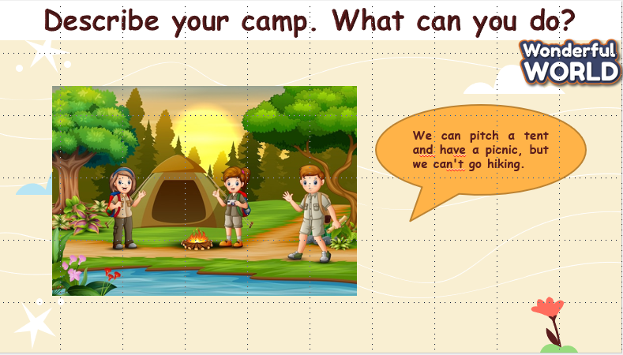 | - Listen to the teacher  - Listen to the game rules  - Look at the picture  - choose the correct answer  - show the board of correct answers.  -Talk to friends about the picture  - Read aloud the answers about objects.  - Write down the answer on their own board/book.
Activity 3: Assessment
Aim: Consolidate the content of the lesson.
Evaluation (2 MINUTES)  Answer the multiple choice and show answers  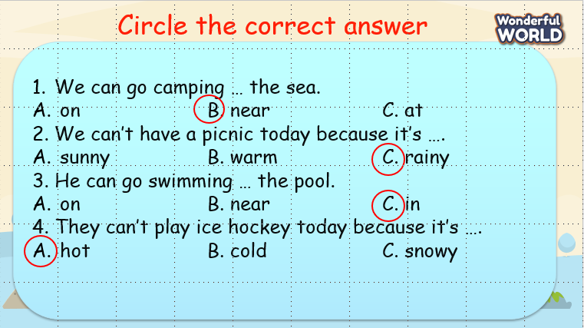  Home work (2 MINUTES) | - Do the assessment

