WEEK 15
Period: 57
Monday, December, 16^{th,} 2024 Class: 5C
English
UNIT 6: FOOD
Lesson 2: Part 4-5-6
I. OBJECTIVES:
1. Knowledge:
- Students will be able to:
+ recall some adjectives to describe food that they have learnt in the previous lesson: crispy, delicious, salty, sour, spicy, sweet, tasty.
+ get to know and use the new grammar about quantifiers: a few, a little.
2. Competences:
- English competences: Students will be able to use English to describe food’s amount and flavors.
- Common competences: Students will be able to develop collaborative skills through pair work.
3. Qualities:
- Students will
+ have a strong sense of respect in pair work.
+ raise their confidence by presenting in front of the class.
II. EQUIPMENT AND MATERIALS:
- Basic things: Student’s Book, Class Audio, dice, flashcards.
- Advanced things: PPT, laptop, TV.
III. LESSON PROCEDURE:
Activity 1: Warm-up
Activity 2: Presentation
Activity 3: Practice
Activity 4: Production
Activity 5: Wrap-up & Assessment
Activity 1: Warm-up (4 minutes)
A game “Stop the bus”
Teacher’s Activities | Students’ Activities
a. Aims: Welcome students. Engage the class with a game to review words that Ss have learnt: crispy, delicious, salty, sour, spicy, sweet, tasty.
b. Procedure:  1. Greeting Ss and chatting: Before starting our new lesson, let’s play a game to review some adjectives to describe food!  2. Introducing and playing the game “Stop the bus”:  Game rules:  - The class will be divided into some teams (2 or 4 - depending on teacher’s plan).  - There is a bus with one picture shown on the screen. Ss have to look at the picture and guess what adjective it is.  - Ss from each team raise their hands to speak up for points or stars. If no team has the correct answer, the teacher will minus 1 point/star of all teams.  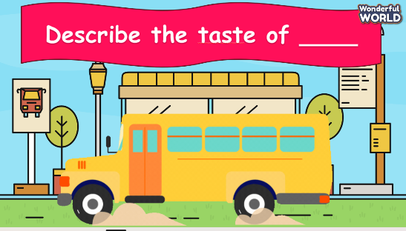  3. Leading in the lesson: Unit 6 – Lesson 2 task 4, 5, 6.  Lead in: Now, let’s move on to our new lesson. Today, we are going to learn some new quantifiers to describe food’s amount. | - Greet Teacher  - Listen to the teacher.  - Join the activity.  - Look and listen.
Activity 2: Presentation (11 minutes)
Teacher’s Activities | Students’ Activities
a. Aims:
- Present two new quantifiers: a few, a little and guide Ss how to use these quantifiers correctly in sentences.
- Instruct Ss to finish task 4.
b. Procedure:  1. (3 minutes) Eliciting quantifiers “a few”, “a little” (Track 6.3 – Task 4: Listen and read):  - Have Ss listen to Track 6.3 separately and show corresponding pictures at the same time.  - Encourage Ss to repeat what they have heard with each sentence then show the sentences on the screen.  - Ask Ss to listen again and repeat after the track by class and groups.  - Ask Ss to identify the quantifiers in 2 sentences (a few, a little).  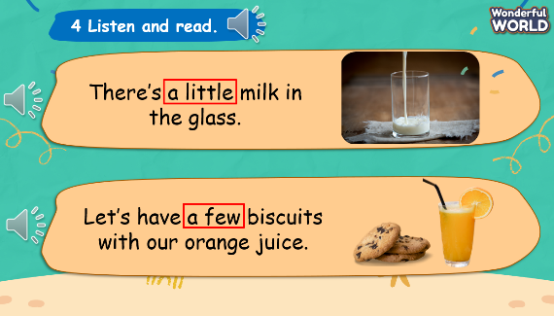  2. (5 minutes) Instructing how to use the quantifiers:  2.1. A little:  - Show a full glass of milk to lead in the quantifier “a lot of” and explain: “a lot of” means a large number or amount of something”.  - Show another glass of milk and ask Ss to give the correct answer then explain: “a little” means a small amount of something”.  - Ask Ss what type of nouns is used after “a little”.  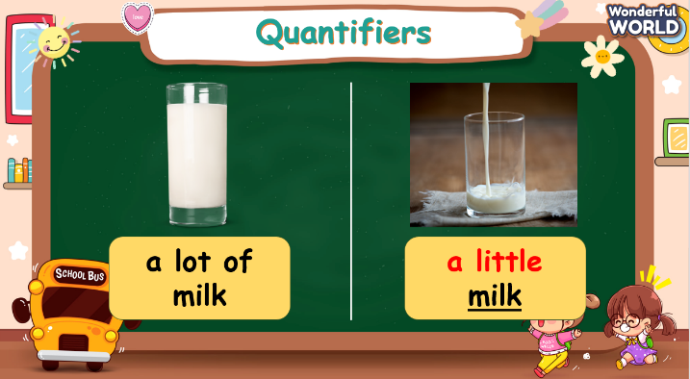  2.2. A few:  - Repeat the above steps with “a few”.  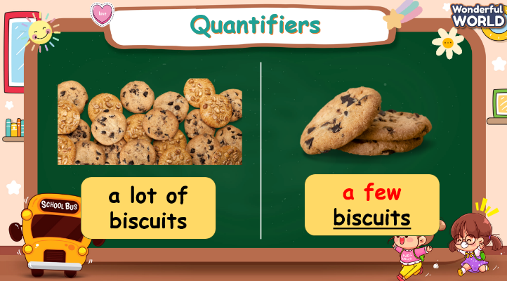  2.3. Quantifiers in sentences:  - Show a table to compare “a few” and “a little” and encourage Ss to make sentences with the given pictures.  - Explain how the verb “be” is used in each case:  + We use “There is” if the quantifier “a little” is in the sentences.  + We use “There are” if the quantifier “a few” is in the sentences.  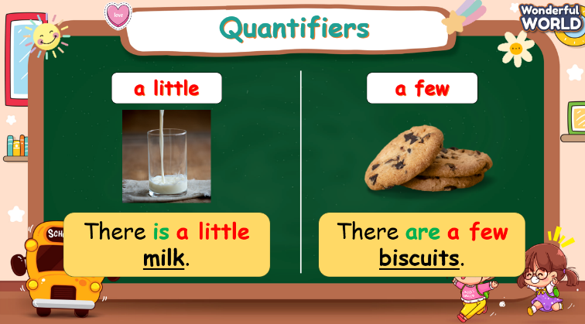  3. (3 minutes) Finishing Task 4 – Now, read, circle and say:  - Tell students to look at the pictures in the book and complete the sentences by circling “a few” or “a little”.  - Check students understand the task. Elicit the first answer if necessary.  - Allow them enough time to practice saying the sentences both individually and in pairs.  - Check answers as a class.  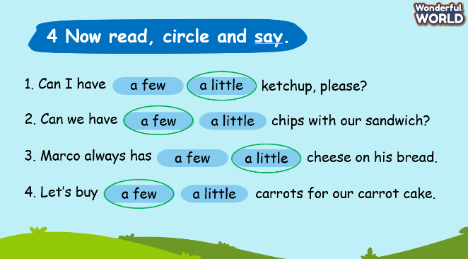 | - Listen to the audio.  - Volunteer to fulfill teacher’s requirements.  - Repeat after the audio.  - Answer teacher’s question.  - Listen to the teacher.  - Answer the question.  - Listen to the teacher.  - Answer the question.  - Volunteer to make sentences.  - Listen to the teacher.  - Work on task 4 individually.  - Check the answers.
Activity 3: Practice – Controlled practice (8 minutes)
Teacher’s Activities | Students’ Activities
a. Aims:
- Practice the quantifiers through Quiz activity.
- Practice using quantifiers in sentences through Task 5.
b. Procedure:  1. (4 minutes) Play Quiz game:  Instructions:  - The game includes three types of questions, Ss need to look and think carefully before answering.  - Three types of questions:  + Type 1: Look and choose the correct answer - Ss need to look at the pictures and choose the correct quantifiers.  + Type 2: Read and fill in the blank – Ss need to read and fill in the missing “be” in the blanks to have correct sentences.  + Type 3: Look, read, and choose True or False – Ss have to look at the pictures, read the sentences and identify if the sentences are true or false. If the sentences are false, Ss must correct the mistakes to have the correct sentences.  - Reward points/ stars with each correct answer. If the chosen team answers wrong, the teacher has to choose the other team.  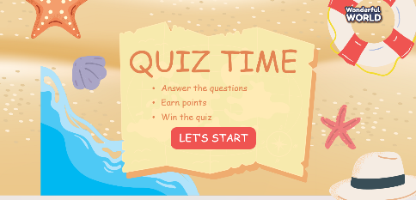  2. (4 minutes) Complete Task 5 - Put the words in the correct order to make sentences or questions:  - Tell students to write the words in the correct order.  - Go through the example sentence together to ensure students understand the task.  - Allow students to work individually to reorder the words in each sentence.  - After individual work, students can compare their answers with a partner or in small groups.  - Bring the class together and discuss the correct order of words for each sentence.  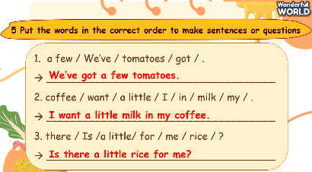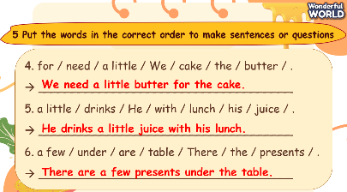 | - Join the activity.  - Complete the exercise individually.  - Work in pairs to practice saying the sentences  - Correct the exercise with the teacher.
Activity 4: Production (7 minutes)
Teacher’s Activities | Students’ Activities
a. Aim: Ss apply the words and grammar to finish Task 6.
b. Procedure:  - Tell Ss to look and read out the dialogue by class, groups and individuals  - Role play the example conversation with a student in front of the class.  - Pair up the Ss and give them some minutes to practice with each other.  - Go around the class and observe the conversations to ensure Ss are using the questions appropriately and responding effectively.  - Ask some volunteers to speak in front of the class when time’s up.  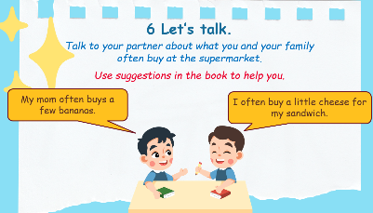 | - Read aloud the dialogue.  - Pay attention to the role play.  - Work in pairs.  - Present in front of the class.
Activity 5: Wrap up & Assessment (5 minutes)
Teacher’s Activities | Students’ Activities
a, Aims:
- Check students’ understanding of what they have learned.
- Students rehearse what they have learned in the lesson.
- Assessment: Do the activity to sort food into the correct quantifiers:  Answer:  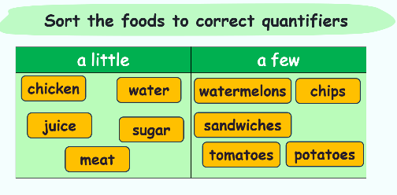  - Wrap up:  * Remember  - Review Vocabulary: crispy, delicious, salty, sour, spicy, sweet, tasty.  - Grammar: a few, a little  - There are a few sandwiches.  - There is a little water. | - Do the quick sorting activity.  - Stand up and say goodbye to the teacher.

