WEEK 13
Period: 49
Monday, December, 2^{nd,} 2024 Class: 5A
English
Unit 5. CELEBRATIONS
Lesson 3: Part 1-2-3

I. OBJECTIVES:
1. Knowledge:
- Students review words relating to celebrations
- Students practice listening and writing skills about traditions in countries
2. Competences:
- English competences: Students can use English to talk about the celebrations.
- Common competences: Students can draw their parties or celebrations and introduce them to their friends.
3. Qualities:
- Students will
+ develop a deeper appreciation and understanding of festivals around the world.
+ enrich their academic experience but also promote cultural awareness and global citizenship.
II. EQUIPMENT AND MATERIALS:
- Basic things: Student’s book, flashcards, photos, papers
- Advanced things: PPT, laptop, TV.
III. LESSON PROCEDURE:
Activity 1: Warm-up
Activity 2: Review
Activity 3: Practice
Activity 4: Production
Activity 5: Wrap-up & Assessment
Activity 1: Warm-up (5 minutes)
A guessing game “ Festivals around the world”
 | Aims: Welcome students. Warm the class up with a game to check their knowledge and widen their understanding of the festivals around the world.
 | Teacher’s Activities | Students’ Activities
 | Procedure
 | -Lead in: “Do you want to travel with me? I will take you to discover the countries in the world! Let’s watch the photos of the countries.”  1. Can you guess what festival is this? Notice the things in the photo. Can you see a cup of beer in the hand of the man? (T points.)  OKTOBERFEST – BEER FESTIVAL in Munich, Germany ( Large quantities of beer, traditional Bavarian foods such as pretzels and sausages, and lively celebrations with music and dancing)  2. Can you guess what festival? something is red. Yes, It’s the tomato festival. La Tomatina in Buñol, Spain, is a famous festival where participants throw tomatoes at each other purely for fun. Thousands of people from around the world gather to take part in this unique and messy event.  3. Do you see water? If not, do you know the country that is famous for its elephants?" It’s SONGKRAN Festival in Thailand, the Thai New Year's festival, which is celebrated in April each year. It's known for its water festival aspect, where people participate in water fights and splash water on each other as a way to cleanse and purify for the new year.  4. Notice the activities in winter including parades, ice sculptures, snow slides and the ambassador of the festival (a cheerful snowman) – It’s the largest winter festival in the world and a significant cultural event in Quebec City, Canada. The Carnival features a variety of activities, including parades, ice sculptures, outdoor concerts, night parades with illuminated floats, snow slides, and canoe races.  -The teacher shows the pictures of the festivals so that students can remember and each festival has its own thing such as snow, beer, tomato, and water.  -The teacher reviews how to use uncountable and countable nouns and does the task to check their understanding. | - Greet Teacher  - Join the activity.  - 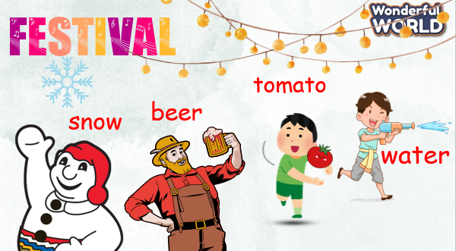
Activity 2: Review (8 minutes)
a. Aims: Ss can practice listening and writing skills in the activities in the past ( last birthday party.)
b. Procedure
Teacher’s Activities |  | Students’ Activities
A.Show the picture of the birthday party and give Students the question :
- “Did they have a birthday cake at the party?”
- Yes, they did.
- What did they do? (Did the boy blow out the candles and make a wish ?) - The birthday boy blew out the candles and made a wish.
What song did they sing? - Everyone sang "Happy Birthday" with smiles on their faces.
B. Part 2. Listen and write short answers.
1. Tell students to read each question, then listen.
2. Check students’ understanding of the task.
3. Elicit the first answer.
4. Play the recording one time or two times if necessary.
5. Ask students to give a short answer to each question.
6. Check answers as a class. Write them on the board if necessary.
Answer keys :
1. When was his birthday? - yesterday
2 Where did he go first?- a supermarket
3 Who did he go with? - with his close friends
4 Where did he eat? -in a Japanese restaurant
Activity 3: Practice – Controlled practice (8 minutes)
a. Aims: Ss can write the correct form of the verbs in the past.
b. Procedure
Teacher’s Activities |  | Students’ Activities
CHOOSE YOUR GIFT GAME  -Through the game, students will use prompts to write four sentences about their last birthday party :  - My birthday /be/ last Saturday (My birthday was last Saturday.)  - I/ go / bookstore/friends (I went to the bookstore with my friends.)  - I/ have / big / birthday cake (I had a big birthday cake.)  - We/have/ fun/ together (We had a lot of fun together.)  - great / birthday / nice / memories (It was a great birthday with many nice memories.)  - With each correct answer, the student can choose the gift to get the stars. |  | - Join the game.
Activity 4: Production – Free practice (6 minutes)
a. Aims:
Apply their understanding in discovering their favourite festival to draw and talk with their friends
b. Procedure
Teacher’s Activities |  | Students’ Activities
- The teacher asks students to choose a specific event known for its parties or celebrations Focus on details such as clothing, decorations, food, music, and activities.  - Instruct students to draw a detailed picture depicting a scene from the party or celebration they choose.  - Encourage students to include specific elements that reflect the historical period’s culture and traditions. For example, elaborate costumes, traditional foods, musical instruments, or architectural styles.  - Writing Sentences: After completing the drawing, ask students to write several sentences describing the party scene they depicted.  - Presentation Preparation: Have students practice reading their sentences aloud to ensure clarity and fluency.  - Presentation Phase:  Speaking Out: Each student presents their drawing and reads aloud the sentences they wrote.  Engagement: Encourage students to engage with their audience by making eye contact, speaking clearly, and using descriptive language to bring their scene to life.  - Provide constructive feedback to each student based on their drawing accuracy, writing coherence, and presentation skills.  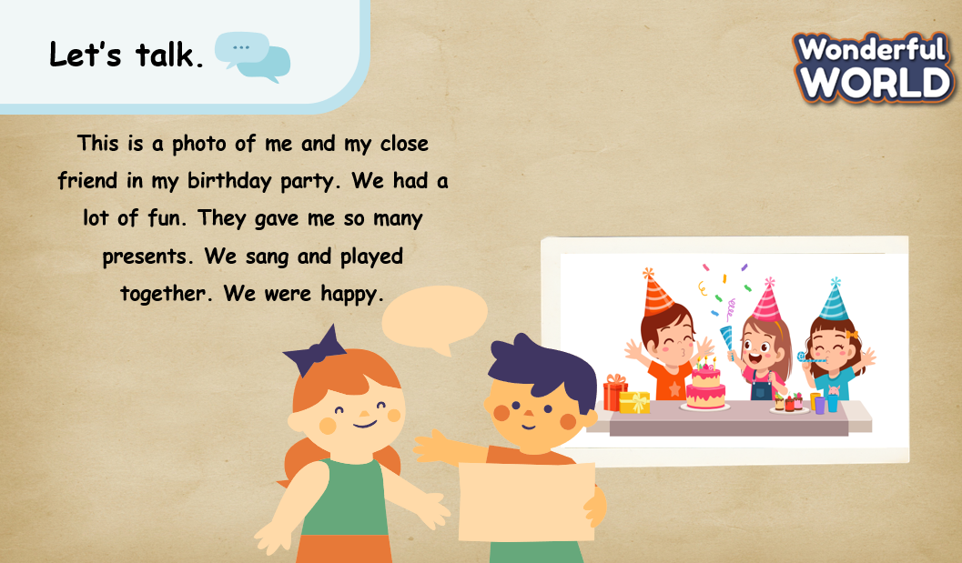 |  | - Draw and say in front of the class.
Activity 5: Wrap up & Assessment (4 minutes)
Teacher’s Activities |  | Students’ Activities
a, Aims:
- Check students’s understanding of what they have learned about the past simple and the countable and uncountable nouns.
- Students rehearse what they have learned in the lesson.
- Ask sts to do the assessment.  - T gives the assessment to the class and some Ss  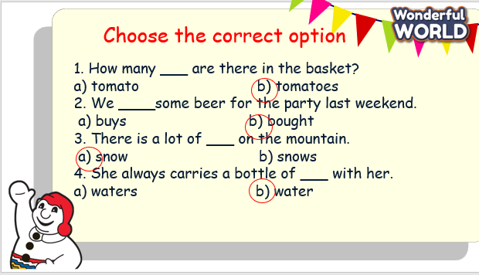  - Check with the class.  - Wrap-up  * Remember  Vocabulary:  Famous festivals around the world.  The verbs in the past. |  | - Do the assessment.  - Check with the teacher  - Sts read the wrap-up  - Stand up and say goodbye to the teacher.

