WEEK 14
Period 54 Monday, December, 9th 2024 Class: 4C
English
Unit: 6 – Outdoor activities
Lesson: 1 - 1, 2, 3
I. OBJECTIVES:
1. Knowledge:
Students will learn how to talk about what someone is doing and vocabulary related to outdoor activities.

2. Competences:
- English competences: Students will be able to ask and answer about outdoor activities.
- Common competences: Students will have the opportunity to develop communication through role-play activities.
3. Qualities:
- Students will be friendly and confident in communicating with friends.
II. EQUIPMENT AND MATERIALS:
- Basic things: Student’s book, flashcards, crayons, paper, glue
- Advanced things: PPT, projector/interactive whiteboard/laptop/TV.
III. LESSON PROCEDURE:
Activity 1: Warm-up (5 minutes)
a. Aims: Lead in Ss and introduce them the topic and vocab of outdoor activities
Teacher’s activities | Student’s activities
- Greet students  - Students will choose to open a picture then ask and answer with it.  - Lead-in: Use the Unit Opener to lead in Ss to the lesson by answering some questions  + What can you see in the picture?  + What are they doing?  + Where are they? | - Greet teacher  - Listen and answer questions
Activity 2: Presentation (8 minutes)
Aims: Present new vocabularies related to outdoor activities
Teacher’s activities | Student’s activities
* New words:  - Demonstrate flashcards and ask Ss to guess what it is  - Ask them to listen and repeat words individually, whole class  - Check their pronunciation | - Listen and do the task.  - Check the answers.
Activity 3: Practice (12 minutes)
Aims: Do some tasks to apply knowledge and practice English skills
Teacher’s activities | Student’s activities
* Task 1: Listen and point. Repeat.  - Ask Ss to open the book p.64  - Listen to the audio and point and repeat one by one word  - Call some Ss to check  * Extra activity: Matching  - Ask Ss to look at pictures and words/phrases then let them match together  - Optional: T can print out the worksheet and give Ss to complete then swap to their partner to check the answers  * Task 2: Listen and read. Check.  - Open the picture and have them answer these questions – Brainstorming:  + What is he doing?  + Where is he?  + What’s the weather like?  - Open the book page 54 – Listen and read. Tick  - have Ss listen to the passage  - Call some Ss to read one by one sentence  * Practice game: Help the Pooh  - Tell Ss how to play the game  - Call some Ss to choose the correct answer in each question  - Award the student  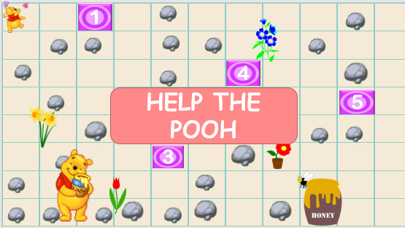 | - Open the book and do the tasks  - Answer the questions  - Stand up and read sentences in the passage  - Listen to the rule.  - Play the game.
Activity 4: Production (5 minutes)
Aims: Apply vocabularies into some specific tasks and develop the 4 skills
Teacher’s activities | Student’s activities
Task 3: Look and say  - Ask Ss open the book page 64  - Have Ss look at 4 pictures and work in pair to practise asking and answering  - T goes around and check their work  - Call some pairs to practise | - Listen the instruction.  - Work in pair.
Activity 5: Assessment and wrap-up (5 minutes)
Aims: Consolidate the content of the lesson, summarize knowledge and evaluate students’ learning competency.
Teacher’s activities | Student’s activities
* Assessment activity: Look at the pictures and write the correct answers  - Ask students to do the assessment.  - Check in pair then the whole class.  - Say goodbye | - Do the assessment.  - Check with friends and then with the teacher and the whole class.  - Listen carefully.  - Say goodbye.

