WEEK 12
Period 45 Tuesday, November 26th 2024 Class : 4B
English
Unit 5: Leisure time -Lesson 1 ( 1,2,3) (SB1 - p.53- p.54)
I. OBJECTIVES:
1. Knowledge: By the end of the lesson, Students will be able to
- Identify some weather phenomena: cloudy, windy, snowy, stormy.
- Listen to and read a dialogue about the weather.
2. Competences:
- English competences: Students can talk about different weather and what they are wearing for different kinds of weather
- Common competences: Students will have the opportunity to develop logical thinking and develop communication among friends.
- Core competences: motivation, communication, creativity, collaboration.
3. Qualities:
Students will:
- Develop a love for different weather.
- Be confident and active in communicating with friends and their teachers.
II. EQUIPMENT AND MATERIALS:
- Student’s book, flashcards, track 5.1, track 5.2.
- PowerPoint (PPT) presentation, projector/ laptop, speaker.
III. LESSON PROCEDURE:

Teacher’s Activities | Students’ Activities
Activity 1: Warm-up (5 minutes)
a. Aims: Review some kinds of weather and engage students in the topic “weather” of the lesson.
b. Procedure  Warm-up: Play a small game “Guess weather”  -The teacher asks SS to listen to the sound and guess what weather it is.  -T calls Ss to answer and check their answers.  -T asks Ss to repeat the names of the weather.    Answer keys:  - Rain  - Wind  - Storm  - Sunshine  Lead in: Photo time!  -T shows the picture of a boy throwing snow into the air and gives students some questions: What can you see? What is he wearing? Is it sunny/ rainy/cold/ hot?  - T calls SS to answer and check their answers.  - T introduces that they will learn about “Weather” today.  - Write on the board “Leisure time” and introduce the lesson.  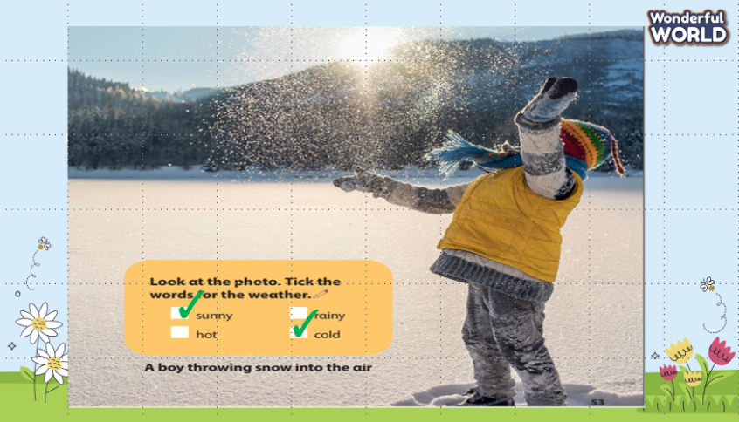 | -Listen to the sound and guess.  -Answer the questions.  - Repeat the name of the weather.  - Listen to the teacher.  - Answer the questions.  - Listen to the teacher.
Activity 2: Presentation (8 minutes)
a. Aims: Present new vocabulary about some weather phenomena.
b. Procedure  Task 1: Listen and point. Repeat. (Track 5.1)  - Use flashcards to introduce the vocabulary and structure of the lesson.  - Say the words for students to repeat in the chorus.  - Say a word for students to repeat then point.  - Play track 5.1 for the students to listen to, point to, and repeat the words in chorus and groups.  - Check their pronunciation and give them feedback.  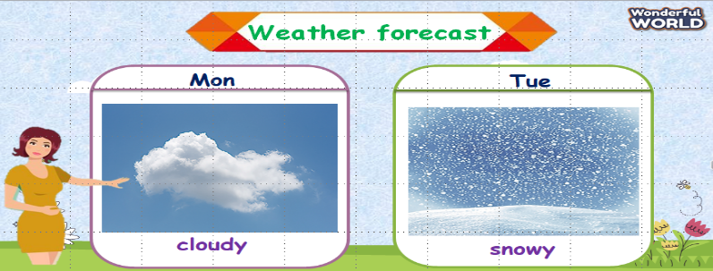  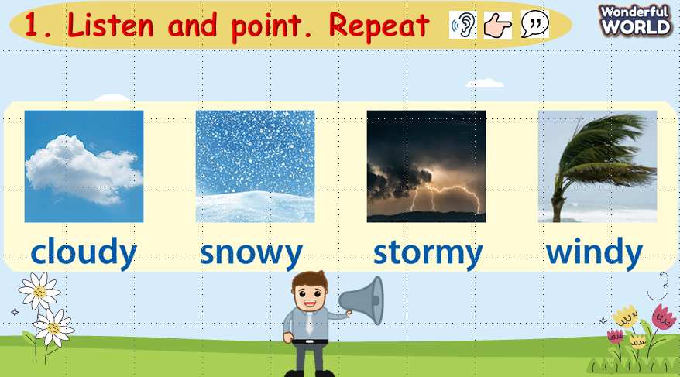  VOCABULARY CHECKING:  - Show pictures in random order and ask students to read aloud the correct words.  - Ask SS to say the words again.  - Check and give them feedback.  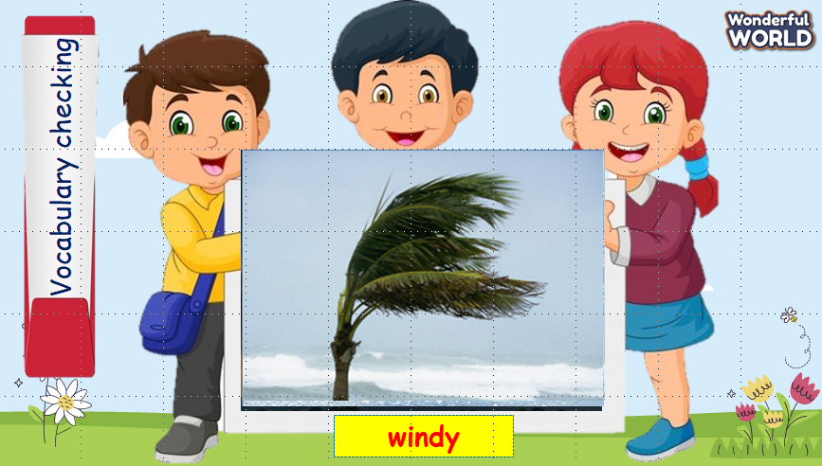 | - Listen to the teacher.  - Repeat after the teacher.  - Listen and repeat then point.  - Listen to track 5.1, point, and repeat the words.  - Look and answer.  - Read aloud the words.  - Listen to the teacher.
Activity 3: Practice (10 minutes)
a. Aims: Controlled practice: to listen to and read a dialogue about the weather, then make sentences to describe the weather.
b. Procedure  Task 2: Listen and read. Tick.  - Ask SS to identify the names of characters in the dialogue.  - Play track 5.2 and let SS listen to the dialogue, then repeat each sentence.  - Ask SS to read again, then tick the correct answers.  - Let Sts read the dialogue by role-playing “Jane and Tom” to practice the words and the sentences.  - Check and give them feedback.  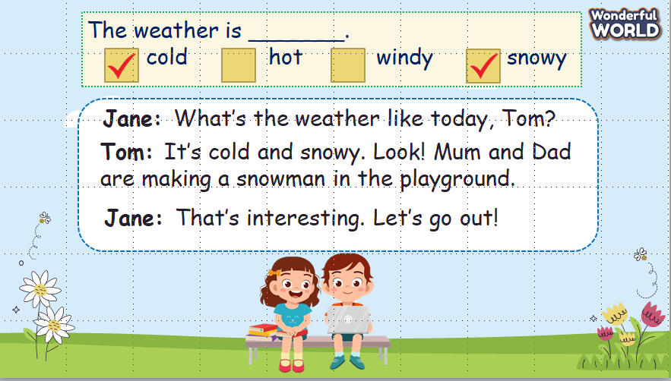  Task 3: Look and say:  - Look at the picture and let SS write the sentences and say these sentences like the example.  - Call SS to say aloud in front of the class.  - Check and give them feedback.  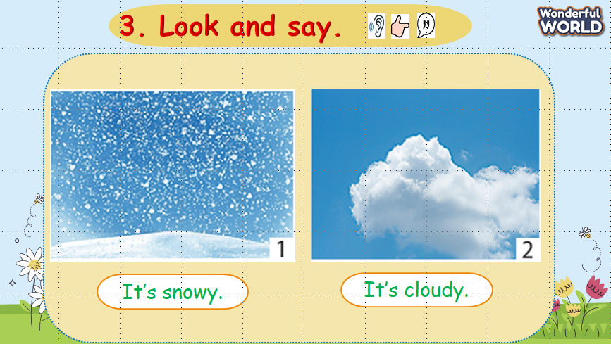 | -Answer the teacher.  -Listen to track 5.2 and repeat each sentence.  -Read and tick the correct answers.  -Role-play 2 characters: Jane and Tom to practice the dialogue.  - Listen to the teacher.  - Write the sentences and say.  - Say aloud in front of the class.
Activity 4: Production (9 minutes)
a. Aims: Apply vocabulary to the real world.
b. Procedure  - Work in pairs.  - Ask SS to look at the board and identify what they can see.  - Guide SS to answer 2 questions on the slides.  - Work in pairs and discuss what they are wearing in different kinds of weather.  - Call pairs to present in front of the class.  - Check and give feedback.  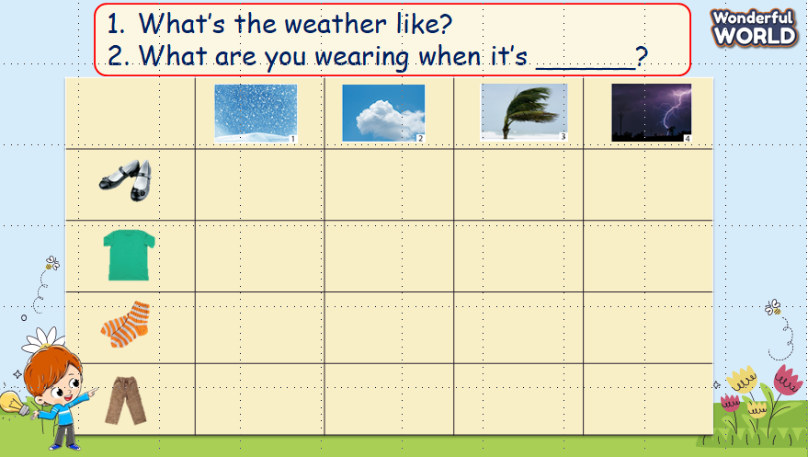 | - Look at the board and answer the questions on the slides.  - Work in pairs and discuss.  - Some pairs present in front of the class.  - Listen to the teacher.
Activity 5: Assessment (3 minutes)
a. Aims: Consolidate the content of the lesson.
b. Procedure  - Ask sts to do the assessment.  - Check with the class.  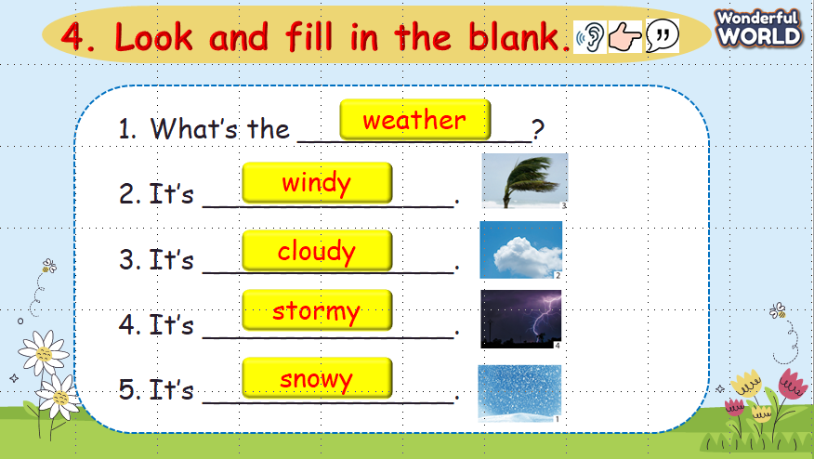 | - Do the assessment.  - Check with the teacher.

