WEEK 11 Monday, November, 18th 2024 Class: 4C
Period 41 Tuesday, November 19th 2024 Class : 4A, 4B
English
Review 2 – Part 1
I. OBJECTIVES:
1. Knowledge:
Students will learn words and phrases related to the topic the farm
We’ve got α field. They’ve got αlpαcαs on their fαrm and Hαs α chicken got wings? Hαve αlpαcαs got blαck fαces?
2. Competences:
- English competencies: Students will be able to remember the words and structures they have learnt.
- Common competences: Students will have the opportunity to develop logical thinking and develop communication among friends.
3. Qualities:
- Students develop love for different leisure activities and be friendly to their friends in the class.
II. EQUIPMENT AND MATERIALS:
- For Teacher: PPT, flashcards.
- For students: textbook
III. LESSON PROCEDURE:

Activity 1: Warm-up (10 minutes)
Aim: Revise the words and structures learnt in unit 4
Teacher’s Activities | Students’ Activities
Warm-up:  Dance and sing: The ocean jam  - Ask students to watch the video  - Dance and sing along the song.  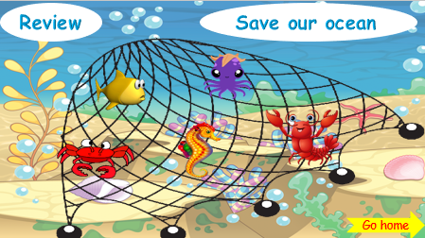  - Tell students how to play the game  Instructions:  1) Divide into Teams  2) Ask a sea animal to a Team (click the sea animal)  3) If correct, click “the house” button to go back  4) Continue until out of sea animals – click the “go home” button to finish.  - Do as a model  - T asks Ss to repeat after checking. | - Listen to the instructions carefully and watch the video.  - Watch the video again and sing along to the song.  - Repeat.  - Listen to T.
Activity 2: Practice (12 minutes)
Aim: - practise words and structure
- Practise speaking in front of the class
Teacher’s Activities | Students’ Activities
Task 1: Match  • Tell students to look at the pictures and then match each picture with the sentence describing it.  • Tell students to look at the example. Read the sentence and ask students to repeat.  • Check if students understand the task. They allow enough time for students to complete the task.  • Check the answers as a class.  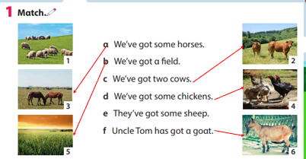 | - Look and answer.  - Work in pairs.  - Play the game.
Teacher’s Activities | Students’ Activities
Task 2: find and circle  • Tell students that they are going to find the given words in the puzzle.  • Divide the students into pairs or groups to do the puzzle.  • Show students how to do the task by circling the first word if necessary.  • Praise or award a prize to the quickest pair or group will all correct answers.  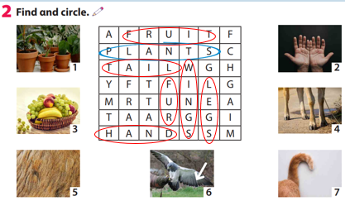 | - Listen and work in pairs.  - Present in front of the class  - Listen.
Task 3: Write  Read the first question and the sample answer. Explain to students and have them read the question and write the answer.  • Check students understand the task. Allow enough time to complete it.  • Check answers as a class.  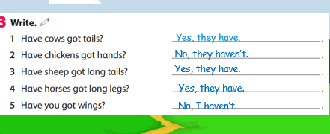 | - Look and answer.  - Work in pairs.
Activity 4: Product (3 minutes)
Aim: Review the vocab and grammar of the previous lesson- using the fun activities in the lesson.
Click on the number to show the question  Click next to go to the next part  Click star to display the crown  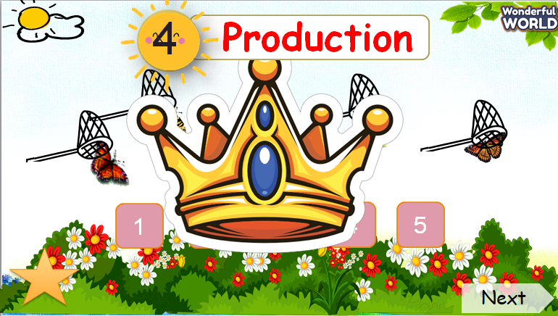 |  | - Look and answer.  - Work in pairs.
Activity 5: Assessment (3 minutes)
Aims: Do the exercise to review and practice the words
Consolidate the content of the lesson.

Teacher’s Activities | Students’ Activities
-Ask sts to do the assessment.  - Check with the class.  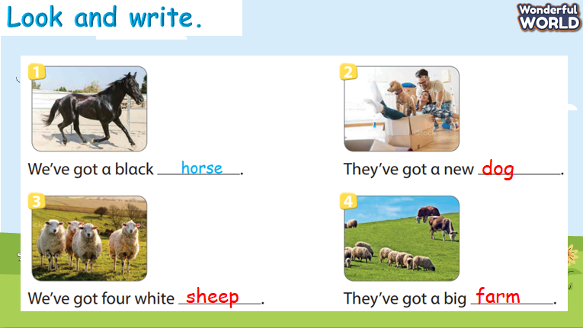 | -Do the assessment.  - Check with the teacher.

