WEEK 8
Wednesday, October 30th 2024 Class : 3B
English
Unit 2: My school
Lesson 3: 4,5,6
I. OBJECTIVES:
1. Knowledge:
Students will learn the structure Are you …?/ Are they…? and review words related to the topic school.
2. Competences:
- English competences: Students will be able to ask and answer about their school
- Common competences: Students will have opportunity to develop communication in working with friends
3. Qualities:
- Students will be benevolent in adapting concept about Alien
II. EQUIPMENT AND MATERIALS:
- For Teacher: PP, track 2.11, Word set, 6 bells, worksheet
- For students: student books, notebooks, pens.
III. LESSON PROCEDURE:

Activity 1: Warm up (5 minutes)
Teacher’s Activities | Students’ Activities
Game: Penguins find the way home  Arrange sts to play in 8 groups. Teacher hands each group a set of vocabulary: pen, pencil, book, rubber, ruler, student, teacher, clock. There are 8 little penguins hanging out far away from home. They play happily on ice with each other. It’s getting dark, however; they can not remember the way home. Please help each penguin find the way home by press on each penguin’s picture, answer the question behind. Sts look at the picture on screen and as fast as possible pick up the equivalent word and group says it aloud. If the answer is correct, you save that penguin.  Set sts as 8 groups  Give game instruction  Hand each group a set of words  Choose a penguin to play as a demo  The first correct team will get a chance to choose the next penguin  Award the winner that has highest score | -Sit in 8 circles  - Listen to the teacher  - Receive the words  - Watch the demo carefully  - Choose a penguin to save  - Pick up the word and say it aloud
Activity 2: Presentation (8 minutes)
Teacher’s Activities | Students’ Activities
Task 4: Listen and repeat  -Set context: Your Alien wants to visit your school on earth. However, he doesn’t know any things about it. He asks you so many questions whenever he meets anyone or anything. Guess what he asks. Then listen and check the question. How you answer.  - Show the picture one by one  - Ask sts to guess the Alien’s question  - Show answer with audio sound  - Sts repeat the questions  - Ask them to answer the Alien  - Show answer to check  - Ask sts to repeat  - Continue until the end of the four pictures  Checking: Play role  - Divide class into 2 big groups  One group will take a role of an Alien and one will be school teachers/ students  - Let sts Tick-tac-toe to choose their favourite role  - Fix the role duty: alien asks, the other answers  - Ask sts to play in 2 big groups several times  - Have pairs ask and answer  - Stick star on the board for each team after a correct asking and answering  - Explain the grammar point:  Are you …?/ Are they ..  I’m not = I am not  aren’t = are not | - Listen to teacher  - Look at the picture and guess the question one by one  - Listen and check  - Give response to Alien’s question  - Listen and check. Then repeat  -Tick-tac-toe  - Play role  - Ask and answer in groups  - Ask and answer in pairs  - Listen and make notes on lesson grammar points
Activity 3: Practice (14 minutes)
Teacher’s Activities | Students’ Activities
Task 5: Point and ask  Ring the Bell Game  -Split sts into 6 teams. Give each team a bell to ring.  Teacher shows the pictures of: 1. teacher, 2. Students, 3. rubbers, 4. chairs, 5. pencils, 6. books, 7. pens, 8. rulers on the board at a time.  - Show the phrases one by one:  1.you/teacher  2. they/ books  3. they/ students  4. they/chairs  5. they/ pencils  6. They/ clocks  7. they/ pens  8. they/ rubbers  - Sts look at the words and the number on each picture  - Ring the bell to take the opportunity to ask the question  - The first ringing bell asks questions. Others answer  - Have sts continue playing  - Give 5 points for each correct questions, 3 points for a correct answer  - Award the winner  Look, ask and answer  Show the picture in task 5 with some changes on it  Ask sts to work in pairs  Hand them a set of words  1.you/teacher  2. they/ books  3. they/ students  4. they/chairs  5. they/ pencils  6. They/ clocks  7. they/ pens  8. they/ rubbers  9. they/rulers  - Ask pairs to play Rock-scissors-paper.  - The winner picks up the words and asks. The other answers.  - Go around to help when needed  - The person gets most words win the game | - Form 6 teams  - Get the bells  - Look at the pictures and numbers carefully  - Look at the words  - Ring the bell to take answer chances  - Look at the picture, numbers on things carefully  - Receive the words  - Play rock-scissors-paper  - Ask-answer-keep those words as private
Activity 4: Production (9 minutes)
Teacher’s Activities | Students’ Activities
Task 6: Let’s talk  Miming Game  -Ask sts to work in pairs  - Have one st act out as school things  - The other guesses by asking question: are they …?  - The actor answers Yes, they are/ No, they aren’t.  -Change the role after 2 minutes  - The one guesses most things correctly in time gets stickers from teacher | - Work in pairs  - Act  - Ask question  - Answer Yes/ No  - Change the role
Activity 5: Assessment (3 minutes)
Teacher’s Activities | Students’ Activities
-Ask sts to do assessment  Look, read and circle  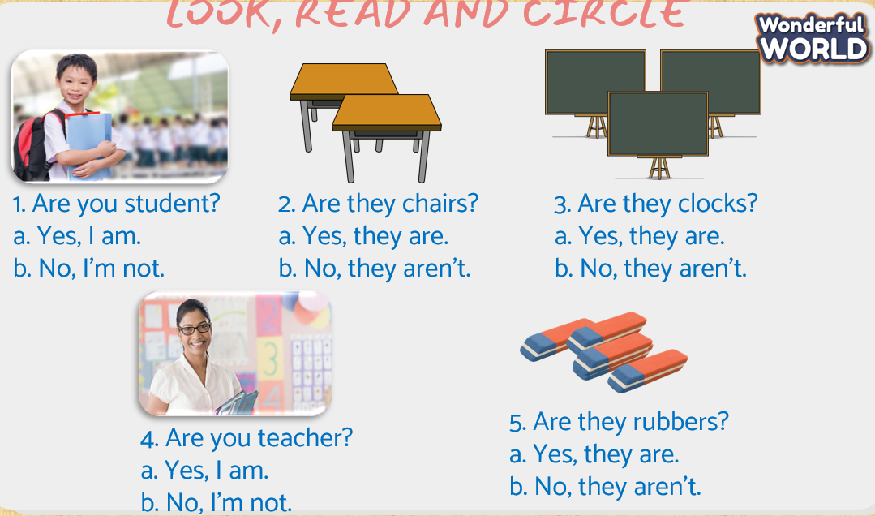  - Check with whole class  - Say goodbye | - Do assessment  - Check with teacher  Answer  1. a  2. b  3. b  4. a  5. a  - Goodbye

