WEEK 5
Monday, October 7th 2024 Class: 5B
English
Unit 2: My favourite things
Fun time and project: 1,2,3
I. OBJECTIVES:
1. Knowledge:
Students will review and practice all get vocabulary and structures of Unit 2 via some fun activities words and structures related to the topic My Favourite Things.
2. Competences:
- English competences: Students will be able to think and talk about topics.
- Common competences: Students will have the opportunity to develop logical thinking and develop communication among friends.
3. Qualities:
- Students develop imagination and show their favourite things.
- Be confident and active in communicating with friends and teachers.
II. EQUIPMENT AND MATERIALS:
- For Teacher: PPT, flashcards, printed papers, dice.
- For students: textbook
III. LESSON PROCEDURE:
Activity 1: Warm-up
Activity 2: Review & Practice
Activity 3: Production
Activity 4: Wrap-up & Assessment
Activity 1: Warm-up (5 minutes)
“TOP 5 QUIZ”
 | Teacher’s Activities | Students’ Activities
 | a, Aims: Welcome students. Engage the class with a game and review the vocabulary of Unit 2.
 | b, Procedure  GAME RULE :  1. Write down ONE answer  2. If your answer is in the “ TOP 5” answers, you get points.  This game helps students to collect the words that they studied.  - Answers:  1. Colours.  2. Days of the week  3. Fruits  4. Toys  5. Animals  To lead in the Board game, the teacher says: “ You will have a chance to think about your favourite things.” | - Greet Teacher  - Listen to the rules of the game.  - Join the activity.
Activity 2: Review & Practice (17 minutes)
Teacher’s Activities |  | Students’ Activities
- Aims:
- Engage the class with a board game to review the favourite things
b, Procedure  REVIEW VOCABULARY  -The teacher asks students to apply the words to play the game.  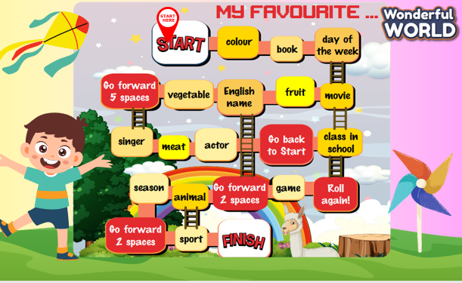  -Then, show the students some words: computer, puzzle, typewriter, photo, country, map, globe, spider.  REVIEW GRAMMAR :  - Past simple with To Be  - Position prepositions: below, above, inside, outside, in the middle of  - Connectors: and, but  PRACTICE: Answer the questions of the lesson to review the vocabulary and the grammar.  #1: Crab  #2: Spider  #3: A doll  #4: But  #5: Outside |  | - Join the activity.
Activity 3: Production (8 minutes)
Teacher’s Activities |  | Students’ Activities
a. Aims: - Controlled practice: develop reading skills.
b, Procedure  1. Show the lyrics on screen.  2. Have students look at the lyrics.  3. Read the lyrics aloud and have students repeat them sentence by sentence.  4. Play the recording twice and have students listen.  5. Play the audio again and have students sing along as the whole class.  6. Divide the class into two groups. Group A and Group B take turns to sing.  7. The teacher will hide some words, and students will say the correct words to check their understanding.  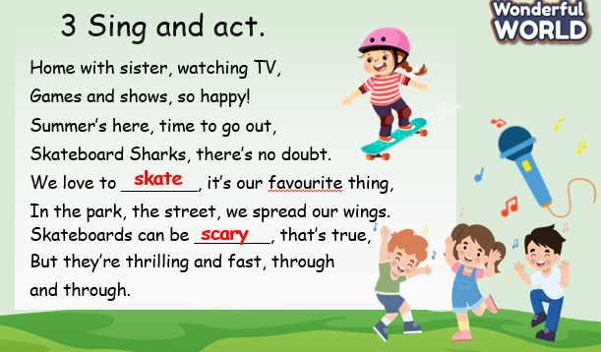 |  | -Read  -Sing along.  -Say the correct words.
Activity 4: Wrap up & Assessment (5 minutes)
Teacher’s Activities |  | Students’ Activities
a, Aims:
- Do a quick exercise to review the words and grammar used in Unit 2
- Check with the class if necessary. |  | - Join in the activity.  - Check with the teacher.

