WEEK 3
Thursday, September 26th 2023 Class : 3A
English
Unit 1: My family
Lesson 2: 7,8,9
I. OBJECTIVES:
1. Knowledge:
- Students will review the words and phrases related to the topic Family: family, grandpa, grandma, mum, dad, uncle, aunt, brother, sister, me.
- Students can review all structure: Simon is my uncle, This is my family, My grandma is Laura.
2. Competences:
- English competences: Students will listen and understand a short introduction about a family, fill in information in a family tree and about their family.
- Common competences: Students will have opportunity to develop the creativeness in drawing their own family tree, Solving problems and active role of learners.
3. Qualities:
- Students will be respectful in family, and develop the love toward family.

II. EQUIPMENT AND MATERIALS:
- Basic things: Student’s book, flashcards, pictures of family, pieces of papers, coloured pencils/crayons to draw family tree.
- Advanced things: PPT, projector/interactive whiteboard/laptop/TV.
III. LESSON PROCEDURE:
Activity 1: Warm up (5 minutes)
Teacher’s activities | Student’s activities
- Greet students.  Movement Game: Play “Move and Freeze”  -Let the sts stand up, listen to the music and dance.  -When the music stops and they hear the word “freeze”, they have to stop and stand still, the ones move have to come to the board.  -The team (1 of 4) has the most sts at their desks will get the points.  -Turn on the music and let the sts follow.  Needed: music  Review: Hidden pictures game  -Divide class into 2 teams-Boys and Girls  -Let the sts look at 1 of the pieces and guess the picture behind.  Lead in: Tell the sts that they are going to study more about the family. | - Greet teacher.  - Listen and do the action with teacher.  - Follow teacher if possible.  - Play the game.  - Look at the pieces of pictures and guess
Activity 2: Practice Listening (8 minutes)
Teacher’s activities | Student’s activities
Task 7: Listen and tick. (Track 1.7)  - -Tell the students that they are going to listen to a short introduction about a family.  - -Ask student to read through the questions and options.  - -Ask students to look at question 1. Play the first part of the recording and tell students to read the sample answer. -Elicit why it is the correct answer for question 1.  - -Play the recording and tell students to listen and tick the correct answers for questions 2 – 4.  - -Play the recording more than once if students cannot catch the answers.  - -Play the recording again and pause after each sentence to check answers.  - Option 1: Game: Listen and choose! (use flashcards)  - - Sts listen and choose the correct answer.  - - Show flashcards of family member.  - - Play the the recording (or teacher calls a family member). Sts choose the correct one.  - Option 2: Game: Save the world! (ppt)  - -T divides class into 2 teams: Boys and Girls.  - 1 boy and 1 girl take turn to answer 1 question by listening and choosing the correct pictures.  - -After choosing the correct pictures, T asks 1 student to write the answers (words) on the board.  - - Who can make it will save the world (the rocket flies to save the world) | - Read the questions and options.  -Look at the sample answer.  -Listen and tick the correct answers.  -Listen and check the answers  - Play the game  - Listen and choose the correct picture  - Group work  -Enjoy the game and write the words on the board.
Activity 3: Practice Writing (9 minutes)
Teacher’s activities | Student’s activities
Task 8: Write on the family tree  -Tell students they are going to fill in information in a family tree.  - -Tell students to look at the picture and the family tree. Explain that a family tree shows people in a family and their relationship.  - -Tell them to look at the picture again. Hold up your book, point at each member of the family and read out the prompts.  - -Ask students to look at the family tree and the names of the people there. Elicit answers on the people who are missing.  - -Allow students enough time to fill in the missing names in the family tree.  - -Check answers as a whole class.  - -Ask volunteers to show their work and read out the name of each member and their role in the family.  - Game: Who is who?  - Divide the class into 4 groups.  - Teacher calls a name of a member of the family member in the picture.  - Teacher hides a name of a family member.  - Sts have to say the name or who the person is.  Who says it fast will get points for the groups. | - Listen to the teacher  - Point at each member of the family and read out the prompts.  - Fill the names missing.  - Check the answers.  - Come to the front and read out loud.  - Play the game.
Activity 4: Practice Speaking (10 minutes)
Teacher’s activities | Student’s activities
Task 9: Let’s talk  Students bring the family pictures and present in group, using.  This is my family.  My grandma is...  My grandpa is...  Have some students present in front of the class  Extension:  Game: Memorization  -Let the sts show their picture of family they bring from home.  -Let the others listen and remember.  -Let other students talk about their friend’s family tree. | - Work in group  Present in front of the class  Play the game.
Activity 5: Assessment (3 minutes)
Teacher’s activities | Student’s activities
Look at the pictures and circle the correct answers.  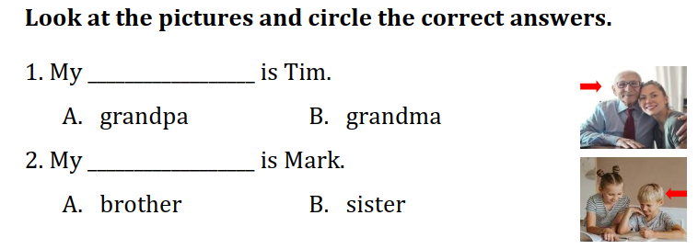  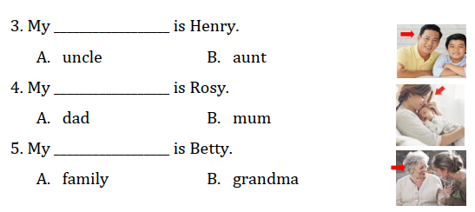  Answer: 1A, 2A, 3A, 4B, 5B  - Say goodbye | - Do the assessment.  - Check answer with friends and then with teacher and whole class.  - Say goodbye.

