WEEK 1
Wednesday, September 11th 2024 Class : 1A
Engish
UNIT 1: IN THE SCHOOL PLAYGROUND
Lesson 1: 1,2

I. OBJECTIVES | By the end of the lesson, pupils will be able to:
- pronounce the sound of the letter B/b in isolation.
- say the words Bill, bike, book, ball.
II. INPUT | Language:
- Sound /b/
- Vocabulary: ball, bike, book
Resources/Material:
- Student’s book p. 6
- hoclieu.vn
- Flashcards for Unit 1
- Poster for Unit 1
- Teacher’s guide pp. 7-9
- Computer, projector
III.PROCEDURE | Warm-up – Listen and repeat – Point and say – Game - Homelink

Procedure | Teaching and learning activities | Classroom management
Warm-up | 5 minutes
 | - Greet the class by saying Hi.  - Introduce your name I’m + name.  - Encourage pupils to say their names and where they come from (in Vietnamese).  - Introduce (in Vietnamese) Tiếng Anh 1 - Sách học sinh (the number of units, the number of lessons in one unit, and the number of activities in each unit).  - Have pupils open the books and look at Unit 1, Lesson 1 (Page 6). | Whole class
1. Listen and repeat 10 minutes
Step 1:  Step 2:  Step 3:  Step 4:  Step 5:  Step 6:  Extension | Open books or access hoclieu.vn. Have pupils look at the picture, saying Look at the picture, please! and describe it (in Vietnamese). Draw pupils’ attention to the letter B/b, the word next to Bill and other words next to the things and the colour of the letter B/b (as mentioned in Input).  Ask pupils to point to the letter B/b. Have them listen and repeat the sound of the letter B/b (saying Listen and repeat, please!) more than once, if necessary.  Tell pupils to point to Bill and the word Bill (saying Point to Bill and the word Bill). Ask them to listen and repeat the word, saying Listen and repeat, please!  Repeat the same procedure with the ball, the bike and the book. Give further support to those pupils who find it difficult to do the task.  Play the recording again and have them listen, point to the letter B/b and the ball, bike and book and repeat until they feel confident. Correct pronunciation, if necessary.  Play the recording again and call some pupils to say the letter B/b and the words Bill, ball, bike and book in front of the class (saying Well done! when they performed well).  With a better class, have pupils look again at the picture and find the pictures of the birds, bees (or/and butterfly). Teach the words bee, bird (or/and) butterfly. | Whole class  Individual work  Whole class  Individual work  Whole class
2. Point and say 7 minutes
Step 1:  Step 2:  Step 3:  Step 4:  Step 5:  Step 6: | Have pupils look at the picture again (Student’s book, p. 6 or hoclieu.vn) or at Poster for Unit 1, saying Look at the picture on Page 6, please! Ask them to describe the picture again (in Vietnamese). Draw their attention to the letter B/b, Bill and the things, if necessary.  Get them to point to the letter B/b and say it, saying Point to the letter B/b and say, please!  Let them point to Bill and say his name, saying Point to Bill and say, please! Give further support to those pupils who find it difficult to do the task.  Follow the same procedure with other things. Give further support to those pupils who find it difficult to do the task.  Ask pupils to work in pairs or in groups to point to the picture and say the sound of the letter B/b and the words. Go around and offer help or correct pronunciation, if necessary.  Invite two or three pupils to point to the picture and say the sound of the letter and the words in front of the class. If they performed well, praise them, saying Well done! | Whole class  Individual work  Individual work  Individual work  Pair or group work  Whole class
Fun corner | Slap the board 10 minutes
Step 1:  Step 2:  Step 3:  Step 4:  Step 5: | Write four words Bill, ball, bike and book or stick the flashcards with these words on the board. Tell pupils to look at the board, saying Look at the board, please! What words can you see? OK, now let’s play the game.  Tell pupils how the game is played, saying This game is played in a group of four people. When I say, for example, Bill, you will run as quickly as possible to the board and touch/slap your hand on the word/flashcard. The one who is the quickest to touch/slap the correct word/flashcard gets one point.  Ask pupils to listen to four words and touch/slap the flashcards/words as correctly and quickly as possible, saying Are you ready? Now listen to me and let’s play the game.  Have pupils play the game in groups of four. The pupil who gets the highest score will be the winner.  Invite four pupils to play the game in front of the class, if there is time. | Whole class  Whole class  Whole class  Group work  Whole class
Homelink | 3 minutes
Option 1: | Pupils use Student’s books:  - to pronounce the sound of the letter B/b.  - to point to Bill and the things in the picture on page 6 and say the words Bill, bike, ball, book. | Whole class
Option 2: | Pupils may use hoclieu.vn:  - to listen and pronounce the sound of the letter B/b.  - to listen and say the words Bill, bike, ball, book.  Pupils play Slap the board with the words bike, book, ball in hoclieu.vn.
Option 3: | Pupils use pencils or colour pencils to:  - draw and colour the pictures of the bike, the ball and the book in the notebooks.  - then to point to the the bike, the ball and the book and say the words bike, ball, book.

Activity 4: Production (10 minutes)
Teacher’s activities | Student’s activities
Task 3: Let’s play  - Tell students they are going to play a game to ask and answer about colours.  - Tell students to look at the picture and the sample sentences. Read out the sample sentences and ask students to repeat.  - Explain to students that they’re going to play the game in pairs. One student holds up an object (or crayons) and asks What colour is it? The other student then answers the question.  - Give an example by asking a student to do the activit.  - Ask students to work in pairs to play the game.  - Ask volunteers to play it in front of the class. | -Listen to the rules of game.  -Pair work.  -Play the game.  -Come to the board and play it in front of the class.
Activity 5: Assessment (5 minutes)
Teacher’s activities | Student’s activities
Let’s colour!  Show a picture for sts to colour. Ask the sts to say the colours that they need to use to make the picture more beautiful.  Show the pictures to their classmates and practice the sentence: What colour is it? It’s …  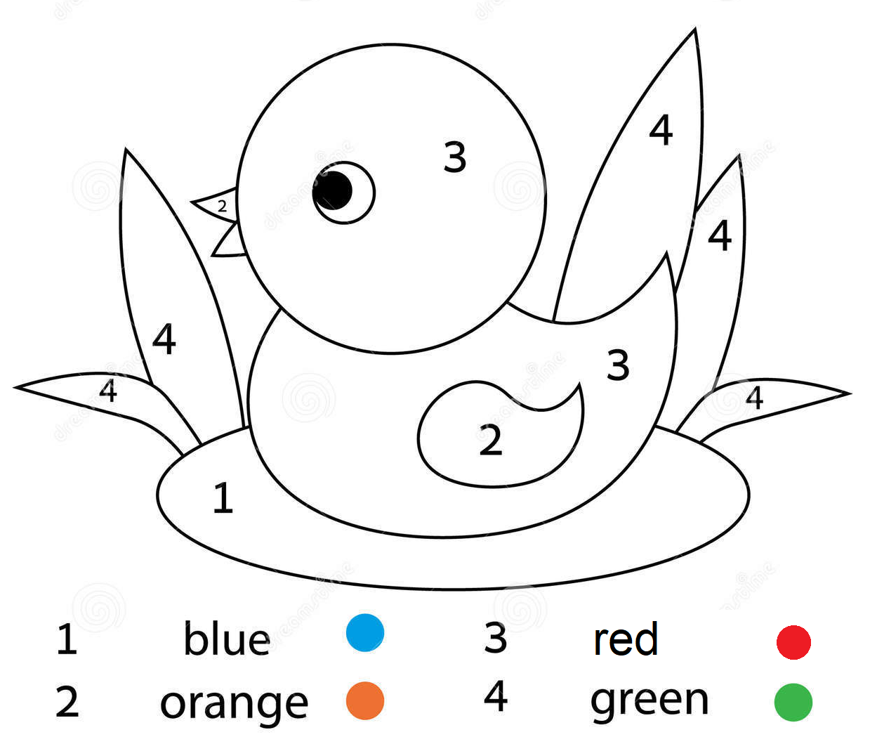  Good bye song. | - Do the assessment.  - Individual work  - Pair work.  Sing a song and say goodbye.

