LESSON PLAN
TEXTBOOK: TIẾNG ANH 6 - GLOBAL SUCCESS
UNIT 5: NATURAL WONDERS OF VIETNAM
LESSON 5: SKILLS 1 (page 54)
(TIẾT DẠY TẠI THƯ VIỆN)
Period: 37
Date of teaching: 02/12/2025

A. OBJECTIVES:
By the end of this unit, students will be able to:
- read about natural wonders
- talk about famous places
- have love for natural wonders in Viet Nam and awareness of protecting natural wonders.
B. LANGUAGE FOCUS:
1. Vocabulary:
- The words related to the topic natural wonders of Viet Nam.
2. Grammar:
- countable and uncountable nouns.
- modal verbs must/ mustn’t
C. TEACHING AIDS:
- Grade 6 textbook, Unit 5, Skills 1 (page 51,52)
- Smart TV or computer
- hoclieu.vn
- Map of Viet Nam (34 provinces and cities), books in the library
D. TEACHING APPROACH: CLT
E. PROCEDURES:
ACTIVITIES | CONTENTS
1. Warm – up: (7’)  Objectives:  - To introduce some famous places in Viet Nam, especially after connecting from 63 provinces and cities into 34 provinces and cities.  To introduce the topic of reading and to lead in the lesson about Skills 1.  Organization:  T introduces 3 books in the library about some famous natural wonders in Viet Nam.  + The first book:  Name: Đất nước gấm hoa – Atlas Việt Nam  Writer: Võ Thị Mai Chi  Editor: Hồ Quốc Cường  Publisher: Nhà xuất bản Kim Đồng  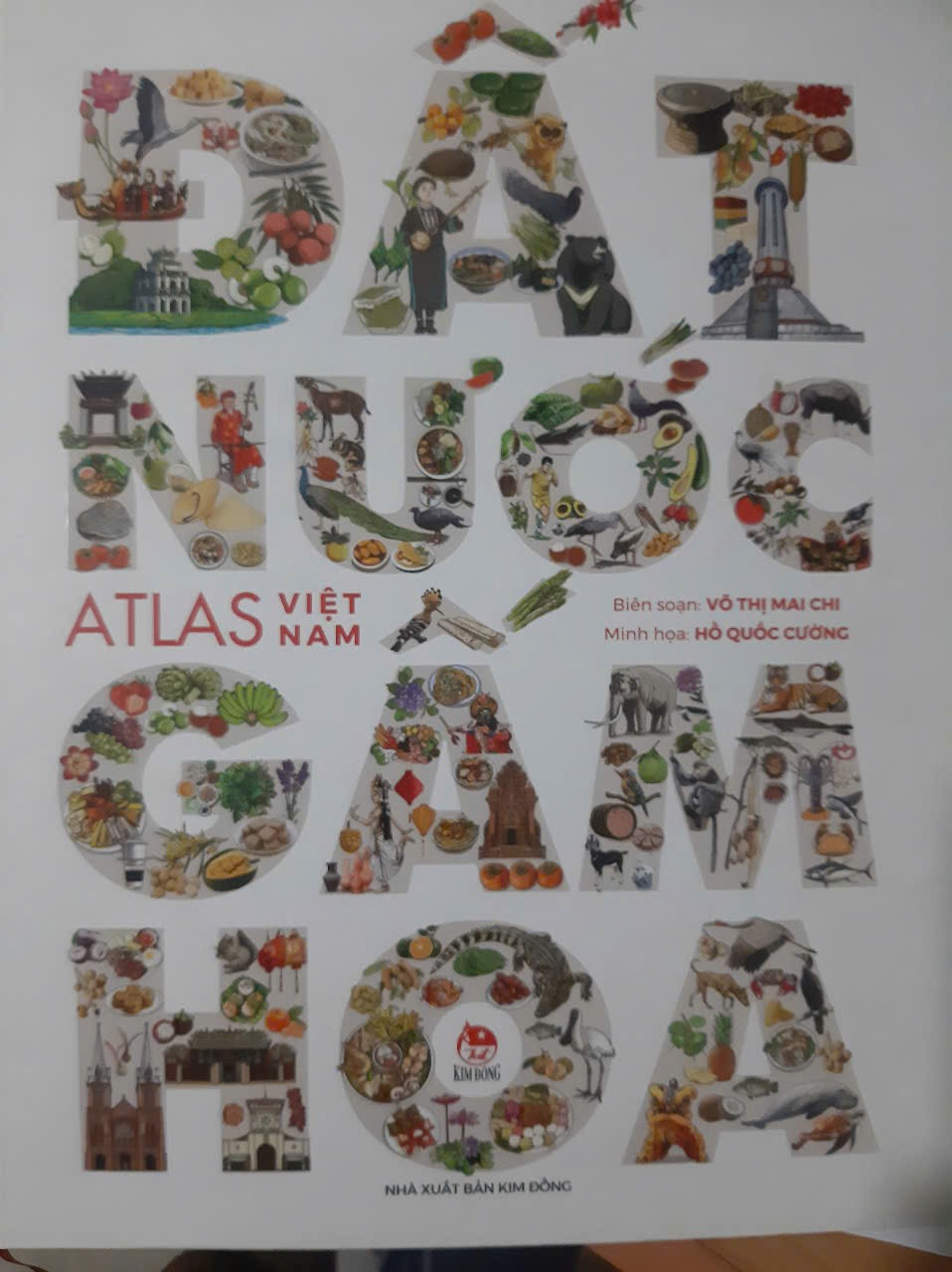  + The second book:  Name: Lâm Đồng – My lovely hometown  Writer: Nguyễn Kim Long – Trần Thị Cẩm Vân  Editor: Huỳnh Kim Ngân  Publisher: Nhà xuất bản Giáo dục Việt Nam  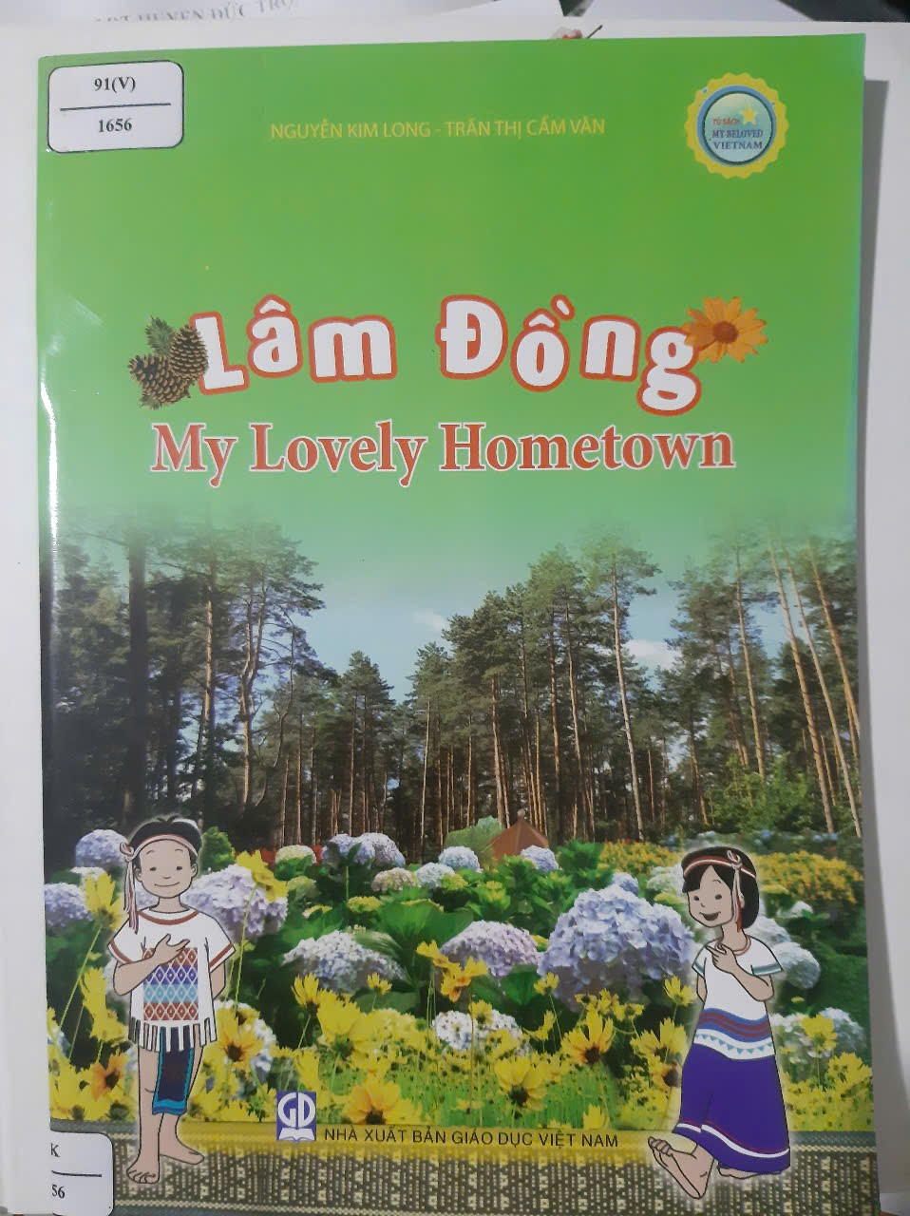  + The third one: The map of Viet Nam consits of 34 provinces and cities  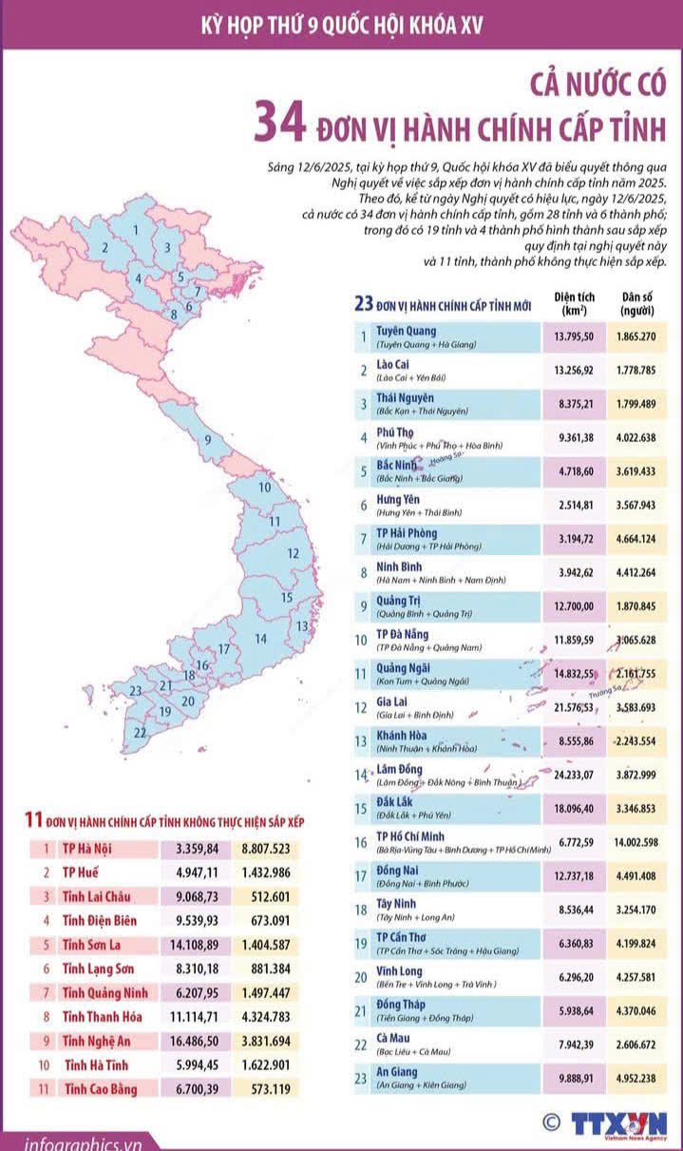  * Set the scene.  - Teacher sets the scene: “Next month, I am going travelling. Guess where I will visit.”  - Let’s students guess the places by opening the boxes one by one. The pictures are hidden behind the boxes.  - Teacher shows the pictures on the screen.  - Teacher leads in the lesson by asking questions:  - Teacher introduces the new lesson  “Today, let’s see what do they have.”  2. Pre-reading: (10’)  Objective:  - Get ready for the lesson  Organization  * Teach some newwords if necessary.  - T follows steps to teach new words.  Island; amazing; landscape; desert; slope; | * Game: Hidden picture.    1. Da Lat city in Lam Dong  2. Ha Long Bay in Quang Ninh  3. Mui Ne in Lam Dong (Binh Thuan cũ)  4. Ganh Đá Đĩa in Phu Yen (cũ) – nay Daklak  - Have you ever been to these places?”  Discussion  Look at the pictures and make predictions about the reading. Then read and check your ideas.  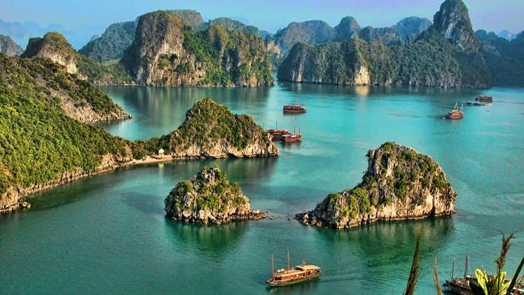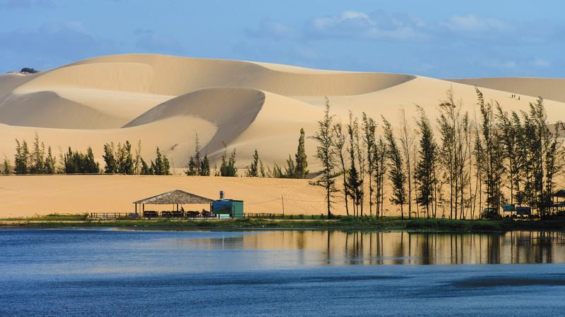  1. What is the reading about?  2. What do you know about these places?  * Vocabulary  - cave (n) hang động  - beach (n) bãi biển  - tourist (n) khách du lịch  - attraction (n) lôi cuốn  - landscape (n) phong cảnh  - slope (n) độ dốc (- sườn núi)
2. While-reading: (10’)  Task 2  Objective:  To develop Ss’ skill of using vocabulary in different contexts.  Organization  - Have Ss read the words first. These words all appear in the texts, but now they are in different contexts. Ss then read the sentences and fill the blanks.  - T checks as a class.  - T may call on some Ss to read the sentences  Task 3  Objective:  To develop Ss’ skill of reading for specific information.  Organization:  - Set a longer time limit for Ss to reread the texts and answer the questions. Again ask Ss to note where they found the information that helped them complete the activity.  - Ss can compare answers before discussing them as a class.  Encourage Ss to support their answers with reasons.  - Ask them to give evidence to support their answers  - Check and confirm the correct answers | 2. Complete the sentences, using the words from the box.  Key :  1. islands  2. wonder  3. desert  4. remember  5. visit  3. Read the text again. Answer the following questions.  *Key :  1. It is in Quang Ninh  2. We can enjoy (great) seafood and join in exciting activities  3. No, there isn’t  4. By the beach  5. Early morning or late afternoon.
3. Post- reading: (18’)  Task 4  Objective:  Practise describing the tourist attraction they choose.  Organization  - Discuss with Ss which things they find special about Ha Long Bay and Mui Ne. Brainstorm ideas onto the board. Ask Ss to close their books.  - Divide Ss into group A and group B. Tell group A to describe Ha Long Bay. Tell group B to describe Mui Ne.  - Ss use the notes only to help them tell their partner about their place  - Ask them to practice their description together before they rejoin with their partners .  - Go round and offer help if necessary.  - Check and confirm the correct answers  Task 5  Objective  Talk about famous/ interesting places and what one must/ mustn’t do there.  Organization  - Tell Ss to review interesting features of their city / town / area.  - Ask them to think of the things tourists must / mustn’t do.  - Encourage them to give as many ideas as possible.  - Ask them to share their ideas in pairs before calling some Ss to present in front of the class.  - Then give feedback: comment on their strengths and correct a few errors in the target language.  - T helps if necessary  - Ss present  - Practice speaking in front of the class.  - Correct mistakes | 4. Work in pairs. Make notes about one of the places in the reading. You can add your own ideas.  Ha Long Bay has a lot of interesting islands. It also has many caves and beautiful beaches. You can enjoy great seafood here and take part in exciting activities.  5. Some foreign visitors are visiting your city/ town/ area. You are their tour guide. Tell them some interesting things about the places as well as what they must and mustn’t do there.  Example:  - You must wear sun scream when you're in Mui Ne beach.  - You must go to the Sam Son beach in early morning or in late afternoon.  - You mustn't litter on the beach.  - You mustn't swim alone.
  Ha Long Bay | Mui Ne
  - interesting islands  - many islands and caves  - beautiful beaches  - great seafood  - exciting activities | - a beautiful places  - amazing landscapes  - different colour  - like a desert  - many activities
5. Assignment: (1’)  - Students do homework and prepare the new lesson. | - Practice talking about famous places  - Read the 3 books in the library carefully and tell some information you know about Quang Ninh province, Lam Đong province (from Lam Dong +Binh Thuan + Đăk Nông) about climate; famous lanscapes, specialities; ...  - SS make a video to introduce 2 places above.  - Prepare new lesson. Skills 2

