TỔ XÃ HỘI

NHÓM TIẾNG ANH
GV: TRẦN THỊ KIM LIÊN

GIÁO ÁN POWER POINT- TIẾNG ANH 9- SÁCH GLOBAL SUCCESS- NĂM HỌC 2025-2026

Period 29
UNIT 4: REMEMBERING THE PAST
Lesson 2: A CLOSER LOOK 1
I. OBJECTIVES
By the end of this lesson, Ss will be able to:
- identify the vocabulary related to the topic Remembering the past.
- pronounce the sounds /m/ and /l/ in words and sentences correctly.
- develop communication skills and creativity.
- be collaborative and supportive in pair work and teamwork.
- actively join in class activities.
II. LANGUAGE FOCUS
- Vocabulary: * Vocabulary about the topic Remembering the past.
III. PREPARATIONS: student’s book and teacher’s book, laptop, projector/ smart TV.
IV. PROCEDURES
ACTIVITIES | CONTENTS and OUTCOME
1. Warm up  Objective  - To create an active atmosphere in the class before the lesson.  - To lead into the new lesson.  Organization  Brainstorming  - Show on the screen some images related to the history of Viet Nam or other countries.  - Encourage Ss to name these places and give some information about them.  – Lead into the new lesson . |   
II. Activity 1: Vocabulary  Objective:  - To identify some vocabulary related to the topic Remembering the past.  - To use these words in sentences correctly.  Organization:  - Introduce the vocabulary, using pictures, giving explanation or examples.  - Have Ss listen and repeat the new words.  - Give comments on Ss’ pronunciation.  TASK 1: Complete the following table. There is one example.  - Have Ss work in pairs. Tell them to look at the verbs given in the left column and give their equivalent nouns.  - Check their answers and have Ss read the verbs and nouns aloud.  - Correct their pronunciation if necessary.  - Ask Ss to work in groups. Each group finds three verbs in Getting Started, and then give their equivalent nouns.  - Ask Ss to represent from each group give their groups’ answers.  - Get feedback and give comments.  TASK 2: Complete the following sentences, using the correct forms of the words from 1.  - Have Ss work in pairs. Tell them to look back at the words in 1.  - Ask Ss to read the sentences carefully and look for clues to find the right words to complete the sentences. The word to fill each blank may be a noun or a verb in its correct tense.  - Ask Ss to write the words on the board.  - Confirm the correct answers.  - Call on some Ss to read the sentences.  TASK 3: Complete the following sentences with the words from the box.  - Ask Ss to read the sentences and choose the correct word from the box to fill in each blank in the sentences.  - Tell them to read the sentences carefully and look for clues to choose the correct words.  - Go around and give assistance if necessary.  - Get feedback and confirm the correct answer. | 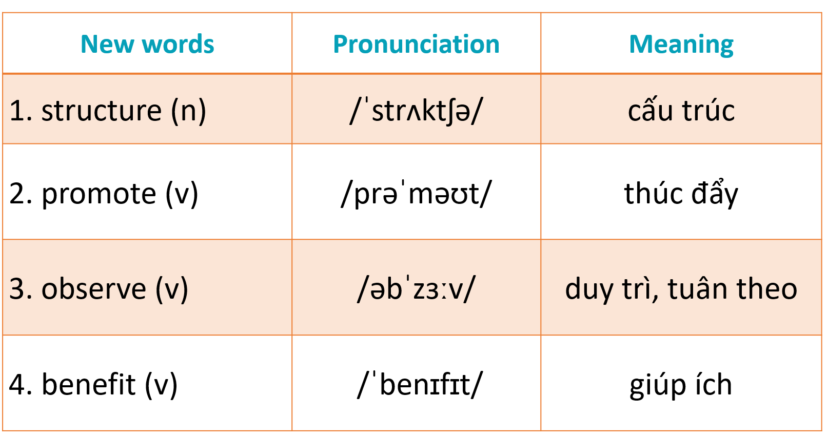  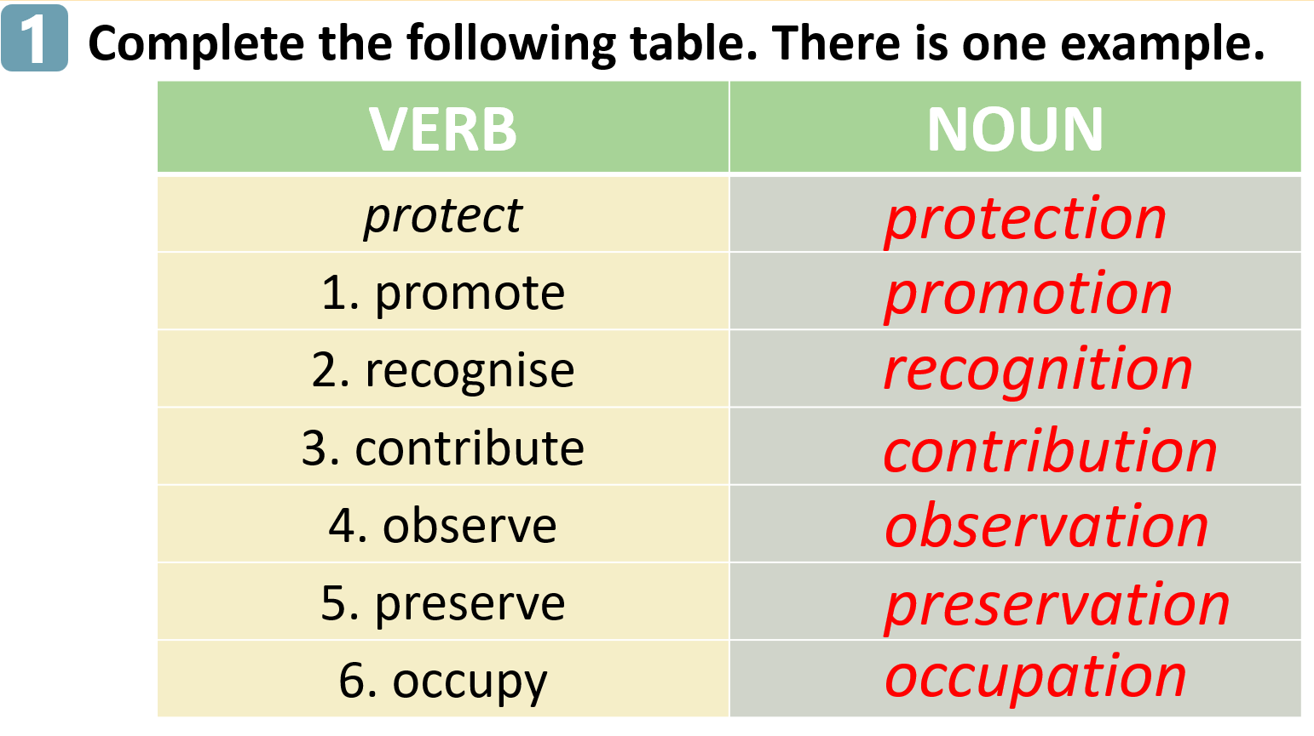  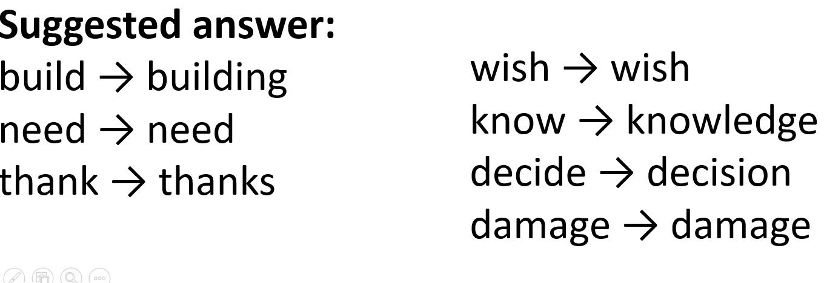  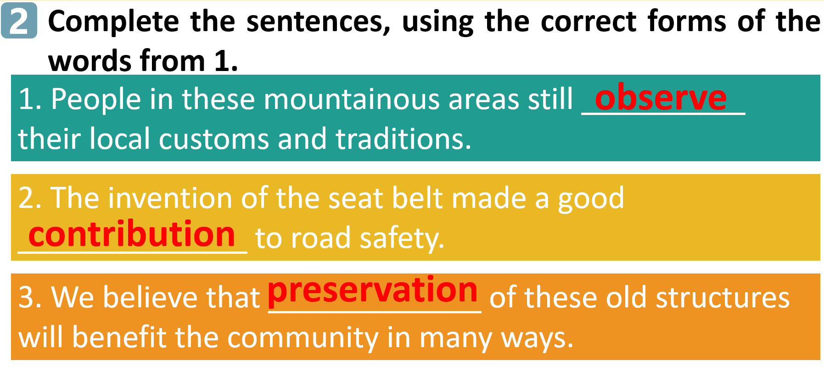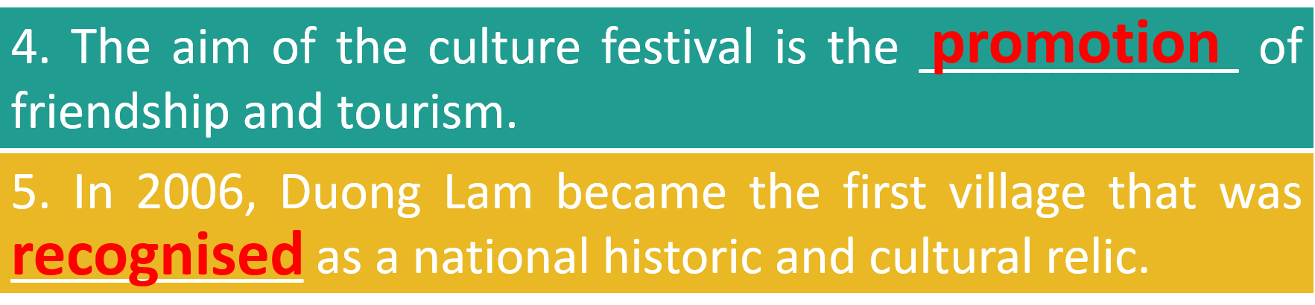  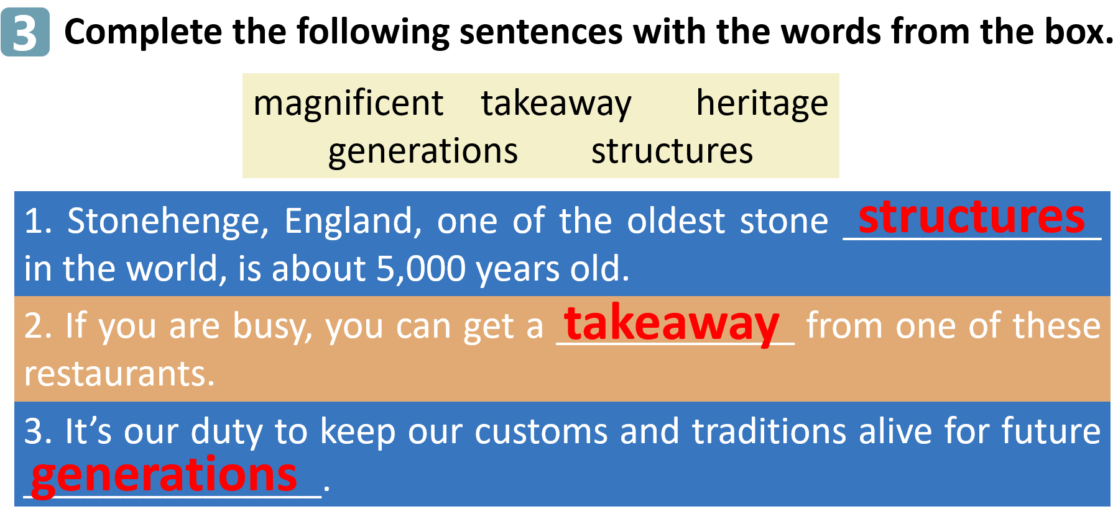  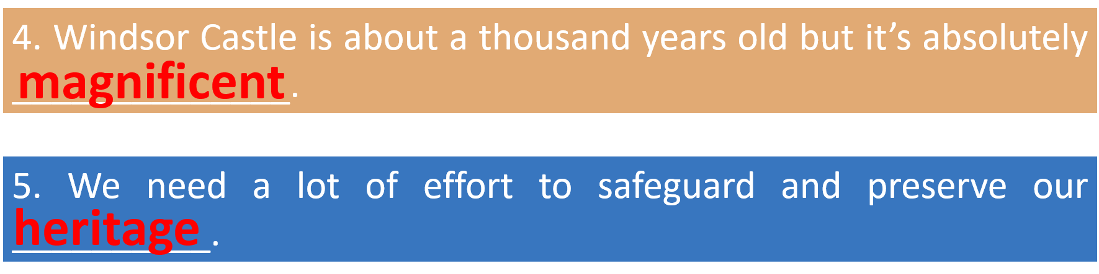
3. Activity 2: Pronunciation  Objective:  - To help Ss identify how to pronounce the sounds /m/ and /l/ correctly.  - To help Ss practise pronouncing these sounds in words and sentences.  Organization:  TASK 4: Listen and repeat the words. Pay attention to the sounds /m/ and /l/.  - First give examples of the sounds /m/ and /l/.  - Instruct how to pronounce /m/ and /l/.  - Play the recording and ask Ss to listen to these words and repeat. Correct their pronunciation. Play the recording as many times as necessary.  - Explain the two types of sound /l/ in the Remember! box and invite Ss to give some examples.  - Comment on Ss’ work.  TASK 5: Listen and repeat the sentences. Pay attention the underlined words.  - Have Ss quickly read the sentences and look carefully at the underlined words.  - Play the recording for Ss to listen.  - Play the recording again. Let Ss listen and repeat sentence by sentence, paying attention to the underlined words.  - Ask Ss to read aloud the sentences  - Comment on Ss’ pronunciation. | 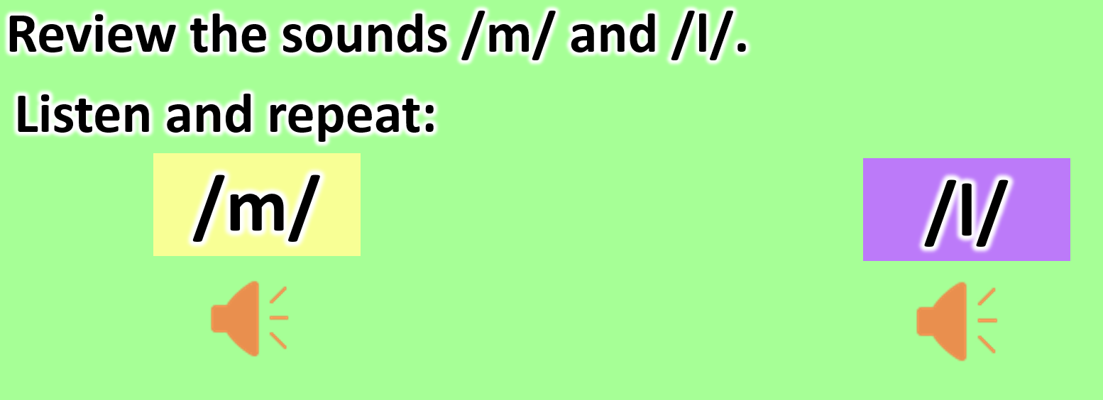  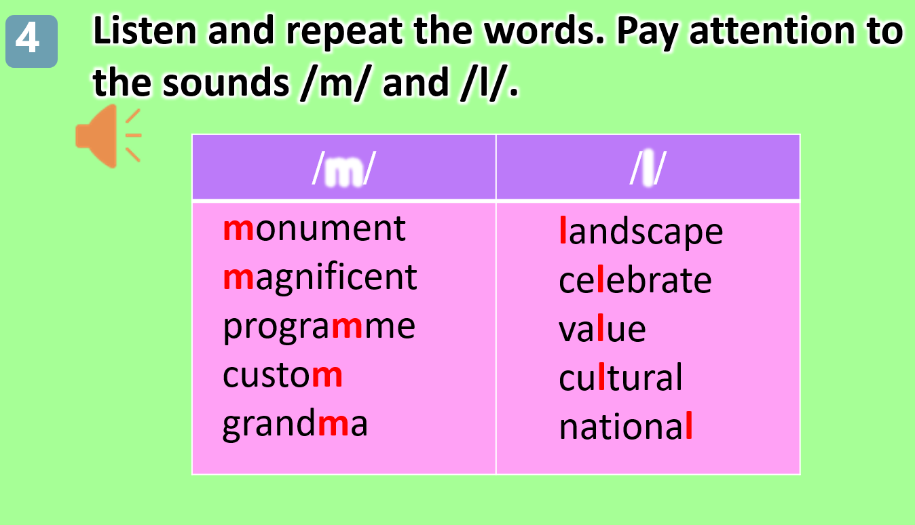  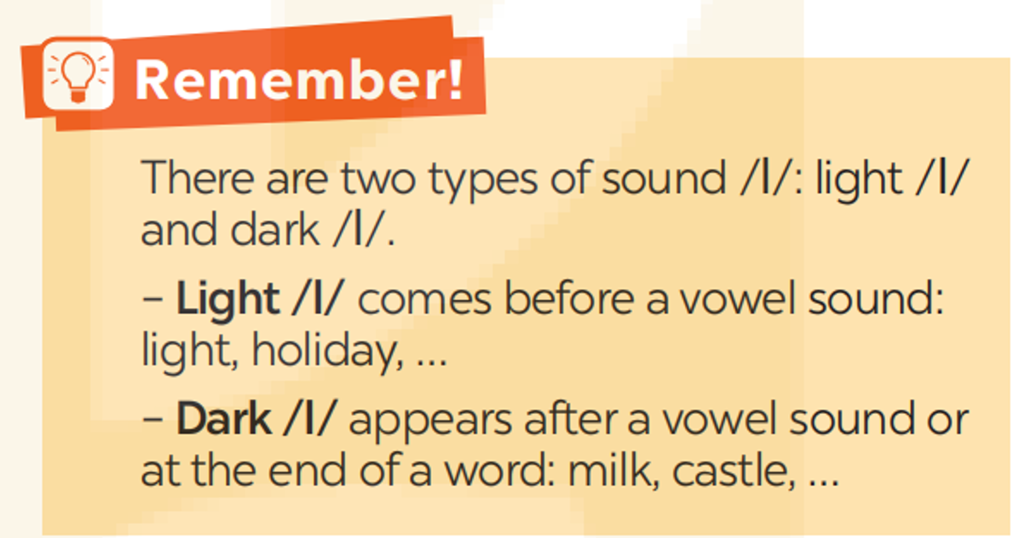  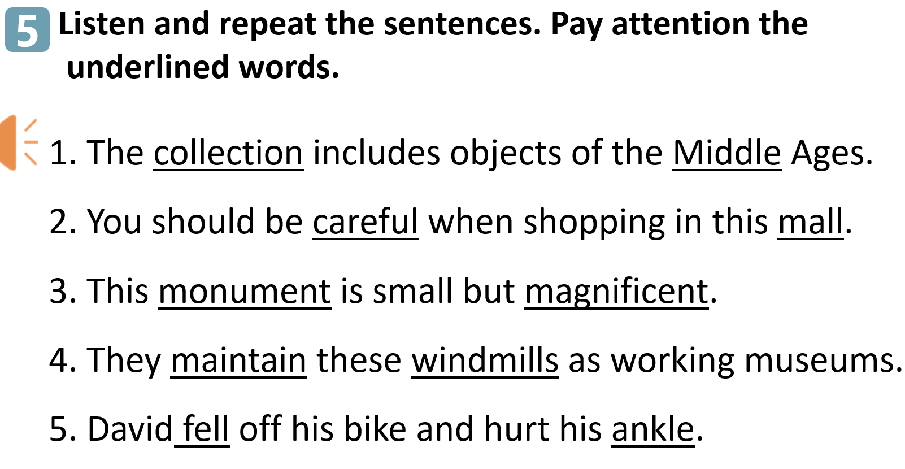
4. Consolidation
- Ask Ss to retell the main points of the lesson.
5. Homework
- Have Ss prepare for the next lesson (A closer look 2)

