PERIOD: 38
UNIT 5: OUR CUSTOMS AND TRADITIONS
LESSON 4: COMMUNICATION
- OBJECTIVES:
By the end of this lesson, Ss will be able to:

Knowledge:
- Give advice.
- Get some information about the Japanese lion dance and compare to the Vietnamese unicorn dance.

Competences
- Develop creativity and communication skills
- Be collaborative and supportive in pair work and team work
- Actively join in class activities

Personal qualities
- Be willing to give advice
- Be interested more in local festivals.
- TEACHING AIDS:
- Grade 8 textbook, Unit 5, Communication
- Computer connected to the Internet
- Projector / TV
- hoclieu.vn
- PROCEDURES
- WARM-UP: (5mins)

Aim:
- To create an active atmosphere in the class before thelesson
- To lead into the newlesson
b. Content:
- Ask and answer about table manners with a picture

Expected outcomes:
- Ss get some general ideas about table manners and get ready for the newlesson

Organization:

TEACHER’S AND STUDENTS’ ACTIVITIES | CONTENTS
- T shows a picture of a child having dinner with family. Ask Ss what the child is doing and whether she is behaving well at thetable.  - Tell Ss that “table manners” means the polite ways of behaving when eating. These behaviours differ from one culture toanother.  - Ask Ss to give some examples of table manners that they know.  - Lead in to the lesson and introduce the objectives of the lesson. | 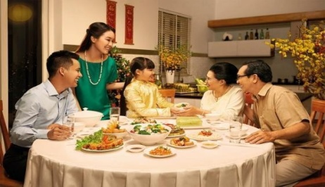  Suggested answers:  - Wait for the table arrangement before sitting down  - Wait for the oldest people to startfirst  - Pass your bowl with two hands  - Do not stick the chopstick against the bowl  - Do not point the chopsticks to anyone  - Do not dig into the dish  - Do not eat directly from shared dishes  - Stay until other people finish  - Say Thanks to the host after themeal

- PRESENTATION: (15mins)

Aim:
- To introduce ways of givingadvice.
- To help Ss practise givingadvice.

Content:
- Task 1: Listen and practise the conversation.
- Task 2: Work in pairs. Make similar conversations with the following situations.

Expected outcomes:
- Ss know how to give advice.
- Students can make dialogue using the structures of givingadvice.

Organization:
TEACHER’S AND STUDENTS’ ACTIVITIES | CONTENTS
Task 1: Listen and read the conversation below. Pay attention to the highlighted parts. (6 mins)
- Teacher plays the recording for Ss to listen and read the dialogue between Tom andMai.  - T asks Ss to pay attention to the highlightedlanguage.  - T elicits from Ss that the first two highlighted phrases are ways to advise what one should do, and the last highlighted word is for saying what one should NOT do.  - Teacher has Ss practise the dialogue in pairs. Call on some pairs to practise the dialogue in front of the class.  -> Structure to give advice  - Perhaps you should + V₀  - It’s a good idea to +V₀  - Don’t + V₀ | 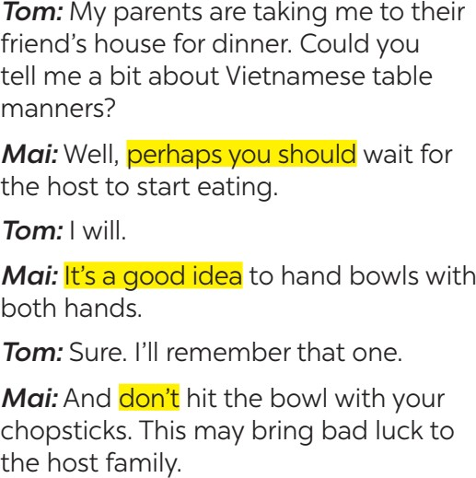
Task 2: Work in pairs. Make similar conversations with the following situations. (9 mins)
- Teacher asks Ss to work in pairs (5 minutes) to make similar dialogues with the given situations, using the expressions they have learnt.  - Teacher moves around to observe and provide help. T calls on some pairs to practise in front of theclass.  - T comments on their performance. | Suggested answers:  - Perhaps you should bring warm clothes, a scarf, coat, jacket,…  - It’s a good idea to bring a gift such as a birthday cake, pen, pencil,clothes…

PRACTICE: (18 mins)
- Aim:
- To provide Ss with information about lion dance inJapan.
- To help Ss compare the Vietnamese unicorn dance with the Japanese liondance.

Content:
- Task 3: Read the text about the lion dance in Japan and complete the table with the information from the text.
- Task 4: Work in groups. Read Mai’s notes on the Vietnamese unicorn dance. Compare the Vietnamese unicorn dance with the Japanese liondance.

Expected outcomes:
- Ss can understand the text and fill in the blank with the correct information.
- Students can compare the Vietnamese unicorn dance with the Japanese liondance.

Organization:

TEACHER’S AND STUDENTS’ ACTIVITIES | CONTENTS
Task 3: Read the text about the lion dance in Japan and complete the table with the information from the text. (10 mins)
- Teacher writes “Lion Dance” on the board or shows a picture of a lion dance. T tells Ss that this is called the lion dance and it is popular in many Asian countries. T elicits from Ss the  occasion(s) when they may see a lion dance performance. | Answer key:  - shishi-mai  - New Year celebrations  - acrobatics

- Teacher tells Ss that they are going to read about lion dance in Japan.  - Teacher has Ss look at the table of information and think of the type of information they need for each blank.  - Teacher asks Ss to work in pairs to do this activity. They can draw this table on a sheet of paper. After pairs finish their work, T asks them to share their table with the wholeclass.  - Teacher comments on theiranswers.  - If time allows, have some pairs use the information in the table to talk about the Japanese lion dance without looking again at the text. | - flutes  - bad spirits
- PRODUCTION: (5mins)

Aim:
- To give further practice with articles at sentence and textlevel.

Content:
- Task 4: Work in groups.

Expected outcomes:
- Compare the Vietnamese unicorn dance with the Japanese lion dance
  - Organization:

TEACHER’S AND STUDENTS’ ACTIVITIES | CONTENTS
Task 4: Work in groups. Read Mai’s notes on the Vietnamese unicorn dance. Compare the
Vietnamese unicorn dance with the Japanese lion dance. (10 mins)
- Teacher shows two pictures, one of the Vietnamese unicorn dance and one of the Japanese lion dance next to eachother.  - Teacher has Ss look at the pictures and point out some similarities and differences between the two pictures. T encourages Ss to use the structures “Both…. and …..” and “…. but….”.  - Teacher tells Ss to look at Mai’s notes on Vietnamese unicorn dance. T asks them if there is any information they didn’tknow.  - Teacher has Ss work in groups to compare the Vietnamese unicorn dance and the Japanese lion dance, using the tables in 3 and 4. Tell the groups that they need to write at least 5 sentences using 5 pieces of information from the tables.  - Teacher asks some Ss to report their group’s answers to the class. | Suggested answers:  - There are one or more performers in both Vietnamese unicorn dance and Japanese lion dance.  - Both Vietnamese unicorn dance and Japanese lion dance perform in the New Year Festivals.  - Vietnamese unicorn dance needs ong Dia but Japanese lion dance doesn’t needit.  …
- CONSOLIDATION: (2mins)

Wrap-up:
- T asks Ss to summarise what they have learnt in thelesson.
- T has Ss look at the objectives written on the board at the beginning of the lesson and tick the objectives they have learnt.

Homework:
- Do exercises in the workbook
- Compare Vietnamese Tet Holiday and Chinese Tet Holiday.
- Prepare Skills 1.

