PERIOD: 37
UNIT 5: OUR EXPERIENCES
LESSON 2: A CLOSER LOOK 2 (Page 53)

I. OBJECTIVES:
By the end of this lesson, Ss will be able to:
1. Knowledge:
- Teach grammar: the present perfect tense.
* Vocabulary: Words related to the topic “Our experiences”

* Grammar: The present perfect tense

2. Competences:
- Develop communication skills and cultural awareness.
- Be cooperative and supportive in pair work and teamwork.
- Be actively join in class activities.

3. Personal qualities:
- Exchange personal information with friends and be friendly at school.
- Be collaborative and supportive in pair work and teamwork

- Actively join in class activities

II. TEACHING AIDS:
- Textbook: English 9 – Unit 5: A closer look 2 – Page 53
- Projector/ smart TV and computer

- hoclieu.vn

III. PROCEDURES:

1. WARM-UP: (2’)

a. Aim:
- To activate students’ prior knowledge related to the targeted grammar of the present perfect tense.
- To enhance students’ skills of cooperating with teammates.
b. Content:
- Game: Sentence puzzling
c. Expected outcomes:
- Students can answer the teacher's question using the structure of present simple.

d. Organization:
TEACHER’S & STUDENTS’ ACTIVITIES | CONTENTS
+ Game: Sentence puzzling  - Teacher divides the class into 4 groups.  - Teacher delivers 4 sets of word cards which are 4 jumbled sentences in present perfect to each group.  - Students will have to work in groups to create as many correct sentences from the word cards as possible.  - The group with the most correct sentences will be the winner. | + Game: Sentence puzzling  - T_Ss.  Answer key:  1. Sarah has joined the camp since the beginning of summer.  2. She has gone to Paris with her family since last December.  3. They haven’t played for the school’s band for 4 months.  4. Have you done your homework yet? No, I have not.
2. PRESENTATION: (10’)
a. Aim:
- To revise the past form and teach the past participle form of some verbs.
b. Content: Grammar explanation.
- Task 1: Write the correct forms of the verbs on the table.
c. Expected outcome: Students understand how to use the target grammar: The present perfect tense.
d. Organization:
TEACHER’S & STUDENTS’ ACTIVITIES | CONTENTS
- Teach grammar note: The present perfect tense. (See Remember)  - Teacher has Ss work individually to read the Remember! box about the present perfect.  - Teacher asks Ss when they should use the present perfect.  - Teacher asks some Ss to give an example for each of the uses.  - Teacher writes the examples on the board. Remind Ss of the form of verbs in the present perfect.  Task 1:  - Teacher has students work individually to look at the table and write the correct form of the verbs  - Teacher has some Ss write the verbs in different forms on the board before checking with the whole class.  - Teacher asks several Ss to read aloud the verb forms and corrects their pronunciation if necessary. | UNIT 5: OUR EXPERIENCES  LESSON 2: A CLOSER LOOK 2 (Page 53)  I. Remember!  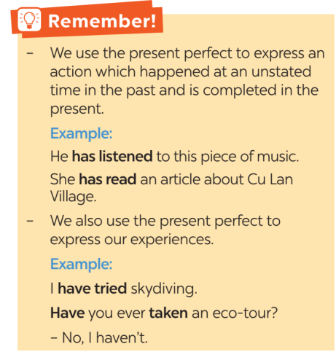  Task 1: Write the correct forms of the verbs in the table.  * Answer key:
  Verbs | Past simple | Past participle
  work | worked | worked
  join | joined | joined
  play | played | played
  be | was/were | been
  go | went | gone
  do | did | done
3. PRACTICE: (20’)
a. Aim:
+ To help Ss use the correct verb forms in the present perfect.
+ To give Ss further practice with the present perfect in various situations.
+ To help Ss practice using present perfect tense to write sentences about Mai's experiences
b. Content: Complete the sentences with the correct forms of the verbs in the present perfect.
- Task 3: Choose the correct answer A, B, C, or D to complete each sentence.
- Task 4: Write sentences about Mai’s experiences, using the information in the table
c. Expected outcome:
- Students understand how to use the target grammar.
d. Organization:
TEACHER’S & STUDENTS’ ACTIVITIES | CONTENTS
Task 2:  - Remind Ss that they should put the verb in past participle form.  - Have Ss work in pairs to finish the sentences with the correct verb forms.  - Ask some Ss to write their sentences on the board if necessary.  - Check Ss' answers. Correct any mistakes and re-explain the rule if necessary.  Task 3:  - Have Ss work individually to underline the  words / phrases denoting which verb tense to  use.  - Ask Ss to work individually to choose the  correct verb form. Remind them of the words  / phrases they have just underlined in each of  the sentences.  - Ask some Ss to read out their answers.  Correct pronunciation if necessary.  - Check the answers as a class.  Task 4:  - Have Ss work individually for five minutes to write full sentences. Then ask them to work in pairs to swap and check their answers.  - Ask some Ss to write their sentences on the board.  - Check the answers as a class.  - Have the class read out the sentences. Correct pronunciation if necessary.  * Teacher corrects for students as a whole class. | II. Practice:  Task 2: Complete the sentences with the correct forms of the verbs in the present perfect.  * Answer key:  1. have joined  2. have played  3. has… worked  4. has… been  5. have gone  Task 3: Choose the correct answer A, B,  C, or D to complete each sentence.  - T_ Ss  * Answer key:  1. B  2. A  3. A  4. C  5. C
  Task 4: Write sentences about Mai’s experiences, using the information in the table.
  - T_ Ss.
  * Answer key:
  1. Mai hasn’t climbed a mountain.
  2. Mai has seen an elephant.
  3. Mai hasn’t joined a tribal dance.
  4. Mai has taken a photo of the forest.
  5. Mai has gone on an eco-tour.
4. PRODUCTION: (8’)
a. Aim:
+ To enable Ss to practice asking each other about their experiences.
+ To create a lively atmosphere of playing and learning.
b. Content:
- Task 5: Work in pairs. Ask and answer questions about your experiences using the present perfect.
c. Expected outcome:
- Students understand how to use the target grammar.
d. Organization:
TEACHER’S & STUDENTS’ ACTIVITIES | CONTENTS
Task 5:  - Ask Ss to work in pairs to ask and answer questions about experiences using the present perfect.  - Remind them that they can start with Have you ...?  - Ask some pairs to demonstrate in front of the class.  - Correct any grammar and pronunciation mistakes if necessary.  * Teacher gives corrections and feedback. | III. Production:  Task 5: Work in pairs. Ask and answer questions about your experiences using the present perfect.  - T_ Ss.  * Example:  A: Have you visited a village of an ethnic group?  B: Yes, I have. / No, I haven’t.
5. CONSOLIDATION: (2’)

a. Wrap-up

- Ask one or two Ss to tell the class what they have learnt.

- Ask Ss to say aloud the grammar points they remember from the lesson. Tells Ss that they will learn these language points in the following lessons.

b. Homework
- Learn by heart all the words that they have just learnt

- Do exercises in the workbook.
- Prepare new lesson: Lesson 4: Communication.

