TIẾNG ANH 6_FRIENDS PLUS
REVIEW 1,2 - TEST 2
Thời gian làm bài: 45 phút (Không kể thời gian giao đề)
-------------------------
I. Pronunciation
Câu 1. Which word has the underlined part pronounced differently from that of the others?
A. doctor B. come
C. mother D. brother
Đáp án đúng: A
A. doctor - /ˈdɒktə(r)/
B. come - /kʌm/
C. mother - /ˈmʌðə(r)/
D. brother - /ˈbrʌðə(r)/
Câu 2. Which word has a different stress pattern from that of the others?
A. travel B. picture
C. behind D. lovely
Đáp án đúng: C
A. travel - /ˈtrævl/
B. picture - /ˈpɪktʃə(r)/
C. behind - /bɪˈhaɪnd/
D. lovely - /ˈlʌvli/
Câu 3. Which word has a different stress pattern from that of the others?
A. nationally B. television C. geography D. vegetable
Đáp án đúng: C
A. nationally - /ˈnæʃnəli/
B. television - /ˈtelɪvɪʒn/
C. geography - /dʒiˈɒɡrəfi/
D. vegetable - /ˈvedʒtəbl/
Câu 4. Which word has the underlined part pronounced differently from that of the others?
A. stereos B. lamps
C. erasers D. libraries
Đáp án đúng: B
A. stereos - /ˈsteriəʊz/
B. lamps - /læmps/
C. erasers - /ɪˈreɪzə(r)z/
D. libraries - /ˈlaɪbrəriz/
II. Choose the answer (A, B, C or D) that best fits the space in each question.
Câu 5. What food does your mother like?
A. Pasta with beef. B. No, she likes vegetables.
C. Yes, she likes noodles. D. She likes cooking.
Đáp án đúng: A
Câu 6. How do you stay with your uncle? – “About three years.”
A. long B. much
C. many D. often
Đáp án đúng: A
Câu 7. There’s a in front of my house.
A. garden flower B. flowers garden
C. flower garden D. garden flowers
Đáp án đúng: C
Câu 8. Children walk home from the park nearby.
A. into B. from C. to D. _
Đáp án đúng: D
Câu 9. Charlie always half an hour surfing on the internet every day.
A. takes B. gets C. uses D. spends
Đáp án đúng: D
Câu 10. They play soccer in the every day.
A. building B. mall
C. stadium D. temple
Đáp án đúng: C
Câu 11. The opposite of “dirty” is .
A. safe B. clean C. comfortable D. easy
Đáp án đúng: B
Câu 12. Sue is unhappy because she any close friends.
A. have B. doesn’t have C. has D. don’t have
Đáp án đúng: B
Câu 13. I have a/an feeling because it is my fault.
A. comfortable B. comfortably C. uncomfortable D. comfort
Đáp án đúng: C
Câu 14. “Is exercise very easy?” – “No, isn’t”
A. this/ its B. these/ it C. that/ it D. these/ this
Đáp án đúng: C
III. Look at the signs. Choose the best answer (A, B, C or D).
Câu 15.
When do Rini and Rina meet?
Dear Rini,
Please meet me in the canteen at the first break. Be on time. I’ll tell you a secret.
See you,
Rina

A. At the last break. B. At the first break.
C. In the canteen. D. In their school.
Đáp án đúng: B
Câu 16.
What does this sign mean?
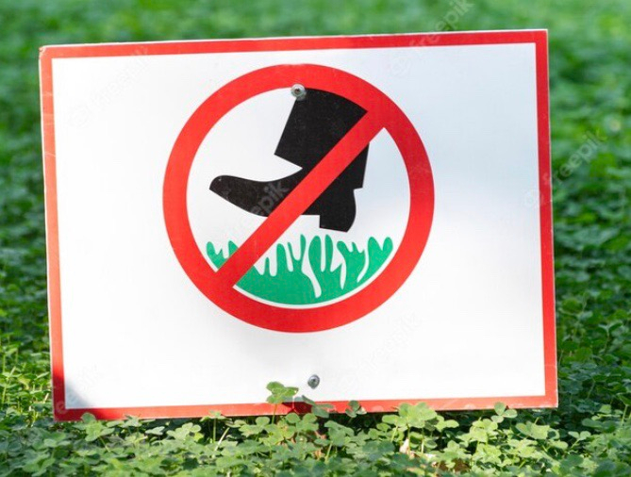
A. Do not water the grass. B. Do not walk on the grass.
C. Do not pick flowers. D. Do not grow vegetables.
Đáp án đúng: B
IV. Read the following conversation and do as direct.
There are four people in Nick’s family: his father, his mother, his elder sister and him. His father is a worker. He works in a factory. His factory produces bicycles. His mother is a nurse. She takes care of sick people in the hospital. His sister studies at a university and she’ll be a teacher next year. Nick is a student at a local junior high school. He studies very well. All the members in the family are very happy.
Câu 17. His father works in a hospital.
A. True B. False
Đáp án đúng: B
Câu 18. His mother takes care of sick people.
A. False B. True
Đáp án đúng: B
Câu 19. His sister wants to become a teacher.
A. False B. True
Đáp án đúng: B
Câu 20. Nick is a good student.
A. True B. False
Đáp án đúng: A
Câu 21. What does Nick’s father’s company produce?
A. Bikes B. Motorcycles
C. Car D. All kinds of transportation
Đáp án đúng: A
Câu 22. How do his family’s member feel?
A. Interesting
B. Happily
C. Well
D. Happy
Đáp án đúng: D
V. Choose the word (A, B, C or D) that best fits the blank space in the following passage.
Halloween is a holiday celebrated on October 31st. The most __23___ colors of the day are orange and black. Halloween __24___ from the ancient Celtic festival Samhain. The ancient Celts believed that __25___ October 31st, now known as Halloween, the boundary between the living and the deceased is not clear, and the dead become __26__ for the living by causing problems such as sickness or damaged crops. On Halloween day, the ancient Celts would place a skeleton by their window to represent the dead. Believing that the head was the most powerful part of the body, containing the spirit and knowledge, the Celts used the “head” of the vegetable to decorate __27___ houses. On this day people often wear strange clothes as characters in horrible novels __28___ movies to frighten others. People usually like to dress as ghosts, skeletons, or witches. Now Halloween is an official holiday in almost all European countries.
Câu 23. Choose the correct answer.
A. commoner B. commonest C. common D. more common
Đáp án đúng: C
Câu 24. Choose the correct answer.
A. come B. comes C. to come D. coming
Đáp án đúng: B
Câu 25. Choose the correct answer.
A. at B. on C. in D. after
Đáp án đúng: B
Câu 26. Choose the correct answer.
A. dangerous B. dangerously C. danger D. endanger
Đáp án đúng: A
Câu 27. Choose the correct answer.
A. his B. her C. their D. our
Đáp án đúng: C
Câu 28. Choose the correct answer.
A. but B. like C. as D. or
Đáp án đúng: D
VI. Supply the correct form of the word given in each sentence.
Câu 29. Miss Janet us Biology at school. (teacher)
Đáp án đúng: teaches
Câu 30. We have lots of at the campsite. (act)
Đáp án đúng: activities
Câu 31. We often buy cheap bread in the . (bake)
Đáp án đúng: bakery
Câu 32. Lucy enjoys taking part in shows. (beautifully)
Đáp án đúng: beauty
Câu 33. Don’t make a fire here. It’s so . (danger)
Đáp án đúng: dangerous
Câu 34. Do you know any jokes? (fun)
Đáp án đúng: funny
VII. Rearrange the groups of words in a correct order to make complete sentences.
Câu 35. twenty two/ the stadium./ are/ There/ in/ football players
__________________________________________________________________________
Đáp án đúng: There are twenty two football players in the stadium.
Câu 36. the floor/ Does/ clean/ every morning?/ Sue’s mother
__________________________________________________________________________
Đáp án đúng: Does Sue’s mother clean the floor every morning?
VIII. Rewrite each of the following sentences in another way so that it means almost the same as the sentence printed before it.
Câu 37. Mr. Thompson drives to work every day. (use “travels”)
Mr. Thompson __________________________
Đáp án đúng: Mr. Thompson travels to work by car every day.
Câu 38. These boys are intelligent but those ones are not. (use comparative)
These boys ________________________
Đáp án đúng: These boys are more intelligent than those ones.
Câu 39. Remember to lock the door carefully before going to bed.
Don’t _____________________________
Đáp án đúng: Don’t forget to lock the door carefully before going to bed.
Câu 40. Jack’s family usually goes to the supermarket for the vegetables on Sunday. (use “buys”)
Jack’s family _____________________________
Đáp án đúng: Jack’s family usually buys vegetables in the supermarket on Sunday.
----HẾT---

