LỊCH DẠY TUẦN 14: 08/ 12/ 2025 đến 12/ 12/ 2025

LỚP | TIẾT | BÀI HỌC
3C, 3G | 1 | Unit 4: Home – Lesson 1.3 – SB + WB
 | 2 | Unit 4: Home – Lesson 2.1 – SB + WB
 | 3 | Unit 4: Home – Lesson 2.2 – SB + WB
 | 4 | Unit 4: Home – Lesson 2.3 – SB + WB
 | 5 | PHẦN MỀM: Theme 4: Home – Lesson 3
 | 6 | PHẦN MỀM: Theme 4: Home – Lesson 4

UNIT 4 – HOME
Lesson 1 (page 54)
- Objectives
By the end of this lesson, students will be able to ask where people are.
  - Language knowledge and skills
Vocabulary: living room, bedroom, kitchen, bathroom, yard.
Sentence pattern: Where’s Tom?/ He’s in the living room.
Skills: Listening, Reading, Writing, and Speaking.
  - Competences
Self-control and independent learning: identify and ask where people are.
Communication and collaboration: work in pairs or groups to ask where people are.
Critical thinking and creativity: learn how to ask where people are correctly and fluently.
  - Attributes
Kindness: support their friends to complete the learning tasks or play the games.
Diligence: focus on the lesson and work hard to complete all the tasks.
Honesty: play fair.
Accountability: appreciate kindness, diligence, and honesty.
- Teaching aids and materials
- Teacher’s aids: Tiếng Anh 3 i-Learn Smart Start Student’s Book and Teacher’s book, Class CDs, Flashcards, DCR & DHA on Eduhome, Projector/Interactive Whiteboard /TV (if any), PowerPoint slides.
- Students’ aids: Tiếng Anh 3 i-Learn Smart Start Student’s Book, Workbook, Notebook.
- Procedures
- Warm up (5 minutes)
- Objectives: To review the vocabulary items about the rooms, days of the week and school subjects, generate students’ interests and, lead in the new lesson.
- Content: Playing the game: “Vocabulary Race” or “Slap the board”.
- Expected outcomes and assessment
- Task completed with excellence: Students can slap flashcards or write the words quickly and correctly.
- Task completed: Students can slap flashcards or write the words.
- Task uncompleted: Students slap the wrong flashcards or write the words incorrectly.
- Organization
Teacher’s activities | Students’ activities
Option 1: Play the Vocabulary Race game.  - Divide the class into four groups and ask them to stand in two lines facing the board.  - Draw four columns on the board for Teams A, B, C, and D.  - Give a marker to the first student of each team.  - Say “1 2 3” and then the students run to the board quickly to write a word related to the given topics on it. Next, the students pass the markers to the next friends and join back of the line.  - Have them one minute write the words on the board and say “Stop”. The team with the most words wins. | - Make four lines to play this game.  - Follow their teacher’s instructions before playing the game.  - Run to the board quickly to write a word on it.  - Pass the markers to the next friends and join back of the line.
Option 2: Play the Slap the board game.  - Divide the class into two teams and have them form two lines.  - Place the flashcards about the given topics on the board, showing the images.  - Call out a word and have the first student from each group race to slap the correct image on the board and say it correctly. The first student to slap the correct flashcard wins a point for their team. | - Make two lines to play this game.  - Look at the flashcards on the board.  - Carefully listen and run to the board to slap the correct card and read aloud the word on it.

- Presentation (10 minutes)
- Objective: To help the students recognize the sentence pattern and name the rooms in a house correctly.
- Contents: Listening and repeating.
- Expected outcomes and assessment
- Task completed with excellence: Students can recognize the sentence pattern and name the rooms in a house correctly.
- Task completed: Students can recognize the sentence pattern and name the rooms in a house.
- Task uncompleted: Students are unable recognize the sentence pattern and name the rooms in a house.
- Organization
Teacher’s activities | Students’ activities
Present the sentence pattern.  - Use DCR on Eduhome to show the class the sentence structure on Part E, page 54 in their Student’s Book.  - Give the students enough time to look at the target sentence structure and have them read it silently.  - Ask them to identify the rooms in the pictures 1-8.  - Control the class and give them help if needed.  - Lead in the new lesson. | - Listen and follow their teacher’s instructions.  - Look at the target sentence structure on the screen and read it silently.  - Name the rooms in the pictures 1-8.

C. Practice (10 minutes)
- Objectives: To practice asking and answering the question by using the vocabulary items in the target sentence pattern.
- Contents: Pointing, asking, and answering.
- Expected outcomes and assessment
- Task completed with excellence: Students can ask and answer about where people are fluently.
- Task completed: Students can ask and answer about where people are.
- Task uncompleted: Students fail to ask and answer about where people are.
- Organization:
Teacher’s activities | Students’ activities
- Point, ask, and answer.  - Divide the class into two pairs.  - Demonstrate the activity using the speech bubbles.  - Have the student A point and ask, have the student B answer.  - Swap roles and repeat.  - Afterwards, have some pairs demonstrate the activity in front of the class. | - Work with their partner to complete the task.  - Follow their teacher’s instructions.  - Ask and answer the other student’s question.  - Present their work in front of the class.

- Production (5 minutes)
- Objectives: To help them produce the target sentence pattern.
- Content: Playing the game: “Guess the picture” or using DHA.
- Expected outcomes and assessment
- Task completed with excellence: Students can follow the simple instructions in class and do the correct actions quickly.
- Task completed: Students are able to perform the task with some teacher’s and friends’ support.
- Task uncompleted: Students cannot identify the simple instructions in class.
- Organization
Teacher’s activities | Students’ activities
- Option 1: Play Guess the picture.  - Use DCR on Eduhome to show the examples to the whole class.  - Give the students enough time to look at the examples and read them silently.  - Divide the class into two teams.  - Have a student stand facing away from the board and stick a flashcard on the board behind them.  - Ask the student to guess the flashcard by asking a question.  - Have someone from the same team answer.  - Give a point to that team if it’s a correct guess.  - Invite the other student from each team to continue the game. | - Look at the examples and read them silently.  - Work with their friends to play the game.  - Stand facing away from the board and guess the flashcard by asking their teammates a question.
Option 2: Use DHA on Eduhome.  - Open DHA (Unit 4 – Lesson 1) on Eduhome to help the students review the vocabulary through games: Look and find, Listen and find, and Grammar. | - Follow their teacher’s instructions.  - Play the game with the whole class.

E. Consolidation and homework assignment (5 minutes)
- Objectives: To help the students remember the target sentence structures.
- Contents: Asking and answering the questions and assigning homework in the Workbook.
- Expected outcomes and assessment
- Task completed with excellence: Students can whisper the words to their friends correctly and smoothly.
- Task completed: Students are able to whisper the words to their friends.
- Task uncompleted: Students fail to listen the new words or whisper them to their friends.
- Organization
Teacher’s activities | Students’ activities
Consolidation  - Divide the class into two teams.  - Show a flashcard to the class and say a name.  - Have Team A make a question and Team B answer.  - Swap roles and repeat.  e.g.  (Teacher shows a flashcard “living room”.)  Teacher: “Ben”  Team A: “Where’s Ben?”  Team B: “He’s in the living room.” | - Work with their teammates to complete the task.  - Follow their teacher’s instructions.  - Make questions or answer the questions from the other team.
Homework Assignment  - Require the students to practice the structures at home.  - Ask them to prepare Parts A and B, Lesson 2, Unit 4 on page 55 in the Student’s Book. | - Practice the structures at home.  - Prepare the new lesson.

- Reflection
- What I liked most about this lesson today:
………………………………………………………………………………………
- What I learned from this lesson today:
………………………………………………………………………………………
- What I should improve for this lesson next time:
………………………………………………………………………………………

UNIT 4 – HOME
Lesson 2 (page 55)
- Objectives
By the end of this lesson, students will be able to ask what people are doing.
  - Language knowledge and skills
Vocabulary: cleaning, playing, eating, sleeping, cooking.
Sentence pattern: What’s he doing?/ He’s sleeping.
Skills: Listening, Reading, Writing, and Speaking.
  - Competences
Self-control and independent learning: ask and answer about what people are doing.
Communication and collaboration: work in pairs/ groups to ask and answer about what people are doing.
Critical thinking and creativity: learn how to ask and answer about what people are doing.
  - Attributes
Kindness: support their friends to complete the learning tasks or play the games.
Diligence: focus on the lesson and work hard to complete all the tasks.
Honesty: play fair.
Accountability: appreciate kindness, diligence, and honesty.
- Teaching aids and materials
- Teacher’s aids: Tiếng Anh 3 i-Learn Smart Start Student’s Book and Teacher’s book, Class CDs, Flashcards, DCR & DHA on Eduhome, Projector/Interactive Whiteboard /TV (if any), PowerPoint slides.
- Students’ aids: Tiếng Anh 3 i-Learn Smart Start Student’s Book, Workbook, Notebook.
- Procedures
- Warm up (5 minutes)
- Objectives: To help the students review vocabulary about the rooms, generate students’ interests and, lead in the new lesson.
- Content: Playing the game: “Yes or No” or “Repeating game”.
- Expected outcomes and assessment
- Task completed with excellence: Students can jump to the correct side or repeat the correct words on the flashcards quickly.
- Task completed: Students can jump to the correct side or repeat the correct words on the flashcards.
- Task uncompleted: Students jump to the incorrect side or find it difficult to pronounce some words.
- Organization
Teacher’s activities | Students’ activities
Option 1: Play the Yes or No game.  - Draw a line on the ground with chalk.  - Explain to the students that one side is Yes and the other side is No.  - Show the students a flashcard and ask them a question: Is this a living room?  - Get the class to jump to the correct side to the answer.  - Lead in the new lesson. | - Play the game with the whole class.  - Listen to their teacher’s instructions.  - Look at the flashcards and carefully listen to teacher’s questions.  - Jump to the correct side (Yes/No) to show their answer.  - Be ready for the new lesson.
Option 2: Play the Repeating game.  - Put a selection of the flashcards about the rooms on the board.  - Point to a flashcard and say a word. If the word is correct, the students repeat it. If not, they stay silent. | - Follow their teacher’s instructions before playing the game.  - Look at the flashcard, listen to their teacher saying the word on each card, and repeat the word if it is correct.

- Presentation (10 minutes)
- Objective: To help the students recognize some verbs ending with the -ing form.
- Contents: Listening, pointing, and repeating.
- Expected outcomes and assessment
- Task completed with excellence: Students can identify and read out loud the words correctly.
- Task completed: Students can identify and read out loud the words.
- Task uncompleted: Students are unable to point and read the correct words.
- Organization
Teacher’s activities | Students’ activities
- 1. Listen and point. Repeat. (CD2 Track 30)  - Arrange the flashcards (cleaning, playing, eating, sleeping, cooking) on the board.  - Ask the students to listen and pay their attention.  - Use DCR on Eduhome to play the audio and point to each flashcard.  - Then play the audio again and have them point to the pictures in their Student’s Books.  - Play the audio and require them to listen and repeat.  - Help them with their pronunciation if necessary.  - Have the class work in pairs. One student randomly points to the pictures in their book, and the other one says the words. Then have them swap roles and continue this activity.  - Walk round the class and support them if needed. | - Listen and follow their teacher’s instructions.  - Point to the pictures in their Student’s Books.  - Listen and repeat.  - Work with their partner to complete the task.
2. Play Slow motion.  - Divide the class into two teams.  - Have the students look the pictures in their Student’s Books and guide them how to play the game.  - Hold up one flashcard that is covered with a piece of paper.  - Very slowly move the paper to reveal the flashcard.  - Have the students say the new word aloud.  - The first student to say the correct word wins one point for their teams.  - The team with the most points at the end wins. | - Play with their teammates.  - Follow their teacher’s instructions.  - Look at the flashcard covered with a piece of paper and quickly say the new word when their teacher slowly moves the paper.

- Practice (10 minutes)
- Objectives: To practice asking and answering about what people are doing.
- Contents: Listening and Speaking.
- Expected outcomes and assessment
- Task completed with excellence: Students can ask and answer about what people are doing smoothly.
- Task completed: Students can ask and answer about what people are doing.
- Task uncompleted: Students fail to ask and answer about what people are doing.
- Organization:
Teacher’s activities | Students’ activities
- 1. Listen and practice. (CD2 Track 31)  - Use DCR on Eduhome to show the useful language and have the students look and read the useful language silently.  - Explain that we use this to ask someone if they like something or not.  - Play the audio and have them look at the useful language.  - Ask them to work in pairs and practice the useful language.  - Require them to use the vocabulary from Part A.  - Go around the class and support them if necessary. | - Look and read the useful language silently.  - Listen to their teacher’s explanation.  - Listen and look at the useful language again.  - Work in pairs and practice the useful language.  - Use the new words from Part A when practicing the useful language.
2. Look and write. Practice.  - Demonstrate the activity using the example.  - Have the students look and write their answers in their Student’s Books.  - Divide the class into pairs and have them check each other’s work.  - Use DCR on Eduhome to check the answers as a whole class.  - Have some pairs practice saying the sentences.  - Monitor the class and support if needed. | - Carefully look at the teacher demonstrating the activity.  - Look and write their answers in their Student’s Books.  - Work in pairs and check their partner’s answers.  - Check the answers with the teacher and friends.  - Practice saying the sentences with a friend.

- Production (5 minutes)
- Objectives: To help the students remember the vocabulary items.
- Content: Playing the game: “Disappearing cards” or using DHA.
- Expected outcomes and assessment
- Task completed with excellence: Students can name all the flashcards in order quickly.
- Task completed: Students can remember the flashcard’s sequence.
- Task uncompleted: Students cannot remember some disappearing flashcards on the board.
- Organization
Teacher’s activities | Students’ activities
Option 1: Play the Disappearing cards game.  - Put a selection of flashcards in a line on the board.  - Get the students to name them in order.  - When they can do this activity easily, start to turn the flashcards over so that they have to remember the sequence. | - Look at the flashcards on the board.  - Name the flashcards in order.  - Try to remember the flashcard’s sequence.
Option 2: Use DHA on Eduhome.  - Open DHA (Unit 4 – Lesson 2) on Eduhome to help the students review the vocabulary through games: Look and find, Listen and find, and Grammar. | - Follow their teacher’s instructions.  - Play the game with the whole class.

- Consolidation and homework assignment (5 minutes)
- Objectives: To help the students remember and pronounce the vocabulary items.
- Contents: Practicing the sentence structure and assigning homework in the Workbook.
- Expected outcomes and assessment
- Task completed with excellence: Students can use the vocabulary items and sentence structure to ask and answer about what people are doing confidently.
- Task completed: Students are able to use the vocabulary items and sentence structure to ask and answer about what people are doing.
- Task uncompleted: Students fail to identify and pronounce the vocabulary words or ask and answer about what people are doing incorrectly.
- Organization
Teacher’s activities | Students’ activities
Consolidation  - Ask the students to focus on the language structure: What’s he/she doing?  - Randomly invite some pairs to practice the structure.  - Show the flashcards to the students so that they take turns asking and answering the questions.  - Correct the students’ mistakes if needed. | - Follow their teacher’s instructions.  - Work with their partner to complete the task.  - Ask and answer the questions using the target pattern sentence structure.
Homework Assignment  - Require the students to do exercises on page 40 in the Workbook.  - Have them copy each new word six times in their Tiếng Anh 3 i-Learn Smart Start Notebook, page 23.  - Ask them to prepare Parts C and D, Lesson 2 on page 56 in the Student’s Book. | - Follow their teacher’s instructions.  - Do homework, copy the new words, and prepare the new lesson.

- Reflection
- What I liked most about this lesson today:
………………………………………………………………………………………
- What I learned from this lesson today:
………………………………………………………………………………………
- What I should improve for this lesson next time:
………………………………………………………………………………………

UNIT 4 – HOME
Lesson 2 (page 56)
- Objectives
By the end of this lesson, students will be able to identify the /iː/ sound and practice the conversations.
  - Language knowledge and skills
Vocabulary: cleaning, playing, eating, sleeping, cooking.
Sentence pattern: What’s he doing?/ He’s sleeping.
Skills: Listening, Reading, Writing, and Speaking.
  - Competences
Self-control and independent learning: identify the /iː/ sound.
Communication and collaboration: work in pairs/ groups to ask and answer about what people are doing.
Critical thinking and creativity: learn how to ask and answer about what people are doing.
  - Attributes
Kindness: support their friends to complete the learning tasks or play the games.
Diligence: focus on the lesson and work hard to complete all the tasks.
Honesty: play fair.
Accountability: appreciate kindness, diligence, and honesty.
- Teaching aids and materials
- Teacher’s aids: Tiếng Anh 3 i-Learn Smart Start Student’s Book and Teacher’s book, Class CDs, Flashcards, DCR & DHA on Eduhome, Projector/Interactive Whiteboard /TV (if any), PowerPoint slides.
- Students’ aids: Tiếng Anh 3 i-Learn Smart Start Student’s Book, Workbook, Notebook.
- Procedures
- Warm up (5 minutes)
- Objectives: To review the vocabulary items about the verbs with the -ing form, generate students’ interests and, lead in the new lesson.
- Content: Playing the game: “Aha” or “Slap the board”.
- Expected outcomes and assessment
- Task completed with excellence: Students can slap flashcards or/and say the words quickly and correctly.
- Task completed: Students can slap flashcards or/and say the words.
- Task uncompleted: Students slap the wrong flashcards or/and pronounce the words incorrectly.
- Organization
Teacher’s activities | Students’ activities
Option 1: Play the Aha game.  - Cover the flashcard with a piece of paper or card.  - Very slowly move the paper to reveal the picture.  - Ask the students to guess the picture on the flashcard.  - Have them say “Aha” and the vocabulary. | - Follow their teacher’s instructions before playing the game.  - Look at the teacher showing the flashcard and try to guess the picture on it.  - Say “Aha” and the vocabulary.
Option 2: Play the Slap the board game.  - Divide the class into two teams and have them form two lines.  - Place the flashcards on the board, showing the images.  - Call out a word and have the first student from each group race to slap the correct image on the board and say it correctly. The first student to slap the correct flashcard wins a point for their team. | - Make two lines to play this game.  - Look at the flashcards on the board.  - Carefully listen and run to the board to slap the correct card and read aloud the word on it.

- Presentation (10 minutes)
- Objective: To help the students identify the /iː/ sound and practice saying the sound in the chant.
- Contents: Listening and repeating.
- Expected outcomes and assessment
- Task completed with excellence: Students can identify the /iː/ sound and pronounce it correctly.
- Task completed: Students can identify the /iː/ sound and pronounce it.
- Task uncompleted: Students are unable to identify the /iː/ sound and pronounce it.
- Organization
Teacher’s activities | Students’ activities
- 1. Listen and repeat. (CD2 Track 32)  - Draw attention to the /iː/ sound.  - Briefly explain and demonstrate the sound.  - Play the audio (using DCR).  - Have the students notice the sound.  - Play the audio again.  - Have the students listen and repeat.  - Correct the students’ pronunciation if needed. | - Listen and follow their teacher’s instructions.  - Listen to the audio.  - Listen and notice the sound first.  - Listen to the audio again and repeat the sound.
2. Chant. (CD2 Track 33)  - Write the words or put up the flashcards on the board.  - Play the audio (using DCR).  - Have the students listen to the chant.  - Point to a word or picture on the board, say the sound and word and have the students listen and repeat.  - Play the audio again.  - Have the students listen and clap along with the sound and words as they hear them in the chant. | - Follow their teacher’s instructions.  - Listen to the chant.  - Listen and repeat the sound.  - Listen to the chant again.  - Listen and clap along with the sound and words as they hear them in the chant.
C. Practice (10 minutes)
- Objectives: To help the students identify the people and things in the story and practice listening and writing the missing words in the blanks.
- Contents: Listening, speaking, and writing.
- Expected outcomes and assessment
- Task completed with excellence: Students can understand the story and fill in the missing words correctly.
- Task completed: Students can understand the story and fill in the missing words.
- Task uncompleted: Students fail to understand the story and fill in the missing words.
- Organization:
Teacher’s activities | Students’ activities
D. 1. Look and listen. (CD2 Track 34)  - Introduce the situation: “It’s moving day…”  - Have the students look at the story and ask these questions.  - Who can you see? (Alfie, Dad/ Mr. Brown, Grandpa/ Dan, Lucy, Mom/ Mrs. Brown, Tom)  - Where’s Grandpa doing? (cleaning)  - What’s Lucy doing? (cooking)  - What’s Tom doing? (sleeping)  - Play the audio (using DCR).  - Have the students look and listen. | - Listen to their teacher’s introduction about the situation.  - Look at the story and answer their teacher’s questions.  - Listen to the story.
2. Listen and write. (CD2 Track 35)  - Play the audio (using DCR) and demonstrate the activity using the example.  - Play the audio and have the students listen and write.  - Play the audio again and check answers as a whole class. | - Listen and follow their teacher’s demonstration.  - Listen to the story and write.  - Listen to the story again and check the answers as a whole class.
3. Practice with your friends.  - Divide the class into two pairs.  - Have the students practice saying the sentences.  - Have some pairs demonstrate the activity in front of the class. | - Work with their partner to complete the task.  - Practice saying the sentences.  - Demonstrate the activity in front of the class.

- Production (5 minutes)
- Objectives: To help them practice the stories and use their own ideas.
- Content: Working with their partners.
- Expected outcomes and assessment
- Task completed with excellence: Students can practice and use their own ideas to make a story naturally.
- Task completed: Students can practice and use their own ideas to make a story.
- Task uncompleted: Students cannot practice and use their own ideas to make a story.
- Organization
Teacher’s activities | Students’ activities
Make their own stories.  - Have the students work in pairs.  - Ask them to choose one of the stories from Part 2 – Listen and write. as a sample.  - Give the students enough time to make their stories using their own ideas.  - Walk around the class and support them if necessary.  - Invite some pairs to present their stories in front of the class.  - Help the students with feedback and correct them if any. | - Work with their partner to complete the task.  - Choose one of the stories from Part 2 – Listen and write. as a sample.  - Make their stories using their own ideas.  - Present their stories in front of the class.

- Consolidation and homework assignment (5 minutes)
- Objectives: To help the students review the lesson by rearranging the sentences to make a meaningful conversation.
- Contents: Making a conversation and assigning homework in the Workbook
- Expected outcomes and assessment
- Task completed with excellence: Students can rearrange the sentences to make a meaningful conversation correctly.
- Task completed: Students can rearrange the sentences to make a meaningful conversation.
- Task uncompleted: Students fail to can rearrange the sentences to make a meaningful conversation.
- Organization
Teacher’s activities | Students’ activities
Consolidation  - Ask the students work in groups of four or five students.  - Give each group a set of sentences and ask them to make a meaningful conversation.  - Give them enough time to rearrange the given sentences.  - Invite each group to present their answer.  - Have other groups comment and give the correct answer if any.  - Check the students’ answers as a whole class. | - Work in groups to complete the task.  - Make a meaningful conversation from the given sentences.  - Present their answer in front of the class.  - Give comments to other groups.
Homework Assignment  - Require the students to do exercises on page 41 in the Workbook.  - Have them copy structures in their Tiếng Anh 3 i-Learn Smart Start Notebook, page 23.  - Ask them to prepare Parts E and F, Lesson 2 on page 57 in the Student’s Book. | - Follow their teacher’s instructions.  - Do homework, copy the structures, and prepare the new lesson.

- Reflection
- What I liked most about this lesson today:
………………………………………………………………………………………
- What I learned from this lesson today:
………………………………………………………………………………………
- What I should improve for this lesson next time:
………………………………………………………………………………………

UNIT 4 – HOME
Lesson 2 (page 57)
- Objectives
By the end of this lesson, students will be able to ask what people are doing confidently.
  - Language knowledge and skills
Vocabulary: cleaning, playing, eating, sleeping, cooking.
Sentence patterns: Where’s Dan?/ He’s in the yard.
What’s he doing?/ He’s sleeping.
Skills: Reading and Speaking.
  - Competences
Self-control and independent learning: identify and ask what people are doing.
Communication and collaboration: work in pairs/ groups to ask and answer about what people are doing.
Critical thinking and creativity: learn how to ask and answer about what people are doing.
  - Attributes
Kindness: support their friends to complete the learning tasks or play the games.
Diligence: focus on the lesson and work hard to complete all the tasks.
Honesty: play fair.
Accountability: appreciate kindness, diligence, and honesty.
- Teaching aids and materials
- Teacher’s aids: Tiếng Anh 3 i-Learn Smart Start Student’s Book and Teacher’s book, Class CDs, Flashcards, DCR & DHA on Eduhome, Projector/Interactive Whiteboard /TV (if any), PowerPoint slides.
- Students’ aids: Tiếng Anh 3 i-Learn Smart Start Student’s Book, Workbook, Notebook.
- Procedures
- Warm up (5 minutes)
- Objectives: To review the vocabulary items about the verbs ending with the -ing form, generate students’ interests and, lead in the new lesson.
- Content: Playing the game: “Circle jump” or “Slap the board”.
- Expected outcomes and assessment
- Task completed with excellence: Students can slap flashcards or jump inside the correct circle and say the words quickly and correctly.
- Task completed: Students can slap flashcards or jump inside the correct circle and say the words.
- Task uncompleted: Students slap the wrong flashcards or pronounce the words incorrectly.
- Organization
Teacher’s activities | Students’ activities
Option 1: Play the Circle jump game.  - Divide the class into two groups and make two lines to play the game.  - Draw two large circles on the ground with chalk.  - Place a flashcard in each circle.  - Call out a word, and a student from each team has to run and stand inside the corresponding circle as quickly as possible.  - Ask them to say the word when standing inside the circle.  - The first student getting the correct answer wins a point for their team. | - Make two lines to play this game.  - Follow their teacher’s instructions before playing the game.  - Quickly run and stand inside the corresponding circle when the teacher says a word.  - Say aloud the word when standing inside the circle.
Option 2: Play the Slap the board game.  - Divide the class into two teams and have them form two lines.  - Place the flashcards on the board, showing the images.  - Call out a word and have the first student from each group race to slap the correct image on the board and say it correctly. The first student to slap the correct flashcard wins a point for their team. | - Make two lines to play this game.  - Look at the flashcards on the board.  - Carefully listen and run to the board to slap the correct card and read aloud the word on it.

- Presentation (10 minutes)
- Objective: To help the students recognize the sentence patterns, identify the rooms, and name things in the pictures correctly.
- Contents: Listening and repeating
- Expected outcomes and assessment
- Task completed with excellence: Students can recognize the sentence patterns, identify the rooms, and name things in the pictures correctly.
- Task completed: Students can recognize the sentence patterns, identify the rooms, and name things in the pictures.
- Task uncompleted: Students are unable to recognize the sentence patterns, identify the rooms, and name things in the pictures.
- Organization
Teacher’s activities | Students’ activities
Present the sentence pattern.  - Use DCR on Eduhome to show the class the sentence structures in Part E, page 57 in their Student’s Book.  - Give the students enough time to look at the target sentence structures and have them read it silently.  - Continue asking them to identify the rooms and name things in each room.  - Control the class and give them help if needed.  - Lead in the new lesson. | - Listen and follow their teacher’s instructions.  - Look at the target sentence structures on the screen and read it silently.  - Identify the rooms and name things in each room.

C. Practice (10 minutes)
- Objectives: To practice asking and answering the question by using the vocabulary items in the target sentence patterns.
- Contents: Pointing, asking, and answering.
- Expected outcomes and assessment
- Task completed with excellence: Students can point to the people/ things to ask and answer where people are and what people are doing smoothly and correctly.
- Task completed: Students can point to the people/ things to ask and answer where people are and what people are doing.
- Task uncompleted: Students fail to point to the people/ things to ask and answer where people are and what people are doing.
- Organization:
Teacher’s activities | Students’ activities
- Point, ask, and answer.  - Divide the class into two pairs.  - Demonstrate the activity using the speech bubbles.  - Have the student A point and ask, have the student B answer.  - Swap roles and repeat.  - Afterwards, have some pairs demonstrate the activity in front of the class. | - Work with their partner to complete the task.  - Follow their teacher’s instructions.  - Ask and answer the other student’s question.  - Present their work in front of the class.

- Production (5 minutes)
- Objectives: To help them produce the target sentence patterns about asking what people are doing.
- Content: Playing the game: “Pretend” or using DHA.
- Expected outcomes and assessment
- Task completed with excellence: Students can ask and answer about what people are doing fluently.
- Task completed: Students are able to ask and answer about what people are doing.
- Task uncompleted: Students cannot ask and answer about what people are doing.
- Organization
Teacher’s activities | Students’ activities
F. Option 1: Play Pretend game.  - Have the students look at the example.  - Have one student come to the front of the class.  - Have that student do an action silently.  - Have the other students try to guess the action.  - Have the students swap roles and repeat. | - Look at the example.  - Come to the front of the class.  - Do an action silently.  - Try to guess the action.
Option 2: Use DHA on Eduhome.  - Open DHA (Unit 4 – Lesson 2) on Eduhome to help the students review the vocabulary through games: Look and find, Listen and find, and Grammar. | - Follow their teacher’s instructions.  - Play the game with the whole class.

E. Consolidation and homework assignment (5 minutes)
- Objectives: To help the students remember the target sentence structures.
- Contents: Asking and answering the questions and assigning homework in the Workbook.
- Expected outcomes and assessment
- Task completed with excellence: Students can whisper the words to their friends correctly and smoothly.
- Task completed: Students are able to whisper the words to their friends.
- Task uncompleted: Students fail to listen the new words or whisper them to their friends.
- Organization
Teacher’s activities | Students’ activities
Consolidation  - Divide the class into two teams.  - Show one or two flashcards to the class and say “he” or “she”.  - Have Team A make a question and Team B answer.  - Swap roles and repeat.  e.g.  (Teacher shows the flashcard “playing”.)  Teacher: “he”  Team A: “What’s he doing?”  Team B: “He’s playing.” | - Work with their teammates to complete the task.  - Follow their teacher’s instructions.  - Make questions or answer the questions from the other team.
Homework Assignment  - Require the students to practice the structures at home.  - Ask them to prepare Parts A and B, Lesson 3, Unit 4 on page 58 in the Student’s Book. | - Practice the structures at home.  - Prepare the new lesson.

- Reflection
- What I liked most about this lesson today:
………………………………………………………………………………………
- What I learned from this lesson today:
………………………………………………………………………………………
- What I should improve for this lesson next time:
………………………………………………………………………………………

PHẦN MỀM
Theme 4 – HOME
Lesson 3
- Lesson objectives:
At the end of the lesson, students will be able to:
- Ask the location of things
- Language focus:
- Vocabulary: bottle, blanket, towel, cup, glass, bowl, fan.
- Structure: A: Where’s the fridge?
B: It’s near the table.
A: Where’s the clock?
B: It’s above the fridge.
- Skills: Speaking, listening, reading
- Teaching aids: interactive whiteboard, projector, interactive device.
STAGES | TEACHER’S ACTIVITIES |  | STUDENTS’ ACTIVITIES | NOTES
STAGES | NATIVE TEACHER’S ACTIVITIES | CO-TEACHER’S ACTIVITIES | STUDENTS’ ACTIVITIES | NOTES
Warm up  3 minutes | Slide 1:  - Greet students  - Sing along and dance with students (warm-up song) | - Sing and dance with students | - Sing and dance with the teachers
Presentation  20 minutes | Slide 2: Theme introduction  (5 minutes)  - Elicit responses from students by asking some questions  Slide 3: New Vocabulary (7 minutes)  - Invite students to come to the board to touch the clouds, open the words, listen and repeat the words.  - Play audio again and have all students listen, repeat. Teacher corrects their pronunciation. Teacher can use actions to describe some words  - Click to the pictures to listen to the sentences. Have students repeat if they can.  - Randomly point at the words and have students repeat loudly  - Reload slide 3, ask students: “Where is the blanket?” have students come to the board and choose the correct clouds.  Slide 4: Grammar Structure (8 minutes)  - Introduce the speaking context by asking questions.  Ex: “What can you see in this picture”  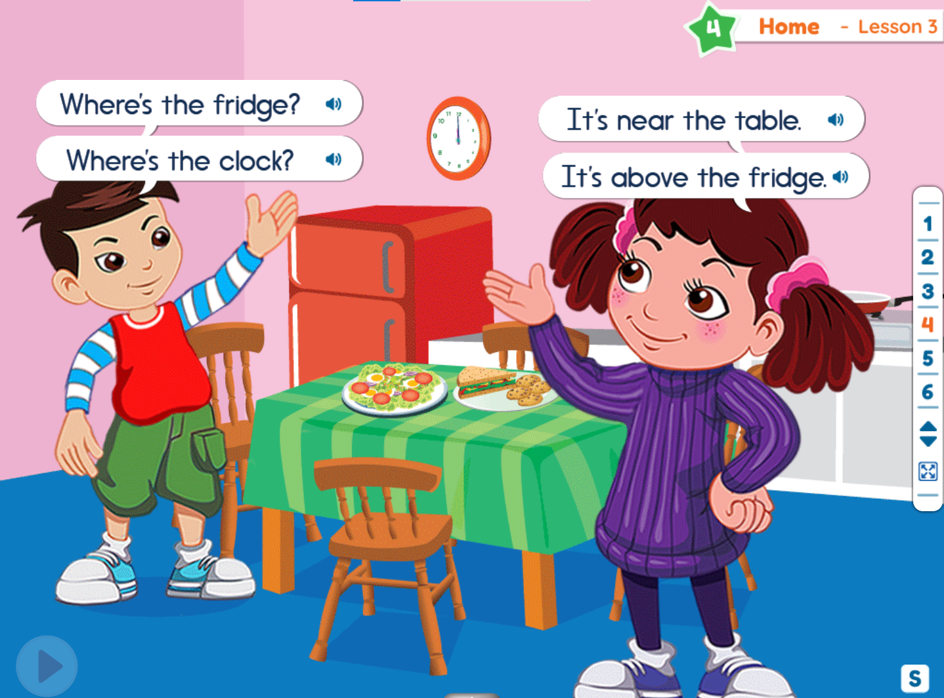  - Click Play button, have students listen to the question about the picture.  - Have students listen and practice the sentence.  - Invite some students to repeat the sentence.  - Open the structure box [S] and ask them to practice more. | - Promote students’ involvement  - Assist to select students to come to the board, make sure every student has a chance to interact with the board.  - Help the students correct their pronunciation if necessary  - Elicit if students do not remember  - Cooperate with the foreign teacher to demonstrate the sample sentence.  - Encourage students to come to board  - Perform an example with foreign teacher if necessary  - Observe and foster students’ understanding | - Pay attention, listen and answer the questions  - Go to the board, open the new words and repeat the words and sentences.  - Repeat the words  - Answer the questions  - Answer the teacher’s questions  - Listen to the sentence and practice  - Practice more with the sentences in the structure box
Practice  5 minutes | Slide 5  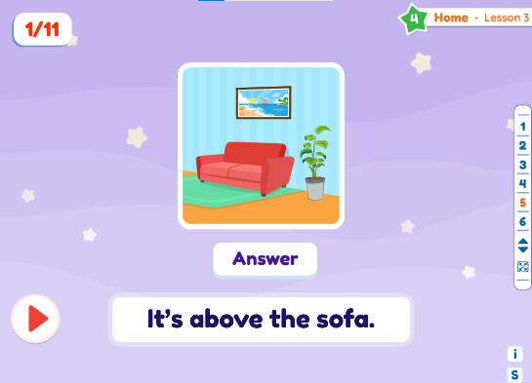  - Follow the instruction, teacher does a sample so that students know how to play.  Step 1: Click play to play the audio and show the picture.  Step 2: Have two students come to the board.  Step 3: Have student A repeat the question and student B answer according to the picture.  Step 4: Click answer to show the correct answer.  Step 5: Repeat for all questions with the students taking turns asking and answering. | - Work with the foreign teacher to demonstrate how to play  - Encourage students to join the activity  - Invite the students who do not raise their hands to play  - Go around the classroom and check students’ understanding by asking some questions based on the game context. | - Listen to the instruction  - Join the activity  - Come to the board and answer
Production  5 minutes | Slide 6  - Follow the instruction, teacher does a sample so that students know how to play.  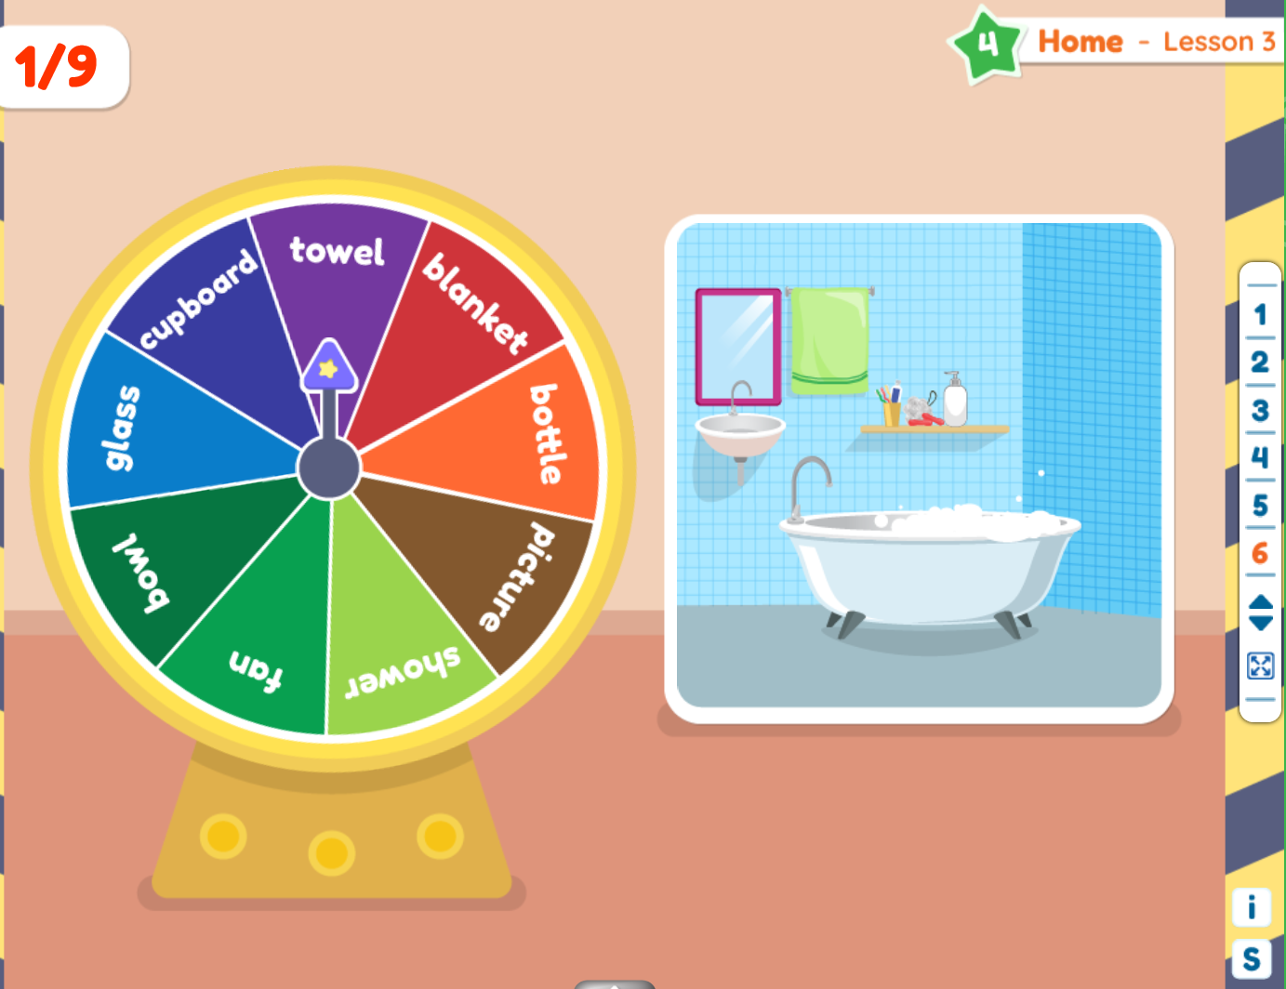  Step 1: Have two students come to the board.  Step 2: Student A clicks the wheel to spin it.  Step 3: When the wheel stops, student A asks student B “Where is the ____?” using the word wheel has landed on. E.g. “Where is the blanket?”  Step 4: Student B must answer the question and then find the item in the house and click in it.  Step 5: Repeat process for new students. | - Work with the foreign teacher to demonstrate how to play  - Invite students to go to the board  - Go around the classroom and check students’ understanding by asking some questions based on the game context. | - Listen to the instruction  - Work in pairs  - Go to the board, spin the wheel, ask and answer
Summary  2 minutes | - Open Slide 2, teacher checks students’ understanding by pointing and asking some questions using the structures that students have learnt. | - Invite the students who did not have a chance to come on the board  - Go around the classroom and ask some questions based on the picture. | - Go to the board and answer the questions.

Theme 4 – HOME
Lesson 4
- Lesson objectives:
At the end of the lesson, students will be able to:
- Ask the location of things and people.
- Language focus:
- Vocabulary: first, second, third, floor, elevator/lift, roof, apartment.
- Structure: A: Which floor do you live on?
B: I live on the first floor.
A: Which floor does he live on?
B: He lives on the third floor.
- Skills: Speaking, listening, reading
- Teaching aids: interactive whiteboard, projector, interactive device.
STAGES | TEACHER’S ACTIVITIES |  | STUDENTS’ ACTIVITIES | NOTES
STAGES | NATIVE TEACHER’S ACTIVITIES | CO-TEACHER’S ACTIVITIES | STUDENTS’ ACTIVITIES | NOTES
Warm up  3 minutes | Slide 1:  - Greet students  - Sing along and dance with students (warm-up song) | - Sing and dance with students | - Sing and dance with the teachers
Presentation  20 minutes | Slide 2: Theme introduction  (5 minutes)  - Elicit responses from students by asking some questions  Slide 3: New Vocabulary (7 minutes)  - Invite students to come to the board to touch the clouds, open the words, listen and repeat the words.  - Play audio again and have all students listen, repeat. Teacher corrects their pronunciation. Teacher can use actions to describe some words  - Click to the pictures to listen to the sentences. Have students repeat if they can.  - Randomly point at the words and have students repeat loudly  - Reload slide 3, ask students: “Where is the first?” have students come to the board and choose the correct clouds.  Slide 4: Grammar Structure (8 minutes)  - Introduce the speaking context by asking questions.  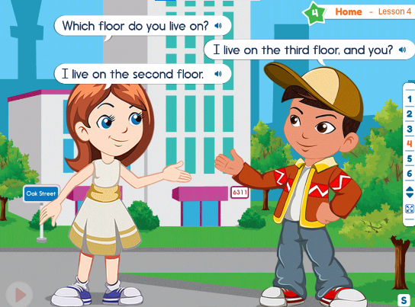  Ex: “What can you see in this picture”  - Click Play button, have students listen to the question about the picture.  - Have students listen and practice the sentence.  - Invite some students to repeat the sentence.  - Open the structure box [S] and ask them to practice more. | - Promote students’ involvement  - Assist to select students to come to the board, make sure every student has a chance to interact with the board.  - Help the students correct their pronunciation if necessary  - Elicit if students do not remember  - Cooperate with the foreign teacher to demonstrate the sample sentence.  - Encourage students to come to board  - Perform an example with foreign teacher if necessary  - Observe and foster students’ understanding | - Pay attention, listen and answer the questions  - Go to the board, open the new words and repeat the words and sentences.  - Repeat the words and sentences  - Answer the questions  - Answer the teacher’s questions  - Listen to the sentence and practice  - Practice more with the sentences in the structure box
Practice  5 minutes | Slide 5  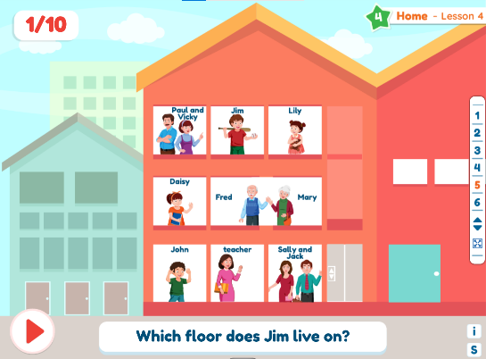  - Follow the instruction, teacher does a sample so that students know how to play.  Step 1: Have two students come to the board.  Step 2: Click play to play audio and show a question.  Step 3: Student A will ask the question and student B will answer.  Step 4: The rest of the class will practice the question and answer in pairs.  Step 5: Repeat for all questions. | - Work with the foreign teacher to demonstrate how to play  - Encourage students to join the activity  - Invite the students who do not raise their hands to play  - Go around the classroom and check students’ understanding by asking some questions based on the game context. | - Listen to the instruction  - Join the activity  - Invited students practice the question and answer
Production  5 minutes | Slide 6  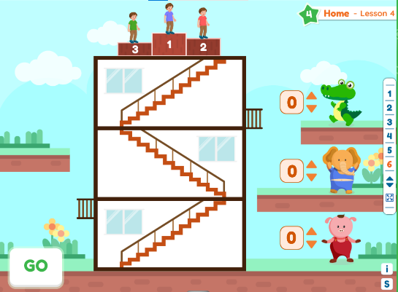  - Follow the instruction, teacher does a sample so that students know how to play.  Step 1: Divide the class into three teams (or two teams and you as a team).  Step 2: Have each team choose a color.  Step 3: Clicks “GO” to start the race.  Step 4: Have each team say where they are on the podium. E.g. “We are first!”.  Step 5: Award 3 points for 1st place, 2 points for the 2nd place and 1 point for 3rd place.  Step 6: Repeat process but allow the 3rd place team to choose their color first. | - Work with the foreign teacher to demonstrate how to play  - Help foreign teacher divide the class into three teams  - Invite 3 students from 3 teams to go to the board  - Go around the classroom and check students’ understanding by asking some questions based on the game context. | - Listen to the instruction  - Work in three teams  - Students from each team say where they are on the podium
Summary  2 minutes | - Open Slide 2, teacher checks students’ understanding by pointing and asking some questions using the structures that students have learnt. | - Invite the students who did not have a chance to come on the board  - Go around the classroom and ask some questions based on the picture. | - Go to the board and answer the questions.

