LỊCH DẠY TUẦN 6: 13/ 10/ 2025 đến 17/ 10/ 2025

LỚP | TIẾT | BÀI HỌC
3C, 3G | 1 | Unit 1: My friends - Lesson 4.3 – SB +WB
 | 2 | Review & Practice 1 – SB + WB
 | 3 | Review & Practice 2 – SB + WB
 | 4 | Unit 2: Family – Lesson 1.1 – SB +WB
 | 5 | PHẦN MỀM: Theme 1: My friends – Lesson 5
 | 6 | PHẦN MỀM: Theme 1: My friends – Lesson 6

UNIT 1 – MY FRIENDS
Ethics Lesson (page 21)
- Objectives
By the end of this lesson, students will be able to use polite greetings.
Language knowledge and skills
Vocabulary: hi, good, great
Sentence patterns: How are you?/ I’m good, and you?
It’s nice to meet you./ It’s nice to meet you, too.
Thank you./ You’re welcome.
Skills: Listening, Reading, Writing, and Speaking.
  - Competences
Self-control and independent learning: identify and use polite greetings.
Communication and collaboration: work in pairs or groups to use polite greetings.
Critical thinking and creativity: learn how to use polite greetings.
  - Attributes
Kindness: support their friends to complete the learning tasks or play the games.
Diligence: focus on the lesson and work hard to complete all the tasks.
Honesty: play fair.
Accountability: appreciate kindness, diligence, and honesty.
- Teaching aids and materials
- Teacher’s aids: Tiếng Anh 3 i-Learn Smart Start Student’s Book and Teacher’s book, Class CDs, Flashcards, DCR & DHA on Eduhome, Projector/Interactive Whiteboard /TV (if any), PowerPoint slides.
- Students’ aids: Tiếng Anh 3 i-Learn Smart Start Student’s Book, Workbook, Notebook.
- Procedures
- Warm up (5 minutes)
- Objectives: To help students have some general ideas about the reading.
- Content: Asking some questions.
- Expected outcomes and assessment
- Task completed with excellence: Students can answer the teacher’s questions correctly and quickly.
- Task completed: Students can answer the teacher’s questions.
- Task uncompleted: Students fail to answer the teacher’s questions.
- Organization
Teacher’s activities | Students’ activities
Play the Name memory game.  - Have the class play the game together.  - Write the sentence patterns: “I’m… / He’s… / She’s…” on the board.  - Give a student a ball and ask them to introduce their name and pass the ball to a friend. The student with the ball has to introduce their name and his friend’s name.  Eg.  Student 1: Hello, I’m Quan.  Student 2: Hello, I’m Lan. He’s Quan.  Student 3: Hello, I’m Minh. He’s Quan. She’s Lan.  - Correct the students’ mistakes if necessary.  - Lead in the new lesson. | - Play the game with their friends.  - Look at the patterns and follow their teacher’s instructions.  - Introduce their name and their friends’ names.

- Presentation (10 minutes)
- Objectives: To help the students have some general ideas about the reading.
- Content: Asking some questions.
- Expected outcomes and assessment
- Task completed with excellence: Students can answer the teacher’s questions correctly and quickly.
- Task completed: Students can answer the teacher’s questions.
- Task uncompleted: Students fail to answer the teacher’s questions.
- Organization
Teacher’s activities | Students’ activities
Ask some questions.  - Use DCR on Eduhome to show the class the story on page 21.  - Have some look at the picture and answer some questions.  - How many people are there in the picture? (two)  - What are they talking about? (greet each other)  - Are they happy? (Yes)  - Correct the students’ mistakes if necessary.  - Lead in the new lesson. | - Work individually to complete the task.  - Look at the picture and answer the teacher’s questions.

- Practice (10 minutes)
- Objectives: To help the students know how the greetings are used and practice writing a story.
- Contents: Reading, Writing, and Speaking.
- Expected outcomes and assessment
- Task completed with excellence: Students can know how the greetings are used and practice writing a story naturally.
- Task completed: Students can know how the greetings are used and practice writing a story.
- Task uncompleted: Students fail to know how the greetings are used and practice writing a story.
- Organization:
Teacher’s activities | Students’ activities
E. Read and circle True or False.  - Use DCR on Eduhome to show the students the text.  - Have the students read the text individually.  - Read the text as a whole class.  - Demonstrate the activity using the example.  - Have them read and circle “True” or “False”.  - Check answers as a whole class. | - Listen and follow their teacher’s instructions.  - Read the text individually.  - Read the text as a whole class.  - Read and circle “True” or “False”.
F. Look at E. Write a story.  - Have the students read the text in Part E again.  - Ask them to fill in the blanks to make a story. | - Read the text in Part E again.  - Fill in the blanks to make a story.

- Production (5 minutes)
- Objectives: To help them remember the vocabulary items and sentence patterns about the polite greetings.
- Content: Asking and answering or using DHA.
- Expected outcomes and assessment
- Task completed with excellence: Students can use the vocabulary items and sentence patterns about the polite greetings correctly.
- Task completed: Students can use the vocabulary items and sentence patterns about the polite greetings.
- Task uncompleted: Students cannot use the vocabulary items and sentence patterns about the polite greetings.

- Organization
Teacher’s activities | Students’ activities
Option 1: G. Role-play.  - Divide the class into pairs.  - Have some pairs make role-plays similar to Part E with their own information.  - Afterwards, have some pairs speak in front of the class. | - Work with their partner to complete the task.  - Make role-plays similar to Part E with their own information.  - Present their answers in front of the class.
Option 2: Use DHA on Eduhome.  - Open DHA (Unit 1 – Ethics Lesson) on Eduhome to help the students review the vocabulary through games: Look and find, Listen and find, and Grammar. | - Follow their teacher’s instructions.  - Play the game with the whole class.

- Consolidation and homework assignment (5 minutes)
- Objectives: To help students remember and pronounce the vocabulary items about the polite greetings.
- Contents: Playing the game “Whispers” and assigning homework in the Workbook.
- Expected outcomes and assessment
- Task completed with excellence: Students can whisper the words to their friends correctly and smoothly.
- Task completed: Students are able to whisper the words to their friends.
- Task uncompleted: Students fail to listen the new words or whisper them to their friends.
- Organization
Teacher’s activities | Students’ activities
Consolidation  - Have the students play the game “Whispers”.  - Divide the class into two teams.  - Ask the students to form two lines.  - Whisper a word to the first student from each group. Then they whisper the word into the ear of the student standing next to them. They continue whispering the word until the end of the line. The last student has to say it out loud.  - The first student to say the correct word wins a point for their team.  - The team having more correct answers will win the game. | - Play the game “Whispers” with their teammates.  - Follow their teacher’s instructions before playing the game.  - Quickly whisper the word into the ear of the friend standing next to them.
Homework Assignment  - Ask them to prepare Unit 1 – Review and Practice on page 22 in the Student’s Book. | - Follow their teacher’s instructions.  - Prepare the new lesson.

- Reflection
- What I liked most about this lesson today:
…………………………………………………………………………………………
- What I learned from this lesson today:
…………………………………………………………………………………………
- What I should improve for this lesson next time:
…………………………………………………………………………………………

UNIT 1 – MY FRIENDS
Review and Practice (page 22)
- Objectives
By the end of this lesson, students will be able to review spelling names, asking where people are from, and asking what their friends like doing.
  - Language knowledge and skills
Vocabulary: name, age, class number, sing, read, India.
Sentence patterns: What’s your name?/ Where are you from?/ How do you spell…?/ Do you friends like…?
Skills: Listening, Reading, Writing, and Speaking.
  - Competences
Self-control and independent learning: review spelling names, asking where people are from, and asking what their friends like doing.
Communication and collaboration: work in pairs or groups to spell names, ask where people are from, and ask what their friends like doing.
Critical thinking and creativity: learn how to spell names, ask where people are from, and ask what their friends like doing.
  - Attributes
Kindness: support their friends to complete the learning tasks.
Diligence: focus on the lesson and work hard to complete all the tasks.
Honesty: play fair.
Accountability: appreciate kindness, diligence, and honesty.
- Teaching aids and materials
- Teacher’s aids: Tiếng Anh 3 i-Learn Smart Start Student’s Book and Teacher’s book, Class CDs, Flashcards, Digital Book (DCR & DHA on Eduhome), Projector/Interactive Whiteboard /TV (if any), PowerPoint slides.
- Students’ aids: Tiếng Anh 3 i-Learn Smart Start Student’s Book, Workbook, Notebook.
- Procedures
- Warm up (5 minutes)
- Objectives: To help the students review the previous lessons, generate the students’ interests, and lead in the Review and Practice lesson.
- Content: Playing the game: “Slap the board” or “Snake”.
- Expected outcomes and assessment
- Task completed with excellence: Students can slap flashcards and say the words correctly.
- Task completed: Students can slap correct flashcards and say the words.
- Task uncompleted: Students can slap flashcards, but mispronounce the words/ say nothing.
- Organization
Teacher’s activities | Students’ activities
Option 1: Play the Slap the board game.  - Divide the class into two teams and have them form two lines.  - Place the flashcards about the letters (A-Z) and numbers (1-10) on the board, showing the images.  - Call out a word and have the first student from each group race to slap the correct image on the board and say it correctly. The first student to slap the correct flashcard wins a point for their team. | - Make two lines to play this game.  - Look at the flashcards on the board.  - Carefully listen and run to the board to slap the correct card and read aloud the word on it.
Option 2: Play the Snake game.  - Have the class stand up and play the game.  - Give the ball to the first student and ask them to begin by saying a letter or number.  - Then the first student passes the ball to any of their friends. The second friend will name another letter/ number.  - The students who are unable to say the letters/ numbers will sit down. The last student who stands up at the end of the game is the winner.  - Lead in the new lesson. | - Follow their teacher’s instructions before playing the game.  - Play the game with the whole class.  - Be ready for the new lesson.

- Presentation (5 minutes)
- Objective: To help the students identify the picture and get some general ideas before doing the listening task.
- Content: Speaking.
- Expected outcomes and assessment
- Task completed with excellence: Students can identify the picture and answer their teacher’s questions correctly.
- Task completed: Students can identify the picture and answer their teacher’s questions.
- Task uncompleted: Students are unable to identify the picture and answer their teacher’s questions.
- Organization
Teacher’s activities | Students’ activities
Answer the questions.  - Use DCR on Eduhome to show the class the picture on page 22.  - Ask them to ask these questions.  - What can you see in the picture?  - How many people are there?  - How do they feel?  - Where are they?  - Ask them to look at the key word(s) in each question and guess the answer whether it is a word or a number.  - Walk round the class and support them if needed. | - Look at the picture on page 22.  - Answer their teacher’s questions.  - Look at the key word(s) in each question and guess the answer whether it is a word or a number.

- Practice (10 minutes)
- Objectives: To practice their listening skill by writing a name or number, asking where people are from, and asking what their friends like doing.
- Contents: Listening, Reading, Writing, and Speaking.
- Expected outcomes and assessment
- Task completed with excellence: Students can understand and write a name or number, ask where people are from, and ask what their friends like doing correctly.
- Task completed: Students can understand and write a name or number, ask where people are from, and ask what their friends like doing.
- Task uncompleted: Students fail to understand and write a name or number, ask where people are from, and ask what their friends like doing.
- Organization:
Teacher’s activities | Students’ activities
- Listen and write a name or a number.  (CD1 Track 34)  - Have the students focus on the Listening task.  - Play the audio and ask them to listen and write a name or a number in each blank.  - Invite some students to give their answers.  - Check the answers with the whole class. | - Focus on the Listening task.  - Listen and write a name or a number in each blank.  - Present their answers in front of the class and check the answers with their teacher and friends.
- Look and read. Put a () or a ().  - Demonstrate the activity using the example.  - Have the students look at the pictures, read each statement, and put a tick in the box if the statement is true, or a cross if the statement is false.  - Check the answers as a whole class using DCR  - Afterwards, have the students give a new true statement for each of the false statements.  - Monitor the class and support if needed. | - Look at the pictures, read the statements, and put a tick in the box if the statement is true, or a cross if the statement is false.  - Check the answers with the whole class.  - Give a new true statement for each of the false statements.

- Production (10 minutes)
- Objectives: To help them remember the vocabulary and sentence pattern.
- Content: Asking and answering the questions.
- Expected outcomes and assessment
- Task completed with excellence: Students can ask and answer the questions about spelling names, asking where people are from, and asking what their friends like doing fluently.
- Task completed: Students are able to ask and answer the questions about spelling names, asking where people are from, and asking what their friends like doing.
- Task uncompleted: Students cannot ask and answer the questions about spelling names, asking where people are from, and asking what their friends like doing.
- Organization
Teacher’s activities | Students’ activities
Ask and answer.  - Let the class work in pairs to complete the task.  - Have the students practice using the structures to ask and answer about spelling names (How do you spell…?), asking where people are from (Where are you from?), and asking what their friends like doing (Do your friends like…?).  - Show the flashcards to the class.  - Require them to look at the flashcards and use the appropriate structures to ask their friends.  - Monitor the class and support them if necessary. | - Work with their partner to complete the task.  - Follow their teacher’s instructions.  - Look at the flashcards and use the appropriate structures to ask their friends.

- Consolidation and homework assignment (5 minutes)
- Objectives: To help the students memorize the key language structures they learned.
- Contents: Asking the questions and assigning homework in the Workbook.
- Expected outcomes and assessment
- Task completed with excellence: Students can memorize the target sentence patterns correctly.
- Task completed: Students are able to memorize the target sentence patterns.
- Task uncompleted: Students fail to memorize the target sentence patterns.
- Organization
Teacher’s activities | Students’ activities
Consolidation  - Give the students enough time to memorize the target language structures they learned.  - Ask some students to say the language structures in front of the class.  - Correct the students if needed. | - Memorize the target language structures they learned.  - Present the language structures in front of the class.
Homework Assignment  - Ask Ss to do the exercises on pages 16, 17 in the Workbook.  - Have Ss do the exercises in TA3 i-Learn Smart Start Notebook, page 11.  - Ask them to prepare the next lesson on page 23 in the Student’s Book. | - Follow their teacher’s instructions.  - Do homework and prepare the new lesson.

- Reflection

- What I liked most about this lesson today:
…………………………………………………………………………………………
- What I learned from this lesson today:
…………………………………………………………………………………………
- What I should improve for this lesson next time:
…………………………………………………………………………………………

UNIT 1 – MY FRIENDS
Review and Practice (page 23)
- Objectives
By the end of this lesson, students will be able to review spelling names, asking where people are from, and asking what their friends like doing.
  - Language knowledge and skills
Vocabulary: name, spell, dance, sing, draw.
Sentence patterns: What’s your name?/ Where are you from?/ How do you spell…?/ Do you friends like…?
Skill: Speaking.
  - Competences
Self-control and independent learning: review spelling names, asking where people are from, and asking what their friends like doing.
Communication and collaboration: work in pairs or groups to spell names, ask where people are from, and ask what their friends like doing.
Critical thinking and creativity: learn how to spell names, ask where people are from, and ask what their friends like doing.
  - Attributes
Kindness: support their friends to complete the learning tasks.
Diligence: focus on the lesson and work hard to complete all the tasks.
Honesty: play fair.
Accountability: appreciate kindness, diligence, and honesty.
- Teaching aids and materials
- Teacher’s aids: Tiếng Anh 3 i-Learn Smart Start Student’s Book and Teacher’s book, Class CDs, Flashcards, Digital Book (DCR & DHA on Eduhome), Projector/Interactive Whiteboard /TV (if any), PowerPoint slides.
- Students’ aids: Tiếng Anh 3 i-Learn Smart Start Student’s Book, Workbook, Notebook.
- Procedures
- Warm up (5 minutes)
- Objectives: To help the students review the previous lessons, generate the students’ interests, and lead in the Review and Practice lesson.
- Content: Playing the game: “Circle jump” or “Slap the board”.
- Expected outcomes and assessment
- Task completed with excellence: Students can slap flashcards or jump inside the correct circle and say the phrases quickly and correctly.
- Task completed: Students can slap flashcards or jump inside the correct circle and say the phrases.
- Task uncompleted: Students slap the wrong flashcards or pronounce the phrases incorrectly.
- Organization
Teacher’s activities | Students’ activities
Option 1: Play the Circle jump game.  - Divide the class into two groups and make two lines to play the game.  - Draw two large circles on the ground with chalk.  - Place a flashcard in each circle.  - Call out a phrase, and a student from each team has to run and stand inside the corresponding circle as quickly as possible.  - Ask them to say the phrase when standing inside the circle.  - The first student getting the correct answer wins a point for their team. | - Make two lines to play this game.  - Follow their teacher’s instructions before playing the game.  - Quickly run and stand inside the corresponding circle when the teacher says a phrase.  - Say aloud the phrase when standing inside the circle.
Option 2: Play the Slap the board game.  - Divide the class into two teams and have them form two lines.  - Place the flashcards about the letters, numbers, countries, free time activities on the board, showing the images.  - Call out a phrase and have the first student from each group race to slap the correct image on the board and say it correctly. The first student to slap the correct flashcard wins a point for their team. | - Make two lines to play this game.  - Look at the flashcards on the board.  - Carefully listen and run to the board to slap the correct card and read aloud the phrase on it.

- Presentation (5 minutes)
- Objective: To help the students identify the pictures and get some general ideas before playing the game.
- Content: Speaking.
- Expected outcomes and assessment
- Task completed with excellence: Students can identify the pictures and answer their teacher’s questions correctly.
- Task completed: Students can identify the pictures and answer their teacher’s questions.
- Task uncompleted: Students are unable to identify the pictures and answer their teacher’s questions.
- Organization
Teacher’s activities | Students’ activities
Answer the questions.  - Use DCR on Eduhome to show the class the pictures on page 23.  - Point to each picture and ask them to ask these questions.  - What activity is it?  - How many people are there?  - Where is it?/ What country is it?  - Walk round the class and support them if needed. | - Look at the picture on page 23.  - Look at the pictures and answer their teacher’s questions.

- Practice (10 minutes)
- Objective: To practice their speaking skill by spelling names, asking where people are from, and asking what their friends like doing.
- Content: Speaking.
- Expected outcomes and assessment
- Task completed with excellence: Students can spell names, ask where people are from, and ask what their friends like doing correctly.
- Task completed: Students can spell names, ask where people are from, and ask what their friends like doing.
- Task uncompleted: Students fail to spell names, ask where people are from, and ask what their friends like doing.
- Organization:
Teacher’s activities | Students’ activities
Play the board game.  - Divide the class into groups of four with two pairs in each group.  - Guide the students how to play the game.  - Have the pairs play rock, paper, scissors for each turn.  - The winning pair moves forward two spaces. The losing pair moves forward one.  - Each pair must match the symbol to the useful language and then ask and answer. If they answer incorrectly, they must move back one space.  - The pair getting to the Finish first wins the game. | - Work in groups to complete the task.  - Follow their teacher’s instructions before playing the game.  - Play rock, paper, scissors to start the game.  - Look at the pictures to make the correct language structures to ask their friends.
Correct homework.  - Ask some students to present their homework (Workbook, pages 16, 17) on the board.  - Walk around the class and check the students’ homework.  - Afterwards, check the answers on the board with the whole class. | - Write the answers on the board.  - Check the answers with their teacher and friends.

- Production (10 minutes)
- Objectives: To help them remember the vocabulary and sentence pattern.
- Content: Asking and answering the questions.
- Expected outcomes and assessment
- Task completed with excellence: Students can ask and answer the questions about spelling names, asking where people are from, and asking what their friends like doing fluently.
- Task completed: Students are able to ask and answer the questions about spelling names, asking where people are from, and asking what their friends like doing.
- Task uncompleted: Students cannot ask and answer the questions about spelling names, asking where people are from, and asking what their friends like doing.
- Organization
Teacher’s activities | Students’ activities
Ask and answer.  - Let the class work in pairs to complete the task.  - Have the students practice using the structures to ask and answer about spelling names (How do you spell…?), asking where people are from (Where are you from?), and asking what their friends like doing (Do your friends like…?).  - Show the flashcards to the class.  - Require them to look at the flashcards and use the appropriate structures to ask their friends.  - Monitor the class and support them if necessary. | - Work with their partner to complete the task.  - Follow their teacher’s instructions.  - Look at the flashcards and use the appropriate structures to ask their friends.

- Consolidation and homework assignment (5 minutes)
- Objectives: To help the students memorize the key language structures they learned.
- Contents: Asking the questions and assigning homework.
- Expected outcomes and assessment
- Task completed with excellence: Students can memorize the target sentence patterns correctly.
- Task completed: Students are able to memorize the target sentence patterns.
- Task uncompleted: Students fail to memorize the target sentence patterns.

- Organization
Teacher’s activities | Students’ activities
Consolidation  - Give the students enough time to memorize the target language structures they learned.  - Ask some students to say the language structures in front of the class.  - Have the class evaluate their learning achievement by circling the happy/unhappy faces.  - Correct the students if needed. | - Memorize the target language structures they learned.  - Present the language structures in front of the class.
Homework Assignment  - Ask them to prepare Lesson 1 – Unit 2 on page 24 in the Student’s Book. | - Prepare the new lesson.

- Reflection

- What I liked most about this lesson today:
…………………………………………………………………………………………
- What I learned from this lesson today:
…………………………………………………………………………………………
- What I should improve for this lesson next time:
…………………………………………………………………………………………

UNIT 2 – FAMILY
Lesson 1 (page 24)
- Objectives
By the end of this lesson, students will be able to introduce family members.
  - Language knowledge and skills
Vocabulary: father, mother, brother, sister.
Sentence patterns: This is my father./ Hello, I’m Alfie./ Hello, Alfie.
Skills: Listening, Reading, Writing, and Speaking.
  - Competences
Self-control and independent learning: identify and introduce family members.
Communication and collaboration: work in pairs or groups to introduce family members.
Critical thinking and creativity: learn how to introduce family members correctly and fluently.
  - Attributes
Kindness: support their friends to complete the learning tasks or play the games.
Diligence: focus on the lesson and work hard to complete all the tasks.
Honesty: play fair.
Accountability: appreciate kindness, diligence, and honesty.
- Teaching aids and materials
- Teacher’s aids: Tiếng Anh 3 i-Learn Smart Start Student’s Book and Teacher’s book, Class CDs, Flashcards, DCR & DHA on Eduhome, Projector/Interactive Whiteboard /TV (if any), PowerPoint slides.
- Students’ aids: Tiếng Anh 3 i-Learn Smart Start Student’s Book, Workbook, Notebook.
- Procedures
- Warm up (5 minutes)
- Objectives: To review the vocabulary items about free time activities and countries, generate students’ interests and, lead in the new lesson.
- Content: Playing the game: “Turn over the flashcards” or “Slap the board”.
- Expected outcomes and assessment
- Task completed with excellence: Students can slap flashcards or say and turn over the correct flashcards quickly and correctly.
- Task completed: Students can slap flashcards or say and turn over the correct flashcards.
- Task uncompleted: Students slap flashcards or say and turn over the correct flashcards incorrectly.
- Organization
Teacher’s activities | Students’ activities
Option 1: Turn over the flashcards.  - Place the flashcards on the floor with the picture-side down.  - Divide the class into two groups and sit on opposite sides of the flashcards.  - Ask them to say a free time activity/ country and turn over the flashcard that they think shows the picture of the activity/ country. If they are right, they keep the flashcard. If they are wrong, they leave it in its original place.  - The team with the most flashcards at the end wins the game. | - Follow teacher’s instructions before playing the game.  - Make two lines to play this game.  - Say a free time activity/ country and turn over the flashcard that they think shows the picture of the activity/ country.
Option 2: Playing the Slap the board game.  - Divide the class into two teams and have them form two lines.  - Place the flashcards about family members on the board, showing the images.  - Call out a word and have the first student from each group race to slap the correct image on the board and say it correctly. The first student to slap the correct flashcard wins a point for their team. | - Make two lines to play this game.  - Look at the flashcards on the board.  - Carefully listen and run to the board to slap the correct card and read aloud the word on it.
- Presentation (10 minutes)
- Objective: To help students identify and name some family members.
- Contents: Listening, pointing, and repeating.
- Expected outcomes and assessment
- Task completed with excellence: Students can identify and read out loud the words correctly.
- Task completed: Students can identify and read out loud the words.
- Task uncompleted: Students are unable to point and read the correct words.
- Organization
Teacher’s activities | Students’ activities
- 1. Listen and point. Repeat. (CD1 Track 35)  - Arrange the flashcards (father, mother, brother, sister) on the board.  - Ask the students to listen and pay their attention.  - Use DCR on Eduhome to play the audio and point to each flashcard.  - Then play the audio again and have them point to the pictures in their Student’s Books.  - Play the audio and require them to listen and repeat.  - Help them with their pronunciation if necessary.  - Have the class work in pairs. One student randomly points to the pictures in their book, and the other one says the words. Then have them swap roles and continue this activity.  - Walk round the class and support them if needed. | - Listen and follow their teacher’s instructions.  - Point to the pictures in their Student’s Books.  - Listen and repeat.  - Work with their partner to complete the task.
2. Play Four corners.  - Put one flashcard in each of the four corners of the classroom.  - Make sure that all students can pronounce the new word in each card.  - Choose one student to come to the front of the class.  - Have the student close their eyes and have the rest of the class stand up and point to a flashcard of their choice.  - Have the student at the front say one of the words. All students pointing at that flashcard are “out”. They must sit down.  - Continue the game until only one student is left standing. | - Play with the whole class.  - Identify and say the new words in the flashcards of the four corners correctly.  - One student to come to the front of the class.  - Stand up and point to a flashcard they like.  - One student at the front of the class says one of the new words. Students pointing at that flashcard must sit down.  - Play the game until the last student is still standing.

- Practice (10 minutes)
- Objectives: To practice introducing their family members.
- Contents: Listening and Speaking.
- Expected outcomes and assessment
- Task completed with excellence: Students can introduce family members correctly.
- Task completed: Students can introduce family members.
- Task uncompleted: Students fail to introduce family members.
- Organization:
Teacher’s activities | Students’ activities
- 1. Listen and practice. (CD1 Track 36)  - Use DCR on Eduhome to show the useful language and have students look and read the useful language silently.  - Explain that we often use “This is my…” to introduce our family member and we use “Hello, I’m…” to introduce ourselves.  - Play the audio and have them look at the useful language.  - Ask them to work in pairs and practice the useful language.  - Require them to use the vocabulary from Part A.  - Go around the class and support them if necessary. | - Look and read the useful language silently.  - Listen to their teacher’s explanation.  - Listen and look at the useful language again.  - Work in pairs and practice the useful language.  - Use the new words from Part A when practicing the useful language.
2. Fill in the blanks. Practice.  - Demonstrate the activity using the example.  - Have the students read and fill in the blanks.  - Divide the class into pairs and have them check each other’s work.  - Use DCR on Eduhome to check the answers as a whole class.  - Have pairs practice saying the sentences.  - Monitor the class and support if needed. | - Carefully look at the teacher demonstrating the activity.  - Look and write their answers in their Student’s Books.  - Work in pairs and check their partner’s answers.  - Check the answers with the teacher and friends.  - Practice saying the sentences with a friend.

- Production (5 minutes)
- Objectives: To help them remember the vocabulary and sentence patterns.
- Content: Playing the game: “Introducing family members” or using DHA.
- Expected outcomes and assessment
- Task completed with excellence: Students can introduce family members quickly.
- Task completed: Students are able to introduce family members.
- Task uncompleted: Students cannot introduce family members.
- Organization
Teacher’s activities | Students’ activities
Option 1: Use the structure: “This is… .”  - Show a flashcard to the class.  - Have students practice the structure using the new word.  - Repeat with other flashcards.  e.g.  (Teacher shows the flashcard “sister”.)  Class: “This is my sister.”  (Teacher shows the flashcard “brother”.)  Class: “This is my brother.” | - Work with their teammates to complete the task.  - Follow their teacher’s instructions.  - Make questions or answer the questions from the other team.
Option 2: Use DHA on Eduhome  - Open DHA (Unit 2 – Lesson 1) on Eduhome to help the students review the vocabulary through games: Look and find, Listen and find, and Grammar. | - Follow their teacher’s instructions.  - Play the game with the whole class.

- Consolidation and homework assignment (5 minutes)
- Objectives: To help students remember and pronounce the vocabulary items.
- Contents: Playing the game “Whispers” and assigning homework in the Workbook.
- Expected outcomes and assessment
- Task completed with excellence: Students can whisper the words to their friends correctly and smoothly.
- Task completed: Students are able to whisper the words to their friends.
- Task uncompleted: Students fail to listen the new words or whisper them to their friends.
- Organization
Teacher’s activities | Students’ activities
Consolidation  - Have students play the game “Whispers”.  - Divide the class into two teams.  - Ask students to form two lines.  - Whisper a word to the first student from each group. Then they whisper the word into the ear of the student standing next to them. They continue whispering the word until the end of the line. The last student has to say it out loud.  - The first student to say the correct word wins a point for their team.  - The team having more correct answers will win the game. | - Play the game “Whispers” with their teammates.  - Follow teacher’s instructions before playing the game.  - Quickly whisper the word into the ear of the friend standing next to them.
Homework Assignment  - Require students to do exercises on page 18 in the Workbook.  - Have them copy new words and structure in their Tiếng Anh 3 i-Learn Smart Start Notebook, page 12.  - Ask them to prepare Parts C and D, Lesson 1 on page 25 in the Student’s Book. | - Follow their teacher’s instructions.  - Do homework, copy the new words, and prepare the new lesson.

- Reflection
- What I liked most about this lesson today:
…………………………………………………………………………………………
- What I learned from this lesson today:
…………………………………………………………………………………………
- What I should improve for this lesson next time:
…………………………………………………………………………………………

PHẦN MỀM
Theme 1 – My Friends
Lesson 5
- Lesson objectives:
At the end of the lesson, students will be able to:
- Know about their friends.
- Language focus:
- Vocabulary: Review vocabularies from Lesson 1-4.
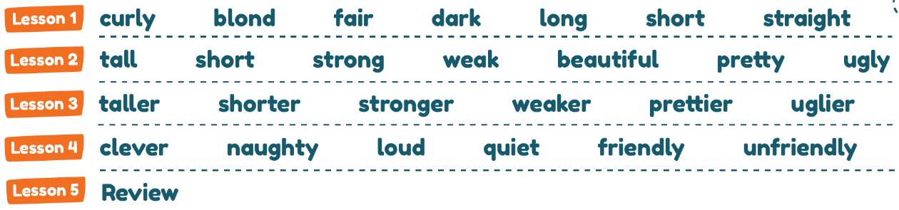
- Structure: Review structures from Lesson 1-4
- Skills: Speaking, listening, reading
- Teaching aids: interactive whiteboard, projector, interactive device.
STAGES | TEACHER’S ACTIVITIES |  | STUDENTS’ ACTIVITIES | NOTES
STAGES | NATIVE TEACHER’S ACTIVITIES | CO-TEACHER’S ACTIVITIES | STUDENTS’ ACTIVITIES | NOTES
Warm up  3 minutes | Slide 1:  - Greet students  - Sing along and dance with students (warm-up song) | - Sing and dance with students | - Sing and dance with the teachers
Presentation  20 minutes | Slide 2: Theme introduction  (7 minutes)  - Elicit responses from students by asking some questions  Slide 3: (5 minutes) Have students to sing along to the song  Slide 4: Review Vocabulary (8 minutes)  - Invite students to come to the board to touch the clouds, open the words, listen and repeat the words.  - Play audio again and have all students listen, repeat. Teacher corrects their pronunciation. Teacher can use actions to describe some words  - Click to the pictures to listen to the sentences. Have students repeat if they can.  - Randomly point at the words and have students repeat loudly  - Reload slide 4, ask students: “What’s number (1)?” or “Where is (curly)?”, have students come to the board and choose the correct clouds. | - Promote students’ involvement  - Sing and dance with the students  - Assist to select students to come to the board, make sure every student has a chance to interact with the board.  - Help the students correct their pronunciation if necessary  - Have students listen to the audio and repeat  - Elicit if students do not remember  - Invite the students who do not raise their hands to come to the board | - Pay attention, listen and answer the questions  - Sing and dance with the teachers  - Go to the board, open the new words and repeat the words and sentences.  - Repeat the words and sentences  - Join the activity  - Repeat loudly  - Invited students come to the board and practice. The others observe and repeat in pairs
Production Activity  7 minutes | Slide 5  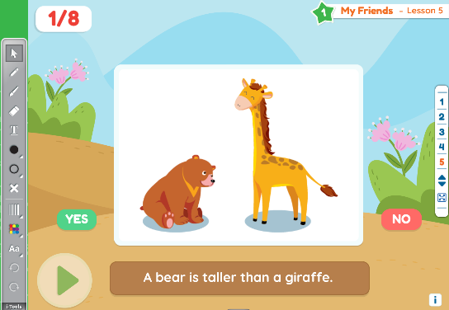  - Follow the instruction; teacher does a sample so that students know how to play.  Step 1: Click play to show a picture and three words.  Step 2: Have students write the correct word.  Step 3: Have a student come to the board and click on the correct word.  Step 4: Repeat process for all words. | - Work with the foreign teacher to demonstrate how to play  - Help foreign teacher divide the class into 2 teams.  - Encourage students to join the activity  - Invite the students who do not raise their hands to come to the board  - Go around the classroom and check students’ understanding by asking some questions based on the game context, correct their pronunciation if necessary. | - Listen to the instruction  - Join the activity  - Invited students come to the board and practice. The others observe and repeat in pairs
Summary  5 minutes | - Open Slide 2, teacher check students’ understanding by pointing and asking some questions using the structures that students have learnt. | - Invite the students who did not have a chance to come on the board  - Go around the classroom and ask some questions based on the picture. | - Go to the board and answer the questions.

Theme 1 – My Friends.
Lesson 6
- Lesson objectives:
At the end of the lesson, students will be able to:
- Know about their friends.
- Language focus:
- Vocabulary: Review vocabularies from Lesson 1-4
- Structure: Review structures from Lesson 1-4.
- Skills: Speaking, listening, reading
- Teaching aids: interactive whiteboard, projector, interactive device.
STAGES | TEACHER’S ACTIVITIES |  | STUDENTS’ ACTIVITIES | NOTES
STAGES | NATIVE TEACHER’S ACTIVITIES | CO-TEACHER’S ACTIVITIES | STUDENTS’ ACTIVITIES | NOTES
Warm up  5 minutes | Slide 1:  - Greet students  - Sing along and dance with students (warm-up song) | - Sing and dance with students | - Sing and dance with the teachers
Presentation  15 minutes | Slide 2: Review (5 minutes)  - Follow the instruction; teacher does a sample so that students know how to play.  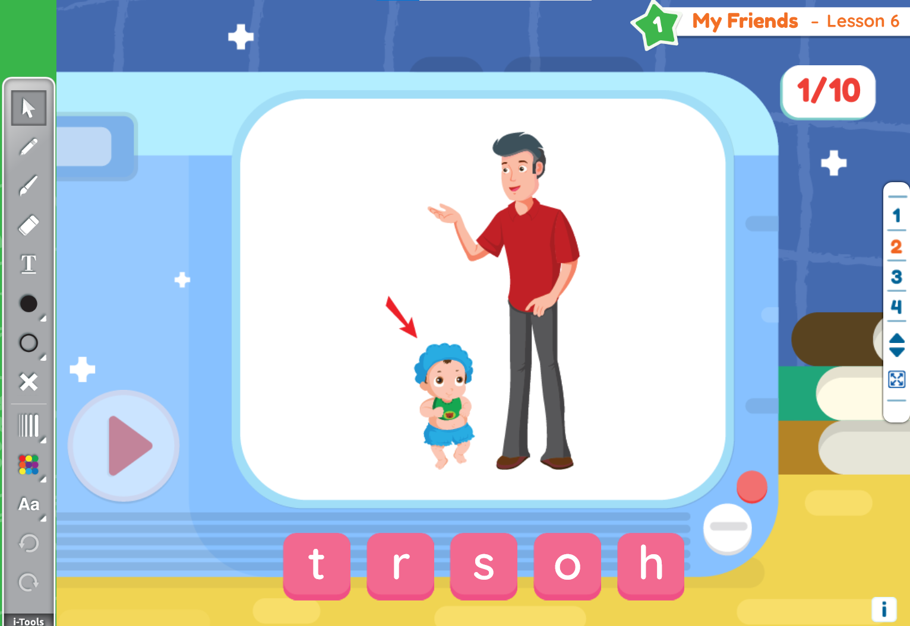  Step 1: Click play to show picture and scramble letters.  Step 2: Have a student come to the board to rearrange the letters and spell the word correctly.  Step 3: When finished spelling the word, the student makes a sentence using that word.  Step 4: Repeat the process for all words. | - Work with the foreign teacher to demonstrate how to play  - Promote students’ involvement  - Assist to select students to come to the board, make sure every student has a chance to interact with the board.  - Help the students correct their pronunciation if necessary  - Elicit if students do not remember | - Listen to the instruction  - Join the activity  - Write down the word and check the answer with the teacher
Production Activity  10 minutes | Slide 3  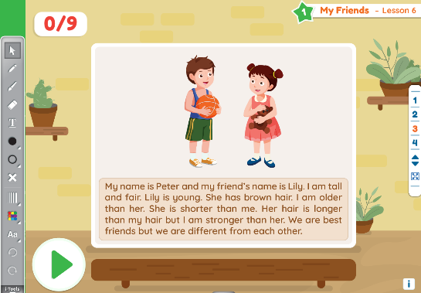  - Follow the instruction; teacher does a sample so that students know how to play.  Step 1: Have students read the paragraph on the board.  Step 2: Click play to play audio and show question.  Step 3: Students must answer the question as a class.  Step 4: Have one student come to the board and click on the correct person. | - Work with the foreign teacher to demonstrate how to play  - Encourage students to join the activity  - Have students answer the question as a class. Elicit if students do not remember  - Invite the students who do not raise their hands to come to the board, make sure every student has a chance to interact with the board.  - Go around the classroom and check students’ understanding by asking some questions based on the game context, correct their pronunciation if necessary. | - Listen to the instruction  - Join the activity  - Answer the question as a class  - Invited students come to the board and answer the question. The others observe and repeat in pairs
Summary  5 minutes | Slide 4:  - Sing along and dance with students | - Sing and dance with students | - Sing and dance with the teachers

