LỊCH DẠY TUẦN 4: 29/ 09/ 2025 đến 03/ 10/ 2025

LỚP | TIẾT | BÀI HỌC
3C,3G | 1 | Unit 1: My friends – Lesson 2.1 – SB +WB
 | 2 | Unit 1: My friends – Lesson 2.2 – SB +WB
 | 3 | Unit 1: My friends – Lesson 2.3 – SB +WB
 | 4 | Unit 1: My friends – Lesson 3.1 – SB +WB
 | 5 | PHẦN MỀM: Theme 1: My friends – Lesson 1
 | 6 | PHẦN MỀM: Theme 1: My friends – Lesson 2

UNIT 1 – MY FRIENDS
Lesson 2 (page 13)
- Objectives
By the end of this lesson, students will be able to ask where people are from.
  - Language knowledge and skills
Vocabulary: the USA, the UK, Italy, India, Japan, Alpha.
Sentence patterns: Where are you from?/ I’m from the USA./ Where’s she from?/ She’s from Japan.
Skills: Listening, Reading, Writing, and Speaking.
  - Competences
Self-control and independent learning: ask and answer about the countries people are from.
Communication and collaboration: work in pairs/ groups to ask and answer about the countries people are from.
Critical thinking and creativity: learn how to ask and answer about the countries people are from.
  - Attributes
Kindness: support their friends to complete the learning tasks or play the games.
Diligence: focus on the lesson and work hard to complete all the tasks.
Honesty: play fair.
Accountability: appreciate kindness, diligence, and honesty.
- Teaching aids and materials
- Teacher’s aids: Tiếng Anh 3 i-Learn Smart Start Student’s Book and Teacher’s book, Class CDs, Flashcards, DCR & DHA on Eduhome, Projector/Interactive Whiteboard /TV (if any), PowerPoint slides.
- Students’ aids: Tiếng Anh 3 i-Learn Smart Start Student’s Book, Workbook, Notebook.
- Procedures
- Warm up (5 minutes)
- Objectives: To help students introduce the alphabet, generate students’ interests and, lead in the new lesson.
- Content: Playing the game: “Draw the alphabet” or “Repeating game”.
- Expected outcomes and assessment
- Task completed with excellence: Students can guess the correct letter or repeat the correct words on the flashcards quickly.
- Task completed: Students can guess the correct letter or repeat the correct words on the flashcards.
- Task uncompleted: Students cannot guess the letter or find it difficult to pronounce some words.
- Organization
Teacher’s activities | Students’ activities
Option 1: Draw the alphabet.  - Divide the class into two teams.  - Invite the first two students of each group to come to the front of the class.  - Ask the second student to draw a letter on the back of the first student so that they can guess the letter.  - The first student to get the correct letter wins a point for their team.  - Continue this activity with the next pairs.  - Lead in the new lesson. | - Play the game with their classmates.  - Listen to their teacher’s instructions.  - Come to the front of the class.  - Draw a letter on the back of the first student so that they can guess the letter.  - Be ready for the new lesson.
Option 2: Playing the Repeating game.  - Put a selection of the flashcards about the alphabet on the board.  - Point to a flashcard and say a letter. If the letter is correct, the students repeat it. If not, they stay silent. | - Follow their teacher’s instructions before playing the game.  - Look at the flashcard, listen to their teacher saying the letter on each card, and repeat the letter if it is correct.

- Presentation (10 minutes)
- Objective: To help the students recognize and name some countries.
- Contents: Listening, pointing, and repeating.
- Expected outcomes and assessment
- Task completed with excellence: Students can recognize and name some countries correctly.
- Task completed: Students can recognize and name some countries.
- Task uncompleted: Students are unable to recognize and name some countries.
- Organization
Teacher’s activities | Students’ activities
- 1. Listen and point. Repeat. (CD1 Track 18)  Arrange the flashcards (the USA, the UK, Italy, India, Japan, Alpha) on the board.  - Ask the students to listen and pay their attention.  - Use DCR on Eduhome to play the audio and point to each flashcard.  - Then play the audio again and have them point to the pictures in their Student’s Books.  - Play the audio and require them to listen and repeat.  - Help them with their pronunciation if necessary.  - Have the class work in pairs. One student randomly points to the pictures in their book, and the other one says the words. Then have them swap roles and continue this activity.  - Walk round the class and support them if needed. | - Listen and follow their teacher’s instructions.  - Point to the pictures in their Student’s Books.  - Listen and repeat.  - Work with their partner to complete the task.
2. Play Guess.  - Arrange the flashcards on the board and write a number under each card.  - Have the students look at the flashcards for the count of ten.  - Turn the flashcards over to face the board when the students are not looking.  - Call out a number and have the students take turns guessing the face-down card. Turn the card over after each guess. | - Play with the whole class.  - Look at the flashcards for the count of ten.  - Take turns guessing the face-down card.

- Practice (10 minutes)
- Objectives: To practice asking and answering about the countries people are from.
- Contents: Listening and Speaking.
- Expected outcomes and assessment
- Task completed with excellence: Students can ask and answer about the countries people are from correctly and smoothly.
- Task completed: Students can ask and answer about the countries people are from.
- Task uncompleted: Students fail to ask and answer about the countries people are from.

- Organization:
Teacher’s activities | Students’ activities
- 1. Listen and practice. (CD1 Track 19)  - Use DCR to show the useful language and have students look and read the useful language silently.  - Explain that we use this to ask where a person comes from. It can be used for countries, cities, provinces, or other areas.  - Play the audio and have them look at the useful language.  - Ask them to work in pairs and practice the useful language.  - Require them to use the vocabulary from Part A.  - Go around the class and support them if necessary. | - Look and read the useful language silently.  - Listen to their teacher’s explanation.  - Listen and look at the useful language again.  - Work in pairs and practice the useful language.  - Use the new words from Part A when practicing the useful language.
2. Fill in the blanks. Practice.  - Demonstrate the activity using the example.  - Have the students read and fill in the blanks.  - Divide the class into pairs and have them check each other’s work.  - Use DCR to check the answers as a whole class.  - Have pairs practice saying the sentences.  - Monitor the class and support if needed. | - Carefully look at the teacher demonstrating the activity.  - Look and write their answers in their Student’s Books.  - Work in pairs and check their partner’s answers.  - Check the answers with the teacher and friends.  - Practice saying the sentences with a friend.

- Production (5 minutes)
- Objectives: To help them remember the vocabulary about countries.
- Content: Playing the game: “Disappearing cards” or using DHA.
- Expected outcomes and assessment
- Task completed with excellence: Students can name all the flashcards in order quickly.
- Task completed: Students can remember the flashcard’s sequence.
- Task uncompleted: Students cannot remember some disappearing flashcards on the board.
- Organization
Teacher’s activities | Students’ activities
Option 1: Playing the Disappearing cards game.  - Put a selection of flashcards in a line on the board.  - Get the students to name them in order.  - When they can do this activity easily, start to turn the flashcards over so that they have to remember the sequence. | - Look at the flashcards on the board.  - Name the flashcards in order.  - Try to remember the flashcard’s sequence.
Option 2: Use DHA on Eduhome.  - Open DHA (Unit 1 – Lesson 2) on Eduhome to help students review the vocabulary through games: Look and find, Listen and find, and Grammar. | - Follow their teacher’s instructions.  - Play the game with the whole class.

- Consolidation and homework assignment (5 minutes)
- Objectives: To help students remember and pronounce the vocabulary items.
- Contents: Practicing the sentence structures and assigning homework in the Workbook.
- Expected outcomes and assessment
- Task completed with excellence: Students can use the vocabulary items and sentence structures to ask and answer the questions about the countries people are from confidently.
- Task completed: Students are able to use the vocabulary items and sentence structures to ask and answer the questions about the countries people are from.
- Task uncompleted: Students fail to identify and pronounce the vocabulary words or ask and answer questions about the countries people are from incorrectly.
- Organization
Teacher’s activities | Students’ activities
Consolidation  - Ask the students to focus on the language structures: Where are you from?/ I’m from… .  - Randomly invite some pairs to practice the structure.  - Show the flashcards about the countries to the students so that they take turns asking and answering the questions.  - Correct the students’ mistakes if needed. | - Follow their teacher’s instructions.  - Work with their partner to complete the task.  - Ask and answer the questions using the target pattern sentence structures.
Homework Assignment  - Require the students to do exercises on page 10 in the Workbook.  - Have them copy new words and structure in their Tiếng Anh 3 i-Learn Smart Start Notebook, page 8.  - Ask them to prepare Parts C and D, Lesson 2 on page 14 in the Student’s Book. | - Follow their teacher’s instructions.  - Do homework, copy the new words, and prepare the new lesson.

- Reflection
- What I liked most about this lesson today:
…………………………………………………………………………………………
- What I learned from this lesson today:
…………………………………………………………………………………………
- What I should improve for this lesson next time:
…………………………………………………………………………………………

UNIT 1 – MY FRIENDS
Lesson 2 (page 14)
- Objectives
By the end of this lesson, students will be able to identify the /ə/ sound and practice the conversations.
  - Language knowledge and skills
Vocabulary: the USA, the UK, Italy, India, Japan, Alpha.
Sentence patterns: Where are you from, Alfie?/ I’m from the Alpha.
Skills: Listening, Reading, Writing, and Speaking.
  - Competences
Self-control and independent learning: identify the /ə/ sound.
Communication and collaboration: work in pairs or groups to ask and answer about the countries people are from.
Critical thinking and creativity: learn how to ask and answer about the countries people are from correctly and fluently.
  - Attributes
Kindness: support their friends to complete the learning tasks or play the games.
Diligence: focus on the lesson and work hard to complete all the tasks.
Honesty: play fair.
Accountability: appreciate kindness, diligence, and honesty.
- Teaching aids and materials
- Teacher’s aids: Tiếng Anh 3 i-Learn Smart Start Student’s Book and Teacher’s book, Class CDs, Flashcards, DCR & DHA on Eduhome, Projector/Interactive Whiteboard /TV (if any), PowerPoint slides.
- Students’ aids: Tiếng Anh 3 i-Learn Smart Start Student’s Book, Workbook, Notebook.
- Procedures
- Warm up (5 minutes)
- Objectives: To review the vocabulary items about the countries, generate students’ interests and, lead in the new lesson.
- Content: Playing the game: “Aha” or “Slap the board”.
- Expected outcomes and assessment
- Task completed with excellence: Students can slap flashcards or/and say the words quickly and correctly.
- Task completed: Students can slap flashcards or/and say the words.
- Task uncompleted: Students slap the wrong flashcards or pronounce the words incorrectly.
- Organization
Teacher’s activities | Students’ activities
Option 1: Play the Aha game.  - Cover the flashcard with a piece of paper or card.  - Very slowly move the paper to reveal the picture.  - Ask students to guess the picture on the flashcard.  - Have them say “Aha” and the vocabulary. | - Follow their teacher’s instructions before playing the game.  - Look at the teacher showing the flashcard and try to guess the picture on it.  - Say “Aha” and the vocabulary.
Option 2: Play the Slap the board game.  - Divide the class into two teams and have them form two lines.  - Place the flashcards about the countries on the board, showing the images.  - Call out a word and have the first student from each group race to slap the correct image on the board and say it correctly. The first student to slap the correct flashcard wins a point for their team. | - Make two lines to play this game.  - Look at the flashcards on the board.  - Carefully listen and run to the board to slap the correct card and read aloud the word on it.

- Presentation (10 minutes)
- Objective: To help students identify the /ə/ sound and practice saying the sounds in the chant.
- Contents: Listening and repeating.
- Expected outcomes and assessment
- Task completed with excellence: Students can identify the /ə/ sound and pronounce it correctly and fluently.
- Task completed: Students can identify the /ə/ sound and pronounce it.
- Task uncompleted: Students are unable to identify the /ə/ sound and pronounce it.
- Organization
Teacher’s activities | Students’ activities
- 1. Listen and repeat. (CD1 Track 20)  - Draw attention to the /ə/ sound.  - Briefly explain and demonstrate the sound.  - Play the audio (using DCR).  - Have the students notice the sound.  - Play the audio again.  - Have the students listen and repeat.  - Correct the students’ pronunciation if needed. | - Listen and follow their teacher’s instructions.  - Listen to the audio.  - Listen and notice the sounds first.  - Listen to the audio again and repeat the sound.
2. Chant. (CD1 Track 21)  - Write the words or put up the flashcards on the board.  - Play the audio (using DCR).  - Have the students listen to the chant.  - Point to a word or picture on the board, say the sound and word and have the students listen and repeat.  - Play the audio again.  - Have the students listen and clap along with the sound and words as they hear them in the chant. | - Follow their teacher’s instructions.  - Listen to the chant.  - Listen and repeat the sound.  - Listen to the chant again.  - Listen and clap along with the sound and words as they hear them in the chant.

C. Practice (10 minutes)
- Objectives: To help students identify the people and things in the story and practice listening and writing the missing words in the blanks.
- Contents: Listening, speaking, and writing.
- Expected outcomes and assessment
- Task completed with excellence: Students can understand the story and fill in the missing words correctly.
- Task completed: Students can understand the story and fill in the missing words.
- Task uncompleted: Students fail to understand the story and fill in the missing words.
- Organization:
Teacher’s activities | Students’ activities
D. 1. Look and listen. (CD1 Track 22)  - Introduce the situation: “Where are you from?”  - Have the students look at the story and ask these questions.  - Who can you see? (Alfie, Tom, Nick)  - What can you see? (Alfie’s spaceship)  - What color is Alfie’s spaceship? (red)  - Play the audio.  - Have the students look and listen. | - Listen to their teacher’s introduction about the situation.  - Look at the story and answer their teacher’s questions.  - Listen to the story.
2. Listen and write. (CD1 Track 23)  - Play the audio and demonstrate the activity using the example.  - Play the audio and have the students listen and write.  - Play the audio again and check answers as a whole class. | - Listen and follow their teacher’s demonstration.  - Listen to the story and write.  - Listen to the story again and check the answers as a whole class.
3. Practice with your friends.  - Divide the class into two pairs.  - Have the students practice saying the sentences.  - Have some pairs demonstrate the activity in front of the class. | - Work with their partner to complete the task.  - Practice saying the sentences.  - Demonstrate the activity in front of the class.

- Production (5 minutes)
- Objectives: To help them practice the stories and use their own ideas.
- Content: Working with their partners.
- Expected outcomes and assessment
- Task completed with excellence: Students can practice and use their own ideas to make a story naturally.
- Task completed: Students can practice and use their own ideas to make a story.
- Task uncompleted: Students cannot practice and use their own ideas to make a story.
- Organization
Teacher’s activities | Students’ activities
Make their own stories.  - Have students work in groups of three students.  - Ask them to choose one of the stories from Part 2 – Listen and write. as a sample.  - Give students enough time to make their stories using their own ideas.  - Walk around the class and support them if necessary.  - Invite some pairs to present their stories in front of the class.  - Help students with feedback and correct them if any. | - Work with their friends to complete the task.  - Choose one of the stories from Part 2 – Listen and write. as a sample.  - Make their stories using their own ideas.  - Present their stories in front of the class.

- Consolidation and homework assignment (5 minutes)
- Objectives: To help the students review the lesson by rearranging the sentences to make a meaningful conversation.
- Contents: Making a conversation and assigning homework in the Workbook
- Expected outcomes and assessment
- Task completed with excellence: Students can rearrange the sentences to make a meaningful conversation correctly.
- Task completed: Students can rearrange the sentences to make a meaningful conversation.
- Task uncompleted: Students fail to can rearrange the sentences to make a meaningful conversation.

- Organization
Teacher’s activities | Students’ activities
Consolidation  - Ask the students work in groups of four or five students.  - Give each group a set of sentences and ask them to make a meaningful conversation.  - Give them enough time to rearrange the given sentences.  - Invite each group to present their answer.  - Have other groups comment and give the correct answer if any.  - Check the students’ answers as a whole class. | - Work in groups to complete the task.  - Make a meaningful conversation from the given sentences.  - Present their answer in front of the class.  - Give comments to other groups.
Homework Assignment  - Require the students to do exercises on page 11 in the Workbook.  - Ask them to prepare Parts E and F, Lesson 2 on page 15 in the Student’s Book. | - Follow their teacher’s instructions.  - Do homework and prepare the new lesson.

- Reflection
- What I liked most about this lesson today:
…………………………………………………………………………………………
- What I learned from this lesson today:
…………………………………………………………………………………………
- What I should improve for this lesson next time:
…………………………………………………………………………………………

UNIT 1 – MY FRIENDS
Lesson 2 (page 15)
- Objectives
By the end of this lesson, students will be able to ask where people are from.
  - Language knowledge and skills
Vocabulary: the USA, the UK, Italy, India, Japan, Alpha.
Sentence patterns: Where’s he from?/ He’s from the UK.
Skills: Listening, Reading, Writing, and Speaking.
  - Competences
Self-control and independent learning: ask and answer about the countries people are from.
Communication and collaboration: work in pairs/ groups to ask and answer about the countries people are from.
Critical thinking and creativity: learn how to ask and answer about the countries people are from.
  - Attributes
Kindness: support their friends to complete the learning tasks or play the games.
Diligence: focus on the lesson and work hard to complete all the tasks.
Honesty: play fair.
Accountability: appreciate kindness, diligence, and honesty.
- Teaching aids and materials
- Teacher’s aids: Tiếng Anh 3 i-Learn Smart Start Student’s Book and Teacher’s book, Class CDs, Flashcards, DCR & DHA on Eduhome, Projector/Interactive Whiteboard /TV (if any), PowerPoint slides.
- Students’ aids: Tiếng Anh 3 i-Learn Smart Start Student’s Book, Workbook, Notebook.
- Procedures
- Warm up (5 minutes)
- Objectives: To review the vocabulary items about the countries, generate students’ interests and, lead in the new lesson.
- Content: Playing the game: “Circle jump” or “Slap the board”.
- Expected outcomes and assessment
- Task completed with excellence: Students can slap flashcards or jump inside the correct circle and say the words quickly and correctly.
- Task completed: Students can slap flashcards or jump inside the correct circle and say the words.
- Task uncompleted: Students slap the wrong flashcards or pronounce the words incorrectly.
- Organization
Teacher’s activities | Students’ activities
Option 1: Play the Circle jump game.  - Divide the class into two groups and make two lines to play the game.  - Draw two large circles on the ground with chalk.  - Place a flashcard in each circle.  - Call out a word, and a student from each team has to run and stand inside the corresponding circle as quickly as possible.  - Ask them to say the word when standing inside the circle.  - The first student getting the correct answer wins a point for their team. | - Make two lines to play this game.  - Follow their teacher’s instructions before playing the game.  - Quickly run and stand inside the corresponding circle when the teacher says a word.  - Say aloud the word when standing inside the circle.
Option 2: Play the Slap the board game.  - Divide the class into two teams and have them form two lines.  - Place the flashcards about the countries on the board, showing the images.  - Call out a word and have the first student from each group race to slap the correct image on the board and say it correctly. The first student to slap the correct flashcard wins a point for their team. | - Make two lines to play this game.  - Look at the flashcards on the board.  - Carefully listen and run to the board to slap the correct card and read aloud the word on it.

- Presentation (10 minutes)
- Objective: To help students ask and answer about the countries people come from correctly.
- Contents: Listening and repeating.
- Expected outcomes and assessment
- Task completed with excellence: Students can ask and answer about the countries people come from correctly.
- Task completed: Students can ask and answer about the countries people come from.
- Task uncompleted: Students are unable to ask and answer about the countries people come from.
- Organization
Teacher’s activities | Students’ activities
Present the sentence pattern.  - Use DCR on Eduhome to show to the class the sentence structures on Part E, page 15 in their Student’s Book.  - Give the students enough time to look at the target sentence structures and have them read them silently.  - Invite some students to ask and answer the question.  - Control the class and give them help if needed.  - Lead in the new lesson. | - Listen and follow their teacher’s instructions.  - Look at the target sentence structures on the screen and read it silently.  - Ask and answer the question.

C. Practice (10 minutes)
- Objectives: To practice asking and answering the question about the countries people are from.
- Contents: Pointing, asking, and answering.
- Expected outcomes and assessment
- Task completed with excellence: Students can ask and answer the question about the countries people are from smoothly and correctly.
- Task completed: Students can ask and answer the question about the countries people are from.
- Task uncompleted: Students fail to ask and answer the question about the countries people are from.
- Organization:
Teacher’s activities | Students’ activities
- Point, ask, and answer.  - Divide the class into two pairs.  - Demonstrate the activity using the speech bubbles.  - Have the student A point and ask, have the student B answer.  - Swap roles and repeat.  - Afterwards, have some pairs demonstrate the activity in front of the class. | - Work with their partner to complete the task.  - Follow their teacher’s instructions.  - Ask and answer the other student’s question.  - Present their work in front of the class.
Extra practice.  - Divide the class into two teams.  - Show one or two flashcards to the class and say a pronoun.  - Have Team A make a question and Team B answer.  - Swap roles and repeat.  e.g.  (Teacher shows the flashcard “Alpha”.)  Teacher: “you”  Team A: “Where are you from?”  Team B: “I’m from Alpha.”  (Teacher shows the flashcard “the USA”)  Teacher: “he”  Team A: “Where’s he from?”  Team B: “He’s from the USA.” |  | - Work with their teammates to complete the task.  - Follow their teacher’s instructions.  - Make questions or answer the questions from the other team.

- Production (5 minutes)
- Objectives: To help them produce the target sentence pattern about asking where people are from.
- Content: Playing the game: “Guess the picture” or using DHA.
- Expected outcomes and assessment
- Task completed with excellence: Students can ask and answer the question about the countries people are from quickly.
- Task completed: Students are able to ask and answer the question about the countries people are from.
- Task uncompleted: Students cannot ask and answer the question about the countries people are from.
- Organization
Teacher’s activities | Students’ activities
E. Option 1: Play Guess the picture.  - Have students time to look and read at the examples.  - Divide the class into two teams.  - Have a student stand facing away from the board and stick a flashcard on the board behind them.  - Have someone from the same team ask the student a question about the flashcard.  - Have a student try to guess the answer without looking at the flashcard.  - Give that team one point if it’s a correct guess.  - Have teams take turns asking and guessing. | - Look and read at the sentences on page 15.  - Listen and follow their teacher’s instructions carefully.  - Play the game with the whole class.
Option 2: Use DHA on Eduhome.  - Open DHA (Unit 1 – Lesson 2) on Eduhome to help students review the vocabulary through games: Look and find, Listen and find, and Grammar. | - Follow their teacher’s instructions.  - Play the game with the whole class.

E. Consolidation and homework assignment (5 minutes)
- Objectives: To help students remember the language structures and pronounce the vocabulary items.
- Contents: Practicing the sentence structures and assigning homework in the Workbook.
- Expected outcomes and assessment
- Task completed with excellence: Students can use the vocabulary items and sentence structures to ask and answer the questions about the countries people are from confidently.
- Task completed: Students are able to use the vocabulary items and sentence structures to ask and answer the questions about the countries people are from.
- Task uncompleted: Students fail to use the vocabulary items and sentence structures to ask and answer the questions about the countries people are from.
- Organization
Teacher’s activities | Students’ activities
Consolidation  - Ask the students to focus on the language structures: Where are you from?/ I’m from… .  - Randomly invite some pairs to practice the structures.  - Show the flashcards about the countries to the students so that they take turns asking and answering the questions.  - Correct the students’ mistakes if needed. | - Follow their teacher’s instructions.  - Work with their partner to complete the task.  - Ask and answer the questions using the target pattern sentence structures.
Homework Assignment  - Require the students to practice the structures at home.  - Ask them to prepare Parts A and B, Lesson 3, Unit 1 on page 16 in the Student’s Book. | - Practice the structures at home.  - Prepare the new lesson.

- Reflection
- What I liked most about this lesson today:
…………………………………………………………………………………………
- What I learned from this lesson today:
…………………………………………………………………………………………
- What I should improve for this lesson next time:
…………………………………………………………………………………………

UNIT 1 – MY FRIENDS
Lesson 3 (page 16)
- Objectives
By the end of this lesson, students will be able to ask what their friends like doing.
  - Language knowledge and skills
Vocabulary: dancing, singing, drawing, reading, painting.
Sentence patterns: Do your friends like dancing?/ Yes, they do./ No, they don’t.
Skills: Listening, Reading, Writing, and Speaking.
  - Competences
Self-control and independent learning: identify and ask what their friends like doing.
Communication and collaboration: work in pairs or groups to ask what their friends like doing.
Critical thinking and creativity: learn how to ask and answer about what their friends like doing.
  - Attributes
Kindness: support their friends to complete the learning tasks or play the games.
Diligence: focus on the lesson and work hard to complete all the tasks.
Honesty: play fair.
Accountability: appreciate kindness, diligence, and honesty.
- Teaching aids and materials
- Teacher’s aids: Tiếng Anh 3 i-Learn Smart Start Student’s Book and Teacher’s book, Class CDs, Flashcards, DCR & DHA on Eduhome, Projector/Interactive Whiteboard /TV (if any), PowerPoint slides.
- Students’ aids: Tiếng Anh 3 i-Learn Smart Start Student’s Book, Workbook, Notebook.
- Procedures
- Warm up (5 minutes)
- Objectives: To help students be interested in and lead in the new lesson about the free time activities.
- Content: Playing the game: “Who’s faster?”
- Expected outcomes and assessment
- Task completed with excellence: Students can quickly pick out the correct words ending with the -ing form.
- Task completed: Students can pick out the correct words ending with the -ing form.
- Task uncompleted: Students fail to pick out the correct words ending with the -ing form.
- Organization
Teacher’s activities | Students’ activities
Play Who’s faster? game.  - Divide the class into four groups.  - Give each group a set of words and ask them to find the words: dancing, singing, drawing, reading, painting.  - Have them one minute find these words.  - Correct the students’ mistakes if necessary.  - The first team to find the correct words wins the game.  - Ask them what similarities the words are. (They are verbs./ They end with the -ing form.)  - Lead in the new lesson. | - Work in groups to complete the task.  - Get a set of words from their teacher.  - Find these words: dancing, singing, drawing, reading, painting within a minute.  - Answer their teacher’s question.

- Presentation (10 minutes)
- Objective: To help students recognize and ask what their friends like doing.
- Contents: Listening, pointing, and repeating.
- Expected outcomes and assessment
- Task completed with excellence: Students can recognize and ask what their friends like doing correctly.
- Task completed: Students can recognize and ask what their friends like doing.
- Task uncompleted: Students are unable to recognize and ask what their friends like doing.
- Organization
Teacher’s activities | Students’ activities
- 1. Listen and point. Repeat. (CD1 Track 24)  - Arrange the flashcards (dancing, singing, drawing, reading, painting) on the board.  - Ask students to listen and pay their attention.  - Use DCR on Eduhome to play the audio and point to each flashcard.  - Then play the audio again and have them point to the pictures in their Student’s Books.  - Play the audio and require them to listen and repeat.  - Help them with their pronunciation if necessary.  - Have the class work in pairs. One student randomly points to the pictures in their book, and the other one says the words. Then have them swap roles and continue this activity.  - Walk round the class and support them if needed. | - Listen and follow their teacher’s instructions.  - Point to the pictures in their Student’s Books.  - Listen and repeat.  - Work with their partner to complete the task.
2. Play Slow motion.  - Divide the class into two teams.  - Have students look the pictures in their Student’s Books and guide them how to play the game.  - Hold up one flashcard that is covered with a piece of paper.  - Very slowly move the paper to reveal the flashcard.  - Have students say the new word aloud.  - The first student to say the correct word wins one point for their teams.  - The team with the most points at the end wins. | - Play with their teammates.  - Follow teacher’s instructions.  - Look at the flashcard covered with a piece of paper and quickly say the new word when their teacher slowly moves the paper.

- Practice (10 minutes)
- Objectives: To practice using the useful language about asking what their friends like doing.
- Contents: Listening and Speaking.
- Expected outcomes and assessment
- Task completed with excellence: Students can use the useful language about asking what their friends like doing quickly.
- Task completed: Students can use the useful language about asking what their friends like doing.
- Task uncompleted: Students fail to use the useful language about asking what their friends like doing.
- Organization:
Teacher’s activities | Students’ activities
- 1. Listen and practice. (CD1 Track 25)  - Use DCR to show the useful language and have students look and read the useful language silently.  - Explain that we use this to find out if a person likes an activity or not.  - Play the audio and have them listen to the useful language.  - Ask them to work in pairs and practice the useful language.  - Require them to use the vocabulary from Part A.  - Go around the class and support them if necessary. | - Look and read the useful language silently.  - Listen to their teacher’s explanation.  - Listen and look at the useful language again.  - Work in pairs and practice the useful language.  - Use the new words from Part A when practicing the useful language.
2. Look and match. Practice.  - Demonstrate the activity using the example.  - Have the students look and match the numbers (1-4) with the letters (A-D) in their Student’s Books.  - Divide the class into pairs and have them check each other’s work.  - Use DCR to check the answers as a whole class.  - Have pairs practice saying the sentences.  - Monitor the class and support if needed. | - Carefully look at the teacher demonstrating the activity.  - Look and match the numbers (1-4) with the letters (A-D) in their Student’s Books.  - Work in pairs and check their partner’s answers.  - Check the answers with the teacher and friends.  - Practice saying the sentences with a friend.

- Production (5 minutes)
- Objectives: To help them ask and answer the questions about what people like or don’t like.
- Content: Asking and answering or using DHA.
- Expected outcomes and assessment
- Task completed with excellence: Students can ask and answer their friends’ questions about what they like or don’t like quickly and correctly.
- Task completed: Students can ask and answer their friends’ questions about what people like or don’t like.
- Task uncompleted: Students cannot identify the flashcards or ask and answer their friends’ questions about what people like or don’t like.
- Organization
Teacher’s activities |  | Students’ activities
Option 1: Ask and answer.  - Divide the class into two teams.  - Show a flashcard to the class and say “yes” or “no”.  - Have Team A make a question and Team B answer.  - Swap roles and repeat.  e.g.  (Teacher shows the flashcard “reading”.)  Teacher: “yes”  Team A: “Do your friends like reading?”  Team B: “Yes, they do.”  (Teacher shows the flashcard “singing”.)  Teacher: “no”  Team A: “Do your friends like singing?”  Team B: “No, they don’t.” |  | - Work with their teammates to complete the task.  - Follow their teacher’s instructions.  - Make questions or answer the questions from the other team.
Option 2: Use DHA on Eduhome.  - Open DHA (Unit 1 – Lesson 3) on Eduhome to help students review the vocabulary through games: Look and find, Listen and find, and Grammar. | - Follow their teacher’s instructions.  - Play the game with the whole class.

- Consolidation and homework assignment (5 minutes)
- Objectives: To help students remember and pronounce the vocabulary items about the free time activities.
- Contents: Playing the game “Whispers” and assigning homework in the Workbook.
- Expected outcomes and assessment
- Task completed with excellence: Students can whisper the words to their friends correctly and smoothly.
- Task completed: Students are able to whisper the words to their friends.
- Task uncompleted: Students fail to listen the new words or whisper them to their friends.
- Organization
Teacher’s activities | Students’ activities
Consolidation  - Have students play the game “Whispers”.  - Divide the class into two teams.  - Ask students to form two lines.  - Whisper a word to the first student from each group. Then they whisper the word into the ear of the student standing next to them. They continue whispering the word until the end of the line. The last student has to say it out loud.  - The first student to say the correct word wins a point for their team.  - The team having more correct answers will win the game. | - Play the game “Whispers” with their teammates.  - Follow teacher’s instructions before playing the game.  - Quickly whisper the word into the ear of the friend standing next to them.
Homework Assignment
- Require students to do exercises on page 12 in the Workbook.
- Have them copy new words and structure in their Tiếng Anh 3 i-Learn Smart Start Notebook, page 9.
- Ask them to prepare Parts C and D, Lesson 3 on page 17 in the Student’s Book.

- Reflection
- What I liked most about this lesson today:
…………………………………………………………………………………………
- What I learned from this lesson today:
…………………………………………………………………………………………
- What I should improve for this lesson next time:
…………………………………………………………………………………………

PHẦN MỀM
Theme 1 – My friends.
Lesson 1
- Lesson objectives:
At the end of the lesson, students will be able to:
- Know about their friends’ hair styles.
- Language focus:
- Vocabulary: curly, blond, fair, dark, long, short, straight
- Structure: A: What does (your friend) look like?
B: He has (short hair).
- Skills: Speaking, listening, reading
- Teaching aids: interactive whiteboard, projector, interactive device.
STAGES | TEACHER’S ACTIVITIES |  | STUDENTS’ ACTIVITIES | NOTES
STAGES | NATIVE TEACHER’S ACTIVITIES | CO-TEACHER’S ACTIVITIES | STUDENTS’ ACTIVITIES | NOTES
Warm up  3 minutes | Slide 1:  - Greet students  - Sing along and dance with students (warm-up song) | - Sing and dance with students | - Sing and dance with the teachers
Presentation  20 minutes | Slide 2: Theme introduction  (5 minutes)  - Elicit responses from students by asking some questions  Slide 3: New Vocabulary (7 minutes)  - Invite students to come to the board to touch the clouds, open the words, listen and repeat the words.  - Play audio again and have all students listen, repeat. Teacher corrects their pronunciation. Teacher can use actions to describe some words  - Click to the pictures to listen to the sentences. Have students repeat if they can.  - Randomly point at the words and have students repeat loudly  - Reload slide 3, ask students: “What’s number (1)?” or “Where is (curly)?”, have students come to the board and choose the correct clouds.  Slide 4: Grammar Structure (8 minutes)  - Introduce the speaking context by asking questions. Ex: “Look at the picture, what can you see? What’s this?”  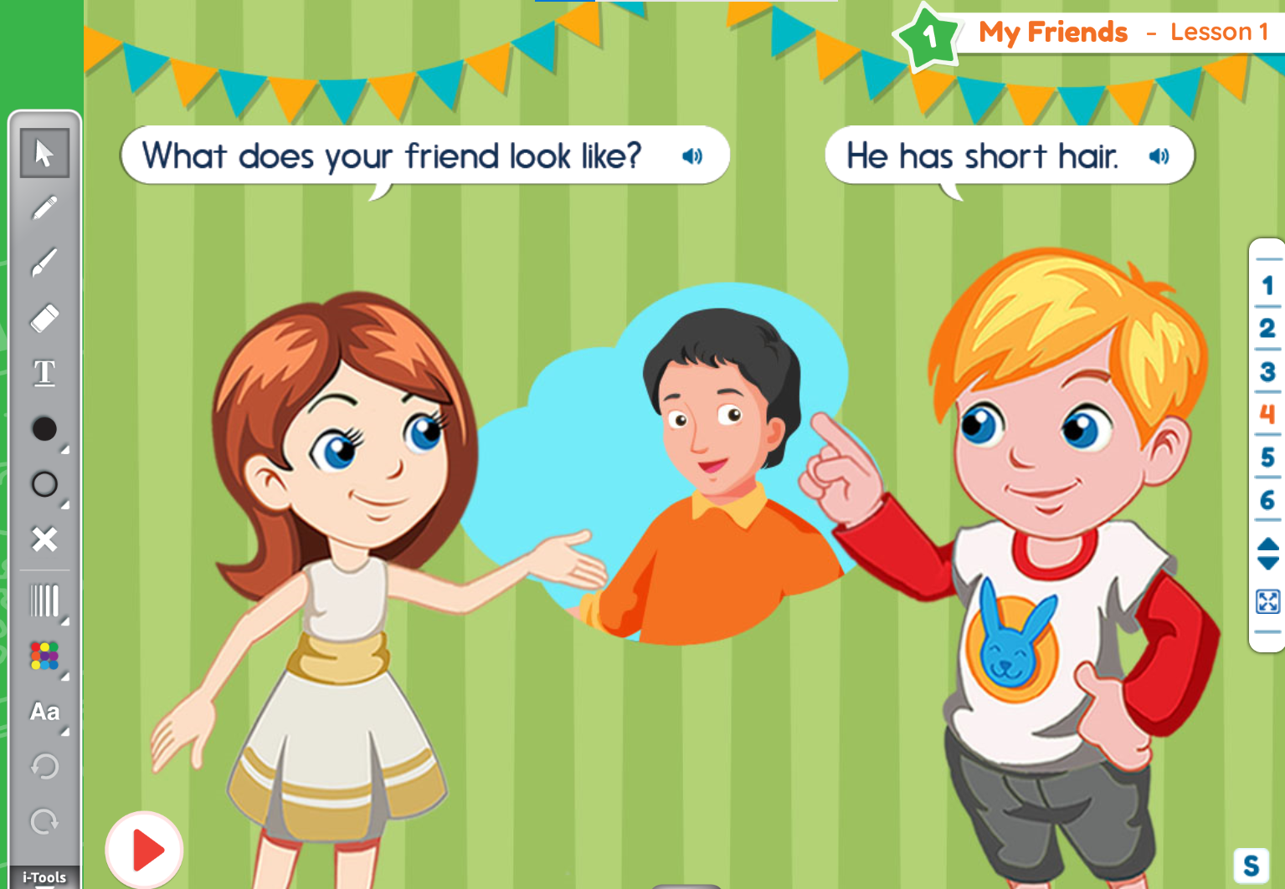  - Click Play button, have students listen to the sentences.  - Have students practice the sentences.  - Invite some students to come to the board and do the role-play  - Open the structure box [S] and ask them to practice more. | - Promote students’ involvement  - Assist to select students to come to the board, make sure every student has a chance to interact with the board.  - Help the students correct their pronunciation if necessary  - Elicit if students do not remember  - Cooperate with the foreign teacher to demonstrate the sample conversation.  - Check students’ pronunciation and correct them if necessary  - Encourage students to come to board  - Perform an example with foreign teacher if necessary  - Observe and foster students’ understanding | - Pay attention, listen and answer the questions  - Go to the board, open the new words and repeat the words and sentences.  - Repeat the words and sentences  - Answer the questions  - Answer the questions  - Listen to the conversation and practice  - Go to the board  - Practice more with the words in the structure box
Grammar Practice  5 minutes | Slide 5  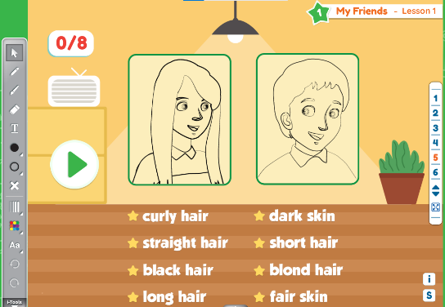  - Follow the instruction; teacher does a sample so that students know how to play.  Step 1: Click play to play audio  Step 2: Have a student come to the board and drag the word to the correct person  Step 3: The student must make a sentence using the words. E.g. “He has blond hair”  Step 4: Repeat process for all audio. | - Work with the foreign teacher to demonstrate how to play  - Encourage students to join the activity  - Invite the students who do not raise their hands to come to the board  - Go around the classroom and check students’ understanding by asking some questions based on the game context. | - Listen to the instruction  - Join the activity
Production Activity  5 minutes | Slide 6  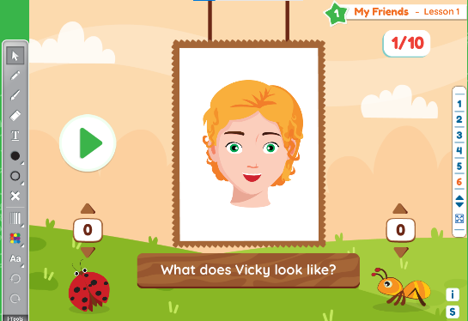  - Follow the instruction; teacher does a sample so that students know how to play.  Step 1: Divide the class into two teams.  Step 2: Click play to play audio and reveal a picture.  Step 3: Have the students describe the picture in pairs. Have a student from team A stand up and describe the picture.  Step 4: If the student misses out any feature, the other team can describe it to get a bonus point.  Step 5: Repeat the process with a student from team B. | - Work with the foreign teacher to demonstrate how to play  - Help foreign teacher divide the class into 2 teams.  - Encourage students to join the activity  - Go around the classroom and check students’ understanding by asking some questions based on the game context, correct their pronunciation if necessary. | - Listen to the instruction  - Join the activity
Summary  2 minutes | - Open Slide 2, teacher check students’ understanding by pointing and asking some questions using the structures that students have learnt. | - Invite the students who did not have a chance to come on the board  - Go around the classroom and ask some questions based on the picture. | - Go to the board and answer the questions.

Theme 1 – My Friends
Lesson 2
- Lesson objectives:
At the end of the lesson, students will be able to:
- Know about their friends’ appearances.
- Language focus:
- Vocabulary: tall, short, strong, weak, beautiful, pretty, ugly
- Structure: A: What is the opposite of (tall)?
B: (Short).
- Skills: Speaking, listening, reading
- Teaching aids: interactive whiteboard, projector, interactive device.
STAGES | TEACHER’S ACTIVITIES |  | STUDENTS’ ACTIVITIES | NOTES
STAGES | NATIVE TEACHER’S ACTIVITIES | CO-TEACHER’S ACTIVITIES | STUDENTS’ ACTIVITIES | NOTES
Warm up  3 minutes | Slide 1:  - Greet students  - Sing along and dance with students (warm-up song) | - Sing and dance with students | - Sing and dance with the teachers
Presentation  20 minutes | Slide 2: Theme introduction  (5 minutes)  - Elicit responses from students by asking some questions  Slide 3: New Vocabulary (7 minutes)  - Invite students to come to the board to touch the clouds, open the words, listen and repeat the words.  - Play audio again and have all students listen, repeat. Teacher corrects their pronunciation. Teacher can use actions to describe some words  - Click to the pictures to listen to the sentences. Have students repeat if they can.  - Randomly point at the words and have students repeat loudly  - Reload slide 3, ask students: “What’s number (1)?” or “Where is (tall)?”, have students come to the board and choose the correct clouds.  Slide 4: Grammar Structure (8 minutes)  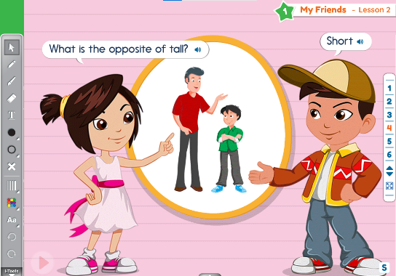  - Introduce the speaking context by asking questions. Ex: “Look at the picture, what can you see? What’s this?”  - Click Play button, have students listen to the sentences.  - Have students practice the sentences.  - Invite some students to come to the board and do the role-play  - Open the structure box [S] and ask them to practice more. | - Promote students’ involvement  - Assist to select students to come to the board, make sure every student has a chance to interact with the board.  - Help the students correct their pronunciation if necessary  - Elicit if students do not remember  - Cooperate with the foreign teacher to demonstrate the sample conversation.  - Check students’ pronunciation and correct them if necessary  - Encourage students to come to board  - Perform an example with foreign teacher if necessary  - Observe and foster students’ understanding | - Pay attention, listen and answer the questions  - Go to the board, open the new words and repeat the words and sentences.  - Repeat the words and sentences  - Answer the questions and choose the correct clouds  - Answer the questions  - Listen to the conversation and practice  - Go to the board  - Practice more the structure box
Grammar Practice  5 minutes | Slide 5: Listen and tick (ü ) the box  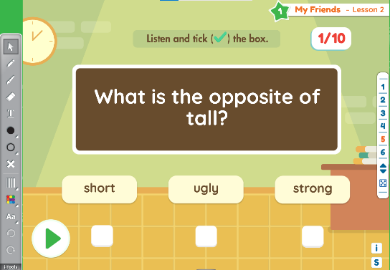  - Follow the instruction; teacher does a sample so that students know how to play.  Step 1: Click play to play audio.  Step 2: Have a student come to the board and answer the question, e.g. “short” and then click on the correct box below the word.  Step 3: Repeat for all audio. | - Work with the foreign teacher to demonstrate how to play  - Encourage students to join the activity  - Invite the students who do not raise their hands to come to the board  - Go around the classroom and check students’ understanding by asking some questions based on  the game context. | - Listen to the instruction  - Join the activity
Production Activity  5 minutes | Slide 6: Ask and answer  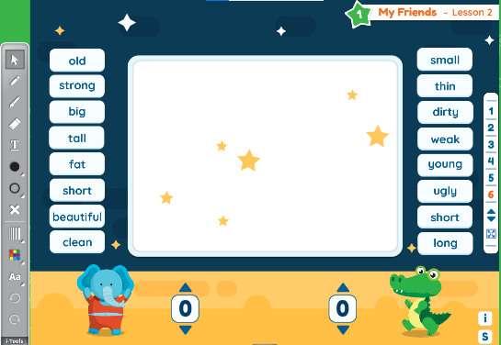  - Follow the instruction; teacher does a sample so that students know how to play.  Step 1: Divide the class into two teams.  Step 2: Have two students from team A come to the board.  Step 3: Student A clicks a word from the left hand side and then makes a sentence, e.g. “What is the opposite of fat?” Student B must answer correctly. E.g. “Thin” and then click the word on the right hand side.  Step 4: If they are correct, the two words they choose will appear on the blackboard in the background. Award a point for correct answers.  Step 5: Repeat the process for team B. | - Work with the foreign teacher to demonstrate how to play  - Help foreign teacher divide the class into 2 teams.  - Encourage students to join the activity  - Go around the classroom and check students’ understanding by asking some questions based on the game context, correct their pronunciation if necessary. | - Listen to the instruction  - Join the activity
Summary  2 minutes | - Open Slide 2, teacher check students’ understanding by pointing and asking some questions using the structures that students have learnt. | - Invite the students who did not have a chance to come on the board  - Go around the classroom and ask some questions based on the picture. | - Go to the board and answer the questions.

