LỊCH DẠY TUẦN 8: 27/ 10/ 2025 đến 31/ 10/ 2025

LỚP | TIẾT | BÀI HỌC
1D | 1 | Review 1
 | 2 | Review 2
 | 3 | PHẦN MỀM: Theme 2: School – Lesson 5
 | 4 | PHẦN MỀM: Theme 2: School – Lesson 6

I-Learn Smart Start 1
REVIEW 1
- Objectives:
By the end of this lesson, students will introduce family members.
- Teaching aids:
Teacher’s aids: student book and teacher’s book, class CDs, flashcards, IWB software, projector/interactive whiteboard/TV.
Students’ aids: Student book, notebooks, workbook.
- Languages focus:
- Vocabulary: father, mother, brother, sister (review).
- Structures:
- This is my (brother).
- Procedure

Time | Steps/Activities | Organization
5’ | Warm-up & Review  Review: Singing.  - Have students sing the songs of letters ‘c’ and ‘d’ again.  - Have them sing and make the gestures of a cap or a door.  - Have some students sing and make the gestures. | - Teacher – whole class/ students
25’ | New lesson  A- Listen and circle (A or B). (10’)  1. Pre-listening: Have students look at the pictures. Point to each person in the pictures and have students call out the people they see.  2. While-listening:  - Play audio and have students look at the picture and people.  - Demonstrate the activity by pointing at the example.  - Have students listen and circle.  - Post-listening: Check the answers as a whole class.  - Post-listening: Point at each person in the picture and have students say "This is my mother/...".  - Post-listening: Have some students demonstrate the activity in front of the class.  - Play "Stepping Stones": (10')  1. Divide the class into pairs.  2. Have Student A start at A and say the first sentence.  3. Have Student B start at B and say the first sentence.  4. Have students take turns saying the sentences and go all the way round.  5. Have some pairs demonstrate the activity in front of the class.  Activity: (5’) (optional)  Play the game “Whispering”.  - Choose 2 groups of the same number of students.  - Have students make 2 lines.  - Teacher whispers a word to the 2 students at the back of the lines. These students then whisper the word to the 2 students standing right in front of them. This is repeated until the word reaches the 2 students at the front of the lines.  - The 2 students at the front of the lines call out the word and the 2 students at the back hold up the flashcard to see whether the word is correct.  - The 2 students at the front of the lines move to the back of the lines. T repeats the activity with other words. | - Teacher – whole class/ students  - Teacher - students in pairs  - Teacher - Students in groups
5’ | Wrap-up  Review.: Draw and say  Have students draw a big picture of their family. Then show it in front of the class and introduce the members of the family.  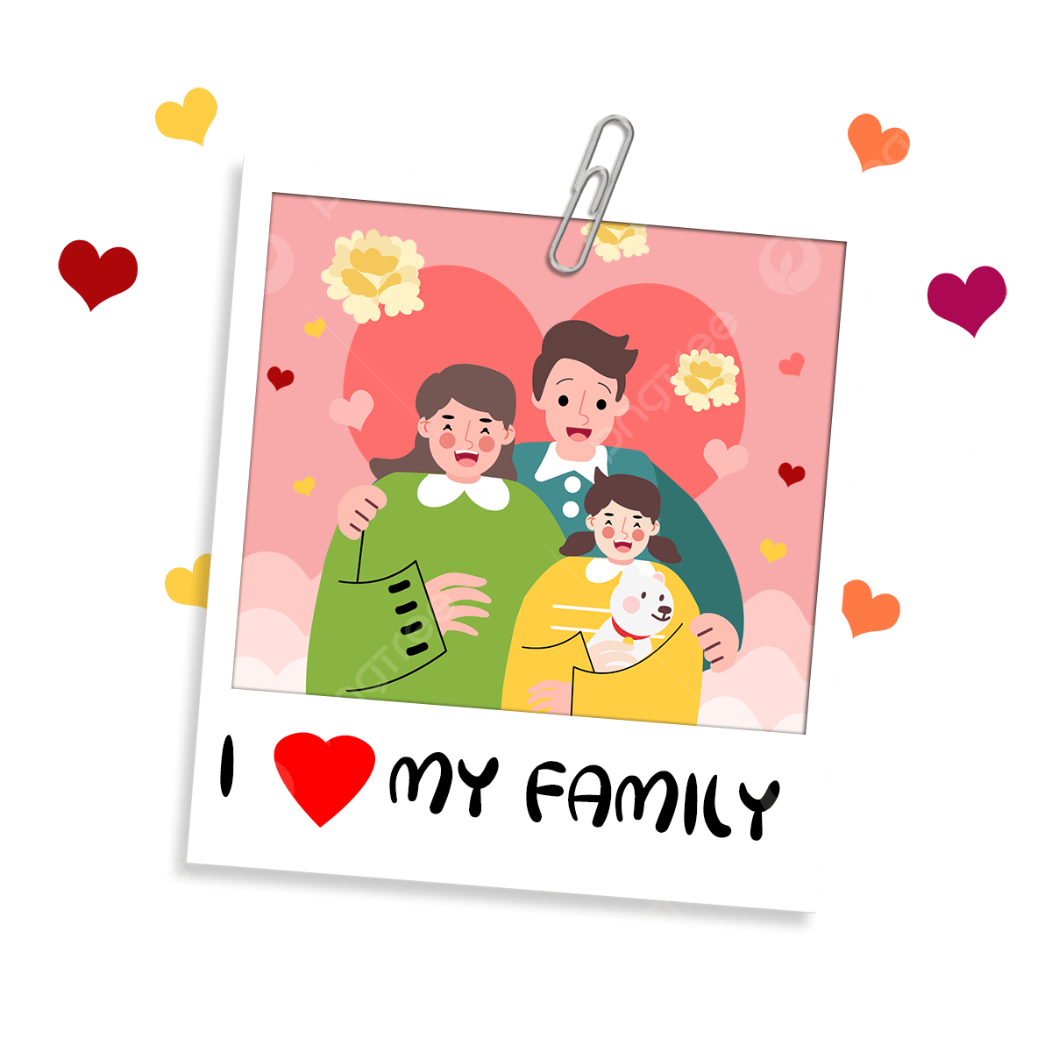  E.g. This is my family. This is my father… | - Teacher - students/ individuals

I-Learn Smart Start 1
REVIEW 2

I. Objectives:
By the end of this lesson, students will review identifying classroom objects.
II. Teaching aids:
Teacher’s aids: student book and teacher’s book, class CDs, flashcards, IWB software, projector/interactive whiteboard/TV.
Students’ aids: Student book, notebooks, workbook.
III. Languages focus:
Vocabulary: review pencil, bag, book.
Structures:
- It’s a (pencil).
IV. Procedures:

Time | Steps/Activities | Organization
5’ | Warm-up & Review  - Option 1: Review. Play the game “Family Jumble”.  - Mix the flashcards of Unit 1 - lessons 1 and 3.  - Put them on a table in front of the class.  - Divide the students into two teams.  - Invite a student from each group to go to the board.  - Say a word and have the students race to find the flashcard.  - Option 2: Review. Sing.  - Play audio Part C (Unit 2) and have students sing the song.  - Have some students sing in front of the class. | - Teacher – students in groups  - Teacher – whole class
25’ | New lesson  A- Listen and circle (A or B). (10’)  1. Pre-listening:  Have students look at the pictures. Point to each object in the pictures and have students call out the objects they see.  2. While-listening:  - Play audio and have students look at the picture and objects.  - Demonstrate the activity by pointing at the example.  - Have students listen and circle.  3.Post - listening:  - Check the answers as a whole class.  - Point at each object in the picture and have students say "It's a bag/...".  - Some students demonstrate the activity in front of the class.  - Play "Guess the picture": (10')  - Have students look at the example.  - Divide the class into 2 teams.  - Have a student stand facing away from the board and stick a flashcard on the board behind him/her.  - Have the student try to guess the answer without looking at the flashcard.  - Give that team 1 point if it's a correct guess.  - Have teams take turns.  Activity: Running dictation (5’)  - Stick some pictures (bag, book, pencil) on the walls in the class.  - Have students work in pairs. One runs and find the pictures around him/ her, then turn back to his pair and tell what he/ she has seen. E. g It’s a pencil. His/ Her friend writes down the word he/ she has heard. E. g pencil. | - Teacher – whole class/ students  - Teacher - students in pairs  - Teacher - Students in pairs
5’ | Wrap-up  Review. Pictionary.  - Have students work in pairs.  - Give each child a piece of paper.  - Have children draw a part of a classroom object on the paper as quickly as possible, then pass their drawings to their partners and ask “A what?’ The partner responds ‘A pencil’.  - Have students continue the game. | - Teacher - students in pairs

PHẦN MỀM
THEME 2: SCHOOL
Lesson 5

- Objectives
By the end of this lesson, students will be able to gain the following:
  - Language knowledge and skills
Vocabulary: review all learnt vocabulary of theme 2.
Sentence pattern: review all learnt sentence patterns of theme 2.
Skills: Identify and use learnt vocabulary of theme 2.
  - Competences
Self-control and independent learning: Building up interests and good habits in learning English.
Communication and collaboration: Being collaborative and supportive in teamwork.
Critical thinking and creativity: Building up responsive and independent-working characteristics to be a life-long learner.
  - Attributes
Kindness: Knowing how to share joyfulness or sympathize with others.
Diligence and Honesty: Being hardworking in studying.
Accountability: Becoming responsible for others.
- Teaching aids and materials
- Teacher’s aids: I-learn interactive software
- Students’ aids: I-learn interactive software
- Procedures
- Slide 1 - Warm up (3 minutes)
- Objectives: Students can sing the “i-Learn Smart Start” song to be ready for the lesson.
- Content: Singing the “i-Learn Smart Start” song to be ready for the lesson.
- Expected outcomes and assessment:
- Task completed with excellence: Students can sing the song to be ready for the lesson correctly and beautifully.
- Task completed: Students can sing the song to be ready for the lesson correctly.
- Task uncompleted: Students can sing the song but with some difficulties.
- Organization
Teacher’s activities | Students’ activities
Sing and Dance  - Play “i-Learn Smart Start” song (from YouTube) and make gestures following the lyrics, have students stand up and make the gestures. | - Follow and do as guided.  - Listen, sing, and dance together.

- New lesson
1. Slide 2 – Theme introduction (5 minutes)
a. Objectives: Students will be able to listen, point, and repeat all learnt vocabulary of theme 2.
b. Contents: Listening, pointing, and repeating all learnt vocabulary of theme 2.
c. Expected outcomes and assessment
- Task completed with excellence: Students can listen, point, and repeat all learnt vocabulary of theme 2 correctly.
- Task completed: Students can listen, point, and repeat all learnt vocabulary of theme 2.
- Task uncompleted: Students have difficulty in listening, pointing, and repeating all learnt vocabulary of theme 2.
d. Organization
Teacher’s activities | Students’ activities
Slide 2 – Theme introduction  - Elicit from students by asking some questions (What can you see? What color is it? What is it? Is it …?) | - Listen and answer the questions.

2. Slide 3 – Song (7 minutes)
a. Objectives: Students will be able to sing the song (follow the audio).
b. Contents: Singing.
c. Expected outcomes and assessment
- Task completed with excellence: Students can sing the song correctly.
- Task completed: Students can sing the song.
- Task uncompleted: Students have difficulty in following the audio and singing.
d. Organization
Teacher’s activities | Students’ activities
Slide 3 – Song  - Split the students into 2 groups.  - Introduce the lyrics to the students.  - Play the song with the class and sing along.  - Let each group stand up and sing the song. | - Follow T’s instructions.

3. Slide 4 – Vocabulary (8 minutes)
a. Objectives: Students will be able to look and say the correct vocabulary.
b. Contents: Looking and saying the correct vocabulary.
c. Expected outcomes and assessment
- Task completed with excellence: Students can look and say the vocabulary correctly and nicely.
- Task completed: Students can look and say the vocabulary.
- Task uncompleted: Students have difficulty in looking and saying the correct vocabulary.
d. Organization
Teacher’s activities | Students’ activities
Slide 4 – Vocabulary  - Introduce all words of theme 2.  - Click on the clouds, have students listen to the words and then have them repeat the words again.  - Have students come and touch the clouds again and guess where the (…) is.  - Invite some students to find other words.  - Repeat the process until there is no word to introduce anymore. | - Follow T’s instructions.

4. Slide 5 – Individual game (5 minutes)
a. Objectives: Students will be able to listen, read and answer “yes” or “no”.
b. Contents: Listening, reading and answering “yes” or “no”.
c. Expected outcomes and assessment
- Task completed with excellence: Students can listen, read and answer “yes” or “no” correctly and nicely.
- Task completed: Students can listen, read and answer “yes” or “no”.
- Task uncompleted: Students have difficulty in listening, reading and answering “yes” or “no”.
d. Organization
Teacher’s activities | Students’ activities
Slide 5 – Individual game  Follow the instruction; the teacher does a sample so that students know how to play.  Step 1: Click play to play audio.  Step 2: Have a student come to the board and click on the correct object.  Step 3: Repeat process for all audio. | - Follow T’s instructions.

4. Consolidation and homework assignment (6 minutes)

Teacher’s activities | Students’ activities
Consolidation (3 minutes)  Option 1: Review. Play the game “Listen and point”.  - Write the vocabulary in different areas on the board.  - Say a word (written on the board) randomly.  - Ask students to use their fingers to point to the vocabulary on the board and say it loudly.  Option 2: Review. Play the game “Lips read”  - Teacher says a word silently.  - Students say that word loudly. | - Do as guided  - Listen to the T and use their fingers to point to the vocabulary on the board and say it loudly.  - Do as guided

5. Reflection
- What I liked most about this lesson today:
…………………………………………………………………………………………
- What I learned from this lesson today:
…………………………………………………………………………………………
- What I should improve for this lesson next time:
…………………………………………………………………………………………

THEME 2: SCHOOL
Lesson 6

- Objectives
By the end of this lesson, students will be able to gain the following:
  - Language knowledge and skills
Vocabulary: review all learnt vocabulary of theme 2.
Sentence pattern: review all learnt sentence patterns of theme 2.
Skills: Identify and use learnt vocabulary of theme 2.
  - Competences
Self-control and independent learning: Building up interests and good habits in learning English.
Communication and collaboration: Being collaborative and supportive in teamwork.
Critical thinking and creativity: Building up responsive and independent-working characteristics to be a life-long learner.
  - Attributes
Kindness: Knowing how to share joyfulness or sympathize with others.
Diligence and Honesty: Being hardworking in studying.
Accountability: Becoming responsible for others.
- Teaching aids and materials
- Teacher’s aids: i-learn interactive software
- Students’ aids: i-learn interactive software
- Procedures
- Slide 1 - Warm up (3 minutes)
- Objectives: Students can sing the “i-Learn Smart Start” song to be ready for the lesson.
- Content: Singing the “i-Learn Smart Start” song to be ready for the lesson.
- Expected outcomes and assessment:
- Task completed with excellence: Students can sing the song to be ready for the lesson correctly and beautifully.
- Task completed: Students can sing the song to be ready for the lesson correctly.
- Task uncompleted: Students can sing the song but with some difficulties.
- Organization
Teacher’s activities | Students’ activities
Sing and Dance  - Play “i-Learn Smart Start” song (from YouTube) and make gestures following the lyrics, have students stand up and make the gestures. | - Follow and do as guided.  - Listen, sing, and dance together.

- New lesson
1. Slide 2 – Choose the correct word (10 minutes)
a. Objectives: Students will be able to click on the correct word and spell it.
b. Contents: Clicking on the correct word and spelling it.
c. Expected outcomes and assessment
- Task completed with excellence: Students can click on the correct word and spell it correctly.
- Task completed: Students can click on the correct word and spell it.
- Task uncompleted: Students have difficulty in clicking on the correct word and spelling it.
d. Organization
Teacher’s activities | Students’ activities
Slide 2 – Choose the correct word  Follow the instruction; the teacher does a sample so that students know how to play.  Step 1: Click play to show the picture and the jumbled word.  Step 2: Have 2 students come to the board. Students drag the letters to spell the word.  Step 3: Students click the picture to check the answer.  Step 4: Repeat the process for all pictures. | - Follow T’s instructions.

2. Slide 3 – Group game (10 minutes)
a. Objectives: Students will be able to listen and click on the words in the correct order to make the correct sentence.
b. Contents: Listening and clicking on the words in the correct order to make the correct sentence.
c. Expected outcomes and assessment
- Task completed with excellence: Students can listen and click on the words in the correct order to make the sentence correctly.
- Task completed: Students can listen and click on the words in the correct order to make the correct sentence.
- Task uncompleted: Students have difficulty in listening and clicking on the words in the correct order to make the correct sentence.
d. Organization
Teacher’s activities | Students’ activities
Slide 3 – Group game  Follow the instruction; the teacher does a sample so that students know how to play.  Step 1: Have a student come to the board and click on the lever to spin the pictures.  Step 2: Student asks the class “Is it a __________?”  Step 3: Class answers “Yes, it is” or “No, it isn’t”. Student clicks (✔) or (🗶).  Step 4: Repeat for all pictures. | - Follow T’s instructions.

3. Slide 4 – Song (10 minutes)
a. Objectives: Students will be able to sing the song (follow the audio).
b. Contents: Singing.
c. Expected outcomes and assessment
- Task completed with excellence: Students can sing the song correctly.
- Task completed: Students can sing the song.
- Task uncompleted: Students have difficulty in following the audio and singing.
d. Organization
Teacher’s activities | Students’ activities
Slide 4 – Song  - Split the students into 2 groups.  - Introduce the lyrics to the students.  - Play the song with the class and sing along.  - Let each team stand up and sing the song.  - Ask some questions about the song. | - Follow T’s instructions.

4. Consolidation and homework assignment (6 minutes)

Teacher’s activities | Students’ activities
Consolidation (3 minutes)  Option 1: Review. Play the game “Listen and point”.  - Write the vocabulary in different areas on the board.  - Say a word (written on the board) randomly.  - Ask students to use their fingers to point to the vocabulary on the board and say it loudly.  Option 2: Review. Play the game “Lips read”  - Teacher says a word silently.  - Students say that word loudly. | - Do as guided  - Listen to the T and use their fingers to point to the vocabulary on the board and say it loudly.  - Do as guided

5. Reflection
- What I liked most about this lesson today:
…………………………………………………………………………………………
- What I learned from this lesson today:
…………………………………………………………………………………………
- What I should improve for this lesson next time:
…………………………………………………………………………………………

