Date of planning : 25 /10 / 2024
Date of teaching : 31 /10 / 2024
Week: 9 UNIT 4: REMEMBERING THE PAST
Period: 27 Lesson 1: Getting started - At an English lesson

I. OBJECTIVES:

By the end of this lesson, Ss will be able to:

1. Knowledge

- Use the words related to the topic remembering the past

- Gain vocabulary to talk about some historical places.

2. Competences

- Develop communication skills

- Be collaborative and supportive in pair work and team work

3. Personal qualities

- Actively participate in class

- Develop self-study skills

II. MATERIALS

- Grade 9 textbook, Unit 4, Getting started

- Computer connected to the Internet

- Projector / TV

- hoclieu.vn
III. PROCEDURES:
Activity1: Warm-up (5’)
a. Aims:
- To activate students’ knowledge on the topic of the unit.
- To lead in to the unit.
b. Content:
- Chatting: Answer the question
c. Expected outcomes:
- Students can answer some questions of the teacher about school
d. Organisation:
Teacher’s and Ss’activities | Content
Warm-up  - Begin the lesson by asking Ss look at the pictures and answer the question.  - Ss work in pairs and give answers.  - T gives feedback  - Then tell Ss that they are going to learn about the topic Remembering the past in this unit.  – Ask Ss to open their books. Draw their attention to the THIS UNIT INCLUDES box and introduce what they are going to learn in this unit. | Warm-up: Chatting  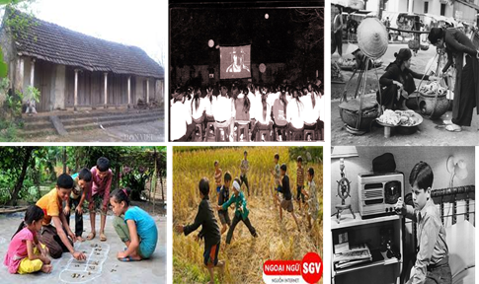  * Looking at these pictures, what do you remember?
Activity2: Presentation (12’)
* Pre teach vocabulary + Task 1
a. Aims:

- To provide students with vocabulary.

- To help students be well-prepared for the listening and reading tasks.

b. Content:

- Vocabulary pre-teaching

- Task1: Listen and read

c. Expected outcomes:

- Students can identify some new words about historical place

d. Organisation
Teacher’s and Ss’activities |  |  | Content
* Teach vocabulary:  + Teacher uses different techniques to teach vocab (situation, realia, translation.)  + Teacher introduces the vocabulary by:  - providing the pictures  - eliciting the definition of the words  + Teacher do the “Rub out and remember” checking technique.  *Set the context: Have Ss look at the title and the picture, and answer some questions, e.g.  - Ss look at the pictures and answer questions  - Encourage Ss to answer.  - Play the recording twice for Ss to listen and read along. Then invite some pairs of Ss to read the conversation aloud.  - Ask Ss what they are talking about. Now confirm the correct answer. (They are talking about historic  buildings / our history / the past / life in the past …)  - Have Ss say the words in the text that they think are related to the unit’s topic. |  |  | * Vocabulary  - complex (n) khu phức hợp, quần thể  - religious (adj) (thuộc) tôn giáo  - monument (n) tượng đài  - magnificent (adj) tráng lệ  - preserve (v) bảo tồn  - heritage (n) di sản  - occupy (v) chiếm giữ  - occupied (adj) có người ở  - ancient (adj) cổ đại, lâu đời.  - generation (n) thế hệ  * Questions:  -What do you see in the picture(s)?  - What do you know about it / them?  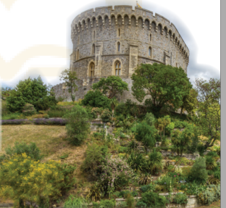  * Suggested answers:  They are talking about historic buildings  It’s a temple complex  It is in Cambodia. It’s a temple complex, the largest religious monument in the world  Task1: Listen and read
Activity 2: Practice (15’)
Task 2, 3, 4
a. Aims:
- To help Ss read for specific information about historical place
- To help Ss learn words and phrases related to historical place
- To help students use the words in context.
b. Content:
- Task 2: Read the conversation again and answer the questions.
- Task 3: Complete each sentence with a word or a phrase from the box.
- Task 4: Look at the pictures and complete the sentences.
c. Expected outcomes:
- Students understand the conversation and topic of the lesson and can complete the tasks successfully
d. Organisation:
Teacher’s and Ss’activities |  | Content
Task 2  - Have Ss read the questions without reading the conversation again. Explain that they focus on some ideas of the conversation.  - Ss work independently to do the activity.  - Have Ss read the conversation again and answer the questions. Check their answers and explain if necessary |  | Task 2: Read the conversation again and answer the questions.  *Answer key:  1. About 900 years old/ Nearly a thousand years old.  2. It’s magnificent.  3. In England.  4. preservation
Task 3  - Ask Ss to read the sentences and find the words and phrase from the box to fill in the gaps.  - Ss read the conversation again and find the words / phrases in it.  - T go around and offer help, if needed.  - Allow Ss to share answers before discussing as a class. Write the correct answers on the board. If there’s time, call on some Ss to read the sentences. |  | Task 3: Complete each sentence with a word or a phrase from the box.  * Answer key:  - heritage  - well preserved  3. magnificent  4. Thanks to  5. occupied
Task 4  - Have Ss work in pairs. Invite them to look at the pictures and complete the sentences with the word / phrase related to each picture.  - SS work in pairs to do the task  - T asks some Ss to read the sentences correctly. Check and correct their pronunciation. |  | Task 4: Look at the pictures and complete the sentences.  * Answer key:  - fish and chips  - communal  3. monument  4. castle  5. temples
Activity 4: Production (8’)
Task 5
a. Aims:

- To help Ss get to know about / remember past events.

- To check students’ vocabulary and improve group work skills.

b. Content:

- Task 5: Game: Remembering past events.

c. Expected outcomes:

- Ss can know more about past events.

d. Organisation
Teacher’s and Ss’activities |  | Content
Task 5  - Have Ss work in groups. Ask them to answer all the questions.  - Set a time limit (3-4 min.) for Ss to discuss and finish the task.  - Ss work in groups to answer questions.  - T may need to explain to the Ss if they don’t know the answers. |  | Task 5: Game: Remembering past events.  *Answer key:  1. King Ly Thai To (Ly Cong Uan).  2. In 1492.  3. In 1776.  4. In 1911.  5. World War I started/ broke out.  6. King Bao Dai (1913 – 1997)
Activity 5: Consolidation (3’)
a. Aims: To consolidate what students have learnt in the lesson.
b. Content: Talk about what they have learnt in the lesson
c. Expected outcomes: Say aloud some words they remember from the lesson.
d. Organisation:
Teacher’s and Ss’activities |  | Content
- T asks Ss to say aloud some words and phrases from the lesson that they can remember. |  | - Say words related to the topic remembering the past  - Talk about some historical places.
* Homework (2’)
a. Aims: To revise the lesson and prepare for the next lesson.
b. Content: Review the lesson and prepare for the next lesson and do exersie in the workbbook
c. Expected outcomes: Students’ preparation and workbooks
d. Organisation:
Teacher’s and Ss’activities |  | Content
- T reminds Ss to do homework and prepare the new lesson. |  | - Learn by heart all the new words.  - Do exercises in the workbook.  - Start preparing for the Project of the unit:  - Prepare lesson 2 ( A closer look 1).
* Evaluation:
…………………………………………………………………………………………………………………………………………………………………………………………………………….

Date of planning : 25 /10 / 2024
Date of teaching : 05 /10 / 2024
Week: 10 UNIT 4: REMEMBERING THE PAST
Period : 28 Lesson 2: A closer look 1
I. OBJECTIVES:

By the end of this lesson, Ss will be able to:

1. Knowledge

- Use the lexical items related to the topic Remembering the past

- Pronounce the sounds /m/ and /l/ in words and sentences correctly.

2. Competences

- Be collaborative and supportive in pair work and teamwork

- Access and consolidate information from a variety of sources

3. Personal qualities

- Actively participate in class and school activities

- Develop self-study skills

II. MATERIALS

- Grade 9 textbook, Unit 4, A closer look 1

- Computer connected to the Internet

- Projector / TV

- hoclieu.vn
III. PROCEDURES:
Activity1: Warm –up (5’)
a. Aims:
- To activate students’ prior knowledge and vocabulary related to the topic.
- To enhance students’ skills of cooperating with teammates.
b. Content:
- Game: Pelmanism
c. Expected outcomes:
- Students can use the correct forms of some verbs and nouns related the lesson .
d. Organisation:
Teacher’s and Ss’activities | Content
+ Game: Pelmanism  - Teacher divides the class into 2 teams and asks them to choose pairs of numbers to find verbs and nouns exactly.  - In 2 minutes, each member from each team has to take turns to turn over one card and try to find a card that matches it.  - If the two cards match each other, the team gets one point.  - If the two cards are different, put them back in the same places, facing down.  - The team with more points will win the game.  →Teacher leads in the lesson. | Warm up  + Game: PELMANISM  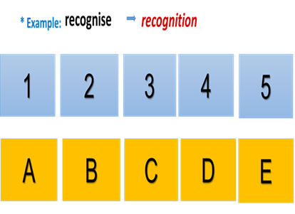
Activity2: Presentation (5’)
(Vocab- pre-teach)
a. Aims:
- To provide students new vocabulary.
- To revise some vocabulary related to Remembering the past.
b. Content:
- Vocabulary pre-teaching
c. Expected outcomes:
- Students can identify some vocabulary about Remembering the past and use them in different contexts
d. Organisation
Teacher’s and Ss’activities | Content
* Teach vocabulary:  - Teacher uses different techniques to teach vocab (situation, realia, translation.)  - Teacher introduces the vocabulary by:  +providing the pictures  + eliciting the definition of the words  - Teacher calls on some students to read aloud the words. | * New words:  1. structure (n) cấu trúc  2. promote (v) thúc đẩy  3. observe (v): duy trì, tuân theo  4. benefit (v): giúp ích
Activity3: . Practice (18’)
Task 1,2,3
a. Aims:

- To provide students new vocabulary.

- To revise some vocabulary related to Remembering the past.

b. Content:

- Task 1: Complete the table.

- Task 2: Complete the sentences, using the correct forms of the words from 1.

- Task 3: Complete the sentences with the words from the box.

c. Expected outcomes:

- Students can identify some vocabulary about Remembering the past and use them in different contexts

d. Organisation
Teacher’s and Ss’activities | Content
Task 1  - Have Ss work in pairs. Tell them to look at the verbs given in the left column and give their equivalent nouns.  - Check their answers as a class.  - Have Ss read the verbs and nouns aloud. Correct their pronunciation if necessary.  EXTRA ACTIVITY:  - Put Ss in groups. Each group finds three verbs in Getting Started, and then give their equivalent nouns.  - Representatives from each group gives their groups’ answers.  - Check their answers as a class. | Task 1: Complete the table.  * Answer key:  - promotion  - recognition  3. contribution  4. observation  5. preservation  6. occupation  * Suggestion:  build → building  do → do / doing  need → need  thank → thanks  wish → wish  know → knowledge  decide → decision  damage → damage
Task 2  - Have Ss work in pairs. Tell them to look back at the words in 1.  - Have them read the sentences carefully and look for clues to find the right words to complete the sentences. The word to fill each blank may be a noun or a verb in its correct tense.  - Ss work in pairs to do the task.  - Have one S write the words on the board. Confirm the correct answers.  - T may call some Ss to read the sentences. | Task 2 : Complete the sentences, using the correct forms of the words from 1  * Answer key:  - observe  2. contribution  3. preservation  4. promotion  5. recognised
Task 3  - Have Ss read the sentences and choose the correct word from the box to fill each blank in the sentences.  - Tell them to read the sentences carefully and look for clues to choose the correct words.  - Ss read the sentences and choose the correct word  - T goes around and gives assistance if necessary and checks their answers. | Task 3: Complete the texts, using the words from the box.  * Answer key:  1. structures  2. takeaway  3. generations  4. magnificent  5. heritage
Activity 4 * PRONUNCIATION (12’)
(Pre-teach the sounds /m/ and /l/)
a. Aims:

- To help students identify how to pronounce the sounds /m/ and /l/

- To help students practise pronouncing these sounds correctly in words and in sentences.

b. Content:

- Task 4: Listen and repeat the words. Pay attention to the sounds /m/ and /l/

- Task 5: Listen and repeat the sentences. Pay attention the the underlined words.

c. Expected outcomes:

- Students can pronounce the sounds /m/ and /l/ in words and in sentences correctly

d. Organisation
Teacher’s and Ss’activities | Content
Task 4  - T instructs how to pronounce /m/ and /l/.  - Play the recording and ask Ss to listen to these words and repeat. Correct their pronunciation. Play the recording as many times as necessary.  - Explain the two sounds of /l/ in the Remember! box and invite Ss to give some examples.  - Ss look at Remember! Box  and give some words that have sounds /m/ and /l/ | Task 4: Listen and repeat the words. Pay attention to the sounds /m/ and /l/.  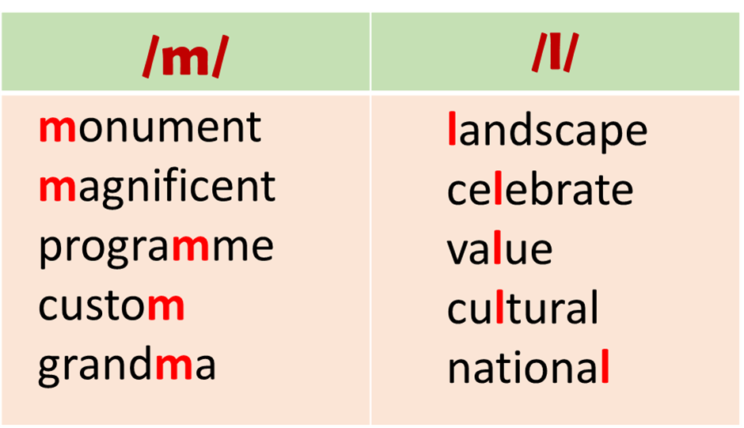
Task 5  - Have Ss quickly read the sentences and look carefully at the underlined words.  - Then play the recording for Ss to listen.  - Play the recording again. Let Ss listen and repeat sentence by sentence, paying attention to the underlined words.  EXTRA ACTIVITY  Ask each student to give at least one word having sound /l/ and one word having sound /m/, preferably words in this unit. | Task 5: Listen and repeat the sentences. Pay attention the underlined words.  * Audio script:  1. The collection includes objects of the Middle Ages.  2. You should be careful when shopping in this mall.  3. This monument is small but magnificent.  4. They maintain these wind mills as working museums.  5. David fell on the ground and hurt his ankle.  Possible answers:  (remember, life, let, look, temple, complex, largest, Cambodia, …)
Activity 5: Consolidation (3’)
a. Aims: To consolidate what students have learnt in the lesson.
b. Content: Talk about what they have learnt in the lesson
c. Expected outcomes: Say aloud some words they remember from the lesson.
d. Organisation:
Teacher’s and Ss’activities
- Teacher asks students to talk about what they have learnt in the lesson | - Vocabulary and how to pronounce the sounds /m/ and /l/
* Homework (2’)
* Aim: To revise the lesson and prepare for the next lesson.
* Content: Review the lesson and prepare for the next lesson and do exersie in the workbbook
* Expected outcomes: Students’ textbook and workbook
* Organization of implementation:
Teacher’s and Ss’ activities | Content
- T reminds Ss to do homework and prepare the new lesson.  Mrs Thu Ba | - Learn by heart all the new words.  - Do exercises in the workbook.  - Find 3 more words that have the sounds /m/ and /l/  - Prepare lesson 3 ( A closer look 2)..
*- Evaluation: :
……………………………………………………………………………………………………………………………………………………………………………………………………………..

Date of planning : 31 /10 / 2024
Date of teaching : 05 /11 / 2024
Week: 10 UNIT 4: REMEMBERING THE PAST
Period : 29 Lesson 3: A closer look 2
I. OBJECTIVES:
1. Knowledge:

By the end of this lesson, Ss will be able to:

1. Knowledge

- Recognise and use past continuous and wish + past simple.

2. Competences

- Develop communication skills

- Be collaborative and supportive in pair work and teamwork

3. Personal qualities

- Compare living place

- Develop self-study skills

- Actively join in class activities

II. MATERIALS

- Grade 9 textbook, Unit 4, A closer look 2

- Computer connected to the Internet

- Projector / TV

- hoclieu.vn
III. PROCEDURES:
Activity 1: Warm-up (7’)
a. Aims:
- To create an active atmosphere in the class before the lesson;
- Lead in the new lesson
b. Content:
To have some warm-up activities to create a friendly and relaxed atmosphere to inspire Ss to warm up to the subject and new lesson.
c. Expected outcomes: Having a chance to speak English and revise the past continuous and know how to use “ wish + past simple in sentences”
d. Organisation:
Teacher’s and Ss’activities | Content
+ Game: JUMBLED SENTENCES  -Teacher gives instructions.  - In groups, Ss discuss to rearrange the words to make meaningful and completed sentences.  - The group which can finish all the sentences first and has all correct answers will be the winner  -Teacher checks and corrects Ss’ answer.  → Lead in: Teacher says: “This lesson helps you recognise and use past continuous and wish + past simple. | Warm up: JUMBLED SENTENCES  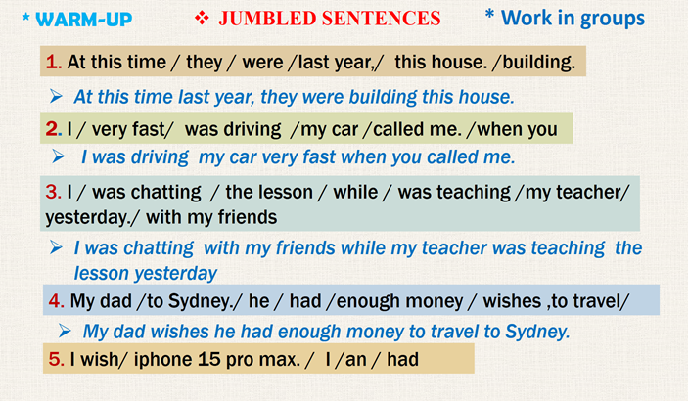
Activity 2: Practice (13’)
Task 1 + Task 2
a. Aims:

- To help students get to know about past continuous.

b. Content:

- Task 1: Put the verbs in brackets in the past continuous

- Task 2: Complete the sentences, using the past continuous forms of the given verbs.

c. Expected outcomes:

- Students know how to use past continuous.

d. Organisation
Teacher’s and Ss’activities |  | Content
Task 1  - Have Ss read the sentences first.  - Give Ss some time to work by themselves and write down the answers.  - Ss do exercise individually.  - T observes and helps when and where necessary.  - Ask some Ss to read their sentences. T may call on some Ss to write their answers on the board. T corrects Ss’ mistakes.  - T asks Ss to study the Remember! Box, and tells them another use of the past continuous: to show that something continued for some time in the past.  - Ss read the Remember box carefully and listen to the teacher.  - Give one or two examples before moving onto activity 2. |  | Task 1: Put the verbs in brackets in the past continuous  * Answer key:  1.was visiting 2. was sleeping  3. was going 4. was looking  5. Were you watching  * Grammar 1  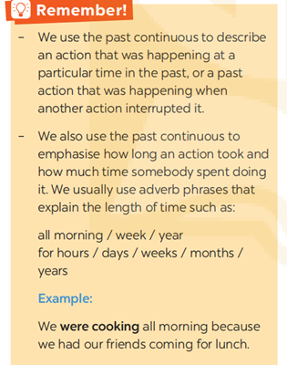
Task 2  - Have Ss work individually for a few minutes. Tell them to pay attention to the context of each sentence, and then choose the correct verb to use.  - Ss do task 2 individually  - Check their answers as a class.  - Have some Ss read out the sentences.  - T corrects their pronunciation and intonation only when necessary. |  | Task 2: Complete the sentences, using the past continuous forms of the given verbs.  * Answer key:  - were preserving  2. was / were living  3. were building  4. Were you still working  5. was making
Activity 3: Practice (15’)

Wish + past simple

a. Aims:

- To help Ss use wish + past simple in sentences..

- To help Ss practise using wish + past simple.

b. Content:

- Grammar explanation

- Task 3: Put the verbs in brackets in the correct forms.

- Task 4: Read the passage and write down five things that Jenny might wish for.

c. Expected outcomes:

- Students understand some wish + past simple.

d. Organisation
Teacher’s and Ss’activities |  | Content
Grammar Explanation  - Focus Ss’ attention on the grammar box.  - T explains to Ss the meaning and use of the structure wish + clause (past simple).  - Ss listen carefully and copy down.  - Tell them to study the two examples. |  | * Grammar 2: Wish + past simple.  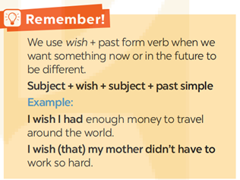
Task 3  - Draw Ss’ attention to the sentence structure:  wish + clause (past simple)  - Have Ss look at the sentences and write down their answers.  - Ss do the task  - Ask Ss to exchange their answers in pairs. Check their answers and explain if necessary. |  | Task 3: Put the verbs in brackets in the correct forms  * Answer key:  - got 2. had  3. had 4. could spend  5. could go
Task 4  -Have Ss do the exercise individually. Tell them to read the passage carefully and study the example, then write down their answers.  - Ss do the exercise individually.  - Have Ss exchange their answers with a partner.  - Call on some Ss to read the sentences aloud. Other Ss comment. Confirm the correct answers as a class. |  | Task 4: Read the passage and write down five things that Jenny might wish for  * Possible answers:  1. Jenny wishes (that) she didn’t have to share the room with her sister.  2. Jenny wishes (that) she didn’t have to clean the room every day.  3. She wishes (that) her sister Jane didn’t lie in bed reading or playing computer games.  4. She wishes (that) her sister Jane didn’t put dirty clothes on her bed.  5. She wishes (that) she had her own room.
Activity 4: PRODUCTION (5’)

a. Aims:
- To help Ss apply wish + past simple in real situation by making sentences about themselves.
b. Content:
- Task 5: Work in pairs. Tell your partner three wishes.
c. Expected outcomes:
- Students can apply the grammar they have learned in practical situations.
d. Organisation
Teacher’s and Ss’activities |  | Content
Task 5  - Give them some time to work in pairs and exchange their wishes.  - T goes round giving help when and where necessary.  EXTRA ACTIVITY  - Put Ss into groups of 5-6. Ask them to talk about what their family members wish.  - Ss work in groups to talk about your family members wish.  - Call on some Ss to say out loud their sentences. Correct their mistakes if necessary. |  | Task 5:Work in pairs. Tell your partner three wishes.  * Suggested answers:  Students’ own answers.  * Example:  My mum wishes (that) she had a new dishwasher.  My little sister often wishes (that) she became a princess.
Activity 5: Consolidation (3’)
a. Aims: To consolidate what students have learnt in the lesson.
b. Content: Talk about what they have learnt in the lesson
c. Expected outcomes: Say aloud some words they remember from the lesson.
d. Organisation:
Teacher’s and Ss’ activities |  | Content
Teacher asks students to talk about what they have learnt in the lesson. |  | - Grammar:  Recognise and use past continuous and wish + past simple.
* Homework (2’)
a. Aims: To revise the lesson and prepare for the next lesson.
b. Content: Review the lesson and prepare for the next lesson and do exersie in the workbbook
c. Expected outcomes: Students’ preparation and workbooks
d. Organisation:
Teacher’s and Ss’ activities |  | Content
- T reminds Ss to do homework and prepare the new lesson. |  | - Do exercises in the workbook.  - Prepare lesson 4 ( communication)
*- Evaluation:
……………………………………………………………………………………………………………………………………………………………………………………………………………..

Date of planning: 01/11/2024  Date of teaching: 07/11/2024  WEEK:10 | Peroid 30 : THE MID-TERM TEST CORRECTION
I. OBJECTIVES:
1. Knowledge:
- To test students’ understanding in grammar, vocabulary listening, reading and writing after unit 1,2,3 English 9 . Also help Ss consolidate and apply what they have learnt in the Unit 1,2,3. To recycle the language from the previous sections. Ss can evaluate their performance and provide further practice. Do some practice exercises.
- By the end of the lesson, Ss will be able to revise, do exercises . Check how progress they have achieved , what they have learnt in the previous lessons.
- Students need to know how much progress they’ve learnt. They know how well they’ve made . They also want to know which language area they must practice more.
* Vocabulary: Ss revise words and phrases related to : Local community; City life; Healthy living for teen
* Grammar :
- Unit 1 : Local community: Question words before to- infinitive; Phrasal verbs
- Unit 2: City life: Double comparatives; Phrasal verbs
- Unit 3 : Healthy living for teen: Modal verbs in first conditional.
* Writing: - write a paragrarh ( about 100 words ) about your favorite community helper.
- write a paragraph ( about 100 words ) about what you like or dislike about living in the city.
- write a paragraph ( about 100- 120 words ) about school days in the past.
2. Competence: Students will be able to revise the language they have learnt and they have practised so far. They have learnt items of language and skills . Practising doing exercises.
- Develop communication skills and creativity.
- Actively join in class activities.
3. Qualities : Having the good attitude to working in groups, individual work, pair work, cooperative learning.
- Develop self-study skills.
II. TEACHING AIDS:
- Teacher: Grade 8 text book, laptop, projector.....
- Students : Text books, studying equipment….
- Computer connected to the Internet.
- Hoclieu.vn.
III. PROCEDURE:
1. WARM UP & INTRODUCTION
Aims: Introduction
- Ask Ss what they have learnt so far in terms of language and skills. Summarise their answers and add some more information if necessary
Teacher’s activities | Student’s activities
+ Greeting  + Chatting  - Teacher (T) asks Ss some questions about them and class.  - Ask Ss to open their book and introduce what they are going to study…. | + Greeting  + T_Ss  - Students (Ss) listen and learn how to do.  - Open their book and write .
A. LISTENING
Part 1: Listen to a school secretary talking to one of the teachers and All in the gaps in the table. ( 1 point )
1. doctor 2. Mexican 3. Lipponen 4. artist
Part 2: Listen to the recording,then choose A, B or C to best answer the questions. (1 point )
5. B. a search for a new apartment 6. C. It's located some distances from school.
7. A. no more than $200 8. B. an apartment with furniture already in it
B. LEXICAL GRAMMAR ( 4 points )
Mark the letter A, B, C, or D on your answer sheet to indicate the word whose underlined part differs from the other three in pronunciation in each of the following questions.
9. A. school 10. B. plan
Mark the letter A, B, C, or D on your answer sheet to indicate the word that differs from the other three in the position of primary stress in each of the following questions.
11.B. promise 12.C. popular
Mark the letter A, B, C, or D on your answer sheet to indicate the correct answer to each of the following questions.
13. B. more talkative 14. D. were playing 15. C. a
16. A. of 17. D. earns 18. C. pulled down
19. A. Yes, I’d love to. 20. D. No, I don’t think so
III. Choose the word(s) CLOSEST in meaning to the underlined words in each of the following questions. (0,5 point )
21. C. situated 22. D. disadvantages
IV. Choose the word(s) OPPOSITE in meaning to the underlined words in each of the following questions. ( 0,5 point)
23. D. modern 24. B. failed
C: READING (2 POINTS)
I. Read the following passage and mark the letter A, B, C, or D on your answer sheet to indicate the correct word or phrase that best fits each of the numbered blanks. (1point)
25. A. compare 26. C. occurred 27. B. able 28. C. tools
II. Read the passage and choose the best answer A, B, C or D for each question. ( 1point )
29. B. Health farms are becoming very popular. 30. D. all of these things
31. D.in winter 32. B. at weekends
D: WRITING ( 2 POINTS )
I. Find out the mistake in each following sentence. ( 0.5 point )
33. B
34. B
II. Reorder the words and phrases to make complete sentences. ( 0,75 point )
35. The more the streets are improved, the more the public services become available
36. If she regularly does sports, she can maintain her well - balanced life
37. I think people in the countryside eat a lot of fresh vegetables so they live longer
III. For each question, complete the second sentence so that it means the same as the first one. Use the word in brackets and do not change it. Write NO MORE THAN FIVE WORDS. ( 0,75 point )
38. to find out
39. of passing down
40. how to get / go to

Date of planning : 06 /11 / 2024
Date of teaching : 12 /11 / 2024
Week: 11 UNIT 4: REMEMBERING THE PAST
Period : 31 Lesson 4 : Communication
I. OBJECTIVES

By the end of this lesson, Ss will be able to:

1. Knowledge

- Know how to thank and respond.

- Talk how to keep traditions alive

2. Competences

- Develop communication skills and creativity

- Be collaborative and supportive in pair work and teamwork

3. Personal qualities

- Be ready and confident in real life conversations

- Know about means of transport.

- Actively join in class activities

II. MATERIALS

- Grade 9 textbook, Unit 4, Communication

- Computer connected to the Internet

- Projector / TV

- hoclieu.vn
III. PROCEDURES:
Activity 1: Warm-up (5’)

a. Aims:

- To introduce the topic.

- To enhance students’ skills of cooperating with team mates.

b. Content:

- Brainstorm

c. Expected outcomes:

- Students can use their background knowledge to answer the questions.

d. Organisation
Teacher’s and Ss’activities | Content
Warm up  – Ask some Ss to make sentences about themselves. Encourage them to talk about how their families keeps their traditions alive.  - Ss listen and follow instruction  – Introduce the objectives of the lesson: learning how to express thanks, respond to thanks, and practice talking about our traditions and how we keep them alive. | * Questions:  How do your family keep your traditions alive?  Eg: We celebrate Lunar New Year with family gatherings and traditional foods.  …
Activity 2: Presentation ( 10’)
* EVERYDAY ENGLISH
Pre teach vocab + Task 1 + 2
a. Aims:

- To introduce ways of thank and respond

b. Content:

- Vocabulary pre-teaching

- Task 1: Listen and read the conversations. Pay attention to the highlighted parts.

- Task 2: Work in pairs. Make similar conversations to express thanks and respond in the following situations.

c. Expected outcomes:

- Students can use the structures to thank and respond

d. Organisation
Teacher’s and Ss’activities | Content
- Introduce the vocabulary by:  + giving situation;  + giving an explanation  - Listen to the explanation of the words.  - Write the new words in their notebooks. | * New words:  1. ancestor (n): tổ tiên  2. gratitude (n): lòng biết ơn  3. worship (v): thờ cúng  4. celebrate (v): tổ chức, kỉ niệm
Task 1  - Play the recording and have Ss listen and read the exchanges at the same time. Tell them to pay attention to the highlighted parts.  - Ss look at the highlighted parts.  - Elicit the two ways of thanking and responding.  - Ask them to act out the exchanges in pairs. Check their pronunciation  - Have Ss write down some ways of thank and respond | Task 1: Listen and read the conversations. Pay attention to the highlighted parts.  * Audio script:  Kate: Thank you very much for showing us around Angkor Wat.  Guide: You’re welcome.  Alice: Thanks a lot for telling us about life in the countryside of Viet Nam.  Mi: No problem.  → Some ways of thank and respond.  - Thank you very much  - Thanks a lot for………….  - I’m so grateful  - You’re the best
Task 2  - Ask Ss to read the instructions.  - Work in pairs to make similar dialogues.  - Have Ss work in pairs, one asks the question, and the other gives the answer. Then they swap roles.  - Students play the role in front of the class. | Task 2: Work in pairs. Make similar conversations to express thanks and respond in the following situations  1/ You: Thank you very much for showing me / us around the craft workshop.  Friend: You’re welcome.  2/ You: Thanks a lot for lending me your history book.  Friend: No problem.
Activity 3: Practice (15’)

HOW OUR FAMILIES KEEP TRADITIONS ALIVE

Task 3+ 4

a. Aims:
- To provide Ss with information about ways of keeping our traditions alive.
- To help Ss practise asking and answering questions about how their family observes customs and traditions.

b. Content:

- Task 3: Read the passage and complete the table.

- Task 4: Work in pairs. Ask and answer about how your family observes customs and traditions.

c. Expected outcomes:

- Students get some information about how to preserve traditions

- Students can talk about how to preserve traditions

d. Organisation
Teacher’s and Ss’activities | Content
Task 3  - Tell Ss that they are going to listen to a passage about our traditions and ways of keeping them alive.  - Ss work in pairs and do the task.  - Play the recording. Tell Ss to listen carefully. Make sure they understand the details and offer explanations if needed.  - Check their answers as a class. | Task 3: Read the passage and complete the table.  * Keys:  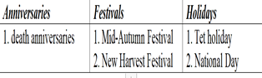
Task 4  - Have Ss work in pairs. Tell them to study the examples. Tell them that they can refer back to the passage in 3 for their answers.  - Ss work in pairs and do the task.  - T goes round the class to monitor.  - Correct Ss’ mistakes only when it is really necessary. | Task 4: Work in pairs. Ask and answer about how your family observes customs and traditions  * Example:  A: What festival(s) does your family celebrate every year?  B: We celebrate Hung Kings’ Temple Festival.
Activity 4: Production (10’)

a. Aims:

- To provide Ss with a chance to talk about what their families do to preserve their family traditions.

b. Content:

- Task 5: Work in groups. Give a short talk about one of the things in 4 that you and your family do to preserve traditions.

c. Expected outcomes:

- Students get some information about how to preserve traditions

- Students can talk about how to preserve traditions

d. Organisation
Task 5  -Tell Ss to study the cues given first.  - Then Ss work in groups, taking turns to choose one of the things in 3 and talk about what their families do to preserve their family traditions, for example celebrating family members’ birthdays.  - Ss give a short talk about one of the things in 4 that you and your family do to preserve traditions.  - Encourage them to talk, and do not stop them when they make minor mistakes. Correct their pronunciation only when it is prevents communication. | Task 5:Work in groups. Give a short talk about one of the things in 4 that you and your family do to preserve traditions.  * Sample Answers:  We celebrate each family member's birthday every year. When someone's birthday is coming, all of us happily prepare for it. We gather around the kitchen table, rolling out dough and decorating cakes with colorful sprinkles and frosting. We share funny stories, create memories that will last a lifetime. These traditions are precious to us, connecting us to our past and shaping our future
Activity 5: Consolidation (3’)
a. Aims: To consolidate what students have learnt in the lesson.
b. Content: Talk about what they have learnt in the lesson
c. Expected outcomes: Say aloud some words they remember from the lesson.

d. Organisation:
Teacher’s and Ss’activities | Content
- Teacher asks students to talk about what they have learnt in the lesson. | - Revise vocabulary related to the topic and know some ways of thank and respond.  - Talk about how to preserve traditions.
* Homework (2’)
a. Aims: To revise the lesson and prepare for the next lesson.
b. Content: Review the lesson and prepare for the next lesson and do exersie in the workbbook
c. Expected outcomes: Students’ preparation and workbooks
d. Organisation:
- T reminds Ss to do homework and prepare the new lesson. | - Learn by heart the structures.  - Do exercise in WB  - To prepare for the next lesson: Skills 1.
*- Evaluation: :
………………………………………………………………………………………………………………………………………………………………………………………………………………

Date of planning : 06 /11 / 2024
Date of teaching : 12 /11 / 2024
Week: 11 UNIT 4: REMEMBERING THE PAST
Period : 32 Lesson 5 : Skills 1
I. OBJECTIVES

By the end of this lesson, Ss will be able to:

1. Knowledge

- Read for specific information about how English people continue their culinary traditions

- Talk about a typical traditional Vietnamese dish

2. Competences

- Develop communication skills and creativity

- Be collaborative and supportive in pair work and teamwork

- Develop presentation skill

3. Personal qualities

- Understand more about city problems and their solutions.

- Actively join in class activities

II. MATERIALS

- Grade 9 textbook, Unit 4, Skills 1

- Computer connected to the Internet

- Projector / TV

- hoclieu.vn
III. PROCEDURES:
Activity 1: Warm-up (5’)
(Task 1)
a. Aims:

- To help Ss understand and activate their knowledge of the topic;

b. Content:

- Brainstorm ; Task 1

c. Expected outcomes:

- Know some information about the UK and England.

d. Organisation
Teacher’s and Ss’activities |  | Content
Warm-up  – Ask some Ss what they know about the UK and England.  - Ss look at the picture and answer .  - Encourage Ss to talk as much as possible. It is not important whether they give the right answers or not; it is important that they speak in English.  - T gives feedback  - Lead into the new lesson: Reading about a traditional dish of England and Speaking about the traditional Vietnamese traditional dishes.  – Introduce the objectives of the lesson. Write the objectives on the top-left corner of the board. |  | Task 1: Work in groups. Discuss the following questions.  - What do you know about the UK and England?  * Possible answer:  + England: one of the 4 parts of the UK (England, Scotland, Wales, the Northern Ireland)  + Capital: London  + Population: over 56 million (2021)  + Area: 130,279 km2  + National language: English  + National dishes: Fish and Chips, Sunday Roast, Full English Breakfast, …  + …
Activity 2: READING (15’)
a. Aims:

- To help Ss learn new vocabulary in the reading text.

- To improve Ss’ skill of reading for details (scanning).

b. Content:

- Vocabulary teaching

- Task 1: Work in groups. Discuss the following questions.

- Task 2: Read the text and write the underlined words in the box.

- Task 3: Read the text again and tick (√) T (True) or F (False) for each sentence.

c. Expected outcomes:

- Students identify some new words and how to use the target vocabulary.

d. Organisation
Teacher’s and Ss’activities |  | Content
Pre- teaching vocab  - Teacher asks students to get the meaning of the words in context.  - Students say the meaning of the words. |  | * New words:  - deep-rooted (adj): lâu đời, ăn sâu- bén rễ  - associated (adj): liên kết  - basic (n): cơ bản  - appear (v): xuất hiện
Task 2  - Have Ss read the text quickly and find the underlined words associated (adj.), deep-rooted (adj.), appeared (v.), basic (adj.)  - Ss read the text and find the highlighted words.  - Tell them to use the contexts in which these words appear to predict their meaning, and then do the matching.  - Check the answers as a class. Confirm Ss’ correct answers. For less able students, ask them to give the Vietnamese equivalent of the words |  | Task 2: Read the text and write the underlined words in the box .  * Keys:  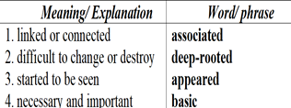
Task 3  - Ask Ss to work with a partner to discuss the answers.  - Explain the new words and clarify anything difficult. T may ask more questions to see if they understand the passage fully.  - Ss work with a partner.  - Call on some Ss to read the passage aloud before the class. Check their pronunciation and intonation.  - Check the answers as a class.  Transition from Reading to Speaking  - Have Ss work in pairs to ask and answer the questions. |  | Task 3: Read the text again and tick (√) T (True) or F (False) for each sentence.  * Keys:  - T  2. T  3. F  4. F  5. F  6. T  * Questions:  1. Do the Vietnamese people feel proud of their traditions and customs?  2. Is the Vietnamese cuisine famous? Do foreigners like it?  3. What are some popular Vietnamese dishes?
Activity 3: SPEAKING (12’)
Task 4,5
a. Aims:

- To help students use what they have learnt so far to talk about typical Vietnamese dish.

- To improve their speaking skill.

b. Content:

- Task 4: Work in pairs. Match 1 - 5 in column A with a - e in column B

- Task 5: Work in groups. Match the Vietnamese dishes with their names in English.

c. Expected outcomes:

- Students can talk about typical Vietnamese dish.

d. Organisation
Teacher’s and Ss’activities | Content
Task 4  - Have Ss work in pairs to do the matching.  - Ss work in pairs to do exercise  - T goes round to monitor and give help when necessary  - Teacher calls on some Ss to share their answers with the class. | Task 4: Task 4: Work in pairs. Match 1 - 5 in column A with a - e in column B .  * Keys:  1c 2. e 3. a 4. B 5. d
Task 5  - Have Ss work in groups and do the matching first.  - Allow some time for Ss to think about one traditional dish and prepare to talk about it.  - Ss work in groups to think about one traditional dish and prepare to talk about it.  - Give help when they have difficulty expressing their ideas.  - Call on some Ss to report to the class. T and other Ss listen and comment. | Task 5: Work in groups. Match the Vietnamese dishes with their names in English.  * Keys:  1b 2. c 3.d 4. e 5. a  * Suggested answer:  Well… One of Vietnamese dishes that I like is Fried rice (Cơm rang). It’s a kind of popular street food. We can make and eat it every day, but I’d like to have it at the weekend. The main ingredients of this dish are cooked rice, meat or sausage and colourful vegetables chopped up into small pieces and mixed together. Then we fry the ingredients slowly with cooking oil and one or two eggs. When you fry the rice, you must stir it constantly with a wooden spoon.
Activity 4: Production (8’)
a. Aims:

- To improve their speaking skill.

b. Content: Summarise the reading text in 50 – 70 words.

c. Expected outcomes:

- Students can summarise the reading text in 50 – 70 words.
d. Organisation
Teacher’s and Ss’activities | Content
EXTRA ACTIVITY  For a more able class, ask Ss to summarise the reading text in 50 – 70 words. T may give some clues:  + English cuisine …  + Fish and chips …  + The earliest fish and chip shop …  + Basic ingredients …  ……  + People sell it in many countries now  - Call on some good Ss to report to the class.  - T and Ss give comments | Task: Summarise the reading text in 50 – 70 words.  * Suggested answer:  English cuisine is one of the traditions that English people are proud to keep alive. Typical English cuisine, fish and chips, has developed for many centuries. The earliest fish and chip shop opened in London in the 1860s. The basic ingredients of the dish are fried fish served with chips. People sell fish and chips in many countries now.
Activity 5 : Consolidation (3’)
a. Aims: To consolidate what students have learnt in the lesson.
b. Content: Talk about what they have learnt in the lesson
c. Expected outcomes: Say aloud some words they remember from the lesson.
d. Organisation:
Teacher’s and Ss’activities | Content
- Teacher asks students to talk about what they have learnt in the lesson. | - Read the text English cuisine.  - Talk about a typical traditional Vietnamese dish
* Homework (2’)
a. Aims: To revise the lesson and prepare for the next lesson.
b. Content: Review the lesson and prepare for the next lesson and do exersie in the workbbook
c. Expected outcomes: Students’ preparation and workbooks
d. Organisation:
Teacher’s and Ss’activities | Content
- Teacher asks students to prepare the new lesson. | - Do Ex in WB  - Prepare: Skills 2
*- Evaluation: :
………………………………………………………………………………………………………………………………………………………………………………………………………………

Date of planning : 08 /11 / 2024
Date of teaching : 14 /11 / 2024
Week: 11 UNIT 4: REMEMBERING THE PAST
Period : 33 Lesson 5 : Skills 2
I. OBJECTIVES

By the end of this lesson, Ss will be able to:

1. Knowledge

- Listen for general and specific information about old school days.
- Write about old school days.

2. Competences

- Develop communication skills and creativity

- Be collaborative and supportive in pair work and teamwork

3. Personal qualities

- Be encouraged to express opinion about city life.

- Actively join in class activities

II. MATERIALS

- Grade 9 textbook, Unit 4, Skills 2

- Computer connected to the Internet

- Projector / TV

- hoclieu.vn
III. PROCEDURES
Activity 1: WARM UP (5’)
a. Aims:

- To create an active atmosphere in the class before the lesson;

- To lead into the new lesson.

b. Content:

- Chatting

- Compare and Contrast

c. Expected outcomes:

- Students can answer the questions related to school.

d. Organisation
Teacher’s and Ss’activities | Content
* Warm up :  - Ask Ss what they know about schools and school days in the past. Elicit answer from them. Tell them to recall what they remember from books, films, or other sources.  – Lead into the new lesson: Listening and Writing about old school days.  – Introduce the objectives of the lesson. Write the objectives in the top-left corner of the board.  - Have students create a Venn diagram to compare and contrast school days in the past and school days to day with information.  - Share their Venn diagrams with the class and disscuss similarities and differences between school days in the past and school days today. | * Warm up : Chatting  What do you know about schools and school days in the past?  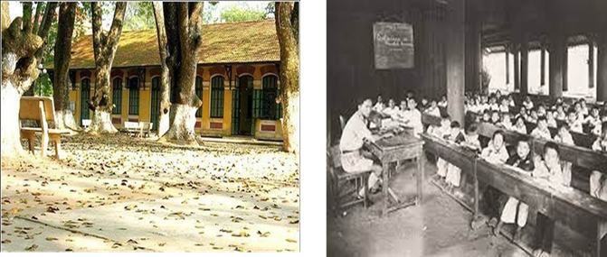  - What students wore to school?  - What subjects students studied?  - How students got to school?  * Suggested answers:  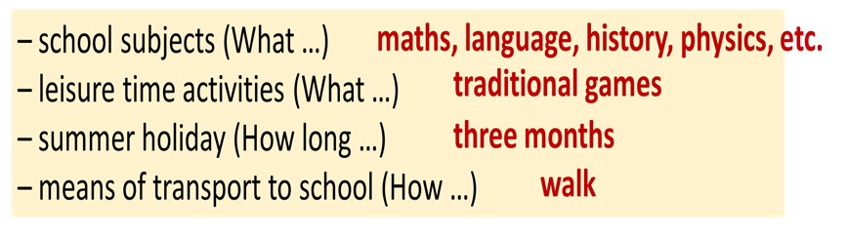
Activity 2: LISTENING (15’)
Task 1,2,3
a. Aims:

- To help Ss develop their skill of listening for specific information.

b. Content:

- Task 1: Match each phrase with the right picture.

- Task 2: Listen to the talk between Thanh and his grandma and tick (√) the things you hear.

- Task 3: Listen again. Choose the correct answer.

c. Expected outcomes:

- Ss can listen for general and specific information to do the learning tasks.

d. Organisation
Teacher’s and Ss’activities |  | Content
Task 1  - Have SS work in groups. Give them 2 – 3 min. to think and do the matching..  - SS work in groups to do exercise  - Teacher calls some Ss to share their answers.  - Teacher confirms the correct answers as a class. |  | Task 1: Match each phrase with the right picture.  * Suggested answers:  1. b 2. a 3. c
Task 2  - Tell Ss that they are going to listen to a conversation about school days in the past.  - Play the recording. Tell Ss to listen carefully and pay attention to key words – words that help them understand the ideas of the recording.  - Ss listen and do exercise  - Check ss answers. |  | Task 2: Listen to the talk between Thanh and his grandma and tick (√) the things you hear.  * Answer key:  1. three-month summer holiday …√…  2. lessons in the morning only …√…  3. a lot of extra lessons ……  4. walking barefoot …√…  5. chatting on mobile phones ……
Task 3  - Have Ss read through the sentences first.  - Play the recording once or twice. Ask Ss to listen carefully and choose the correct answers.  -Ss listen and choose answers.  - Play the recording once more for Ss to check their answers. |  | Task 3: Listen again. Choose the correct answer.  * Answer key:  - B 2. A 3. A 4. C  Audio-script  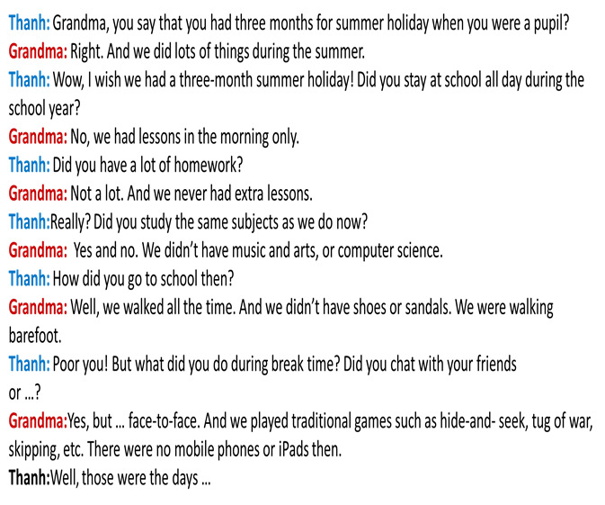
Activity 3: WRITING ( 15’)
Task 4 + Task 5
a. Aims:

- To help Ss practise asking and answering about school days in the past.

- To help Ss write a paragraph about school days in the past.

b. Content:

- Task 4: Work in pairs. Ask and answer about school days in the past.

- Task 5: Write a paragraph (100 - 120 words) about school days in the past.

c. Expected outcomes:

- Students can use learned vocabulary and grammar to write a paragraph about school days in the past

d. Organisation
Teacher’s and Ss’activities |  | Content
Task 4  -Have Ss work in pairs. Tell them to use the cues given to ask and answer about school days in the past.  - Ss work in pairs to ask and answer about school days in the past.  - Tell them they can refer to the listening text for their answers. |  | Task 4: Work in pairs. Ask and answer about school days in the past.  * Cues +  school time (When …)  + study subjects (What …)  + leisure time activities (What …)  + summer holiday (How long …)  + means of transport to school (How …)
Task 5  - Tell Ss to use the ideas in Activity 4 for their writing.  - Ss write the paragraph.  - Tell Ss to use the past tenses, and pay attention to grammar, use of words, spelling and punctuation.  - T may collect some Ss’ papers and mark them, and later comment to the class.  - If there is not enough time for Ss to do their task in class, have them do it as homework. |  | Task 5: Write a paragraph (100 - 120 words) about school days in the past.  * Sample paragraph:  In the past, students had lessons in the morning only. In the afternoon, they stayed home and did other things to help their parents. At school, they learned subjects such as maths, language, history, physics, etc. but they did not have music and arts, or sciences. They did not have extra lessons. In their free time they played traditional games such as hide-and-seek, tug of war, skipping, and so on. Every day they went to school on foot. My grandmother told me that they walked barefoot all the time, as they did not have shoes or sandals. They were lucky in that they had a long summer holiday – about three months!
Activity 4: PRODUCTION (5’)
a. Aims: To peer check, cross check and final check students’ writing.
b. Content: Display some students’ writing.
c. Expected outcomes: Students give feedback and vote the best wrting exactly
d. Organisation:
Teacher’s and Ss’activities |  | Content
-Teacher asks students to share their writing with their partners. Then, call on some students to show their writing in front of the class.  - Teacher checks ideas, grammar, vocabulary and gives comments |  | * PEER CHECKING  Students’ writing.
Activity 5: Consolidation (3’)
a. Aims: To consolidate what students have learnt in the lesson.
b. Content: Talk about what they have learnt in the lesson
c. Expected outcomes: Say aloud some main content from the lesson.
d. Organisation:
Teacher’s and Ss’activities |  | Content
- Teacher asks students to talk about what they have learnt in the lesson. |  | - Listen for general and specific information about old school days.  - Talk about school days in the past.  - Write a paragraph about school days in the past.
* Homework (2’)
a. Aims: To revise the lesson and prepare for the next lesson.
b. Content: Review the lesson and prepare for the next lesson and do exersie in the workbbook
c. Expected outcomes: Students’ preparation and workbooks
d. Organisation:
Teacher’s and Ss’activities |  | Content
Teacher asks students to rewrite their writing in their books.  - Teacher asks students to prepare the new lesson. |  | - Rewrite the writing in the notebook.  - Prepare “ Looking back and project”
*- Evaluation: :
………………………………………………………………………………………………………………………………………………………………………………………………………………

Date of planning : 13 /11 / 2024
Date of teaching : 19 /11 / 2024
Week: 12 UNIT 4: REMEMBERING THE PAST
Period: 34 Lesson 7: Looking back and project
I. OBJECTIVES

By the end of this lesson, Ss will be able to:

1. Knowledge

- Review the vocabulary and grammar of Unit 4

- Apply what they have learnt (vocabulary and grammar) into practice through a project.

2. Competences

- Develop communication skills and creativity

- Develop presentation skill

- Be collaborative and supportive in pair work and teamwork

3. Personal qualities

- Be encouraged to attend school activities.

- Actively join in class activities

II. MATERIALS

- Grade 9 textbook, Unit 4, Looking back and Project

- Computer connected to the Internet

- Projector / TV

- hoclieu.vn
III. PROCEDURES: (STAGES)
Activity 1: Warm -up (5’)
a. Aims:
- To create an active atmosphere in the class before the lesson;
- To lead into the new lesson.
b. Content:
- Game: UNSCRAMBLED WORDS
c. Expected outcomes:
- Students can revise some words learnt in previous lessons
d. Organisation:
Teacher’s and Ss’activities |  | Content
Game:  - T divides the class into 2 teams.  - T asks Ss to unscramble words using given hints.  - Ss play in 2 teams.  - Ss look at the hints to unscramble the words.  - The group having more correct answers is the winner |  | * Warm up: Game - UNSCRAMBLED WORDS  * Answer key:  ancestor, stucture, heritage, gratitude, preserve…..
Activity 2: VOCABULARY( 10’)
Task 1 + Task 2
a. Aims:

- To help Ss review the vocabulary of Unit 4

b. Content:

- Task 1: Choose the correct answer A, B, C, or D.

- Task 2: Finish the sentence by completing each blank with a word. The first letter of each word is given.

c. Expected outcomes:

- Students can use the knowledge they have learnt in this unit to complete the tasks successfully.

d. Organisation
Teacher’s and Ss’activities |  |  | Content
Task 1  - Have Ss do this task individually by choosing the correct answer to each of the questions.  - Ss do this task individually  - Goes round, monitors the class, and give support if necessary.  - Teacher calls some Ss to share their answers.  - Teacher confirms the correct answers as a class. |  |  | Task 1: Choose the correct answer A, B, C, or D  * Answer key:  - A 2. B  3. B 4. D 5. C
Task 2  - Have Ss study the sentences first. Tell them to pay attention to the gaps, and what words they need to use.  - Ss work in pairs to complete each blank with a word.  - T calls on some Ss to write the answers on the board.  - T corrects their mistakes and pronunciation if necessary. |  |  | Task 2: Finish the sentence by completing each blank with a word. The first letter of each word is given.  * Answer key:  1. worshiping  2.deep-rooted  3. heritage  4. generation  5. ingredients
Activity 3: GRAMMAR (10’)
Task 3+ Task 4
a. Aims:
- To help Ss revise the past continuous and use connectors to combine sentences.
- To help Ss revise wish + clause, and know how to rewrite sentences, using this structure.
b. Content:
- Task 3: Put the verb in brackets in the past continuous to complete each sentence.
- Task 4: Rewrite the following sentences, using wish
c. Expected outcomes:
- Recall the uses of the grammar that they have learnt in this unit (past continuous, wish + past simple)
d. Organisation
Teacher’s and Ss’activities | Content
Task 3  - Have Ss review the time connectors and the past continuous before they do the task.  - Have Ss work independently or in pairs to combine the sentences.  - Ss do exercise individually or in pairs.  - Have Ss write their answers in their notebooks.  - Give correction and call on some Ss to read the sentences aloud. | Task 3: Put the verb in brackets in the past continuous to complete each sentence.  * Answer key:  1. was shining  2. were building  3.weren’t studying/ were chatting  4. Were they still waiting  5. was thinking
Task 4  - Allow Ss some time to do the task individually and rewrite the sentences in their notebooks.  - Ss do the task individually  - Then ask Ss to compare their answers in pairs.  - Call on some Ss to write their answers on the board, other Ss give comments, and T checks as a class. | Task 4: Rewrite the following sentences, using wish.  * Answer key:  1. She wishes (that) she had an Iphone.  2. I wish I had three-month summer holiday as my grandma did.  3. I wish (that) my parents let me make my own decisions.  4. Mike wishes (that) he could play musical instruments.  5. I wish (that) my dad was not very busy, and (that) he had more time with me.
Activity 4: Project (15’)

a. Aims:

- To give Ss an opportunity to practise finding information about life in their area about 40 years ago.

- To help Ss improve their creativity and teamwork

- To improve their speaking and presentation skill

b. Content:

- Poster presentation

c. Expected outcomes:

- Students are able to present their posters about a life in the past.

d. Organisation
Teacher’s and Ss’activities | Content
- Tell Ss that they may need to ask their grandparents and / or old people, and / or read books or search the internet to find the information they want.  - Ss listen and follow instructions  - Tell them some information should include | Task 1: Collect information and pictures about life in your area about 40 years ago.  Information  + Means of transport (on foot, on horseback, by bicycle, …)  + Home life (electric devices, cooking, …)  + Community services (electricity, running water, library, communal house, …)  + way of cooking  …
- Have Ss work in groups. Tell them to make a poster to introduce the information they have prepared.  - Tell them to make it as interesting and informative as they can, using pictures, images, figures, etc.  - Ss work in groups to make poster from information they have prepared. | Task 2: Make a poster. Write or print the information and stick the pictures on the poster.  
- Call on some groups to show their posters and make a presentation. Other groups give their comments.  - Ss present their poster  - Give feedback on their presentation.  - The class vote for the best poster. | Task 3: Give a presentation to the class.
Activity 5: Consolidation (3’)
a. Aims: To consolidate what students have learnt in the lesson.
b. Content: Talk about what they have learnt in the lesson
c. Expected outcomes: Say aloud some words they remember from the lesson.
d. Organisation:
Teacher’s and Ss’activities | Content
- Teacher asks students to talk about what they have learnt in the lesson. | - revise vocabulary and grammar in unit 4  - make Project: Posters exhibition
* Homework (2’)
a. Aims: To revise the lesson and prepare for the next lesson.
b. Content: Review the lesson and prepare for the next lesson and do exersie in the workbbook
c. Expected outcomes: Students’ preparation and workbooks
d. Organisation:
Teacher’s and Ss’activities | Content
- Teacher asks students to revise old lesson and to do exercise in workbook.  - Teacher asks students to complete the project and prepare the new lesson. | - Complete the project  - Prepare for the next lesson: Unit 5 ( Getting started)
*- Evaluation: ………………………………………………………………………………………………………………………………………………………………………………………………………………

