**UNIT 8: MY FAVOURITE SUBJECTS**

**Lesson 1:1,2,3**

**I.DESIRED OBJECTIVES**

- Understand and correctly repeat the sentences in two communicative contexts focusing on asking and answering questions about someone’s favourite subject.

- Correctly say the words and use *What’s your favourite subject? – It’s _____.* to ask and answer questions about someone’s favourite subject.

- Enhance the correct use of *What’s your favourite subject?* – *It’s _____.* to ask and answer questions about someone’s favourite subject in a freer context.

**II. INSTRUCTIONAL RESOURCES**

- Student’s book

- Audio tracks

- Teacher’s guide:

- Hoclieu.vn

- Flash cards/ pictures and posters

- Computer, projector

**III. LEARNING PLAN**

**1. Warm up (5’)**

- Greet the class.

- Spend a few minutes revising Unit 7 by getting the class to sing the song *When do you have...?*

**2. Activity 1: Look, listen and repeat**

**+ Vocabulary**

**-** Pre-teach new words by asking pupils to look at the pictures and repeat the words in chorus and individually.

*+ favourite : yêuthích (meaning)*

*+ PE : GDTC (picture)*

*+ IT : Tin học (picture)*

- T models *(3 times).*

- T writes the words on the board.

- Checking: Rub out and remember

+ **Look, listen and repeat.**

**-** Ask pupils to look at Pictures **a** and**b** to identify the characters in the pictures.

**-** Ask pupils to look at Picture **a**. Play the recording for them to listen.

**-** Play the recording again, sentence by sentence, for pupils to listen and repeat individually and in chorus. Correct their pronunciation where necessary. Repeat the same procedure with Picture **b**.

**-** Invite a few pairs to stand up to listen to and repeat the sentences in the recording.

- Draw pupils*’* attention to the pictures. Tell pupils that *What’s your favourite subject?* and*It’s PE.* are used to ask and answer questions about someone’s favourite subject.

*Assessment - Performance products: Pupils’ answers - Assessment tools: Observation; Questions & Answers

**3.Activity 2: Listen, point and say.**

**-** Have pupils look at the pictures. Elicit the subjects from pupils.

**-** Have pupils point at Picture **a** (*art*), listen to the recording and repeat. Repeat the same procedure with Pictures **b, c** and **d**. Have the class point at and repeat the subjects a few times.

**-** Point at the first bubble and have pupils listen to and repeat after the recording (*What’s your favourite subject?*). Point at Picture **a** and have pupils listen to and repeat after the recording (*It’s art.*). Repeat the same procedure with Pictures **b**, **c** and **d.**

**-** Set a time limit for pupils to work in pairs to practise asking and answering the question *What’s your favourite subject? – It’s _____.*

**-** Invite a few pairs to the front of the class to take turns pointing at the pictures and saying the questions and answers.

* Assessment - Performance products: Pupils’ answers. - Assessment tools: Observation; Questions & Answers.

**4.Activity 3. Let’s talk.**

**-** Draw pupils’ attention to the two speech bubbles.

- Read the question aloud, and ask pupils to repeat it. Ask them to look at the girl’s speech bubble to identify what the answer should be. Elicit the answer: *It’s IT.* (the girl’s finger is pointing at IT.) Get pupils to repeat the question and answer several times.

**-** Set a time limit for pupils to work in pairs, point at the different books, ask and answer questions about their favourite subjects using *What’s your favourite subject? –* _____. Go around the classroom to observe and offer help where necessary.

**-** Invite some pairs to take turns asking and answering questions about their favourite subjects in front of the class.

* Play the online game on: https://www.baamboozle.com/game/67278

**5. Consolidation (3’)**

- Ask students to answer the following questions:

1. *What have you learnt from the lesson today?*

2. *What are the core values of the lesson?*

**Preparation for the project:** Ask pupils to prepare for the project on page 61 by doing a survey on their favourite subjects and the reasons why they like these subjects as homework so that they can present the results at Project time.

**IV. REGULATION**

………………………………………………………………………………………………

………………………………………………………………………………………………..

***Date of teaching:29/11/ 2024***

**UNIT 8: MY FAVOURITE SUBJECTS**

**Lesson 1: 4,5,6**

**I.DESIRED OBJECTIVES**

- Use the words and phrases *art, music, PE, IT* in relation to the topic “My favourite subjects”;

- Use *What’s your favourite subject*? – *It’s _____*. to ask and answer questions about someone’s favourite subject;

- Listen to and demonstrate understanding of simple communicative contexts in relation to the topic “My favourite subjects”;

- Read and write about someone’s favourite subject;

**II. INSTRUCTIONAL RESOURCES**

- Student’s book

- Audio tracks

- Teacher’s guide:

- Hoclieu.vn

- Flash cards/ pictures and posters

- Computer, projector

**III. LEARNING PLAN**

**1. Warm up (5’)**

- Greet the class and encourage pupils to respond to the greeting

- Sing a song

**2.Activity 4. Listen and tick or cross.**

**-** Play the recording of the first dialogue and tell pupils to tick or cross the picture. Play the recording again and check their answers. Praise pupils if they have the correct answer.

**-** Repeat **Step 2** with the rest of the dialogues.  
**-** Set a time limit for pupils to swap books with a partner and check their answers before checking as a class.

* Assessment - Performance products: Pupils’ answers. - Assessment tools: Observation; Questions & Answers.

**3.Activity 5. Look, complete and read.**

**\* Procedure:**

**-** Ask pupils to look at the pictures and identify the subjects.

**-** Ask pupils to read Exchange **1**. Draw their attention to the missing word (*music*). Complete the answer. Split the class into two groups to take turns asking and answering the question.

**-** Have pupils look at Exchange **2**. Elicit what is missing (*What’s; art)*. Then have them complete the gaps (*What’s your favourite subject? – It’s art.*). Follow the same procedure with Pictures **3** and **4**.

**-** Set a time limit for pupils to complete the exchanges individually, then invite a few pairs to take turns playing the roles of the characters.

Key: 1. Music 2. What/Art 3. subject/IT 4. favourite subject/PE

* Assessment - Performance products: Pupils’ answers. - Assessment tools: Observation; Questions & Answers

**4.Activity 6. Let’s sing.**

**-** Have pupils read the song to familiarize themselves with the lyrics. Check comprehension and give feedback.

**-** Have pupils listen to the whole song, drawing their attention to the pronunciation and tune.

**-** Play the recording of the song line by line for pupils to listen and repeat, and do related actions, e.g. using a finger to trace the words or clapping their hands.

**-** When pupils feel confident and are familiar with the melody, ask them to sing the whole song while doing actions or clapping their hands.

- Invite a few groups to the front of the class to sing the song. The class may sing along to reinforce the activity.

*. Assessment - Performance products: Pupils’ answers. - Assessment tools: Observation; Questions & Answers.

**5. Wrap -up**

- Ask students to answer the following questions:

1. *What have you learnt from the lesson today?*

2. *What are the core values of the lesson?*

**IV. REGULATION**

………………………………………………………………………………………………

………………………………………………………………………………………………..

***Date of teaching:30/11/ 2024***

**UNIT 8: MY FAVOURITE SUBJECTS**

**Lesson 2:1,2,3**

**I.DESIRED OBJECTIVES**

- Understand and correctly repeat the sentences in two communicative contexts focusing on asking for and giving reasons for liking a school subject, English.

- Correctly say the words and phrases and use *Why do you like ______? – Because I want to be _____*. to ask for and give reasons for liking a school subject, English.

- Enhance the correct use of *Why do you like _____? – Because I want to be _____*. ask for and give reasons for liking a school subject in a freer context.

**II. INSTRUCTIONAL RESOURCES**

- Student’s book

- Audio tracks

- Teacher’s guide:

- Hoclieu.vn

- Flash cards/ pictures and posters

- Computer, projector

**III. LEARNING PLAN**

**1. Warm up (5’)**

- Greet the class.

- Spend a few minutes revising the previous lesson by asking the class to sing the song *Myfavourite subject.*

**2. Activity 1: Look, listen and repeat**

**\*Vocabulary**

**-** Pre-teach new words by asking pupils to look at the pictures and repeat the words in chorus and individually.

*+ singer : casĩ (picture)*

*+ painter : họasĩ (picture)*

- T models *(3 times).*

- T writes the words on the board.

- Checking: What and Where

**\*Look, listen and repeat.**

**-** Ask pupils to look at Pictures **a** and**b**, and identify the characters and the reason why Nam likes English.

**-** Ask pupils to look at Picture **a**. Play the recording for them to listen.

**-** Play the recording again, sentence by sentence, for pupils to listen and repeat individually and in chorus. Correct their pronunciation where necessary. Repeat the same procedure with Picture **b**.

**-** Invite a few pairs to stand up to listen to and repeat the sentences in the recording.

- Draw pupils’ attention to Exchange **b:** *Why do you like English? – Because I want to be an English teacher*. Tell pupils that they are used to asking for and give reasons for liking a school subject, English.

* Assessment - Performance products: Pupils’ answers. - Assessment tools: Observation; Questions & Answers.

**3.Activity 2. Listen, point and say**

**-** Have pupils look at the pictures, and elicit the reason why each pupil likes his / her favourite subject.

**-** Have pupils point at Picture **a**, listen to the recording and repeat the word / phrase (*English / an English teacher*). Have them repeat the word / phrase a few times. Repeat the same procedure with the other three pictures.

**-** Point at the first bubble and have pupils listen to and repeat after the recording *(Why do you like English?*). Point at Picture **a** and have pupils listen to and repeat the question and answer (*Why do you like English? – Because I want to be an English teacher.*). Have the class repeat the exchange a few times. Repeat the same procedure with the other three pictures.

**-** Set a time limit for pupils to work in pairs, point at the pictures, and practise asking and answering *Why do you like _____? – Because I want to be _____*.

- Invite a few pairs to the front of the class to take turns pointing at the pictures, asking and answering *Why do you like _____? – Because I want to be _____*.

* Assessment - Performance products: Pupils’ answers. - Assessment tools: Observation; Questions & Answers.

**4.Activity 3:Let’s talk.**

**-** Have pupils look at the picture and explain that a group of four pupils are in the playground. Each of them is taking in hand the textbook of his / her favourite subject and imagining what they will be in the future. Get pupils to look at the first girl with black hair with the art textbook and ask pupils to identify her favourite subject (*art*) and what she wants to be in the future (*painter*). Then divide the class into two groups to role-play the girl and an interviewer.

**-** Repeat the same procedure with the rest of the three pupils in the picture.  
**-** Set a time limit for pairs of pupils to practise asking and answering the question *Why do you like______? – _____*. Go around the classroom to offer help where necessary.

**-** Invite pairs of pupils to the front of the classroom to take turns asking for and giving reasons why they like the subject. Praise pupils if they perform well.

**Game: Action game**

Round 1: Divide pupils into groups of 6, ask them to take turns drawing in the air or act without saying a word to show their guessing about their friends’ favourite subject for example English, Vietnamese, maths, music, IT, PE.

Round 2: each pupil takes turns to ask the friend on their left hand “Why .... “, the friend answers “because I….”. Count the same subject interests and report the teacher.

**5. Wrap -up**

- Ask students to answer the following questions: *What have you learnt from the lesson today?*

**IV. REGULATION**

………………………………………………………………………………………………

……………………………………………………………………………………………….

***Date of teaching:4/12/ 2024***

**UNIT 8: MY FAVOURITE SUBJECTS**

**Lesson 2:4,5,6**

**I.DESIRED OBJECTIVES**

By the end of the lesson . Students will be able to:

– Listen to and understand four communicative contexts in which pupils give reasons why they like the school subject, and number the correct pictures.

– Complete two dialogues about their favourite subjects and the reasons why pupils like them with the help of picture cues.

– Review asking for and giving reasons for liking a subject by playing the game Sentence making.

- Show their love and interest in their school subjects.

**II. INSTRUCTIONAL RESOURCES**

- Student’s book

- Audio tracks

- Teacher’s guide

- Hoclieu.vn

- Flash cards/ pictures and posters

- Computer, projector

**III. LEARNING PLAN**

**1. Warm up (5’)**

- Greet the class.

- Spend a few minutes revising the previous lesson by inviting a few pairs to the front of the class to take turns asking and giving reasons about why they like a school subject with the structure Why do you like ____? – Because I want to be..............

**2.Activity 4: Listen and number**

**-**T tells the class that they are going to listen and number the pictures.

- SS look at the pictures. Elicit the favourite subject and the reason for liking it. Draw pupils’ attention to the box in the bottom right hand corner of each picture.

- T plays the recording twice for pupils to listen and number.

- SS compare their answers.

-SS read their answers in front of the class.

- T plays the recording again for pupils to listen and check.

- T gives correct answers

* Key:

* Assessment: Questions & Answers.1. What’s your favourite subject? 2. Why do you like Art? 3. Do you want to be an English teacher?……

- Ss’ assessment: Ss assess their friends, forcus on presentation, pronunciation and intonation.

1. **Activity 5: Look, complete and read**

**-** Tell the class that they are going to read 2 dialogues and complete them.

- Have pupils look at Picture 1. Ask them what the girl and the boy are doing in the picture. Elicit the missing words from the Exchange 1 (Why, painter). Repeat the same procedure with Picture 2.

- T sets a time limit for pupils to do the task.

- SS swap books with their partners.

- T calls 2 pupils to write their answers on the board.

- T gives feedback and correct mistakes.

* Assessment:-Invite a few pairs to stand up and read the sentences aloud.

T’s assessment: Give oral comments (*your pronunciation is good*, …)

**4.Activity 6: Let’s play**

-T prepares a few slips of paperon each written a message: music, maths, English….

- Divide players into two lines of five or six to play the game.

- T gets them how to play the game.

- Give pupils time to play the game for several rounds. The teacher moves around the class to check and offer help where necessary.

- When the game is over, all the messages are written on board for the class to ask for and give reasons for liking a subject.

*Assessment - Performance products: Pupils’ answers. - Assessment tools: Observation; Questions & Answers

**5.Wrap- up:-** Play the crossword puzzle.

- SS write their answer on their hand out.( time: 3 minutes)

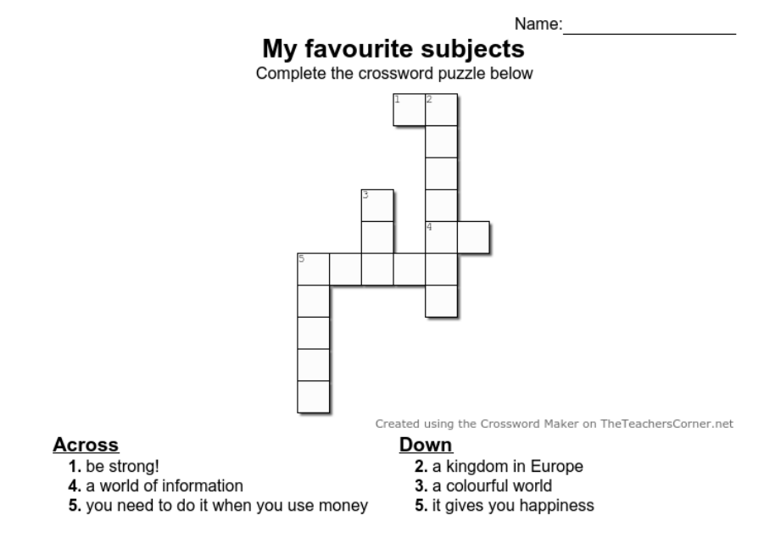

**IV. REGULATION:**

……………………………………………………………………………………………………………………………………………………………………………………………………………………………………………………………………..…………………………

***Date of teaching:5/12/ 2024***

**UNIT 8: MY FAVOURITE SUBJECTS**

**Lesson 3:1,2,3**

**I.DESIRED OBJECTIVES**

By the end of the lesson . Students will be able to:

– Correctly repeat the sounds of the letters **ke** and **te** in isolation, in the words like and write, and in the sentences I like English. and Let's write. with the correct pronunciation and intonation.

– Identify the target words like and write while listening.

– Say the chant with the correct pronunciation and rhythm.

- Show their love and interest in their school subjects.

**II. INSTRUCTIONAL RESOURCES**

- Student’s book

- Audio tracks

- Teacher’s guide:

- Hoclieu.vn

- Flash cards/ pictures and posters

- Computer, projector

**III. LEARNING PLAN**

**1. Warm up:**

-Greet the class and encourage pupils to respond to the greeting. Spend a few minutes revising the previous lesson by inviting a few pairs to ask and give reasons why they like a school subject.

1. **Activity 1: Listen and repeat.**

- Have pupils look at the letters **ke**, listen to the recording and repeat the letters until they feel confident. Correct the pronunciation where necessary.

- Have pupils point at the word like, listen to the recording and repeat the word until they feel confident. Monitor the activity and offer help where necessary

- Get pupils to point at the sentence I like English, listen to the recording and repeat it several times. Then invite a few pupils to stand up, listen to and repeat the sentence.

-Repeat Steps 1 to 3 for the letters **te**, the word and the sentence in line 2. Go around the classroom and correct the pronunciation where necessary.

-Give pupils a time limit to practise pronouncing the letters, saying the words, and reading the sentences in pairs or groups.

*Assessment : Observation; Questions & Answers.

1. **Activity 2: Listen and circle**

**-** Tell pupils that they are going to listen and circle the correct options.

- T asks: 1. How many numbers are there? How many letters are there in number 1 and number 2 ?

- Get them to read the options and guess the sentences they may hear in the recording.

- T plays the recording twice for pupils to listen and circle.

- Tell pupils to swap books with a partner, then check the answers together as a class. Write the correct answers on the board.

- Keys:

*Assessment :- Invite two pupils to stand up, listen to and repeat the sentences.

Ss’ assessment: You observe and give comments: Presentation, voice, pronunciation, intonation.

1. **Activity 3: Let’s chant**

*-* T set the scene: You are going to say the chant: Art, English

- T play the recording all the way through for Ss to listen and follow in their books.

- T play the recording again, pausing after each line for Ss to repeat.

- T play the recording once more for Ss to repeat the whole chant, show Ss how to chant and do the actions

- Ss work in pairs to practice chanting and doing the action.

- Some pairs say the chant and do actions in front of the class

**\*Ss’ assessment**: You observe and give comments (pronunciation; voice, intonation and stress, performance)

**\* T’s assessment**: Give oral comment.

1. Wrap - up: -Play Cross-word game

- SS write their answer on their hand out.( time: 3 minutes)

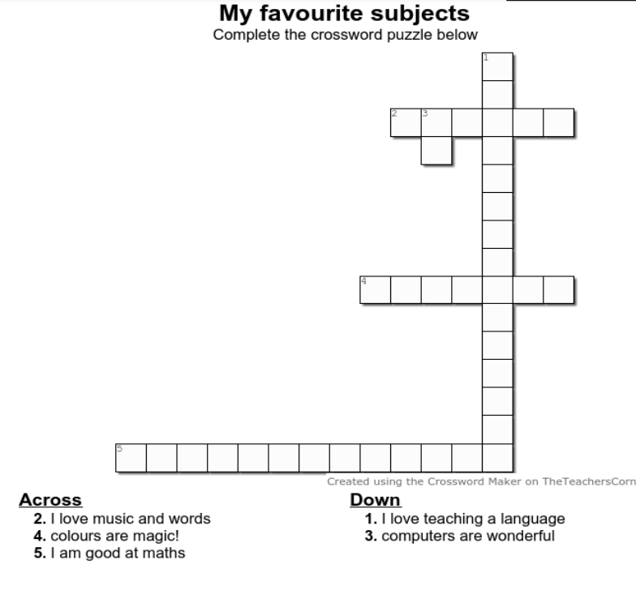

**IV. REGULATION:**

……………………………………………………………………………………………………………………………………………………………………………………………………………………………………………………………………..…………………………

***Date of teaching:6/12/2024***

**UNIT 8: MY FAVOURITE SUBJECTS**

**Lesson 3:4,5,6**

**I.DESIRED OBJECTIVES**

By the end of the lesson . Students will be able to:

- Read a paragraph and decide whether the sentences are true or false.

- Read, understand and complete a paragraph about their favourite subjects.

- Do a survey on their classmates’ favourite subjects and the reasons why they like these subjects and present them to the class

**-** Show their love and interest in their school subjects.

**II. INSTRUCTIONAL RESOURCES**

- Student’s book

- Audio tracks

- Teacher’s guide:

- Hoclieu.vn

- Flash cards/ pictures and posters

- Computer, projector

**III. LEARNING PLAN**

**1. Warm up:**

- Greet to the class.

- Sing the chant.

1. **Activity 4: Read and tick T or F**

- You are going to read a paragraph and decide whether the sentences are true or false.

- Give them a few seconds to look at the task 4 and ask: *How many numbers are there?*

- Have pupils read all the sentences under the paragraph. Tell them to read Sentence 1 and pay attention to the keywords **name and Peter**, then scan the paragraph for Whole class the information.

- Set a time limit for pupils to read the text again and do the task.

- Go around the class and offer help, if necessary.

- Ask pupils to compare their answers before checking as a class

- Call four pupils to write their answers on the board.

-Give feedback and correct mistakes.

* Key:

*Assessment: Invite some pupils to stand up and read the paragraph aloud.

1. **Activity 5: Let’s Write**

**-**T tells SS that they are going to write about their favourite subject.

- T gives them time to read and complete the gaped sentences, using information about their favourite subject.

- Remind pupils to use the structure I have….., my favourite subject…. in their writing.

- Ask pupils to do the task independently.

- Go around offering help, if necessary.

- T asks Ss to write their answers on the board.

- Give feedback.

**\* Assessment:** - Ss’ assessment**:**You pay attention to their content, dictation and give comments.

1. **Activity 6:Project**

- Get pupils to work in groups to show their surveys on their classmates’ favourite subjects and the reasons why they like these subjects which they have prepared at home as homework. They will tell the class about their favourite subjects and the reasons why they like them.

- Invite a pupil to the front of the class to model the presentation. Observe and offer help with the presentation language where necessary. Put the key presentation language on the board e.g. Look at Bill. His favourite subject is maths. He likes it because he wants to be a maths teacher. Have the pupils repeat the language a few times to help them feel confident when they present the project before an audience.

- Set a time limit for pupils to present the project in their groups. Each pupil shows his / her survey to the group and describes his / her classmates’ favourite subjects and the reasons why they like them.

-Invite a few pupils to the front of the class to present their projects. Encourage the class to cheer for the presenters.

**\***Assessment : Observation; Questions & Answers.

1. **Warp -up:**

- Ask pupils what have you learnt from the lesson today.

**IV. REGULATION:**

……………………………………………………………………………………………………………………………………………………………………………………………………………………………………………………………………..…………………………

**------------------------------------------**