UBND XÃ NAM BA ĐỒN  TRƯỜNG TIỂU HỌC QUẢNG TIÊN  Họ và tên. ………………………………..  Lớp. ………… | ĐỀ KIỂM TRA CUỐI HỌC KỲ I  ĐỀ 01  MÔN TIẾNG ANH LỚP 5  NĂM HỌC: 2025 - 2026  Thời gian làm bài. 40 phút
Skills | Listening | Reading | Writing | Speaking | Total
Marks

I. LISTENING (2,5ms)
Task 1. Listen and match. There is one example. (1,0m)

0  1 | A   B 

C 

2

D 
3

E 

4

Task 2. Listen and tick the correct picture. There is an example. (0,75m)
- What’s Linda’s favourite animal?

A. B. C. D.

1. What does the boy like doing in his free time?

A. B. C. D.

2. Where is the library?
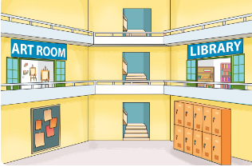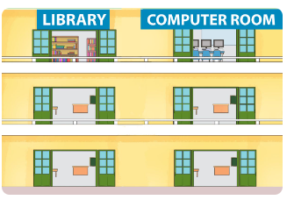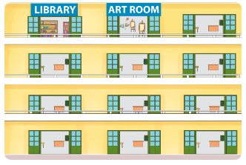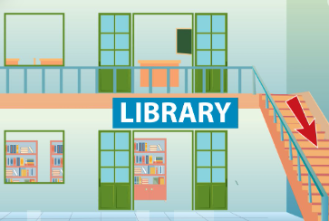
A. B. C. D.

3. Where is Ben’s school bag?
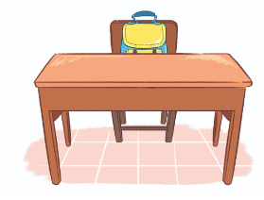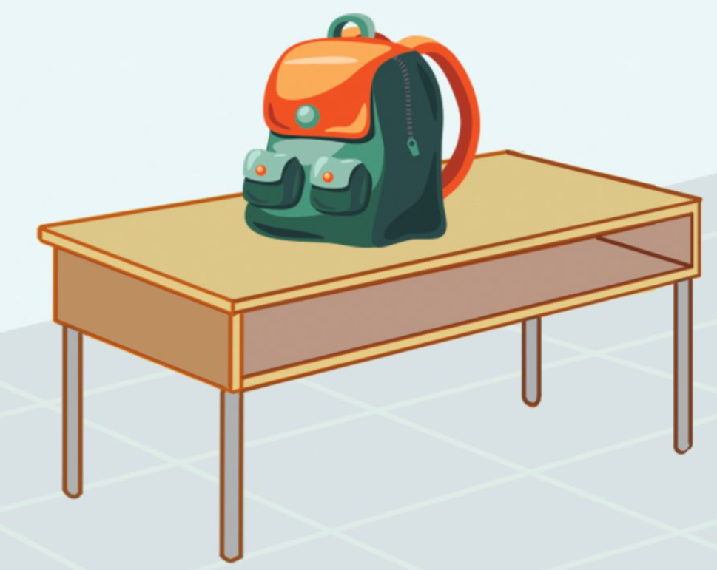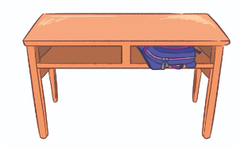

A. B. C. D.

Task 3. Listen and tick Right (R) or Wrong (W). There is one example. (0,75m).
 | R | W
- Phong’s school is in the centre of Ha Noi.
1. The art room is on the second floor.
2. The computer room is on the third floor.
3. Phong likes surfing the Internet in his free time.

II. READING. (2,5ms)
Task 1. Read and write the correct words. There is one example. (0,75m)
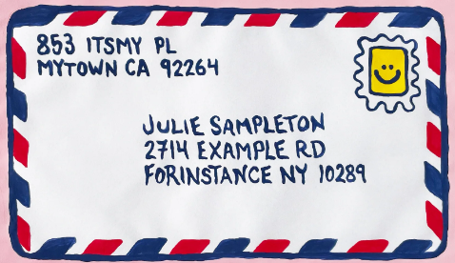
dancing address tower gardener

0. I always do it at the party. dancing
1. It is a tall building. People can live there. ___________________
2. This person often plants beautiful flowers and trees . ___________________
3. This tells where someone lives. ___________________

Task 2. Read and tick () True or False. There is one example. (0,75m).
Hello. My name is Mai. I have a new foreign friend. Her name is Sue. She is American. She lives in New York. Sue is active. She likes playing table tennis in her free time. She usually goes swimming at the weekend. Sue is helpful too. She helps her mother with the cooking in the evening. She sometimes helps me learn English. I am very happy that I have a nice friend like Sue.
 | True | False
0. Sue is Mai’s new foreign friend.
1. Sue lives in Oxford, America.
2. She likes playing table tennis in her free time.
3. She never helps Mai learn English.

Task 3. Read and fill in each gap with one word in the box. There is one word that you do not need. There is one example. (1,0m).
What fun doing friends solving Internet

Hello, my name is Linda. Lucy and Mary are my close (0) friends at school. However, we have different favourite school activities. Lucy likes (1) ..................... projects because she thinks it is useful for group work. Mary likes playing games because she thinks it is (2) ..................... . And I love (3)……….....…..... maths problems because I think it is interesting. What about you?
( 4) ………….. school activities do you like?

III.WRITING. (2,5ms).
Task 1. Reorder the letters to make correct words. There is one example. (1,0m)
Example.  0. wisandch sandwich

 1. Astraliaun………...……..  2. reterpor ……………….

 3. pfulhel ………………  4. fighreterfi ………………..

Task 2. Reorder the words to make sentences. There is one example. (1,0m).
Example. 0. sport / favourite / My / is / basketball.
My favourite sport is basketball.
1. is / Whose / this? / pencil case
…………………………………………………………………..
2. crayons / beside / book. / My / are / the
……………………………………………………………………..
3. sang / They / around / yesterday. / and danced / the / campfire
……………………………………………………………………….
4. at / the / Were / you / yesterday? / campsite
…………………………………………………………………………
Task 3. Answer the questions. There is one example. (0,5m)
Example. 0. What’s your address?
It’s 50 Chu Van An street.
1. What do you like doing in your free time?
…………………………………………………………………………..
2. What would you like to be in the future?
……………………………………………………………………………

