UBND XÃ NAM BA ĐỒN  TRƯỜNG TIỂU HỌC QUẢNG TIÊN  Họ và tên: ………………………………........  Lớp:…......................... |  |  |  | ĐỀ KIỂM TRA CUỐI HỌC KỲ I  ĐỀ 01  MÔN TIẾNG ANH LỚP 4  NĂM HỌC: 2025 - 2026  Thời gian làm bài: 40 phút
Skills | Listening | Reading | Writing |  | Speaking | Total
Marks

I. LISTENING (2,5 ms)
Task 1. Listen and number. There is one example. (1,0 m)
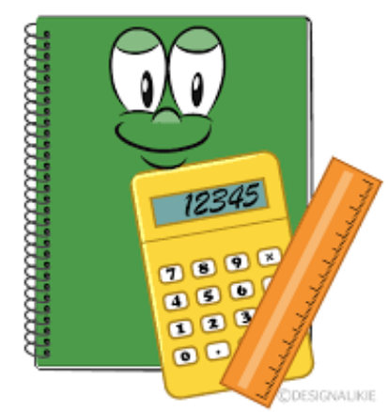




a
d
0
b
c
e

Task 2. Listen and tick (✓) . There is one example. (0,75 m)

  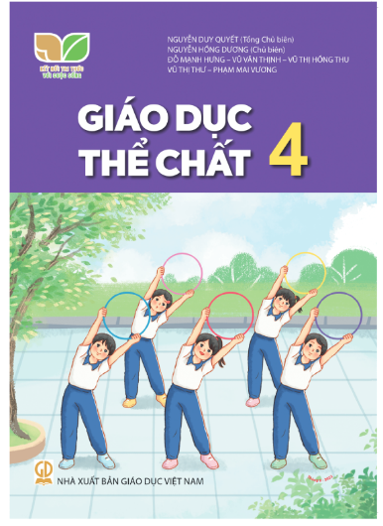  b  ✓  a  0. |     b  a  1.
    b  a  2. |     a  3.  b

Task 3: Listen and match. There is one example. (0,75 m)



1
2
3
0



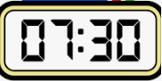
a

b
d
c

II. READING (2,5 ms)
Task 1. Look, read and tick  or cross  . There are two examples. (0,75m)

  A. He can play the guitar. |  |   B. I want some chips.
  1. He's from Japan. |   2. He can swim. |  | 3. It's five forty

Task 2. Read and tick (✓) True or False. There is one example. (0,75m).
Hello, my name is Linda. I'm from Australia. I study at Rose primary school. It is Tuesday today. It is a school day. I go to school on Mondays, Tuesdays, Wednesdays, Thursdays and Fridays. At the weekend, I stay at home. I do my homework on Saturdays. I do housework and listen to music on Sundays.
 | True | False
0. Her name is Linda. | √
1. She goes to school from Mondays to Fridays.
2. She is at school at the weekend.
3. She does housework on Saturdays.

Task 3. Read and complete. There is one example. (1,0m)
name football December playground fun

My (0) name is Tom. Our sports day is in (1)____________________. It is in the school (2)____________________. There are many pupils and teachers. We play different sports and games. The boys play (3)__________________. The girls play badminton. The teachers play volleyball. It is a lot of (4)______________.

III. WRITING. (2,5 ms)

Task 1. Reorder the words to make sentences. There is one example. (1,0 m)

0. in / My / school / the town / is /

=> My school is in the town.
1. have / When / science? / you / do
____________________________________________________________________?
2. Our / is / sports day / November. / in
____________________________________________________________________.
3. yesterday? / on the beach / Were / you
____________________________________________________________________?
4. play the piano, / My sister can't / but she / can play the guitar.
___________________________________________________________________.

Task 2. Look, read and complete. There is one example. (1,0 m)

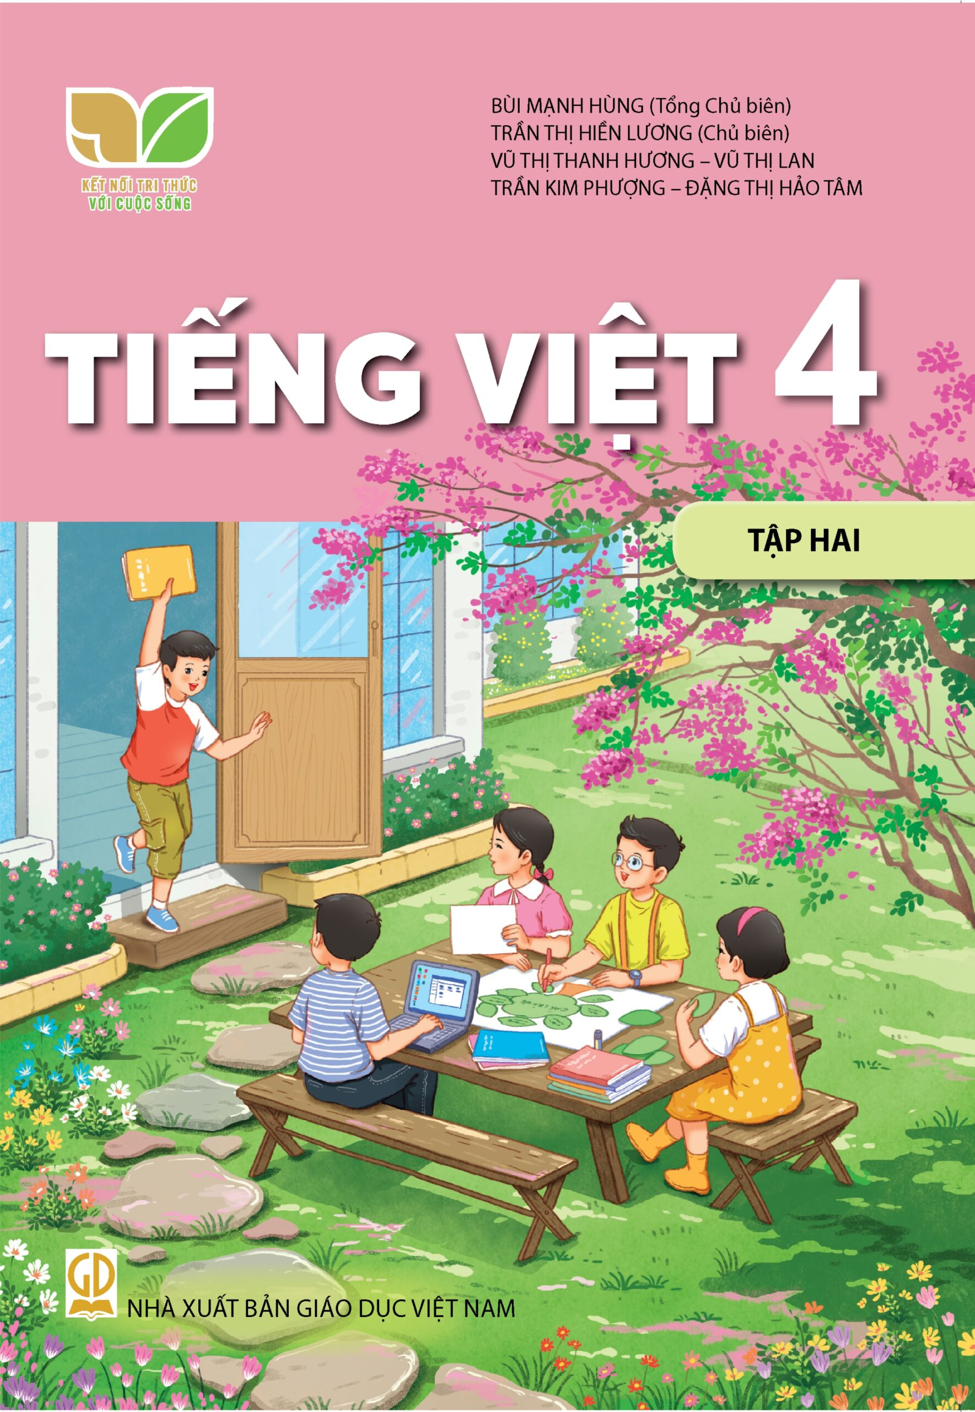
0. I have Vietnamese every school day.
  1. I want to be a maths _ _ _ _ _ _ _. | 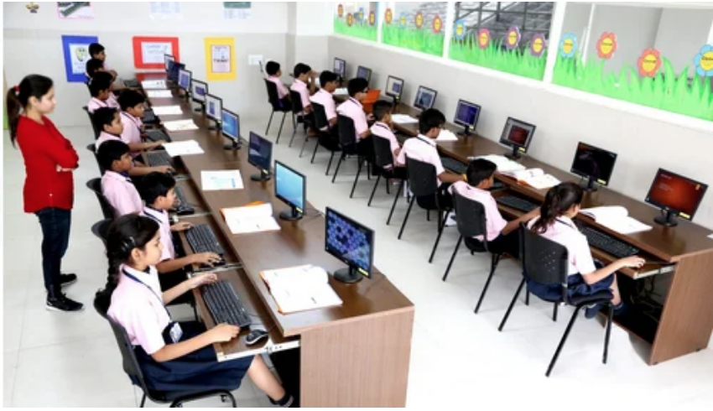  2. There is one _ _ _ _ _ _ _ _ room at my school.
  3. Peter can ride a _ _ _ _ _. |   thứ Tư  4. What day is it today?  - It's _ _ _ _ _ _ _ _ _.

Task 3. Answer the questions. There is one example. (0,5m)

0. Where's your school?
- It's in the town.
1. Can you ride a bike?
_______________________________________________________.
2. What's your favourite subject?
_______________________________________________________.

THE END

