**WEEK 35** *Date of preparing: 11/5/2024*

*Date of teaching: 13/5 – 17 /5/2024*

**REVIEW 4**

**Part 2**

**I. DESIRED OBJECTIVES**

By the end of the lesson, students will be able to:

– Correctly use the following sentence patterns:

– Read and match pairs of target sentence patterns

– Read and show the understanding of the text by completing four gapped sentences about the specific information in the text.

– Write a short paragraph about what people are doing at their summer camp with the help of the leaflet and an incomplete paragraph

**III. LEARNING EXPERIENCES/ LEARNING PLAN**

**1. Warm up:**

Game: Odd one out

**2. Discover to practice the structure**

**Activity 4: Read and match**

- Ss read the questions column, then read the answers column and focus on the information needed to match.

T supports:

+ Give instruction how to do the task

+ Introduce new words if appear

+ Make a model with sentence 1

- Ss do the task individually

- Ss share their answers in front of the class, others give comments.  
 *Key:* *1. c 2. a 3. b 4. e 5. d*

Extension: Invite some pairs of pupils to stand up and read the matched exchanges aloud.

**Activity 2: Read and complete**

- SS read and show the understanding of the text by completing four gapped sentences about the specific information in the text.

- T guides:

+ Explains new words if appear

+ Do question 1 for example

+ Set time limit for ss to do

- A ss read whole the passage and a ss read the statements aloud

- Ss do the task in pairs

- Ss share their answers

***Key:*** *1. sunny 2. playing 3. dancing 4. photos*

Extension: Invite some pairs of pupils to stand up and read the matched exchanges aloud.

**Activivy 3: Read and match**

- Ss write a short paragraph about what people are doing at their summer camp with the help of the leaflet and an incomplete paragraph

T guides:

+ Introduce the topic of the writing

+ Check understanding then elicit the content to write.

+ Show a model writing for ss to refer

- Ss the task individually (T goes around offering help, if necessary).

- Ss swap their writing to partner

- Some ss read their writing aloud, others give comments.

Suggested answer: Welcome to our summer camp. We are doing a lot of activities here. Our teacher is telling a story. Whole class/ Individual work Pair work Some boys are playing tug of war. Some girls are singing and dancing. I am taking photos

**3. Wrap – up.**

**IV. REGULATION:** (Optional)

………………………………………………………………………………………………………………………………………………………………………………

**EXTENSION ACTIVITIES**

**I. DESIRED OBJECTIVES**

By the end of the lesson, students will be able to:

– match the animals with their correct homes. – complete four sentences to introduce the animals and their homes. – review the target vocabulary and sentence patterns by playing Board games.

**II. RESOURCES AND MATERIALS:**

- Pupil’s book

- Flashcards/pictures and posters

- Computer, projector

- Website hoclieu.vn

**III. LEARNING EXPERIENCES/ LEARNING PLAN**

**1. Warm up:**

Guess the animals. - Have students read the clues for some animals and guess.

**2. Discover to practice the structure**

**Activity 1: Look and match**

**-** Ssmatch the animals with their correct homes.

T supports:

+ Instruction about the activity

+ Explain the new words

+ Do sentence 1 as an example

+ Set a limit time for ss to do

- Ss do the task individually

- Some ss share their answer in front of the class

***Key:*** *1. c 2. a 3. d 4. b*

- Ss repeat the words nest, web, den, burrow

**Activity 2:** **Complete**

- Ss complete four sentences to introduce the animals and their homes.

T supports:

+ Tell ss the goal of the activity

+ Do Sentence 1 as an example

- Ss do the task independently.

- Ss swap their answers with their partner

- Ss share their answers in front of the class

*Key: 1. den 2. nest 3. burrow 4. web*

**Activity: Board game. Roll a dice. Listen to a question and answer it.**

**- Ss** review the target vocabulary and sentence patterns by playing Board games.

- Each group rolls the dice in turn. On their turns, they move their game piece along the path according to the number of spaces by the dice.

- When the groups land on a space, the teacher asks a question. The group gives the answer. If it is correct, they can stay in the box

- The game continues until one or all groups reach the “Finish” space.

**3. Wrap – up.**

**IV. REGULATION:** (Optional)

………………………………………………………………………………………………………………………………………………………………………………

**THE FINAL TERM TEST**

**I. DESIRED OBJECTIVES**

By the end of the lesson, students will be able to practice all the knowledge they have learn.

- Develop speaking, reading and writing skills

**II. RESOURCES AND MATERIALS:**

- Audio

**III. CONTENT**

**PART I. LISTENING**

**Task 1: Listen and tick True (T) or False (F) (1pt)**

|  |  |  |
| --- | --- | --- |
|  | **True (T)** | **False**  **(F)** |
| **1.** |  |  |
| **2.** |  |  |
| **3.** Cloudy - Hợp Âm Chuẩn - Thư viện hợp âm lớn nhất Việt Nam |  |  |
| **4.** A Vector Illustration Of Busy City In The Morning Royalty Free SVG,  Cliparts, Vectors, And Stock Illustration. Image 33036879. |  |  |

**Task 2: Listen and number. There is one example. (1pt)**

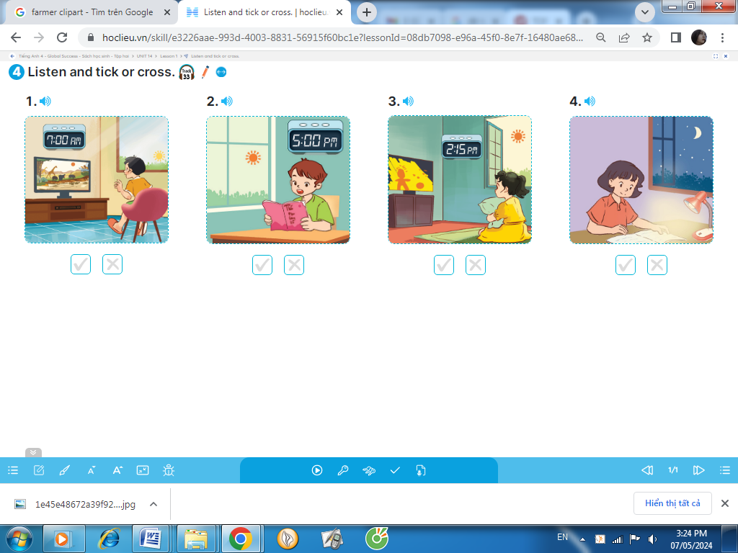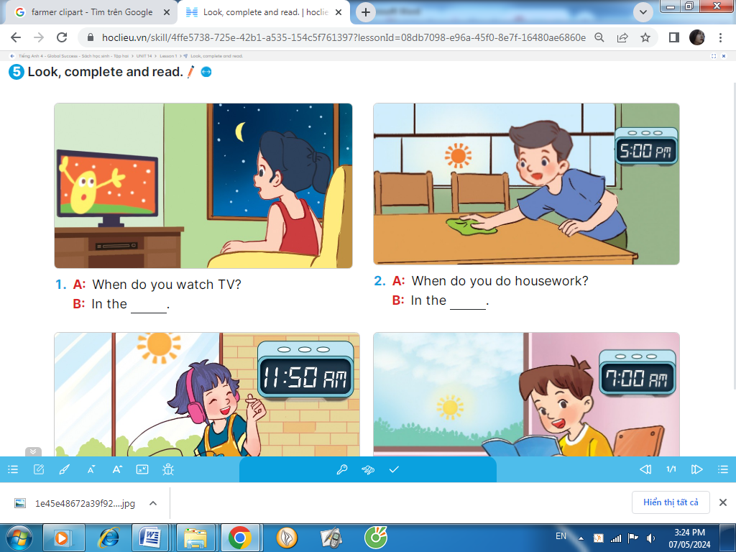 

A. B. C  D.  E. 

0

**Task 3: Listen and write. (1pt)**

a. **A**: Hi, Minh. Where were you last (1) __________?

**B**: I (2) _____in Sa Pa.

**A**: Great! I like Sa Pa.

b. **A**: What was the (3) __________like in Sa Pa?

**B**: It was (4) _________.

**PART II. READING**

**Task 1. Read and complete. (1,25 pts)**

badminton

played

weather

park

windy

The (1) __________was fine yesterday. It was sunny and (2) ____________. We were in the (3) __________. Tom and Linda played (4) ___________. Nam and Phong (5) __________football. We were happy in the park.



**Task 2. Read and match. There is one example (1pt)**

|  |  |  |
| --- | --- | --- |
| 0. What’s the village like? |  | a. I listen to music |
| 1. What does your sister look like? | b. It says stop. |
| 2. What do you do at noon? | c. It was sunny and windy |
| 3. What was the weather like yesterday? | d. It’s a quiet village. |
| 4. Where does your father work? | e. She has a round face. |
| 5. What does it say? |  | f. He works at the factory |

**PART III. WRITING**

**Task 1. Look at the pictures and the letters. Write the words. (1,25 pts)**

|  |  |  |  |  |
| --- | --- | --- | --- | --- |
| Nest Cartoon Images – Browse 25,385 Stock Photos, Vectors, and Video |  Adobe Stock |  |  | Shopping Mall Cartoon Images - Free Download on Freepik | Cartoon Ears PNG Clipart Background | PNG Play |
| 1.bidr  -> _______ | 2. sirkt  -> ______ | 3.nysnu  ->__________ | 4. shppingo cetren  ->____________ | 5. rea  ->_______ |

**Task 2. Reorder the words to make the correct sentence. There is one example.(1,25pts)**

0. What/he/ does/ do/on/Sunday?

*=> What does he do on Sunday?*

1. is / She / farmer. / a /

→ ________________________________________________________________

2. It / thousand / sixty / is/ dong.

→ ________________________________________________________________

3. does /What/ look / she/ like ?

→ ________________________________________________________________

4. morning? / you / What / do / the / in / do /

→ ________________________________________________________________

5. get / I / How / to / can / the / bakery? /

→ ________________________________________________________________

**CORRECTION THE TEST**

**I. DESIRED OBJECTIVES**

By the end of the lesson, students know clearly about the test to correct.

**II. RESOURCES AND MATERIALS:**

- Audio

- Transcript

- Test paper

**III. CONTENT**

**PART I. LISTENING**

Task 1. (0,25*4 =1pt)

1. F
2. F
3. F
4. T

Task 2. (0,25*4 =1pt)

1.D 2.B 3.E 4.C

Task 3.(0,25*4 =1pt)

1. weekend

2. was

3. weather

4. sunny

**PART II. READING**

Task 1: (0,25*5 =1,25pt)

1. weather

2. windy

3. park

4. badminton

5. played

Task 2: (0,25*5 =1,25 pts)

1.e 2.a 3. c 4. f 5. b

**PART III. WRITING**

Task 1 (0,25*5 =1,25 pts)

1. bird

2. skirt

3. sunny

4. shopping centre

5. ear

Task 2 (0,25*5 =1,25 pts)

1. She is a farmer

2. It is sixty thousand dong

3. What does she look like?

4. What do you do in the morning?

5. How can I get to the bakery?

**3. Wrap – up.**

**IV. REGULATION:** (Optional)

………………………………………………………………………………………………………………………………………………………………………………

*Xuân Hóa, ngày ... tháng 5 năm 2024*

**Chuyên môn ký duyệt**

**P. Hiệu trưởng**

**Cao Văn Thơm**