**WEEK 18** *Date of preparing:31 /12/2023*

*Date of teaching: 02/01–05 /01/2024*

**REVIEW 2 (Part 2)**

**I. DESIRED OBJECTIVES**

By the end of the lesson, students will be able to:

- correctly use the following sentence patterns:

+ What subjects do you have today? – I have ____.

+ When do you have ____? – I have it on ____.

+ Is your sports day in ____? – Yes, it is. / No, it isn't. It's in ____.

+ Where were you last summer? – I was in ____.

- Read and match pairs of target sentence patterns, read to complete a text about the learnt topic, and complete a gapped letter about their school

**II. RESOURCES AND MATERIALS:**

- Pupil’s book

- Flashcards/pictures and posters

- Computer, projector

- Website hoclieu.vn

**III. LEARNING EXPERIENCES/ LEARNING PLAN**

**1. Warm up:**

Look and guess!

Have pupils look at parts of the pictures and guess the words. Give points to pupils for correct answers.

**2. Discover to practice the structure**

**Activity 3: Read and match**

- Ss read the dialoge column, then match with appropriate picture

T supports:

+ Check understanding the sentences

+ Ask ss to look at the picture to identify the characters and context

+ Set time for ss to do

- Ss do the task in pairs

- Some ss share their answer in front of the class, tthers give comments.

*- Three pairs of pupils to read the dialogues in front of the class*

***Key:******1.*** *e* ***2.*** *d* ***3.*** *b* ***4.*** *c* ***5.*** *a*

**Activity 4: Look, complete and read.**

- Ss complete the gapped sentences and read them aloud with the help of the picture cues.

- Ss pay attention to Pictures to identify the context and appearances of each

T supports:

+ Have pupils look at the four incomplete sentences. Draw their attention to the missing words in the sentences.

+ Model with sentence 1.

- Ss complete the sentences individually

- A few pupils write their answer on the board, others give feedback.

- Ss practice reading sentences in pair

- Some ss read aloud before class

***Keys: 1.*** *a pencil case* ***2.*** *sit down, you can* ***3.*** *chess* ***4.*** *red*

**Activity 5: Ask and answer**

- Ss read and understand five question patterns, then take it in turns to ask and answer the questions

T supports:

+ Focus on the picture, elicit the answer and give feedback. Write the answer on the board and have pupils read the question and the answer as a class.

+ Set a time limit for pupils to play the game in pairs. Go around the classroom to offer support where necessary

- A few pairs of pupils to stand up and take turns asking and answering the target questions.

**3. Wrap – up.**

**Game: Pass the ball**

- Divide the class into 3 teams.

- Each team has 1 sticky ball.

- Play the music, pupils in each team take turns passing the ball. After the music ends, 3 pupils who have the balls will stand up and say the model sentences.

**IV. REGULATION:** (Optional)

………………………………………………………………………………………………………………………………………………………………………………

**EXTENSION ACTIVITIES**

**I. DESIRED OBJECTIVES**

By the end of the lesson, students will be able to:

- Know more information about some places through reading activity

- Discover some describtion for countryside and city

- Play game *Board game* then practise speaking skill

**II. RESOURCES AND MATERIALS:**

- Pupil’s book

- Flashcards/pictures and posters

- Computer, projector

- Website hoclieu.vn

**III. LEARNING EXPERIENCES/ LEARNING PLAN**

**1. Warm up:**

**Game:** on PPT slide

**2. Discover to practice the structure**

**Activity 1: Read and match**

- Ss look at the pictures then match with staments

T supports:

+ Introduce the new words if appear

+ Tell more about the picture for ss to abroad their knowledge about some areas

- Ss work in pairs, read and match

- Some pairs report their answer with explaination

**Activity 2: Write a for countryside or b for city**

- Ss read the statements and write a or b

T supports:

+ Explain the new words

+ Instruct how to do the task

- Ss share their ideas in front of the class and choose the answer

*Keys: 1.b 2.b 3.a 4.a 5.b 6.b 7.b 8.a*

T presents a video about countrysie and city for ss to know clearer about differences between them.

**Activity 3: Board game. Roll a dice. Listen and answer**

- Ss complete the answers using the picture cues.

T guides:

+Ask Pupils look at Pictures to get informations from them.

+ Give ss a few seconds to work in pairs to read the sentences and guess the answers.

- Ss the task individually (T goes around offering help, if necessary).

- Ss swap and check their answers

- Some ss writing theirs answers on the board, others give comments.

**3. Wrap – up.**

**IV. REGULATION:** (Optional)

………………………………………………………………………………………………………………………………………………………………………………

**THE FIRST TERM TEST**

**PART I - LISTENING**

**1.** **Listen and tick. There is one example.(1pt)**

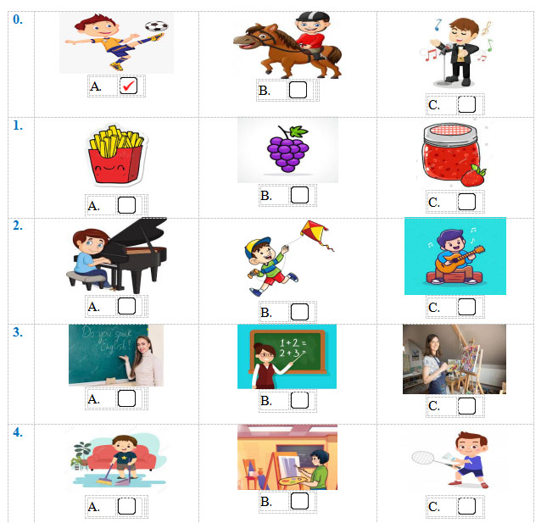

**2.** **Listen and number. There is one example.(1pt)**

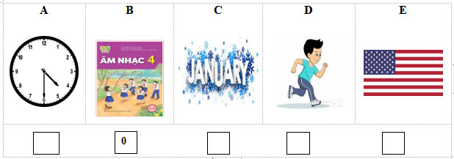

**3. Listen and draw line. There is one example. (1pt)**

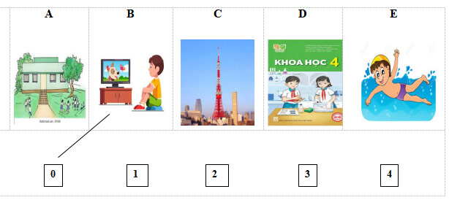

**4.** **Listen and write. There is one example.(1pt)**

0. He’s at the **zoo** at weekends.

1. There’s some …………………. on the table.

2. He’s from ……………………………

3. What day is it today? – It’s ……………………..

4. My favourite subject is………..…………………

**PART II – READING AND WRITING**

1. **Choose the correct words to complete the sentences. There is one example.**

0. What day __________ it today?

A. are B. is C. do

1. I go to the zoo ______ Sunday.

A. at B. in C. on

2. Can you _______ the guitar?

A. play B. do C. go

3. My school is ________ the mountains.

A. on B. at C. in

4. I _________ English on Mondays.

A. have B. do C. sing

1. Look, Read the sentences and write (✓) or (🗶). There is one example.

|  |  |
| --- | --- |
| 0. Linda is from America.  A map of australia with a flag  Description automatically generated  🗶 | 1. It’s the fourth of February.   |
| 2. I was in Sydney. | A building with a red roof and a sign  Description automatically generated3. My school is in village. |
| A calendar with blue text  Description automatically generated4. It’s Wednesday today. |  |

**3. Read and match the questions with the answers. There is one example.**

|  |  |  |
| --- | --- | --- |
| 1. When’s your sports day? | A. It’s in the city. | **0. D** |
| 1. When’s your birthday? | B. I have English, Vietnamese and P.E. | 1. |
| 1. Can she roller skate? | C. It’s in July. | 2. |
| 1. Where’s your school? | D. My birthday is in August. | 3. |
| 1. What subjects do you have today? | E. No, she can’t. | 4. |

**4. Look at the pictures and the letters. Write the words.**

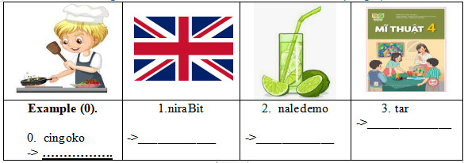

**5. Rearrange the words to make the sentences. There is one example.**

1. day/ your/When’s /sports /?/

→ …………………………………………………………………………………

2. five/ I/ at/ get/ thirty. / up /

………………………………………………………………………………………

3. subject?/your / What’s /favourite/

………………………………………………………………………………………

4. do/on/ I/ Sunday./ housework/

………………………………………………………………………………………

**CORRECTION**

***KEYS***

**PART I - LISTENING**

**1.** **Listen and tick.**

1.B 2.C 3.A 4.B

**2.** **Listen and number**

1.E 2.A 3.D 4.C

**3. Listen and draw line.**

1.E 2.D 3.C 4.A

**4.** **Listen and write.**

1.jam 2.Australia 3. Friday 4. Maths

**PART II – READING AND WRITING**

1. **Choose the correct words to complete the sentences**

1.C 2. A 3. C 4. A

1. **Look, Read the sentences and write (✓) or (🗶).**

1. ✓ 2. X 3. ✓ 4. ✓

**3. Read and match the questions with the answers**

1. C 2. E 3. A 4. B

**4. Look at the pictures and the letters. Write the words.**

0. cooking 1. Britain 2. Lemonade 3. Art

**5. Rearrange the words to make the sentences**

1. When’s your Sports day?

2. I get up at five thirty.

3. What’s your favourite subject?

4. I do housework on Sunday.

**REGULATION**

……………………………………………………………………………………………………………………………………………………………………………………

*Xuân Hóa, ngày ... tháng 01 năm 2024*

**Chuyên môn ký duyệt**

**P. Hiệu trưởng**

**Cao Văn Thơm**