Preparing date: 14/12/2025
Period 45: UNIT 6: VIETNAMESE LIFESTYLE: THEN AND NOW
Lesson 4: Communication

I. OBJECTIVES
By the end of this lesson, Ss will be able to:
1. Knowledge
- Know how to make promises
- Talk about Changes in Lifestyle
2. Competences
- Develop communication skills and creativity
- Be collaborative and supportive in pair work and teamwork
3. Personal qualities
- Be ready and confident in real life conversations
- Know about means of transport.
- Actively join in class activities

II. MATERIALS
- Grade 9 textbook, Unit 6, Communication
- Computer connected to the Internet
- Projector / TV
- hoclieu.vn

III. PROCEDURES
1. WARM-UP:
a. OBJECTIVES:
- To introduce the topic.
- To enhance students’ skills of cooperating with team mates.
b. Content:
- Promise Chain
- Promise Role-play
c. Expected outcomes:
- Students can use their background knowledge to answer the questions.

Option 1: Promise Chain
- Divide class into two teams and arrange them into two lines facing each other.
- Select the first student from each team and whisper a promise-related sentence to them, such as ”I promise to study hard for the upcoming exam”.
- The student must then turn to their teammate and repeat the sentence exactly as they heard it.
- The next student in line must repeat the sentence to their teammate, and so on, until the sentence reaches the end of the line.
- The first team to correctly repeat the entire sentence wins points
- Ss listen and follow instruction.
Promise:
- I promise to be nice
- I promise to give you the PS5
- I promise not to trick you.
- I promise not to cheat in the test.
Option 2: Promise Role-play
- Divide class into pairs and assign roles to each student, such as parent and a child, teacher and student, or friend and friend.
- Provide each pair with a scenario that involves making a promise, such as a child promising to clean their room, a student promising to study for a test, or a friend promising to keep a secret.
- Ask each pair to act out the scenario.
- Have some pairs present their role-play to the class.
- Ss listen and follow instruction.
Scenario: a child promising to clean their room, a student promising to study for a test, or a friend promising to keep a secret.

Task 1: Listen and read the conversations. Pay attention to the highlighted parts.

- Play the recording for Ss to listen and read along the conversation where Mike and Mi make promises. Ask Ss to pay attention to the highlighted parts.
- Elicit the structures for making promises.
- Have Ss practise the conversations in pairs.
- Instruct Ss how to respond appropriately.
- Ss listen and read
- Look at the highlighted parts.

Audio script:
1.
Mike: I will share with you the links about the ancient village of Duong Lam.
Phong: Thank you.
2.
Mi: I promise not to bring my dog to the picnic.
Ann: Great. I appreciate it.
Structures:
I will …
I promise to / not to…
Thank you.
I (highly) appreciate it.

Task 2: Work in pairs. Make promises for the following situations.
- Ask Ss to work in pairs to make similar conversations.
- Comment on their performance.
EXTRA ACTIVITY
Share with the class some promises you usually make in life.
Example: I’ll finish all my homework before I go out, Mum.
I promise not to let you down.
SS work in pairs to make similar dialogues.
Suggested dialogues:
- I will return / I promise to return before 9p.m.
I appreciate it.
- I will be / I promise to be on time for the performance.
I highly appreciate it.

Task 3: Read the passage about changes. Then match the people with the topics they are talking about.
- Tell Ss that they are going to read people talking about changes.
- Have Ss read quickly (skim) three people’s talks and do the matching. To make sure that Ss know how to do this task properly, limit the time to 1 minute.
- Invite some Ss to share their answers. Tell them to show some key words that help them do the task quickly.
- Confirm the correct answers as a class.
- Ss share the answers
- Ss read the passages quickly and do matching.

Key: 1. B 2. C 3. A
Notes:
Tokyo: the capital of Japan
New Delhi: the capital of India
Cairo: the capital of Egypt

Task 5: Work in pairs. Read the list and find out which has remained
- This task allows Ss to apply what they have learnt so far in this unit (ideas, vocabulary, grammar) and the structures of the talks in activity 3 to talk about real changes they can observe happening around them.
- Have Ss work in pairs.
- Allow Ss some time to talk and take notes of their partner’s ideas. Go round and give support if needed.
- Invite some Ss to report what they have taken notes of their partner’s changes.
- Ss work in pairs.
Sample structure:
There have been some changes in Lan’s lifestyle. The first change is her…. However, her … has / have not changed over the past five years.

4. CONSOLIDATION
a. Wrap-up
- Have Ss say what they have learnt in the lesson.
b. Homework
- Do exercises in the workbook.
- Get ready for Skills 1

Preparing date: 14/12/2025

Period 46: UNIT 6: VIETNAMESE LIFESTYLE: THEN AND NOW
Lesson 5: Skills 1

I. OBJECTIVES
By the end of this lesson, Ss will be able to:
1. Knowledge
- Read for specific information about the differences in the learning styles of past and present
- Talk about changes in one’s learning style
2. Competences
- Develop communication skills and creativity
- Be collaborative and supportive in pair work and teamwork
- Develop presentation skill
3. Personal qualities
- Understand more about city problems and their solutions.
- Actively join in class activities

II. MATERIALS
- Grade 9 textbook, Unit 6, Skills 1
- Computer connected to the Internet
- Projector / TV
- hoclieu.vn
III. PROCEDURES
1. WARM-UP:
a. OBJECTIVES:
- To help Ss understand and activate their knowledge of the topic;
b. Content:
- Brainstorm
c. Expected outcomes:
- Students gain knowledge about different learning style at different times
d. Organisation

* Brainstorm
- Introduce the OBJECTIVES of the lesson: reading about the different learning styles at different times and talking about your own learning style.
- Ask Ss to name some learning facilities they know and if each is available in their learning context.
- Share with Ss the lesson OBJECTIVES. Write the OBJECTIVES in a corner of the board and leave them there till the end of the lesson, or put them on a slide to show Ss.
- Ss listen and answer.

Task 2: Two people of different generations are talking about their learning styles. Read the passages and choose the correct answer A, B, C, or D.

- Have Ss work individually.
- Ask Ss to read the text first. Then ask them to read each question and choose the correct answer.
- Invite some Ss to share their answers. Ask them where they find the information for their answers.
- Confirm the correct answers as a class. Explain if needed.
- Do the task individually.
Answer key:
1. A 2. C 3. B 4. A 5. D

Task 3: Fill in each blank with ONE word from the passage.
- Have Ss work individually or in pairs.
- Ask Ss to read each sentence carefully, then refer to the text to look for the answer.
- Have Ss compare their answers in pairs. Ask them to discuss if there are differences in their answers.
- Invite some Ss to share their answers with the class. Ask them where they find the information for their answers.
- Confirm the correct answers as a class.
Transition from Reading to Speaking
- Tell Ss that they are going to do the same thing as in the reading: talking about changes in their learning style. In this task, they will talk about their own experience, combining both the past and the present.
- Ask Ss to refer to the reading for any vocabulary, ideas, or structures they may need for their speaking.
Answer key
1. textbooks
2. memorising
3. various
4. documents, clips, and programmes (any one of these)
5. pursue
Task 4: Work in groups. Discuss and make a list of the changes in your learning over the past five years.

- Have Ss work in groups.
- Tell Ss that they can choose to talk about anything related to their learning, not just the ones as suggested in the task.
- Ask Ss to discuss and take notes of their answers. T goes round and offers support if needed.
This activity helps prepare Ss for activity 5.
- Listen and follow instructions
Possible answers:
Teachers: three or four teachers teach all the subjects -> different teachers for different subjects.
Learning Facilities: almost text book -> use textbooks and internet…
Learning style: dependent -> independent

Task 5: Share with the class the list your group has made in 4
- Have each group choose a presenter.
- Have some groups present the changes that their groups have talked about.
- Ask other Ss to listen to and give comment or ask questions if they have any.
- Comment on their presentation.
- Listen and follow instructions
Sample answer:
Five years ago, we were at primary school. We had only three or four teachers teaching us all the subjects. We depended on the teachers to tell us everything we needed to do: taking notes in our notebooks, doing homework and preparing for exams. We rarely did anything that the teacher did not request. Now, we have different teachers for different subjects. We have also become more independent and active in our learning. We use the internet to learn about our interests. And it costs little to do it.
EXTRA ACTIVITY
Interview two of your classmates and fill in the table below in notes. Then report your findings to the class.
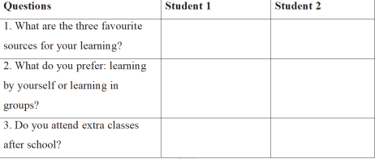

4. CONSOLIDATION
a. Wrap-up

- Summarise what they have learnt in the lesson.
- Have Ss recall some things they can remember.
b. Homework
- Do exercises in the workbook
- Get ready for Skills 2

- Preparing date: 14/12/2025

Period 47: UNIT 6: VIETNAMESE LIFESTYLE: THEN AND NOW
Lesson 6: Skills 2

I. OBJECTIVES
By the end of this lesson, Ss will be able to:
1. Knowledge
- Listen for general and specific information about changes in family life
- Write about the changes in one’s family.
2. Competences
- Develop communication skills and creativity
- Be collaborative and supportive in pair work and teamwork
3. Personal qualities
- Be encouraged to express opinion about city life.
- Actively join in class activities

II. MATERIALS
- Grade 9 textbook, Unit 6, Skills 2
- Computer connected to the Internet
- Projector / TV
- hoclieu.vn

III. PROCEDURES
1. WARM-UP (5 mins)
- Show Ss the picture and ask them “What is it?”
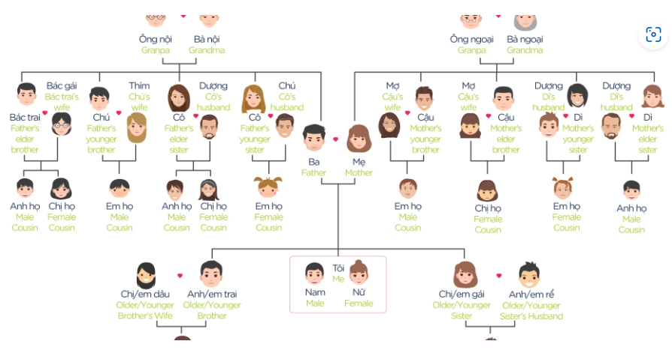
- Have students create a family tree diagram, starting with themselves as the center and extending outwards to include their parents, grandparents, siblings, …
- Encourage students to add details to each branch of their family tree, including names, relationships, occupations, memorable events, and any unique traditions or customs associated with their families.
- Ss share their family trees with the class.
- Discuss how family dynamics and traditions have evolved over time, and how these changes have impacted the family life.

2. ACTIVITY 1: LISTENING (20 mins)
Task 1: Listen to a talk about family life. Work in pairs. Choose the aspect(s) that you think will be mentioned in the talk.
- Have Ss to work in pairs.
- Ask Ss to read the aspects listed under the picture and tick the one(s) they think the text will mention.
- Invite some Ss to share their answers
- Tell Ss that all the five aspects in the list might appear in a talk about family life.
Task 2: Listen to the talk and tick (√) the correct column.
- Have Ss read the facts (1-5) carefully so that they can have some ideas of the listening text.
- Play the recording and tell Ss to listen for the facts 1-5 and decide if each fact refers to the past or the present.
- Have Ss share their answers in pairs.
- Invite some Ss to share their answers with the class.
- Confirm the correct answers as a class.
- Play the recording again if needed. Pause at places where Ss have difficulties and show them how to find the answers.
Answer key:
The past: 1,3
The present: 2, 4, 5
Task 3: Listen again and fill in the blank with a word or number.
- Tell Ss to read the sentences in 3 to determine what information is missing.
- Tell Ss that they are going to listen again to the text with a focus on picking up the missing information.
- Play the recording. Have Ss do the task individually.
- Invite some Ss to share their answers with the class.
- Confirm the correct answers as a class.
- Play the recording again if needed, stopping at the place where students are having difficulties.
Answer key:
1. two (nuclear and extended)
2. three
3. family-oriented
4. elders
5. privacy
Audio-script
Family life has changed a lot over the past 50 years.
Firstly, nuclear families have replaced extended ones. In the past, there were usually three generations living together in a household. Now, there are often two: parents and children. The generation gap has become less obvious.
Secondly, Vietnamese people are traditionally family-oriented. Holidays in the past mostly meant gathering, cooking and eating. Now, more families go out, visit a place, play and eat. Overall, holidays have become more relaxing and less tiring.
Lastly, families in the past spent more time talking and doing things together. Children came to their elders to share their experiences and look for answers to their questions. Today’s children have more opportunities to learn from other sources. They do not depend all on their elders. While they listen to their parents, they want their parents to listen to them, too. The relation between parents and children is more democratic. Parents have learned to respect their children’s independence and privacy.

- Tell Ss that in the coming tasks of writing, they are going to write about the same thing as in the listening: changes in their family over the past five years.
- Ask Ss to refer to the listening (tasks 1-2-3) for any vocabulary, ideas, or structures they may need for their writing.
3. ACTIVITY 2: WRITING (18 mins)
Task 4: Read the list and tick (√) the thing(s) that has/have changed in your family in the past five years. Make notes of those which have changed.
- Have Ss to work individually.
- Ask Ss to read the list and tick the one(s) which has changed in their family. A time set of five years is given to enable Ss to talk about changes they really witness.
- Allow Ss some time to write down in notes the changes. Move around to oﬀer help if needed.
- Tell Ss that not every family has witnessed all the changes. In this lesson, the more important things is how they talk about the change(s).
Sample answer:
Type of family: nuclear family
Home facilities: better, air conditioner, washing machines,…..
Ways of spending free time: eat out, go on holiday, do chores..
Relationship among members: respect each other
Task 5: Write an email (100 - 120 words) to your penfriend about the changes in your family. Use the ideas in 4.
- Ask Ss to read the notes of their discussion in activity 4.
- Allow them some time to arrange the ideas and write out the email. Go round and offer help if needed.
- Invite some Ss to read aloud their emails to the class. Comment on them.
- Collect some writings to correct at home. Otherwise, ask Ss to revise and rewrite their emails at home based on the T’s comments of their friends’ writings. Have them bring their new writings to class in the next lesson. Collect some for marking.
Sample answer:
From: Hoa
To: Tom
Subject: Changes in my family
Hello Tom,
It’s nice to hear from you again. Let me tell you about the changes in my family over the past five years. It’s still a nuclear family with two generations. But our living conditions are much better. Two years ago, my father found another job and he earns more money now. We now have an air conditioner and a washing machine. Sometimes we can eat out or go on holiday. My father also spends more time with my brother and me. He teaches us how to do the chores that adult men should be able to do. We act more like friends. My parents respect our independence and privacy. It’s good news, isn’t it?
All the best,
Hoa

EXTRA ACTIVITY
Write your opinion about the role of children nowadays in the family based on the following suggestions:
1. The number of children in a household.
2. The amount of housework they share with their parents.
3. The amount of time they spend on family activities.
4. How much they are obedient to/ independent of their parents.
5. If they are obliged to take care of their parents when their parents get old.
Sample:
Nowadays families tend to have fewer children than in the past: just one or two per family. Therefore, parents have more time to take care of their children, resulting in their children doing less housework and having fewer responsibilities in the family. Most parents encourage their children to spend more time on their studies, so they may have less time with families. The internet is also a factor to distract children from engaging with family activities. Children become more independent. However, when their parents get old, most children are willing to take care of them.
4. CONSOLIDATION (2 mins)
a. Wrap-up
- Summarise the main points of the lesson.
b. Homework
- Rewrite the paragraph in the notebooks.
- Do exercises in the workbook.

