Date of preparing : 9/11/2025

Period 28: UNIT 4: REMEMBERING THE PAST
Lesson 2: A closer look 1
- OBJECTIVES
By the end of this lesson, Ss will be able to:
  - Knowledge
    - Use the lexical items related to the topic Remembering the past;
    - Pronounce the sounds /m/ and /l/ in words and sentences correctly.
    - Use the past continuous and wish + past simple
  - Competences
    - Be collaborative and supportive in pair work and teamwork;
    - Access and consolidate information from a variety of sources.
  - Personal qualities
    - Actively participate in class and school activities;
    - Develop self-study skills.
- MATERIALS
    - Grade 9 textbook, Unit 4, A closer look 1
    - Computer connected to the Internet
    - Projector / TV
- PROCEDURES
  - WARM-UP
Brainstorming
- Bring to class some posters / pictures or show on the screen some images related to the history of Viet Nam or other countries. Encourage Ss to name these things.
- Lead into this lesson, which focuses on the new words / phrases and the sounds /m/ & /l/.
North Vietnamese tank entering through the gates of the Independence Palace of Saigon on April 30, 1975
- Long Bien Bridge crossing over the Red River, built between 1898 and 1902

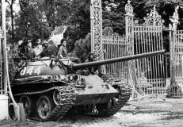
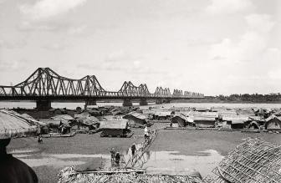

  - ACTIVITY 1: VOCABULARY
- Vocabulary pre-teaching:
- T introduces the vocab by:
- + Providing explanations of the words
- + Showing pictures illustrating the word
- Structure(n)
- Promote(v)
- Observe(v)
- Benefit(v)
- Task 1: Complete the following table. There is one example.
- Have Ss work in pairs. Tell them to look at the verbs given in the left column and give their equivalent nouns.
- Check their answers as a class.
- Have Ss read the verbs and nouns aloud. Correct their pronunciation if necessary.
Answer key:
- promotion
- recognition
- contribution
- observation
- preservation
- occupation

- Task 2: Complete the following sentences, using the correct forms of the words from 1.
- Have Ss work in pairs. Tell them to look back at the words in 1.
- Have them read the sentences carefully and look for clues to find the right words to complete the sentences. The word to fill each blank may be a noun or a verb in its correct tense.
- Have one or two Ss write the words on the board. Confirm the correct answers.
Answer key:
- observe
- contribution
- preservation
- promotion
- recognised
  - ACTIVITY 2: PRONUNCIATION
- Task 4: Listen and repeat the words. Pay attention to the sounds /m/ and /l/.
- Have students watch a video about how to pronounce /m/ and /l/.
- Play the recording and ask Ss to listen to these words and repeat. Correct their pronunciation. Play the recording as many times as necessary.
- Explain the two types of sound /l/ in the Remember! box and invite Ss to give some examples.
- Task 5: Listen and repeat the sentences. Pay attention the the underlined words.
IV.PRODUCTION
- To help Ss apply wish + past simple in real situation by making sentences about themselves.
- CONSOLIDATION

1.Wrap-up
- Ask one or two Ss to tell the class what words, phrases, and sounds they have learnt. Draw Ss’ attention to the objectives on the board or show them the slide with the objectives. Tick the objectives that have been learnt.
- Tell them the grammar points that they will learn in the following lesson.

- Homework
- Do exercises in the workbook.
- Find 3 more words that have the sounds /m/ and /l/.
- Prepare: Unit 4: A closer look 2

Date of preparing : 9/11/2025

Period 29: UNIT 4: REMEMBERING THE PAST
Lesson 3: A closer look 2

  - OBJECTIVES
By the end of this lesson, Ss will be able to:
    - Knowledge
      - Recognise and use past continuous and wish + past simple.
      - Be encouraged to express wishes in practical situations
    - Competences
      - Develop communication skills;
      - Be collaborative and supportive in pair work and teamwork.
    - Personal qualities
      - Develop self-study skills;
      - Actively join in class activities.

  - MATERIALS
      - Grade 9 textbook, Unit 4, A closer look 2
      - Computer connected to the Internet
      - Projector / TV
  - PROCEDURES
    - WARM-UP
Ask Ss if they remember the past continuous they have learnt. Have some of them revise this tense and give some examples.
Introduce the objective of the lesson: the past continuous tense.
Write the objective on the top-left corner of the board.
    - ACTIVITY 1: PAST CONTINUOUS

- To help Ss revise the form and use of the past continuous.

- Have Ss read the sentences first.
- Give Ss some time to work by themselves and write down the answers. T observes and helps when and where necessary.
- Ask some Ss to read their sentences. T may call on some Ss to write their answers on the board. T corrects Ss’ mistakes.
T asks Ss to study the Remember! box, and tells them another use of the past continuous: to show that something continued for some time in the past. Give one or two examples before moving onto Activity 2.
Answer key:
- was visiting
- was sleeping
- was going
- was looking
- Were you watching
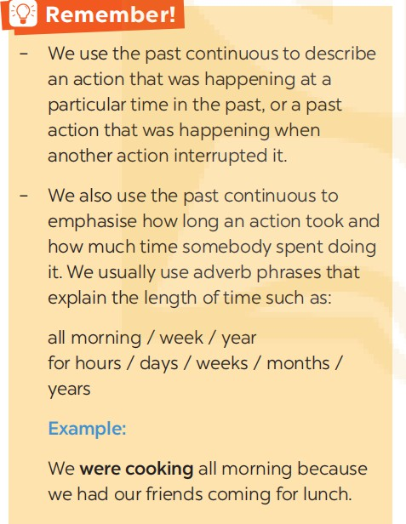
Example:
  - She was studying all day yesterday because she wanted to pass the exam.
I was waiting for you for hours. Where were you?

3.ACTIVITY 2: Wish + past simple
- To help Ss use wish + past simple in sentences;
- To help Ss practise using wish + past simple.
- Grammar explanation
- Task 3: Put the verbs in brackets in the correct forms.
- Task 4: Read the passage and write down five things that Jenny might wish for. Look at the example.
- Focus Ss’ attention on the grammar box. Explain to them the meaning and use of the structure wish + clause (past simple).Tell them to study the two examples.
- 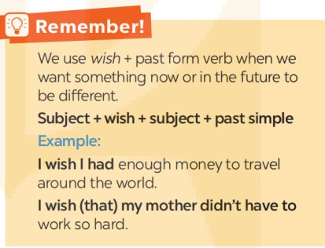
IV. PRODUCTION
- To help Ss apply wish + past simple in real situation by making sentences about themselves.
- Give them some time to work in pairs and exchange their wishes.
- T goes round giving help when and where necessary.
Suggested answers:
- I wish I had less homework every day.
- I wish I had my own room.
- I wish my best friend and I could go around the world together.

  - CONSOLIDATION
    - Wrap-up
- Summarise the main points of the lesson.
    - Homework
- Do exercises in the Workbook;
- Make 5 sentences by using past continuous and wish + past simple.
- Prepare: Unit 4: Communication

Period 30 Preparing date:9/11/2025

Test correction 1
I. Objectives: By the end of the lesson, Ss will be able to:
- Revise pronunciation, vocabulary, grammar, everyday English about leisure activities, life in the countryside,
II. Teaching aid: Textbook, stereo, CD...
III. Methods: Communicative approach, audio-lingual method, 3p, ESA, lexical approach.
  - Procedures
Part 1. Write the letter A, B, C, or D on your answer sheet to indicate the word whose underlined part differs from the other three in pronunciation in each of the following questions.
1. A. fan B. catch C. lake D. hand
2. A. host B. hour C. house D. horse
Part 2. Write the letter A, B, C, or D on your answer sheet to indicate the word that differs from the other three in the position of primary stress in each of the following questions.
3. A. occur B. open C. destroy D. support
4. A. amazing | B. dangerous | C. typical | D. beautiful

Part 3. Write the letter A, B, C, or D on your answer sheet to indicate the best answer to each of the following questions.
5. She ________ a book when the power went out.
A. read B. was reading C. reads D. is reading
6. If Nam studies hard, he the exam.
A.fail B. will fail C. won't fail D. doesn't fail
7. Do you know how ______________ a specific cuisine?
A. cook B. cooked C. cooking D. to cook
8. During my vacation in Paris, I used the metro to_______the city and visit all the famous landmarks.
- get up B. get around C. move on D. carry out
9. They usually go to the park in ______ morning.
A. a B. an C. the D. Ø (no article)
10. She was getting bored ______ listening to the same thing every day.
A. on B. for C. with D. in
11. The new buildings make the city look modern and ____________.
A. attract B. attraction C. attractive D. attracted
12. This isn’t her skirt. is blue.
  - A. Hers B. Her C. She D. He
13. He wasn’t late for school ______ the traffic was heavy.
A. because B. because of C. although D. despite
14 . I wonder if you could me a small favour, Tom?
A. bring B. make C. give D. do
15. The_________ collects and disposes of trash, keeping the neighbourhood clean and sanitary.
- Garbage collector B. police officer C. delivery person D. firefighter
16. I’m_________ with a cold. I have a runny nose and a sore throat.
A. cutting down B. running down C. breaking down D. coming down
17. - Tom: “Thanks for helping me with the project!” - Sarah: “______”
A. No problem B. I’m sorry C. Nice to meet you D. Please
18. - Mark: "We should study harder for the exam." - Jane: "______. It's a difficult subject."
A. I don’t agree B. You’re wrong C. I agree with you D. That’s not true

Part 4. Read the following short texts and write the letter A, B, C, or D on your answer sheet to indicate the best answer that goes with each text.
19. What does the sign mean?   | A. A. Everyone can come in here.  B. B. Allow us to play here.  C. C. In this area, everyone can’t enter.  D. D. This is an entrance to children’s play area.
20. What does Rachel offer to do?  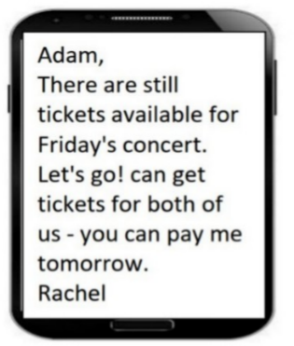 | AA. Get tickets for both of them  BB. Reserve tickets for Adam  CC. Pay for both tickets  DD. Buy tickets for Adam

21. What are the things that Mom asked her kid to pick up?  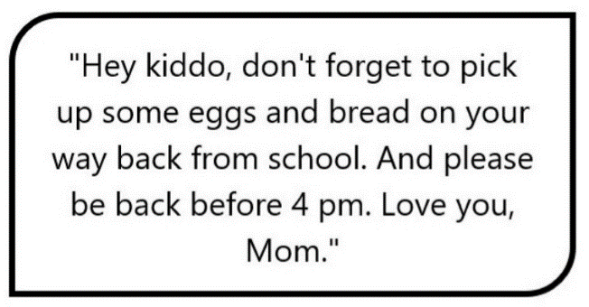 | AA. Eggs, bread, and milk  BB. Eggs and milk  CC. Bread and milk  DD. Eggs and bread

Part 5. Complete the announcement with the correct words. There are two extra words. Write your answers on your answer sheet.

notice event attend friendly inform wonderful

SCHOOL TRIP ANNOUNCEMENT! 🚌🎉

"Dear students! This is a (22) _______ about our upcoming school event. We invite everyone to (23) _______ the fun activities planned for the day. Please (24) _______ your friends and family to join us. We hope you will enjoy a (25) _______ time with us!"

Part 6. Read the following passage and choose the correct answer (A, B, C, or D) that best fits each blank.
In today’s world, taking care of the environment, (26) ______is facing serious pollution, is very important. Many people are trying to use less plastic and waste. For example, some stores now use paper bags instead of plastic ones, and (27) ______ people are recycling their bottles and cans.
(28) _______, there are still some problems. Not everyone knows how to recycle properly, which can make it (29) ______ to help the planet. Also, while small actions are good, it is important for everyone to (30) ______ together to make a big difference.

26. A. which B. who C. whose D. what
27. A. much B. few C. a lot of D. a little
28. A. Moreover B. Though C. In addition D. However
29. A. hard B. boring C. amazing D. interesting
30. A. forget B. work C. look D. ignore

Part 7. Read the following passage and write the letter A, B, C, or D on your answer sheet to indicate the correct answer to each of the questions.
In recent years, many people have become more interested in healthy eating. More fruits and vegetables are being included in diets, and many individuals are trying to reduce their intake of processed foods. This shift towards healthier eating is often driven by a desire to improve overall health and well-being.
However, there are challenges. Healthy foods can sometimes be more expensive than processed options, making it difficult for some people to maintain a healthy diet. Additionally, busy lifestyles can lead to unhealthy eating habits, such as fast food consumption.
Despite these challenges, many people are finding ways to eat healthier. Meal planning and cooking at home are becoming more popular, as they can save money and allow individuals to control what they eat.
- What is the best title for this passage?
A. The Importance of Healthy Eating B. Challenges of Healthy Eating
C. Trends in Food Consumption D. The Benefits of Cooking at Home
32. Why are many people changing their eating habits?
A. They want to eat more processed foods. B. They want to improve their health.
C. Healthy foods are always cheaper. D. They have more time to cook.
- The word desire in paragraph 1 is closest in meaning to ______.
A. plan B. need C. shift D. method
34. The word they in paragraph 3 refers to ______.
A. cooking at home B. challenges C. meal planning D. A and C are correct
35. Which of the following is TRUE according to the passage?
A. Healthy foods are always affordable for everyone.
B. Many people are interested in healthy eating despite challenges.
C. Cooking at home is not popular among busy individuals.
D. Fast food is the only option for busy lifestyles.

Part 8. Rewrite each of the following sentences in such a way that it means the same as the provided sentence. Write the answers on your answer sheet.
36. “Shall we go to the cinema?”
I suggest _________________________________________________________________
37. The red dress is more expensive than the yellow one.
The yellow dress ___________________________________________________________.
38. It took me two hours to do my homework.
→ I spent ______________________________________.
39. You work hard. You become successful.
The harder_______________________________________________________________.
40. You must concentrate on your work more.
You must apply___________________________________________________________.

– The end –

FULL NAME: ......................................................  CLASS: 9……..  MÃ ĐỀ 02 | ĐỀ KIỂM TRA GIỮA HỌC KỲ I  NĂM HỌC 2025 - 2026  MÔN TIẾNG ANH 9

Part 1. Write the letter A, B, C, or D on your answer sheet to indicate the word whose underlined part differs from the other three in pronunciation in each of the following questions.
1. A. find B. drink C. write D. like
2. A. host B. hour C. house D. horse

Part 2. Write the letter A, B, C, or D on your answer sheet to indicate the word that differs from the other three in the position of primary stress in each of the following questions.
3. A. improve | B. begin | C. divide D. travel
4. A. designer | B. director | C. teenager D. computer

Part 3. Write the letter A, B, C, or D on your answer sheet to indicate the best answer to each of the following questions.
5. He__________ in the cafe when his girl friend came.
A. sat B. has sat C. has been sitting D. was sitting
6. If we hurry up, we ______ the train.
A. catch B. will catch C. won’t catch D. caught
7. They can’t decided who ____________ first.
A. go B. to go C. went D. going
8. She is ____________ the flu. She has a runny nose and a sore throat.
A. come up with B. coming up with C. coming down with D. carrying out
9. They usually go to the park in ______ morning.
A. a B. an C. the D. Ø (no article)
10. She was getting bored ______ listening to the same thing every day.
A. on B. with C. for D. in
11. We want to encourage activities that build _________ between people
A. connecting B. connective C. connection D. connect
12. This isn’t her skirt. is blue.
- Hers B. Her C. She D. He
13. He was late for school ______ the traffic was so heavy.
A. because B. because of C. although D. despite
14 . I wonder if you could me a small favour, Tom?
A. bring B. make C. give D. do
15. The collects and disposes of trash, keeping the neighbourhood clean and sanitary.
- garbage collector B. police officer C. delivery person D. firefighter
16. I’m_________ with a cold. I have a runny nose and a sore throat.
A. cutting down B. running down C. breaking down D. coming down
17. - Tom: “Thanks for helping me with the project!” - Sarah: “______”
A. Please B. I’m sorry C. Nice to meet you D. No problem
18. - Mark: "We should study harder for the exam." - Jane: "______. It's a difficult subject."
A. I don’t agree B. I agree with you C. You’re wrong D. That’s not true

Part 4. Read the following short texts and write the letter A, B, C, or D on your answer sheet to indicate the best answer that goes with each text.
19. What does the sign mean? | AA. In this area, everyone can’t enter.  BB. Allow us to play here.  CC. Everyone can come in here.  DD. This is an entrance to children’s play area.
20. What does Rachel offer to do? | A. Buy tickets for Adam  B. Get tickets for both of them  C. Pay for both tickets  D. Reserve tickets for Adam

21. What are the things that Mom asked her kid to pick up? | A. Eggs, bread, and milk  B. Eggs and bread  C. Bread and milk  D. Eggs and milk

Part 5. Complete the announcement with the correct words. There are two extra words. Write your answers on your answer sheet.

notice trip bring intelligent plan exciting

SCHOOL TRIP ANNOUNCEMENT! 🚌🎉

"Hello, everyone! This is a (22) _______ about our school trip next week. We will visit a museum and have lunch in a park. Please (23) _______ your lunch and drinks. Don't forget to (24) _______ the trip with your friends! We hope it will be an (25) _______ day for all of us!"

Part 6. Read the following passage and choose the correct answer (A, B, C, or D) that best fits each blank.
In today’s world, taking care of the environment, (26) ______ is facing serious pollution, is very important. Many people are trying to use less plastic and waste. For example, some stores now use paper bags instead of plastic ones, and (27) ______ people are recycling their bottles and cans.
(28) _______, there are still some problems. Not everyone knows how to recycle properly, which can make it (29) ______ to help the planet. Also, while small actions are good, it is important for everyone to (30) ______ together to make a big difference.
- A. whose B. who C. which D. what
- A. a little B. much C. few D. a lot of
- A. Moreover B. Though C. However D. In addition
- A. boring B. hard C. interesting D. amazing
- A. work B. look C. forget D. ignore

Part 7. Read the following passage and write the letter A, B, C, or D on your answer sheet to indicate the correct answer to each of the questions.
In recent years, many people have become more interested in healthy eating. More fruits and vegetables are being included in diets, and many individuals are trying to reduce their intake of processed foods. This shift towards healthier eating is often driven by a desire to improve overall health and well-being.
However, there are challenges. Healthy foods can sometimes be more expensive than processed options, making it difficult for some people to maintain a healthy diet. Additionally, busy lifestyles can lead to unhealthy eating habits, such as fast food consumption.
Despite these challenges, many people are finding ways to eat healthier. Meal planning and cooking at home are becoming more popular, as they can save money and allow individuals to control what they eat.
31. Why are many people changing their eating habits?
A. They want to eat more processed foods. B. Healthy foods are always cheaper.
C. They want to improve their health. D. They have more time to cook.
32. The word desire in paragraph 1 is closest in meaning to ______.
A. plan B. shift C. method D. need
33. What is the best title for this passage?
A. Challenges of Healthy Eating B. Trends in Food Consumption
C. The Benefits of Cooking at Home D. The Importance of Healthy Eating
34. Which of the following is TRUE according to the passage?
A. Cooking at home is not popular among busy individuals.
B. Healthy foods are always affordable for everyone.
C. Many people are interested in healthy eating despite challenges.
D. Fast food is the only option for busy lifestyles.
35. The word they in paragraph 3 refers to ______.
A. cooking at home B. challenges C. meal planning D. A and C are correct

Part 8. Rewrite each of the following sentences in such a way that it means the same as the provided sentence. Write the answers on your answer sheet.
36. “Shall we come to the party?”
I suggest _________________________________________________________________
37. This book is more interesting than that one.
That book ________________________________________________________________
38. It took me two hours to do my homework.
→ I spent ______________________________________.
39. She gets fat. She feels tired.
The fatter ________________________________________________________________.
40. You must concentrate on your work more.
You must apply ___________________________________________________________.

– The end –

ANSWER KEY

ĐỀ KIỂM TRA GIỮA HỌC KỲ I
Môn: Tiếng anh
----------------------------------------------------------
40 câu X 0,25 = 10 điểm
MÃ ĐỀ 01

Part 1. Write the letter A, B, C, or D on your answer sheet to indicate the word whose underlined part differs from the other three in pronunciation in each of the following questions.
1. C. lake
2. B. hour
Part 2. Write the letter A, B, C, or D on your answer sheet to indicate the word that differs from the other three in the position of primary stress in each of the following questions.
3. D. support
4. A. amazing
Part 3. Write the letter A, B, C, or D on your answer sheet to indicate the best answer to each of the following questions.
5. B. was reading
6. C. won't fail
7. D. to cook
8. B. get around
9. C. the
10. C. with
11. C. attractive
12. A. Hers
13. C. although
14 . D. do
15. A. garbage collector
16. D. Coming down with
17. A. No problem
18. C. I agree with you
Part 4. Read the following short texts and write the letter A, B, C, or D on your answer sheet to indicate the best answer that goes with each text.
19. C. In this area, everyone can’t enter
20. A. Get tickets for both of them
21. D. Eggs and bread
Part 5. Complete the announcement with the correct words. There are two extra words. Write your answers on your answer sheet.
22. notice | 23. attend | 24. inform | 25. wonderful

Part 6. Read the following passage and choose the correct answer (A, B, C, or D) that best fits each blank.
26. A. which
27. C. a lot of
28. D. However
29. A. hard
30. B. work
Part 7. Read the following passage and write the letter A, B, C, or D on your answer sheet to indicate the correct answer to each of the questions.
- A. The Importance of Healthy Eating
- B. They want to improve their health..
- B. need
- D. A and C are correct
- B. Many people are interested in healthy eating despite challenges
Part 8. Rewrite each of the following sentences in such a way that it means the same as the provided sentence. Write the answers on your answer sheet.
36. I suggest going to the cinema./ (that) we (should) go to the cinema.
37. The yellow dress isn’t as/so expensive as the red one
The yellow dress is cheaper than the red one.
38. I spent two hours doing my homework..
39. The harder you work, the more successful you become
40. You must apply yourself to your work more/ yourself more to your work.

MÃ ĐỀ 02

Part 1. Write the letter A, B, C, or D on your answer sheet to indicate the word whose underlined part differs from the other three in pronunciation in each of the following questions.
1. B. drink
2. B. hour
Part 2. Write the letter A, B, C, or D on your answer sheet to indicate the word that differs from the other three in the position of primary stress in each of the following questions.
3. D. travel
4. C. teenager
Part 3. Write the letter A, B, C, or D on your answer sheet to indicate the best answer to each of the following questions.
5. D. was sitting
6. B. will caught
7. B. to go
8. C. coming down with
9. C. the
10. B. with
11. C. connection
12. A. Hers
13. A. because
14. D. do
15. A. garbage collector
16. D. Coming down with
17. D. No problem
18. B. I agree with you
Part 4. Read the following short texts and write the letter A, B, C, or D on your answer sheet to indicate the best answer that goes with each text.
19. A. In this area, everyone can’t enter.
20. B. Get tickets for both of them
21. B. Eggs and bread
Part 5. Complete the announcement with the correct words. There are two extra words. Write your answers on your answer sheet.
22. notice | 23. bring | 24. plan | 25. exciting
Part 6. Read the following passage and choose the correct answer (A, B, C, or D) that best fits each blank.
- C. which
- D. a lot of
- C. However
- B. hard
- A. work
Part 7. Read the following passage and write the letter A, B, C, or D on your answer sheet to indicate the correct answer to each of the questions.
31. C. They want to improve their health.
32. D. need
33. D. The Importance of Healthy Eating
34. C. Many people are interested in healthy eating despite challenges.
35. D. A and C are correct
Part 8. Rewrite each of the following sentences in such a way that it means the same as the provided sentence. Write the answers on your answer sheet.
36. I suggest coming to the party./ (that) we (should) come to the party
37. That book isn’t as/ so interesting as this book
That book is more boring than this book
38. I spent two hours doing my homework.
39. The fatter she gets, the more tired she feels
40. You must apply yourself to your work more/ yourself more to your work.
– The end –

IV. Homework:
- Prepare for unit 4 : Communication

