Date of preparing: 21/9/2025

Period 7: UNIT 1: LOCAL COMMUNITY

Lesson 6: Skills 2
A. OBJECTIVES:
By the end of this lesson, Ss will be able to:

Knowledge
- Listen for specific information about a community helper.
- Write a paragraph about a community helper.

Competences
- Develop communication skills and creativity.
- Be collaborative and supportive in pair work and teamwork.

Personal qualities
- Be friendlier and willing to help the community.
- Actively join in class activities.

B. TEACHING AIDS
- Grade 9 textbook, Unit 1, Skills 2
- Computer connected to the Internet
- Projector / TV
- hoclieu.vn
C. PROCEDURES:
* WARM-UP: Brainstorming
-Have Ss say aloud the names of community helpers they know and have learnt. Ask them who is their favourite community helper and why. Encourage Ss to share their answers.
-Lead into the new lesson: Listening and Writing about favourite community helpers.
-Introduce the objectives of the lesson.
-Write the objectives in the left corner of the board.
- Students answer the questions.
- Student’s answers
I.PRE-LISTENING:
Task 1: Work in pairs. Discuss the questions.
- Have Ss look at the pictures and answer the questions in the book:
Who can you see in the pictures?
What are they doing?
- Elicit answers from Ss. This is an open activity, so accept all answers provided they make sense.
- Students work in pairs to discuss the questions.
Suggested answers:
We can see garbage collectors.
They are taking the garbage away.
- Choose to teach some key words that appear in the listening text if necessary (reflective stripes, garbage cart, sorting, ...)
II.WHILE-LISTENING:
Task 2: Listen and fill in each blank with no more than two words.
- Tell Ss that they are going to listen to a radio broadcast about a
community helper.
- Have Ss read the questions first
and underline the keywords. Have them indentify the kind of information needed for each blank (e.g. blank 1: noun / name of the contest; blank 2: noun / his job...)
- Play the recording and ask Ss to listen and fill in each blank with no more than two words. Ss work in pairs to compare their answers.
- Ask for Ss’ answers and write them on the board without confirming whether they are right or wrong.
- Students find the key words independently and then listen to the recording to do the task.
- Students compare the answers with their partners.
- Some students go to the board to write the answer and then check with the whole
class.
Key:
- Community Helper
- garbage collector
- slim
- friendly
Audio script:
This is An Binh Commune Radio Station. In today’s special programme, we will share with you a piece of writing which won first prize in our writing contest called “My Favourite Community Helper”. This was written by Mi, a grade 9 student. There are many great community helpers in our neigbourhood but my favourite one is MrVinh, the garbage collector. Mr Vinh is a tall and slim man. He usually wears a green uniform with reflective stripes. He is hard-working and responsible. Every day he goes to our neighbourhood at 6 p.m. with a garbage cart. He instructs everyone to put garbage in the correct bin: recyclable and non-recyclable, and then goes to the next neighbourhood. At about 9 p.m. he comes back.and empties all the bins carefully. Mr Vinh is also friendly. He usually keeps a smile on his face. He talks with the people in our community cheerfully about his work and the importance of sorting rubbish. We all love him.
Task 3: Listen again and tick T (True) or F (False).
- Tell Ss that they are going to listen to the broadcast again and decide if each statement is true or false.
- Have Ss read the statements and underline the keywords. Have Ss guess whether each statement is true or false based on their previous listening. Invite some Ss to share their answers. Write their answers on the board.
- Play the recording and ask Ss to listen again and check their answers.
Ss work in pairs to compare their answers with each other and with the answers on the board.
- Play the recording once more for pairs to check their answers to both activities 2 and 3.
- Ask for Ss’ answers to Activity 2.
Confirm and tick the correct answers. Ask for Ss’s answers to
Activity 3. Write them on the board next to their guesses. Confirm the correct answers.
- Some students go to the board to write the answer and then check with the whole
class.
Key: 1. F, 2. F, 3. T, 4. T
Transition from Listening to Writing
Have Ss answer these five questions about Mr Vinh:
- What is his job?
- What does he look like?
- What is he like?
- What does he do to the community?
- How does Mi feel about him?
III. PRE-WRITING:
Task 4: Work in pairs. Choose a community helper you like and answer
-Have Ss work in pairs to answer the questions in the book. Remind them to take notes of their answers.
- Have some Ss present their answers or write their answers on the board.
- Comment on their answers.
V.WHILE-WRITING:
Task 5: Write a paragraph (about 100 words) about your favourite community helper. Use the answers to the questions in 4 to help you
- Have Ss write their paragraphs individually based on their answers in Activity 4.
- Ask one student to write his or her paragraph on the board. Other Ss and T comment on the writing on the board.
- Then teacher collects some writings to correct at home.
Otherwise, ask Ss to revise and rewrite at home based on the T’s comments on their friends’ writing
- Students work to write their full paragraph.
- Students pay attention while the teacher is checking their work.
Suggested answer:
My favourite community helper is Mr Nam. He is a delivery person in my neighbourhood. He is a friendly person. Whenever he delivers something to us, he smiles happily. He sometimes asks me about my study. In addition, he is hard-working and responsible. He delivers goods to my family and other families in the neighbourhood despite the weather. Sometimes he has to return twice to deliver us a parcel because we are not at home. I really appreciate his manner. In general, Mr Nam is a very dedicated community helper who makes our life easy and comfortable.
IV. WRAP-UP:
-Ask Ss to summarize what they have learnt in the lesson.
V. HOMEWORK
-Rewrite the paragraph in the notebooks.
-Do exercises in the workbook.
-Prepare next lesson.(Lookingback and projects)

Date of preparing: 21/9/2025

UNIT 1: LOCAL COMMUNITY
Period 8: Lesson 7: LOOKING BACK + PROJECT
A. OBJECTIVES:
* By the end of this lesson, students will be able to:
1. Knowledge:
- Review the vocabulary and grammar of Unit 1;
- Apply what they have learnt (vocabulary and grammar) into practice through a project.
2. Competences
- Develop communication skills and creativity;
- Develop presentation skill;
- Be collaborative and supportive in pair work and teamwork.
3. Quality/ behavior:
- Be encouraged to attend community services;
- Actively join in class activities.
B. TEACHING AIDS:
- Teacher: Text book, laptop, loudspeaker, projector…
- Students: Text books, studying equipment….
- Method: T-WC; group works; individual ……
C. PROCEDURE:
1. ACTIVITY 1: WARM UP & INTRODUCTION
Game: Golden Bell
- Divide the board, and divide the class into 4 teams.
- Members of each team take turns choose and answer questions.
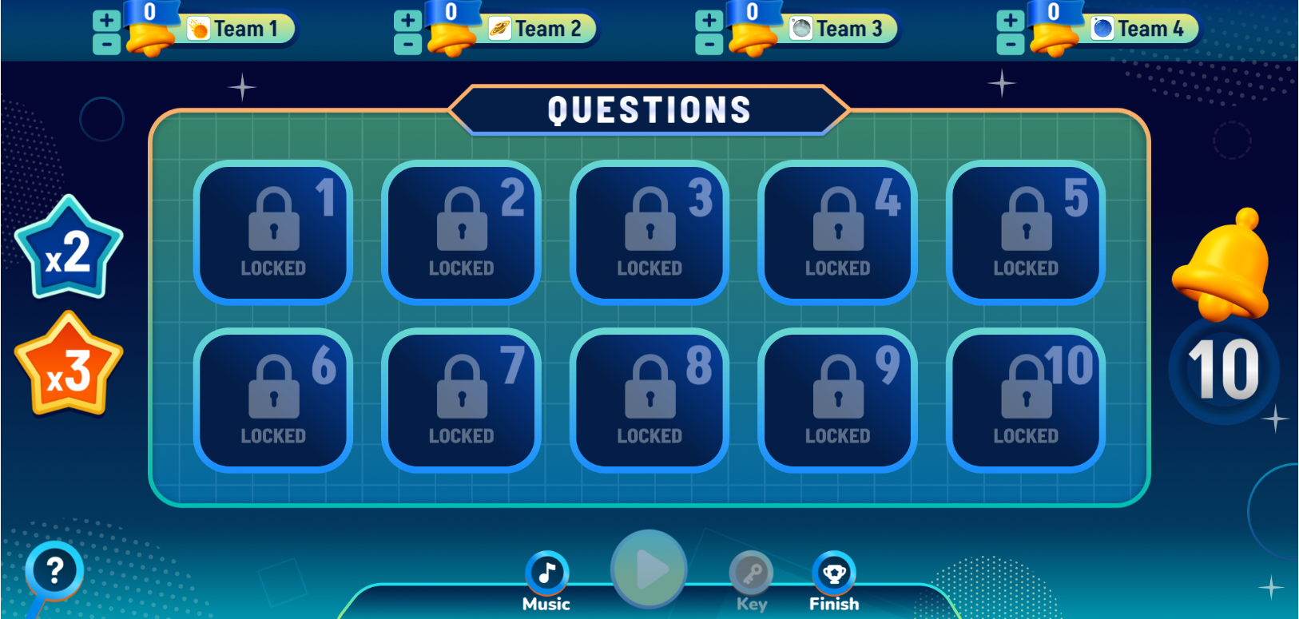
- Teacher confirm the correct answers.

2. ACTIVITY 2: KNOWLEGDE FORMATION ACTIVITIES
Exercise 1: Write a word or phrase for each description below.
Write a word or phrase for each description
- Have Ss do this activity individually then compare their answers with their partners
- Ask for Ss answers or ask one student to write his/her answer om on the board
- Confirm the correct answers
Key: 1. delivery person 2. firefighter 3. tourist attraction 4. pottery 5. artisan
Exercise 2: Choose the correct word or phrase to complete each sentence
- Choose the correct word or phrase to complete each sentence
- Have Ss do this exercise individually
- Ask them to share their answers with a classmate
- Invite some Ss to share their answers.
- Confirm the correct ones
Key: 1. preserve 2. fragrance 3. police officers 4. speciality 5. handicrafts
3. ACTIVITY 3: PRACTICE ACTIVITIES
Exercise 3: Choose the correct answer A, B, C, or D
- Ask Ss about the verbs and the question words that can be used in this kind of structure
- Have Ss do this exercise individually then compare their answers with a partner.
- Call on some Ss to give the answers
- Confirm the correct answers
Key: 1. B 2. C 3.D 4.A 5. C
Exercise 4: Rewrite each sentence so that it contains the phrasal verb in brackets. You make have to change the form of the verb.
Rewrite each sentence so that it contains the phrasal verb in brackets. You make have to change the form of the verb
- Tell Ss that they are going to rewrite the given sentences using the phrasal verbs given in brackets. - Model with the first sentence. Underline the verb ‘reduce’ and write down the new sentence, using ‘cut down on’ instead of ‘reduce’. Remind Ss that they may need to change the form of the verb given. Ask them to read the example on the board carefully.
- Have Ss do this exercise individually then compare their sentences with a partner. - Invite some Ss to write their sentences on the board. Give feedback.
Key:
1. In some villages, people cut down on the number of steps to make the handicraft.
2. My grandparents handed down the skills to my parents.
3. In their community, the eldest child usually takes care of his or her parents.
4. Before we go to a new place, we always find out about it.
5. They get on with all neighbors.
4. ACTIVITY 4: APPICATION
Project
Students are able to give an oral presentation of survey results.
As Ss have prepared for the project throughout the unit, the focus of this lesson should be on the final product, which is an oral presentation of the survey results.
- Have Ss work in their groups. Give them a few minutes to prepare for the presentation.
- Give Ss checklists for peer and self-assessment. Explain that they will have to tick appropriate items while listening to their classmates’ presentations and write comments if they have any. The presenters should complete their self-assessment checklists after completing their presentation.
- If necessary, go through the criteria for assessing their talk to make sure Ss are familiar with them.
Invite two or three groups to give their presentations. Encourage the rest of the class to ask questions at the end.
• Give praise and give feedback after each presentation. T can summarize the feedback given by other Ss and add any other comments. T can also give Ss marks for their presentation as part of their continuous assessment.
*WRAP-UP
- Summarize the main points of the lesson.
* HOMEWORK
- Redo exercises in looking back unit 1
- Students’ workbook: Part E
- Prepare: Unit 2: Getting started.

Planning date : 21/9/2025
Period 9
UNIT 2: CITY LIFE

LESSON 1: Getting started

How is your city?
A. OBJECTIVES:
1. Knowledge: By the end of the lesson, Ss will be able to:
- Use the lexical items related to the topic of city life.
- Interact a conversation about life in London and a city in Vietnam; talk about the things can do there.
a,Vocabulary: vocabulary related to city life.
b, Grammar: recognise and use double comparatives and some phrasal verbs.
c, Skills: Listening, reading and speaking.
2. Competences: develop the competences of- self-study, communication, cooperation, using languages and problem solving in doing exercises.
3. Qualities:
- Be ready to explore other cities in different countries and think about their solutions of city problems.
- Develop self-study skills
B. TEACHING AIDS:
1. Teacher: Textbooks, TV, teaching plan, teacher’s book, website sachmem.vn; hoclieu.vn ….
2. Students: Text books, notebooks….
C. PROCEDURE:
* Warm up: Chatting
Ask Ss to look at the pictures on pages 18-19 and answer the questions below.
- What do you see in each picture?
Ss: traffic jam/ traffic congestion; a construction site/ some construction workers; the cinema…
- Are the things in the pictures common in your hometown?

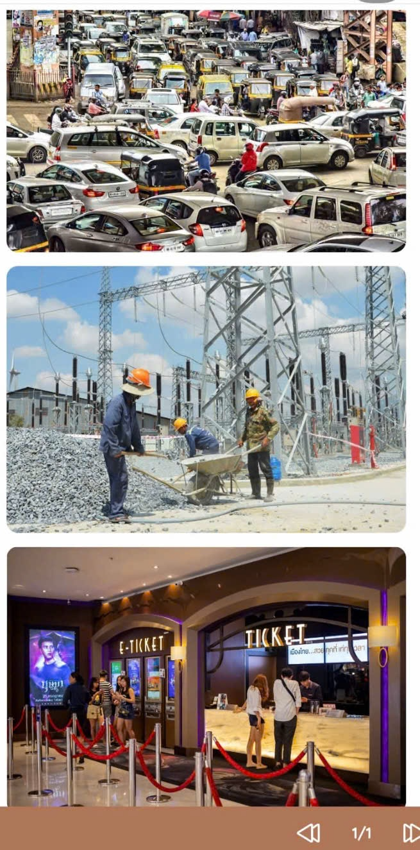
I. Pre-reading:
Task 1,2: Leading into the conversation and understand it.
- T shows the conversation and asks Ss some questions to elicit from Ss that Trang and Ben are living in different cities, and Ben is in London:
+ Who are in the conversation?
+ Where do they live?
+ What are they talking bout?
- T asks Ss to guess T/F statements: Ss work in 2 teams
 |  | T | F
1 | The bus in Trang's city is slow and crowded.
2 | The underground system in Ben's city is unreliable.
3 | There is a dusty and noisy construction site near Trang's house.
4 | Trang thinks new buildings make the city look ugly.
5 | Both Trang and Ben find shopping malls expensive.
II. While- reading:
Listen and Read:
- Ss read the conversation again and do the exercise individually. Then the whole class check and correct.
Key:
1.T
2. F =>It is more realiable than the bus
3.T
4. F => Trang thinks new buildings make the city look modern and attractive.
5. T

Task 3: Introduce some vocabulary items related to the topic by matching the words/ phrases with their pictures.
- Ss work in pairs to do the task: look at the pictures and guess the words and phrases that describe them.
- Ss to share answers before discussing as a class.
- Check and confirm the correct answers.
Key: 1. B / 2.C / 3. A / 4. E / 5. D
Vocabulary:
- Congested road: đường bị tắc nghẽn /əʊ/
- Construction site: công trường xây dựng
- The underground: tàu điện ngầm /aʊ/
- Itchy eyes: ngứa mắt, dị ứng mắt
- Entertainment centre: trung tâm giải trí

Task 4: Remind Ss of some more words/ phrases related to the topic by choosing the correct answer A, B, C, or D.
- Ss work individually to answer the questions, then compare their answers with a partner.
1. I like getting around by the smell of car exhaust. I hate………………
A. underground B. private car C. taxi D. bus
2. Road dust may badly affect our…………………….
A. stomach B. back C. eyes D. leg
3. There's a………………… It's noisy and dusty. in my neighbourhood.
A. building B. construction site C. hospital D. lake
4. The road is narrow, so……………… often occurs at rush hour.
A. traffic light B. traffic flow C. traffic congestion D. traffic safety
5. Many teens fancy spending their weekends in an entertainment………………
A. industry B. value C. business D. centre
- Call on some pairs to give the answers.
- Confirm the correct answers.
Key:
- A
2. C
3. B
4. C
5. D
III. Post-reading:
Help Ss identify some common differences between living in a city and in a village by completing the quiz.
Task 5: QUIZ A lifestyle survey: City life or village life?
Complete the quiz. Then compare your choices with your friends' and the teacher's explanation. Which suits you more, life in the city or in a village?
1. What kind of house do you want to live in?
A. A small and modern apartment.
B. A house with a garden.
2. How do you like to get around?
A. By public transport.
B. By motorbike or bicycle.
3. Where do you frequently enjoy visiting?
A. Shops, restaurants, cinemas, and art galleries.
B. Local farmers' markets.
4. How do you describe your favourite neighbourhood?
A. Crowded and busy.
B. Quiet and green.
5. How do you like to spend time outdoors?
A. Going for a walk or running in the park.
B. Doing gardening or visiting next-door neighbours.
- Set a time limit of 3 - 4 minutes for Ss to do this activity individually.
- Have Ss compare their choices with their friends. They can ask each other to guess which type of life suits them more, city life or village life.
- Tell Ss that in general, Options A in all sentences describe common things in a city while Options B are more often related to life in a village.
- Take a show of hands to see which option is more popular.
- Draw a table with City life in one column and Village life in the other column. Ask Ss to add more ideas to each column.
Key:
- Mostly A: City life suits you more.
- Mostly B: Village life suits you more.
IV. WRAP-UP
- Ask one or two Ss to tell the class what they have learnt.
- Ask Ss to say aloud some words and phrases they remember from the lesson.
- Ask Ss find out the words/ phrases that contain the diphthong sounds /au/, /ǝช/, and /eǝ/ in this lesson such as slow/ road, around/ underground, there and tell Ss to say them out loud.
V. Homework
- Do exercises in the workbook
- Make 5 sentences using new words that you have learnt
- Get ready for A Closer look 1.

