Planning date: 27/9/2025

UNIT 2: MY HOUSE
Period 10/ Lesson 2: A closer look 1
A. Aims:
1. Knowledge:
By the end of the lesson, ss will be able to: use the lexical items related to the topic My house; use the vocabulary and structures to talk about the names of rooms and furniture pieces in the house; and pronounce and recognize the sounds /s/ and /z/.
2. Qualities: show their love to their home, talking about their house with positive attitudes.
3. Competences: enhance self-learning capability, group work, pair work, linguistic competence, cooperative learning and communicative competence.
B. Teaching aids:
- laptop, loudspeaker, TV/ projector.
C. Procedure:
* Warm up: * Jumbled words
- T asks students to work independently to rearrange letters to find out the correct word, the ask them to write the correct words on the board.
- T corrects and confirms the answers.
Answer key:
1. tchekin 1. kitchen
2. thraobom 2. bathroom
3. rodeomb 3. bedroom
4. lngivi moro 4. living room
5. lahl 5. hall
- T leads students into the lesson by telling them that “In today lesson, we are going to learn more words to describes rooms and furniture and two sounds /s/ and /z/.”
I. Vocabulary:
1. Presentation
* Matching (Task 1)
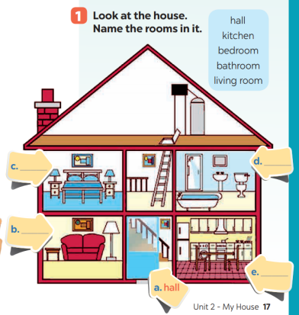- T asks Ss to look at the picture and then
match the word with the picture.
- T tells students to compare their answers
with their partners.
- Answer key:
a. hall
b. living room
c. bedroom
d. bathroom
e. kitchen
2. Name the things in each room in Ex. 1 (Task 2).
- T asks students to work in pairs to do this activity.
- T writes the names of the rooms on the board in different places, then calls on students from different pairs to go to the board and write the name of the furniture under these rooms.
- T remind students that one piece of furniture can belong to more than one room.
- T asks other students to comment and asks them if they can add some more things to each room.
Suggested answers:
- Bedroom: lamp, picture, chest of drawers
- Living room: lamp, sofa, picture
- Hall: picture
- Kitchen: fridge, cupboard, dishwasher, sink
- Bathroom: shower, sink, toilet
Other words: chair, fan, air conditioner, cooker, etc.
2. Practice: Guessing game (Task 3)
- T models this activity with a student.
- T asks students to work in pairs: one student thinks of a room in his / her house; the other asks questions to guess the room.
- T calls some pairs to practise in front of the class.
- T comments on their performance.
Example:
Ss 1: What’s in your room?
Ss 2: A lamp and a chest of drawers.
Ss 1: Is it the bedroom?
Ss 2: Yes.
2. New words:
- chest of drawers (n): tủ có ngăn kéo
- sink (n): bồn rửa

- dish washer (n): máy rửa chén

- cupboard (n): tủ chén

- air conditioner (n): điều hòa không khí
- T shows the English words on the board
- T asks ss to give the Vietnamese meanings of the words.
- T writes on the board.
II. Pronunciation:
- 1. Presentation:
- T introduces 2 sounds s/ and /z/ to students and lets them listen and repeat the words in Ex. 4 (p. 18).
- T has students comment on how to pronounce these two sounds at the end of the words.
- T quickly explains the rules:
+ Final –s is pronounced /s/ after voiceless sounds (/t/, /p/, /k/, /f/, /θ/).
+ Final –s is pronounced /z/ after voiced sounds (/b/, /d/, /g/, /n/, /m/, /l/, etc.) and any vowel sounds.
- T asks students to give some words they know containing these sounds.
Suggested answers:
- /s/: cats, lamps, books, months
/z/: beds, dogs, cans, rooms, videos, cookers, bees+ Final –s is pronounced /s/ after voiceless sounds (/t/, /p/, /k/, /f/, /θ/).
+ Final –s is pronounced /z/ after voiced sounds (/b/, /d/, /g/, /n/, /m/, /l/, etc.) and any vowel sounds.
- Teacher asks students to give some words they know containing these sounds.
2. Practice: *Listen and write the words in the correct column. (Task 4)
- T asks students to read and listen again the words, then put them in the correct column.
- Ss work individually.
- T plays the recording for students to listen, repeat and check their answers.
Answer key:
/s/ | /z/
lamps, sinks, flats, toilets, | cupboards, sofas, kitchens, rooms
* Listen to the conversation. Underline the final “s” in the words and put them into the correct column. (Task 5)
- Have students quickly read the conversation and underline the final “s” in the words. Now play the recording for students to listen to the conversation and write /s/ or /z/ under each “s” that they have underlined.
- Tell them to put the words with the final “s” in the correct column according to the sound of “s”. Have them work in pairs to compare their answers. Check students’ answers. Ask them to explain their answers.
Answer key:
/s/: chopsticks, lamps
/z/: bowls, things, homes
Play the recording again for students to repeat each line of the conversation. Ask students to work in pairs to practice the conversation. Call some pairs to practise the conversation. Comment on their pronunciation of the final “s”.
III. Production: Game: Whispering
- Teacher divides the class into 4 big groups and asks students to stand in four lines.
- The member in the last place will make a sentence containing at least a word and a sound they have learnt; then, whisper the sentence to the next member of the group. They will continue until the member in the first place and this member will say the sentence aloud.
- The fastest group will win the game.
Suggested sentences:
- There are two bedrooms in my house.
- My living room has a TV, two lamps, some pictures and a sofa.
IV. Wrap – up
- T asks students to talk about what they have learnt in the lesson.
V. Homework:
- Learn by heart the new words.
- Find 5 more words with the sound /s/ and 5 more words with the sound /z/. Write them down and practice pronouncing the words.
- Do exercise part A in workbook.
- Prepare Unit 2- A closer look 2

Planning date:27/9/2025
UNIT 2: MY HOUSE
Period 11/ Lesson 3: A closer look 2

A. Aims: By the end of the lesson, Ss will be able to
1. Knowledge: know how to use the possessive case and prepositions of place correctly.
2. Qualities: - Ss identify the correct form of possessive case.
- Ss identify different prepositions of place.
3. Competences: Ss will be able to practise forming the correct form of possessive case and using prepositions of place.
- Co-operation
- Self- study creatively
- Practise communicative skills
B. Teaching aids:
Textbook, planning, laptop, projector or TV
C. Procedure:
* Warm up: Game: Memory game
- Teacher divides the class into 4 groups.
- Teacher tells Ss the rulers of the game:
+ Ss have to study the picture of 3 people(Jack, Polly and Greg) nad try to remember the things belonging to each person in 30 seconds without writing down in their notebooks.
+ After 30 seconds, teacher shows the things of Jack, Polly and Greg and a member of each team has to answer quickly.
+ The group with more correct answer sentences will be the winner.
- Suggested sentences:
- Whose jumper is it?
- It’s Polly’s jumper
2. Whose T- shirt is it?
- It’s Greg’s T-shirt.
3.Whose ball is it?
- It’ Jack’s ball.
4. Whose sock is it?
- It’s Jack’s sock.
……………………………….
I. Presentation:
* The possessive case:
1. Form:
-> Name’s + noun = Polly’s sock
-> singular’s + noun = teacher’s book
2. Use: We use “s” to show possession.
* prepositions of place: in, on, at, under…
- Teacher asks Ss what prepositions of place you know.
Encourage Ss to say as many as possible.
- Have them look at the Remember box to see if the prepositions they have mentioned are the same.
- Teacher confirms how to use prepositions of place: We use prepositions of place to describe where people or things are. (in, on, at, under, behind, in front of, opposite, next to…)
II. Practice:
1. Choose the correct answer.
- Teacher asks Ss to do the exercise individually and then compare their answer with a classmate.
- Check the answer as a class.
- Teacher confirms the correct answers.
- Answer key:
1. Grandmother’s
2. sister’s
3. cousin’s
4. Nam’s
5. An’s

- Complete the sentences with the correct possessive forms.
  - Teacher has Ss do this exercise individually and calls on two Ss to write their answers on the board.
  - Draw all Ss’attention to the board and check the answers together.
  - Confirm the correct answers.

Answer key:
1. Mi’s
2. teacher’s
3. Nick’s
4. father’s
5. brother’s

- Write the correct preposition in the box under each picture .
- Teacher has students do this exercise 3 in pairs, then asks for Ss’ answer and confirms the correct answers.
- Teacher has Ss work in pairs to say sentences describing the pictures. Move around to offer help if needed.
- Teacher calls on some Ss to say their sentences. If there is time, ask some Ss to write their sentences on the board.
Answer key:
1. on 2. next to 3. behind 4. in 5. In front of 6. Between 7. under

- Decide the true or False statements:
  - Teacher has Ss look at the picture of the room and asks them to describe the room briefly, then has them read each sentence is true or false. If it is false, ask them to correct it.
  - Teacher has Ss do this exercise individually before they share their answers with a partner. Ask some Ss to read out their answers.
  - Teacher confirms the correct one.
Answer key:
- T
- F(The school bag is under the table)
- F(The clock is between the two pictures)
- T
- F(The cap is on the pillow)
III. Production:
* Memory challenge
- T has Ss work in pairs to play the game Memory challenge
- Ss look at the picture in EX4 for 30 seconds and then cover it.
They ask and answer the questions about the position of the things in the picture.
- T invites some pairs to perform in front of the class.
Example: Where are the books?
They are on the table.

IV. Wrap - up:
-To consolidate what students have learnt in the lesson.
Teacher asks students to talk about what they have learnt in the lesson.

V. Homework:
- Revise what they have learnt (possessive case and prepositions of place).
- Do Ex part B in work book on page 10,11.
- Prepare: Communication.

Planning date: 27/9/2025
UNIT 2: MY HOUSE
Period 12/ Lesson 4: Communication
A. Aims: By the end of the lesson:
1. Knowledge: Students will be able to identify how to give suggestions and describe their house in English.
2. Qualities: Students will be able to enhance their love for their house.
3. Competences: Students will be able to draw & descibe their house; be more confident to present their house in front of class; communicate and cooperate; and develop their creativity.
B. Teaching aids: Text book, computer, projector/ TV, cassette
C. Procedure:
* Warm up: Set the scene
- T asks Ss to look at the picture on the screen and answer the questions.
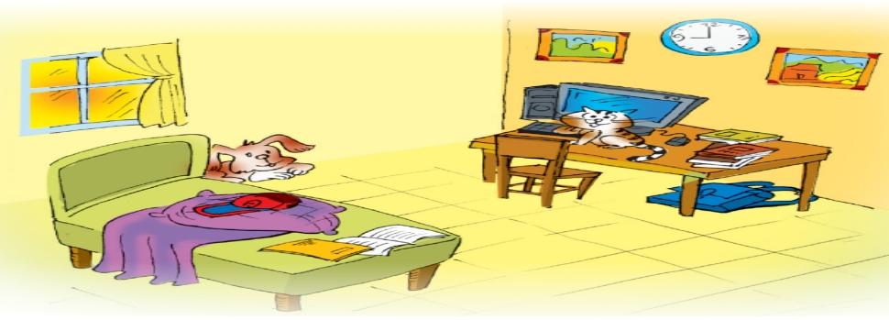
- T asks: What type of room is it?
Is it nice?
How can we make it nice?
- T leads in the new lesson.
I. Pre- speaking: Everyday English
Listen and read the conversations (Task 1)
- T plays the recording for Ss to listen and read the conversation at the same time.
Elena: My bedroom isn’t nice.
Mum: How about putting a picture on the wall?
Elena: Great idea, Mum.
Mum: Let’s go to the department store to buy one.
…
- T has Ss practise the conversations in pairs.
- T calls on some pairs to practise the conversations in front of the class.
- T asks Ss to pay attention to the sentences and phrases used to ask for and give directions
- T elicits the structures to give suggestions from Ss.

Giving suggestions
+ How about + Ving….?
+ Let’s + V(bare)+……
+…
+…
+…

- T asks Ss to copy down the structures and phrases into their notebooks.
II. While - speaking:
1. Make similar conversations (Task 2)
- T asks Ss to work in pairs to make similar conversations for the picture below, using the structures for giving suggestions.

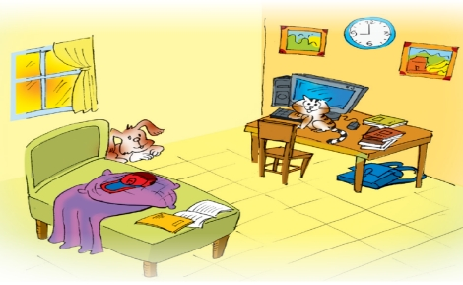
Example:
A: My bedroom isn’t nice. I don’t know how to decorate.
B: How about putting a bookshelf on the wall next to the window?
A: Great idea.
B: Let’s go to the department store to buy one.
………
- T encourages them to give suggestions to decorate their classroom more beautifully.
- T moves around to observe and provide help.
- T calls on some pairs to practise in front of the class.
- T asks for and gives comments on their performance.
2. Complete the sentences: Living places (Task 3)
- T asks Ss to look at the picture of Mi’s grandparents’ house and answer the questions.
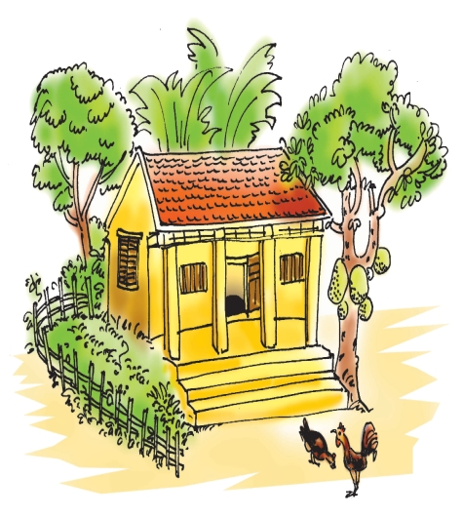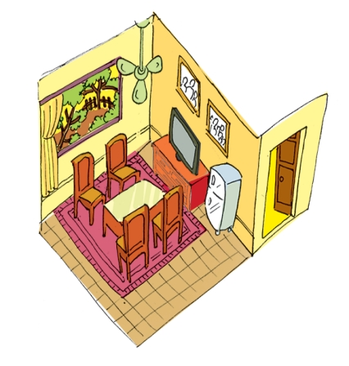
- Where is this house? /Is it a country house or a city house?
- T asks Ss to work in pairs to look at the pictures of Mi’s grandparents’ house and complete the sentences in 2 minutes.
1. My grandparents live in a house in Nam Dinh.
2. There four rooms in the house and big garden.
3. I like the living room. There a big window in this room.
4. There are four and a table in the middle of the room.
5. There are two family photos the wall.
- T checks with the whole class.
Key: 1. country 2. are 3. is 4. Chairs 5. On
- T asks Ss to describe the house using these given sentences and the linking words.
3. Finding the differences between the two houses. Task 4
- T asks Ss to look at the two pictures (Nick’s house on page 21 and Mi’s house on page 25) in pairs.
* Student A look at the picture of Nick’s house on page 21.
* Student B look at the picture of Mi’s house on page 25.
Ask questions to find the differences between the two houses.
Example:
T: Look at Nick’s house: Nick lives in a country house. Where does Mi Live?
Ss: She lives in a town house.
T: How many rooms are there in Mi’s house?
Ss: There are six rooms. What about Nick’s house? How many rooms are there?
…..
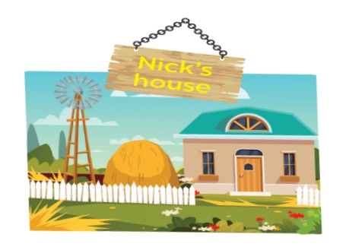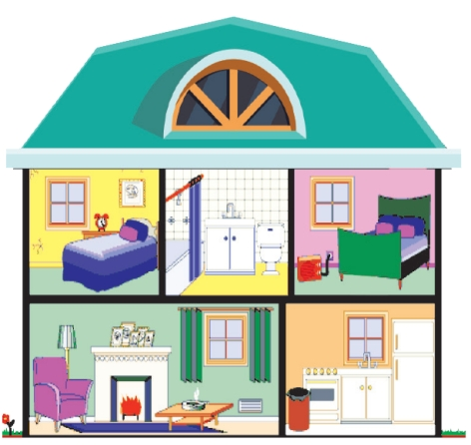
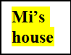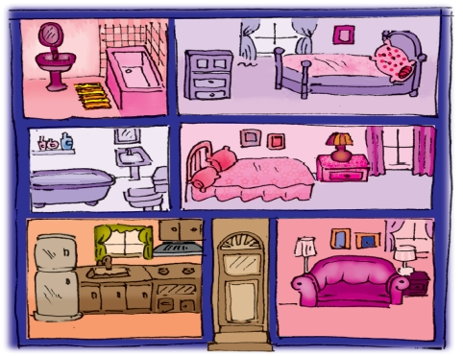
III. Post – speaking
1. Drawing a simple picture of Ss’own house and telling their partner about it. (Task 5)
- T asks Ss to work individually (drawing their house).
- T asks Ss to work in pairs to tell each other about their house (Ss note down the differences between their houses).
- T asks some Ss to describe their friend’s house to the class.
- After each student has finished his/ her talk, T asks for and gives comments on his/ her presentation.
IV. Homework:
- Learn by heart ways to give suggestions.
- Complete the drawing and practise presenting it.
- Do exercises C1,2,3 (P12,13 in WB)
- Get ready for “Skills 1”

