Planning date: 5/10/2025.
Period 13
UNIT 2: MY HOUSE

Lesson 4: SKILLS 1

A. Aims: By the end of the lesson:
1. Knowledge:
- students will be able to understand the description of a room at the Crazy House Hotel in Da Lat; describe one room (in their imagination) in that hotel.
- students will be able to develop their reading skill for specific information (scanning).
2. Qualities: To teach SS to work hard, love their house.
3. Competences: Co-operation, self- study
B. Teaching aids: laptop, TV
C. Procedure:
* Warm up: Shark attack
Teacher divides the class into 2 teams.
Then, teacher lets students play “Shark attack” to find the hidden words.
C R A Z Y
The team which finds the word first will be the winner
I. Pre - reading
Reading skill: Predicting
Teacher asks students to read the “Reading skill” box and explains any words that Ss do not know.
Teacher tells students that predicting is an important reading skill that can help them have a general understanding of the text.
* Set the scene:
1. Is it an email or a letter?
2.What is the text about?

Teacher tells students to quickly look at the text, the pictures and answer the questions.
Teacher asks for students’ answers.
Then teacher tells them to read the text quickly to check their prediction.
After that, teacher confirms the correct answers.
Answer key:
1. It’s an email.
2. The text is about Nick’s room at the Crazy House Hotel
II. While-Reading
Task 1: Read the text and answer the questions. (Ex. 2, p. 22)
Teacher lets students look at Ex. 2 on p. 22 and tells them how to do this kind of exercise:
+ Read the questions.
+ Underline the key words.
+ Locate the key words in the text.
+ Read that part and answering the questions.
Teacher has students read the text in detail to answer the questions and tells them to underline parts of the email that help them with the answers.
Teacher tells them to compare their answers in pairs before giving the answers to teacher.
Teacher asks them to give evidence when giving the answers.
Play a game of lucky room
Answer key:
1. He’s in Da Lat with his parents.
2. There are ten rooms.
3. Because there’s a big tiger on the wall.
4. It’s under the bed.
Task 2: Circle the things in the Tiger Room.
(Ex. 3, p. 22)
Teacher asks students to read through the words given and then locate them in the text. If they find a similar word in the text, they should circle it in the list.
Teacher has students compare their answers.
Teacher checks and confirms the correct answers.
Answer key:
a window
a lamp
a wardrobe
a desk
Pre-teach vocabulary
Vocabulary
Teacher introduces the vocabulary by:
+ Providing the synonym or antonym of the words.
+ Providing the pictures of the words.
+ Providing the definition of the words.
-. wardrobe (n) [visual]: tủ quần áo
-. desk (n) [visual]: cái bàn
- strange (adj) = crazy: kì lạ, lạ thường
- shape (n): hình dạng
- mess (adj): lộn xộn, bừa bộn
III.Post-Reading: Speaking + Communication
Ask students what to include when they want to describe a room in the hotel. Here are some things:
• Name of the room
• Reason for the name
• Position of things in the room
Write these points on the board and retell “Tiger room” to their partners.
Task 4: Create a new room for the hotel. Draw a plan for the room. (Ex. 4, p.22)
Teacher tells each student to create a new room for the hotel and draw a plan for the room.
Teacher sets a time limit for students to do it.
Teacher asks students to give the room a name and bear in mind the organisation of the room including the things in the room and their position.
Have them note down quickly these ideas.

- Why is the room called the … room?
(Dog / Cat / Horse / Dolphin)
- Where is your bed?
(under the window / next to the door / in the corner / in the middle of the room / …)
- What are there in your room?
(a TV / a fridge / air-conditioner / a piano, …)
- How is your room?
(big / bright with a lot of windows / cool / clean / dirty / messy / tidy / nice / …
Task 5: Describe your plan. (Ex. 5, p. 22)
Have students work in pairs and show the plan to their partner. Ask students to take turns to describe their rooms.
Remind them to focus on the three points on the board. Move around to observe and offer help.
Call on some students to show their plan to the whole class and describe it. Other students and the teacher listen and vote for the best plan.

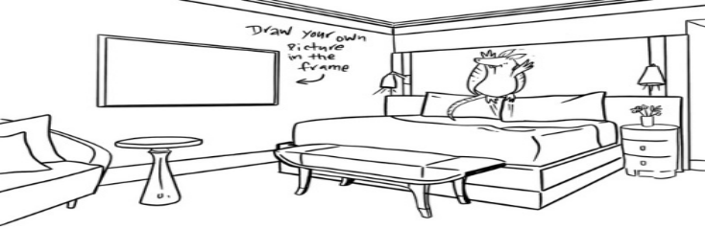
EX:
This is the Dolphin Room. There’s a big Dolphin at the door. There’s a table and a sofa in the middle of the room ...

V. Homework:
- Draw a room and describe it
- Do exercise: Part C, D page 12,13,14
- Prepare the next lesson: Unit 2: Skills 2.

Planning date:5/10/2025

UNIT 2: MY HOUSE

Period 14/ Lesson 6: Skills 2
A. Aims: By the end of the lesson, students will be able to:
1. Knowledge: - use the lexical items related to the topic My house; listen to get information about rooms and houses and write an e-mail to a friend.
2. Qualities: To teach SS to work hard, love their house.
3. Competences: Co-operation, self- study; Students will develop listening and writing skills.
B. Teaching aids: laptop, TV
C. Procedures:
I. Warm up (Individual work)
- T calls some students and asks them to describe their house.
- Describe your house.
Hello every body. Today I want to talk about my house…….
Lead in
- Teacher introduces students the content of the lesson today: “You have just talked about your house. In the listening lesson today, we are going to listen to Mai talking about her house.”
II. Pre-Listening:
Task 1: Name the pieces of furniture.
- Ask students to look at the pieces of furniture and parts of the house and name them.
- Call on some students to read the words out loud.
- Ask some students to write the words on the board.
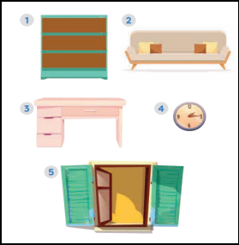
1. bookshelf
2. sofa
3. desk
4. clock
5. window
- Have students guess if these things are mentioned in the listening text. If they say yes for a thing, put a tick next to the word.
II. While - Listening:
- Teacher plays the recording once for students to check their guesses.
- Teacher confirms the correct answers for their prediction.
*Answer key:
Things mentioned in the listening text: bookshelf, desk, clock, window.
Task 2: True or False statements. (Ex. 2, p. 23)
T - Ss, Ss - Ss
- - Have students look at the sentences in this activity. Ask them how to do it. Give them some strategies to do the exercise (e.g. reading the sentences, underlining the key words, listening to the text paying attention to the key words, deciding if each sentence is true or false).
- Play the recording twice for students to do Exercise 2. For a better class, ask students to take notes of the information to explain why a sentence is false.
- Have students share their answers in pairs.
- Invite some pairs to give their answers and confirm the correct ones.
- Play the recording again if needed, stopping at the place where students find it difficult to hear.
- For a better class, ask students to correct the false sentences.
* *Answer key:
1. F (There are three people.)
2. F (There are six rooms.)
3. T
4. T
5. F (She reads books.)
* Audio script:
My name’s Mai. I live in a town house in Ha Noi.
I live with my parents. There are six rooms in our house: a living room, a kitchen, two bedrooms, and two bathrooms.
I love our living room best because it’s bright.
It’s next to the kitchen.
I have my own bedroom. It’s small but beautiful. There’s a bed, a desk,
a chair, and a bookshelf. It also has a big window and a clock on the wall.
I often read books in my bedroom.
III. Pre- writing
- Show this sample email on the slide / on the board or give each student a handout with Ask them several questions:
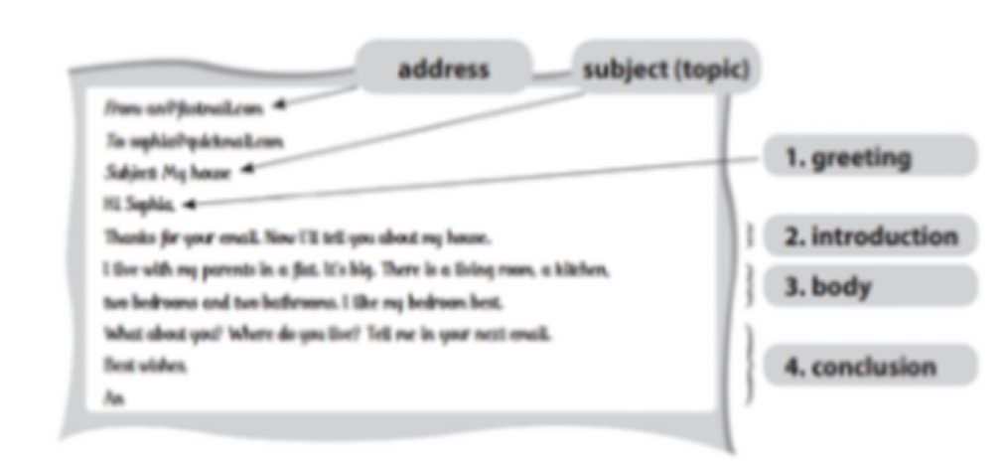 Necessary parts of an email
1. How many parts are there in the email?
(5 parts)
2. What is the subject of the email? Where can you find it? (My house – We can find it in the “Subject line”)
3. What does An write about in the first paragraph of the
email? (The introduction)
4. What does An write about in the second paragraph? (The subject(s) of the email)
* How to write email to friend?
1. In the subject line, write briefly, what the email is about.
2. Begin the email with a greeting (Dear/Hi/Hello).
3. The introduction is the first paragraph. Ask about his/her health, thank him/her for the previous email or write the reasons for the email, etc.
4. In the body, write the subject(s) of the email. Write each subject in a new paragraph.
5. The conclusion is the last paragraph. Say goodbye, ask your friend to write back, etc
IV. While - Writing:
1. Answer the questions. (Ex. 3, p. 23)
- Tell students that now they are going to focus on the body of the email only.
- Tell them that answering the guiding questions is one way to help them brainstorm as well as organise ideas for their writing.
- Have students answer the questions individually, encouraging them to write the answers in full sentences.
- Move around to offer help.
- Invite some students to share their answers to the class. Comment on their answers.
2. Write an email to Mira, your pen friend and tell her about your house. (Ex. 4, p. 23)
- Ask students to write the body of their email individually.
- Ask one or two students to write their email on the board.
* Sample email:
To: Mira@webmail.com
Subject: My house.
Hi Mira,
Thank for your email. Now, I’ll tell you about my house.
I live with my parents and younger brother in a town house.
It's big. There are six rooms: a living room, a kitchen, two bedrooms
and two bathrooms. I like the living room best
because I can watch TV with my parents and younger brother together.
What about you? Where do you live?
Tell me in your next e-mail.
Best wishes,

V. Wrap - up:

- Teacher asks students to talk about what they have learnt in the lesson.

VI. Homework:
- - Rewrite the email
- Prepare the next lesson: “Looking back and project”

UNIT 2: MY HOME
Period 15/ Lesson 7: Looking back & Project

A. Aims: By the end of the lesson students will be able to
- 1. Knowledge: review all what they have learnt in this unit: The prepositions of place and the possessive form with proper names and singular nouns and apply what they have learnt (vocabulary and grammar) into practice through a project.
2. Qualities: students will be more aware of loving types of house, rooms and furniture in a house
3. Competences: groupwork, independent working, pair work, linguistic competence, cooperative learning and communicative competence.
B. Teaching aids:
- Teaching plan, text book, computer, smart TV/ projector…
C. Procedure:
* Warm up: Kim’s game: Teacher shows a picture and asks students to remember the things in the picture, then asks students to come to the board and write.
I. Vocabulary:
Task 1:
- Teacher divides the class into 3 big groups.
- Each group will be assigned a name.
- Teacher asks students to brainstorm all words related to types of house, rooms and furniture.
- The group having the most suitable and correct answers is the winner.
Suggested answers:
- Types of house: flat, town house, country house, stilt house, villa, cottage, farmhouse, bungalow,…
- Rooms: hall, living room, bedroom, bathroom, kitchen, dining room, guest room, utility room,…
- Furniture: chest of drawers, sink, fridge, dishwasher, cupboard, microwave, air conditioner, stool, armchair,…
II. Grammar:
Task 2: Make sentences using prepositions of place. (Ex. 3, p. 24)
(lucky prepositions)
- Ask students to say the prepositions of place they have learnt.
- Have students look at the pictures and do this exercise individually. Ask some students to write the sentences on the board.
- Check students’ answers.
Answer key:
1. The cat is on the table.
2. The dog is in front of the kennel / doghouse.
3. The cat is between the bookshelf and the sofa.
4. The cat is behind the computer.
5. The girl is on the sofa.
6. The boy is next to the sofa.
Task 3: Write three sentences to describe your favourite room. (Ex. 4, p. 24)
- Ask one student what room in the house is his / her favourite.
- Encourage him / her to say one or two sentences about it.
- Have students write three sentences to describe their favourite room.
- Remind students to use prepositions of place.
- Students share their sentences with their partners.
- Some students are asked to write their sentences on the board.
Teacher and other students give feedback.
Task 4: Survey
- Students work in groups. One student in each group asks other group members question “Which one would you like to live in? Why?” and fill the information in the following table.
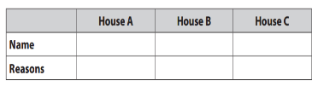

This student then summarises their group members’ answers and reports the result to the whole class

III. Project
- Guide Ss do project: Design their own strange house.
- Ss use given questions to discuss in class.
-Ask Ss to work in group of 5 or 6 and complete the project as homework. (Ss can illustrate it with picture/ posters).
Eg: My dream house is in town. It has three buildings……

IV. Wrap - up:
* T consolidates the knowledge of the lesson (T writes the knowlegde on the board: vocabulary + grammar).
V. Homework.
- Design your own strange house.
- The next lesson: Unit 3: My friends: Getting started.

