Planning date: 26/10/2025
UNIT 3: COMMUNITY SERVICE
Period 22. Lesson 4: Communication
A. OBJECTIVES
- By the end of this lesson, Ss will be able to:
- know how to give compliments
- discuss and present the benefits of community activities
1. Knowledge:
- Vocabulary: vocabulary on community activities.
- Grammar: structures to give compliments.
2. Core competence:
- Develop communication skills and creativity
- Be collaborative and supportive in pair work and teamwork
- Actively join in class activities
3. Personal qualities
- Develop self-study skills
- Raise students’ awareness of the need to keep their neighbourhood green
B. MATERIALS
- Grade 7 textbook, Unit 3, A closer look 2
- Computer connected to the Internet
- Projector/ TV/ pictures and cards
- sachmem.vn
C. PROCEDURES
Warm-up(ALPHABET GAME)
- Teacher divides the class into 4 groups. Students take turns to use the past simple in a sentence. The first letter of the verbs must follow the sequence of the alphabet.
- Students work in groups to play the game. If a student from a group can’t think of one verb, he/she is out of the game. The next student from other groups continues with the next letter.
- Teacher goes around to help weaker students.
- Teacher gives compliments to the group which has the most correct answers.
- Example:
A: He asked me my name.
B: I bought a hat.
C: I came here last month.
LEAD-IN
Today we are going to learn how to give copliments
I. Pre-speaking
1. Listen and read (Ex 1, p. 32)
- Teacher plays the recording for Ss to listen and read the dialogue between Lan and Mark.
- Students pay attention to the highlighted parts.
- Teacher emphasizes the use of the compliments.
- Teacher confirms the answers and gives feedback.
2 ways to give compliments:
- Sounds like great work!
- Wonderful!
II. While-speaking
1. Making dialogue (Ex 2, p. 32)
- Teacher has students work in pairs to make similar dialogues.
- Students work in pairs to make similar dialogues, using the contexts given and the sample compliments.
- Teacher asks some pairs to practice the dialogue so that the whole class can give comments.
- Teacher gives feedback as a class.
III.Post-speaking
1. Read and write (Ex 3, p. 33)
- Teacher has students work in pairs to read the poster and asks them questions like:
- How many projects does Lending Hand offer?
- What activities can you do / join in Projects 1, 2 and 3?
- Students work in pairs to write the number of the projects (1 - 3) next to the benefits (A - E).
- Teacher asks some pairs to to read out their answers.
- Teacher gives feedback and correction (if needed).
Answer key:
1. B, E 2. C, D 3. A
IV. Consolidation
Teacher asks students to talk about what they have learnt in the lesson.
V. Homework
- Think about some environmental problems in your neighbourhood and the activities you want to do to solve those problems
- Prepare skills1

Date:27/10/24
REVIEW 1 (Units 1-2-3)
Period 23. Lesson 1: Language
I. OBJECTIVES
By the end of this lesson, students will be able to:
1. Knowledge
- Revise the words related to hobbies and verbs of liking and disliking; healthy activities and health problems; and words related to community activities;
- Pronounce the sounds /ə/, /ɜ:/, /f/, /v/, /t/, /d/, /ɪd/ correctly in isolation and in context;
- Revise the present simple tense, past simple to talk about past activities;
- Revise how to ask for and give health tips; how to give compliments.
2. Core competence
- Develop communication skills and cultural awareness
- Be collaborative and supportive in pair work and teamwork
- Actively join in class activities
3. Personal qualities
- Develop self-study skills
- Raise students’ awareness of the need to keep their neighbourhood green.
II. MATERIALS
- Grade 7 textbook, Review 1 - Language
- Computer connected to the internet
- Projector/ TV/ pictures and cards
- sachmem.vn
B. PROCEDURE:
Warm up: GAME: FINDING KEYWORDS
- Teacher shows 3 sets of pictures (taken from Project lessons of Unit 1-2-3) and asks students to find a keyword for each set of pictures.
- Students raise hands to answer.
- Teacher and students discuss the answers.
- Teacher checks the answers as a class.
 |  |  |  | 
 | Set 1: HOBBIES
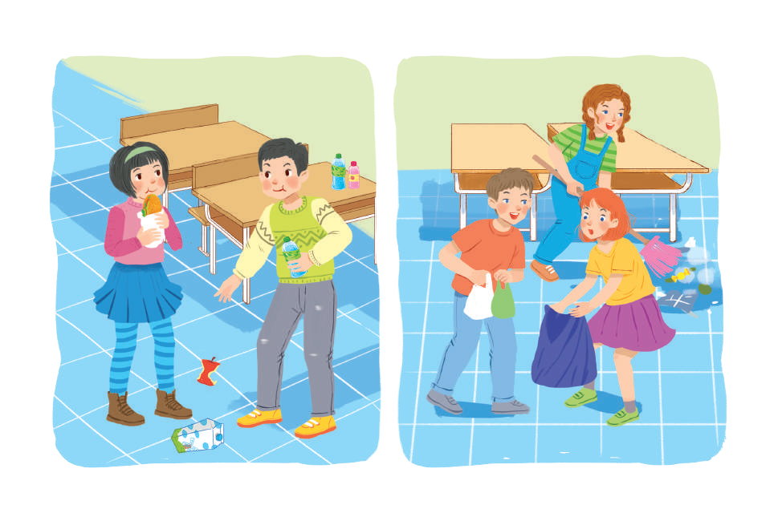 |  |  | 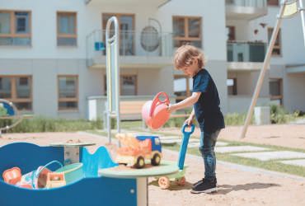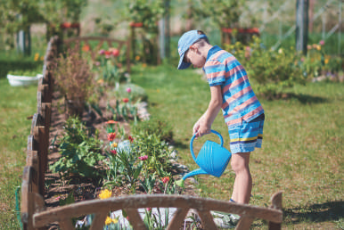
Set 2: HABITS (bad habits, good habits, healthy habits) |  |  | Set 3: COMMUNITY SERVICE

I. Pronunciation
Task 1: Circle the word, listen an check. (Ex 1, p. 38)
- Teacher writes the sounds /ə/ and /ɜː/; /t/, /d/ and /ɪd/; /f/ and /v/ on the board.
- Teacher writes one word containing the sound below each of them.
- Teacher asks students to read the words aloud.
- Students do the task by reading aloud each group and circling the odd one out.
- Teacher can invite some pairs of students to read aloud.
- Teacher check students’ pronunciation ad give feedback.
Answer key:
1. A 2. C 3. B 4. A 5. B
II. Vocabulary
Task 2: Put the phrases below in the correct columns (Ex 2, p. 38)
- Teacher tells students to read the phrases carefully and make sure they remember their meanings.
- Students do this exercise individually by categorising the activities as they do them for their own sake or for the benefit of the community.
- Teacher allows students to share their answers before discussing as a class and encourages them to pronounce the words / phrases correctly.
- Teacher checks the answers as a class and gives feedback.

Answer key:
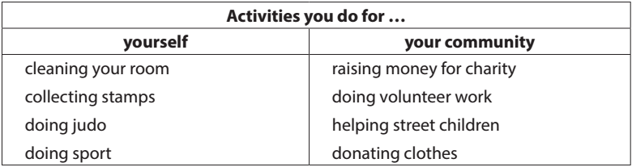
Task 3: Complete the sentences. (Ex 3, p. 38)
- Teacher asks students to work individually to complete the sentences with the given words and phrases.
- Students work individually to complete the task.
- Teacher allows students to share answers before discussing as a class.
- Teacher asks students to say the sentences aloud and makes sure they pronounce the words and phrases correctly. Teacher can ask for translation to check their understanding.
Answer key:
1. coloured vegetables
2. mountainous areas
3. hobby
4. chapped lips
5. community
6. taking photos
III. Grammar
Task 4: Verb tense. (Ex 4, p. 38)
- Teacher asks students to work independently to fill in the blanks with the correct tense of the verbs in brackets.
- Students read the sentences first and underline the clues that help them decide if the verbs are used in the present or past simple tense.
- Teacher reminds students to use the correct forms of the verbs (positive/ negative statements, or questions) as requested in each sentence then allows them to share answers before discussing as a class.
- Teacher can ask students to read aloud the full sentences and correct their pronunciation if necessary.
Answer key:
1. reads
2. Do … do
3. need
4. could not / couldn’t
5. did not / didn’t volunteer
6. joined
Task 5: Turn the sentences into negative and questions (Ex 5, p. 38)
- Teacher asks students to read the sentences first and underline the verb in each sentence, then look at each verb and note if it is used in the present simple or past simple tense.
- Students do the task individually.
- Teacher reminds students to pay attention to the request of each sentence (change it into a negative statement or a question) then allows them to share answers before discussing as a class.
- Teacher can ask students to read aloud the full sentences and correct their pronunciation if necessary.
Answer key:
1. She didn’t like exercising.
2. My family doesn’t always spend time doing housework together on Sundays.
3. I didn’t use a lot of suncream during my holiday.
4. Did your community organise a fair to raise money for the homeless last week?
5. Does Tim make beautiful pieces of art from dry leaves and sticks?
VI. Wrap - up
- Teacher asks students to talk about what they have learnt in the lesson.
V. Homework
- Prepare for Review 1 – Skills.

REVIEW 1 (Units 1-2-3)
Period 24. Lesson 2: Skills
I. OBJECTIVES
By the end of this lesson, Ss will be able to:
1. Knowledge
- Practise reading for general and specific information about a healthy life
- Practise talking about things related to community service
- Practise listening for specific information about a hobby
- Practise writing complete sentences from the prompts provided
2. Core competence
- Develop communication skills and cultural awareness
- Be collaborative and supportive in pair work and teamwork
- Actively join in class activities
3. Personal qualities
- Develop self-study skills
- Raise students’ awareness of the need to keep their neighbourhood green.
II. MATERIALS
- Grade 7 textbook, Review 1 - Skills
- Computer connected to the internet
- Projector/ TV/ pictures and cards
- sachmem.vn
B. PROCEDURE:
Name the pictures: How to get a healthy life?
- Teacher shows pictures and asks students to discuss the ways to get a healthy life.
- Students raise hands to answer.
- Teacher and students discuss the answers.
- Teacher checks the answers as a class.
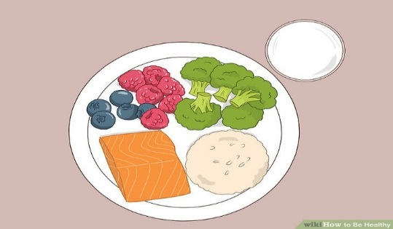 | 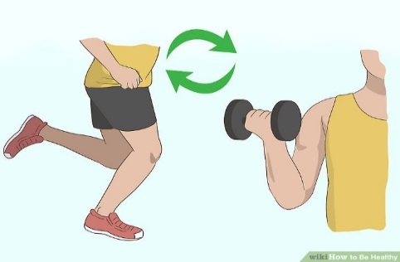
Have a healthy diet | Have a healthy exercise plan
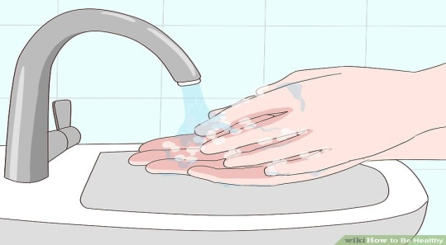 | 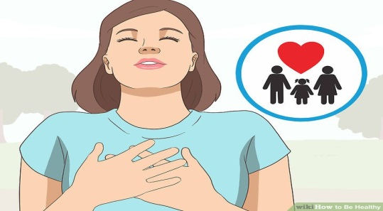
Maintain your personal hygiene | Be happy

I. Reading
Task 1: Read the passage and choose the best answer. (Ex 1, p. 39)
- Teacher guides students by asking them to read the questions first and decide where to look for the information to answer the questions.
- Students read the text fully and choose the correct answers.
- Teacher asks students where they find the answers.
- Teacher confirms the answers as a class.
Answer key:
1. B 2. C 3. C 4. A 5. A
II. Speaking
Task 2: Interviewer (Ex 2, p. 39)
- Teacher asks students to work in pairs and take notes of their answers
- Students work in pairs to exchange their ideas
- Teacher calls on some pairs to report their answers for the class. Each pair may answer just one question to allow room for more pairs.
- Teacher checks the answers and add more information if necessary.
Suggested answer:
1. Anybody.
2. Street children, old and sick people, abandoned / street animals, etc.
3. (It can be any tasks like) cooking / shopping for the old / the sick; collecting books / clothes for street children; opening classes to teach street children; adopting a dog / a cat; cleaning the neighbourhood / beach; painting walls at / decorating public places; reading to the people in
hospitals / nursing homes ...
III. Listening
Task 3: Listen and complete the sentences. (Ex 3, p. 39)
- Teacher has students read the questions first to get an overall idea of what they are going to listen to and decide what information they need to complete the sentences.
- Students work individually to complete the task.
- Teacher allows students to share answers before discussing as a class.
- Teacher asks students to say the sentences aloud and makes sure they pronounce the words and phrases correctly. Teacher can ask for translation to check their understanding.
Answer key:
1. games
2. sandcastles
3. open
4. computer
5. (Any of the following): food, water, compass, sleeping bag, insect cream
Audio script:
Camping can be lots of fun. When we go camping, there is plenty of time for games with friends. If we camp near a beach, we can build sandcastles, go swimming, or play beach volleyball. In other places, we can do other activities like playing football, cycling, bush walking, listening to music or drawing. In the evening, we can have dinner by an open fire. It’s a good time to enjoy the fresh air, tell stories and laugh with friends. While we go camping, there is no television or computer. But don’t worry. You’ll have a great time. Don’t forget to bring important things, like food and water, a sleeping bag, a compass, and some insect cream.
IV. Writing
Task 4: Write the paragraph (Ex 4, p. 39)
- Teacher asks students to work individually to make a passage describing community activities.
- Students read all the six sentences first to help them see the connection among them and decide which tense should be used for each sentence, and which word(s) is / are missing from the sentence.
- Teacher allows students to share answers before discussing as a class.
- Teacher can ask students to read aloud the full sentences and correct their pronunciation if needed.
Answer key:
1. We join community activities once a month.
2. Last month we planted (some) trees in the park.
3. We dug some holes to put the young trees in.
4. Then we watered them for two or three weeks.
5. Now the trees are growing very well.
6. They will make the park greener and the air fresher.
V. Wrap – up
- Teacher asks students to talk about what they have learnt in the lesson.
VI. Homework
- Prepare for the middle term.

