Date:07/12/2025

UNIT 6: A VISIT TO A SCHOOL
Period 44. Lesson 3: A closer look 2

A. OBJECTIVES:
By the end of this lesson, Ss will be able to:
1. Knowledge:
- Use the prepositions of time and place
2. Core competence:
- Develop communication skills and creativity
- Be collaborative and supportive in pair work and teamwork
- Actively join in class activities
3. Personal qualities
- Develop self-study skills
B. TEACHING AIDS
- Grade 7 textbook, Unit 6, A closer look 2
- Computer connected to the internet
- TV
C. PROCUDURE
I. Presentation
Warm up
Game: Watch a video and complete the phrases
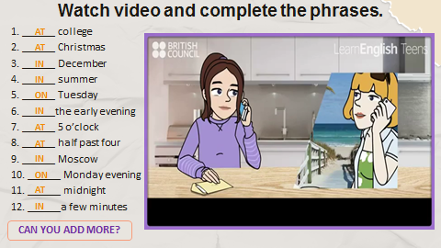
- To introduce the targeted grammar: prepositions of place and prepositions of time.
- Teacher draws students’ attention to the prepositions of place in the commands.
- Teacher introduces the target of the lesson: prepositions of place and prepositions of time.
Teacher asks students to study the Grammar box.
- Teacher draw students’ attention to the meaning and use of at, in, on.
- Teacher then asks some more able students to give some more examples.
Prepositions of time
- at is used to show a point of time (e.g. at six o’clock, at noon, at break time).
- in is used to show a period of time that is longer or shorter than a day (e.g. in the morning, in December, in 2020).
on is used to show a day or part of a day (e.g. on Monday, on January 18th, on Christmas Day)

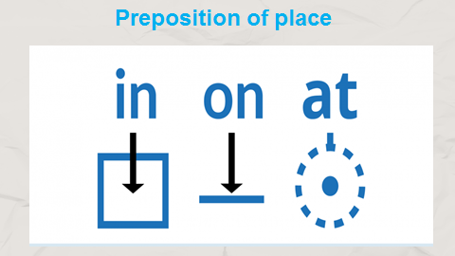
II. Practice
Task 1: Complete the sentences, using suitable prepositions of time.
- Teacher has students work individually.
- Students work individually to complete the sentences.
- Teacher lets students work in pairs and exchange the answers before checking with the whole class (explain each sentence if necessary).
- Teacher confirms the answers and gives feedback.
Answer key:
1. at, at
2. in
3. in
4. on
5. at
Task 2: Work in pairs. Ask and answer the questions about your school.
- Teacher has students read the questions individually. Remind them that the questions with when are used to ask about time and the prepositions of time (in, on, at) are used in - Students work in pairs to ask and answer the questions.
- Teacher calls some pairs to ask and answer the questions in front of the class.
Task 3: Complete the sentences with at, in, or on.
- Teacher asks students to read the instruction to understand how to do the activity.
- Teacher asks students to do the exercise individually, draws their attention to the type of words after the gaps so that they can choose the appropriate prepositions (e.g. he … third floor shows the surface, so they write on in the gap).
- Teacher then has them work in pairs, comparing their answer. Teacher can go around to help students.
- If there is time, have some Ss write the answers on the board. T and other Ss comment.
Task 4: Work in pairs. Look at the pictures and answer the questions.
- Teacher has students read the instructions of the activity to understand what they are going to do.
- Remind them that questions with where are used to ask about places and prepositions of place (at, on, in) are used in the answers. Check comprehension.
- Then call on some pairs to ask and answer the questions in front of the class.
- Teacher confirms the answers and gives feedback.
Suggested answers:
1.At a school/ lower secondary school
2. In the school garden
3. On the board
4. On the stage (of the school, in the meeting room).
III. Production
Task 5: Complete the passage with at, on or in. Then discuss in groups which prepositions express time and which ones express place.
- Teacher has one or two Ss say how the prepositions of time and place are used. Then ask them to read the instructions of the activity to understand what they are going to do.
- Students do the task individually
- Teacher lets Ss discuss in groups and decide which prepositions express time and which ones express place. T goes around and corrects mistakes or gives help when necessary.
- Teacher Call on some Ss to share their answers in front of the class. If time allows, select one or two Ss to read the complete passage in front of the class. T and other Ss comment.
Answer key:
1. in
2. in
3. at
4. at
5. on
6. on
IV. Wrap-up: Teacher asks students to talk about what they have learnt in the lesson.
V. Homework:
-Teachers asks students to make sentences using the prepositions of time and place.
- Do ex part B
-Prepare for Unit 6:Communication

UNIT 6: A VISIT TO A SCHOOL
Period 45. Lesson 4: Communication
A. OBJECTIVE: By the end of this lesson, students will be able to gain the following things:
1. Knowledge:
- Use lexical items related to schools to ask for details and talk about their school.
- Approach and use ways to ask and answer about their school.
+ Vocabulary: use vocabulary related to the topic of “A visit to a school”.such as: a laboratory, learning sources, modern, an activity studio, a sport hall, …
+ Grammar: - Use the structure “Can you tell me more/ Can you tell me why/ Can you tell me how….?.to ask about the school that they have visited.
2. Competence:
- Develop communication skills and creativity.
- Be cooperative and supportive in pair work and teamwork.
- Actively join in class activities.
3. Qualities:
- Promote pride in the values ​​of schools.
- Develop presentation skills about the school you are studying.
- Develop self-study skills.
B. TEACHING AIDS:
- Teacher: Grade 7 text book, laptop, TV.....
- Students: Text books, studying equipment….
- Computer connected to the Internet.
- Sach mem.vn
C. PROCEDURE:
Warm up: Game: Pull out carrot.
- Teacher divides class into two teams. Then T gives the rule of the game
Rule for the game:
- Students choose which answer, please click on the carrot according to that answer.
- The rabbit will go to pick the carrot by itself and will know the right and wrong answer.
- Finally, clicking on the farmer will give the correct answer.
- Click the screen over the slide containing the next question.
 | 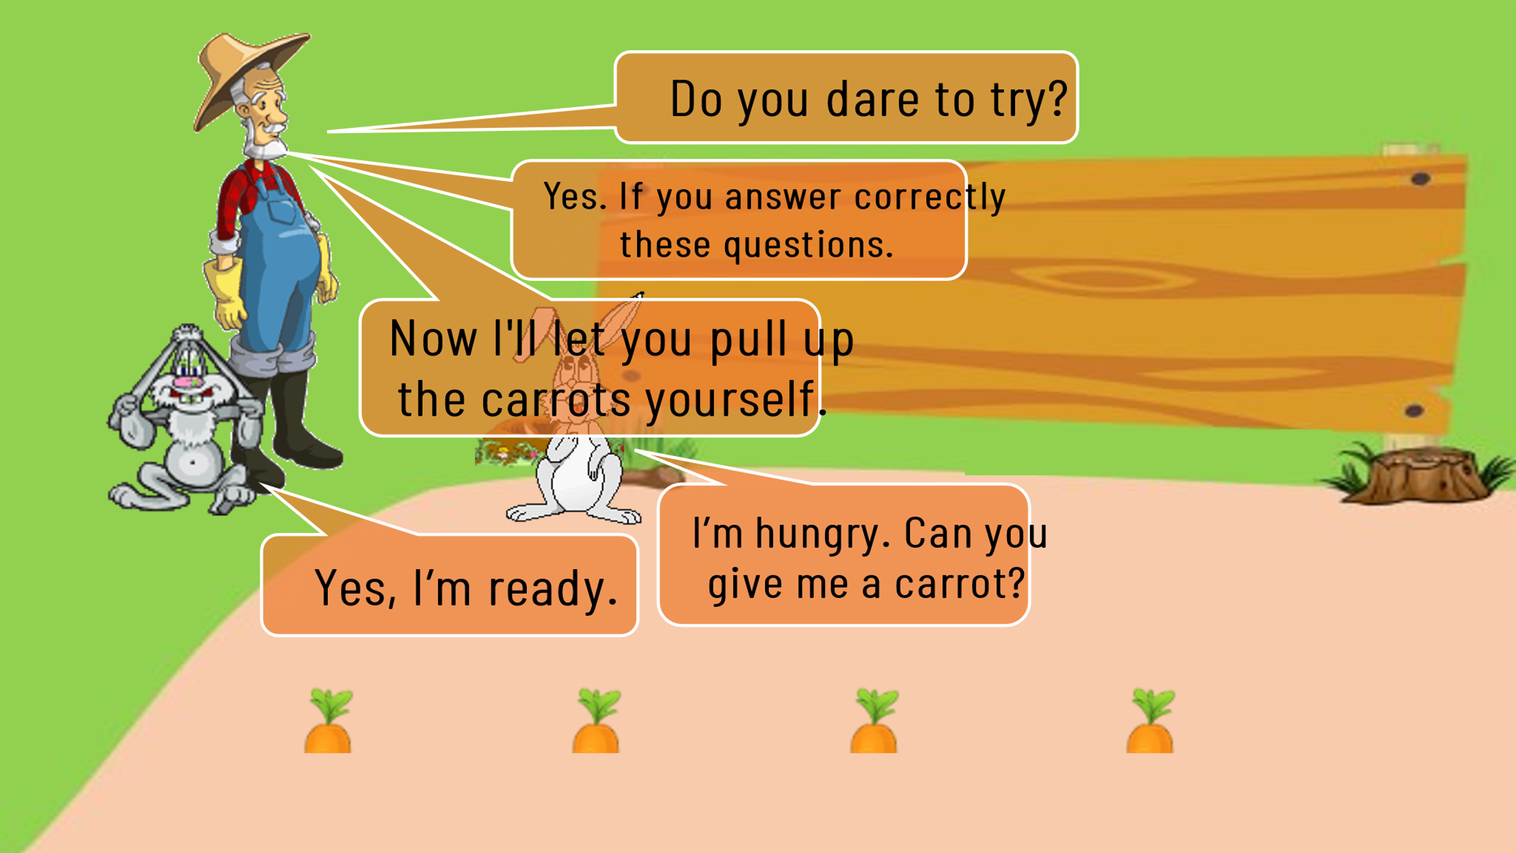
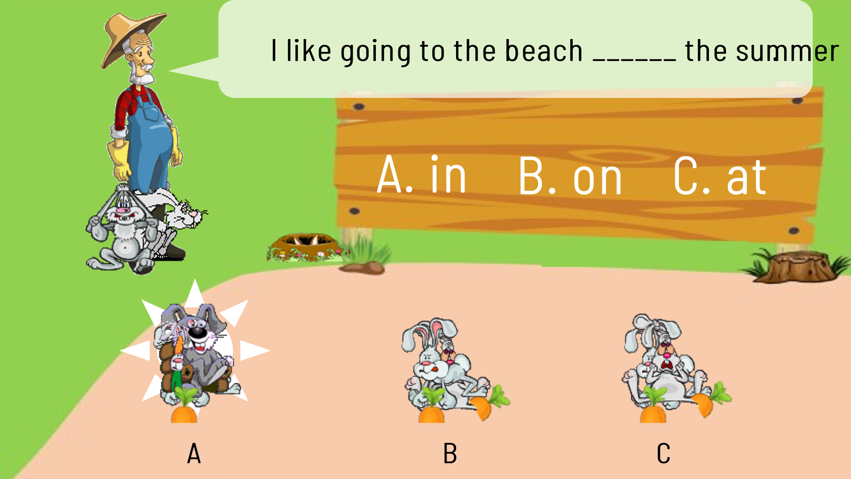 | 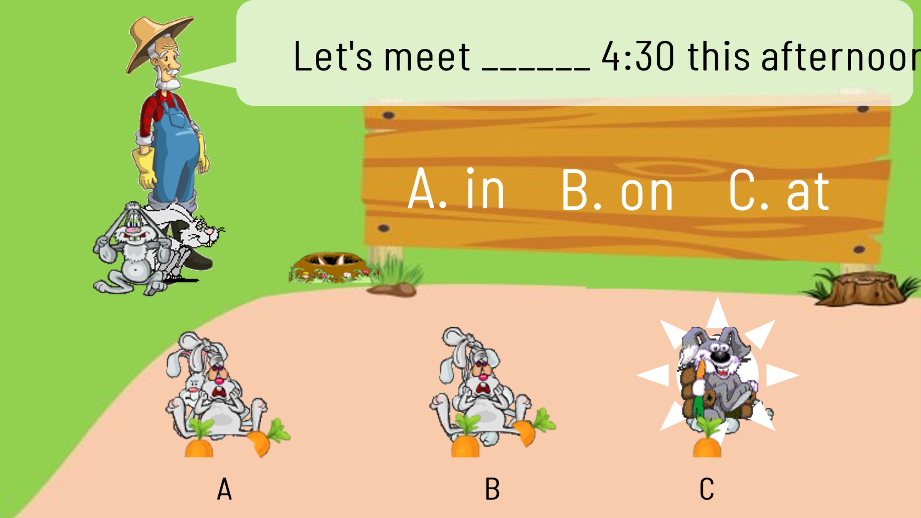
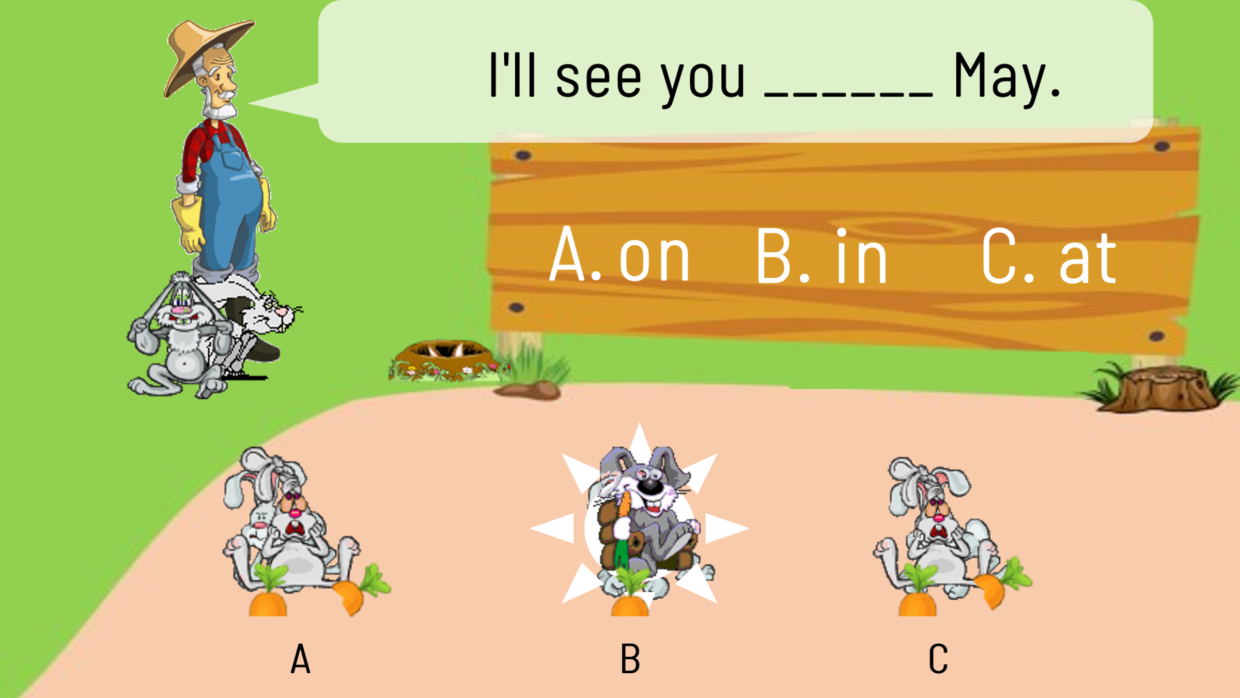 | 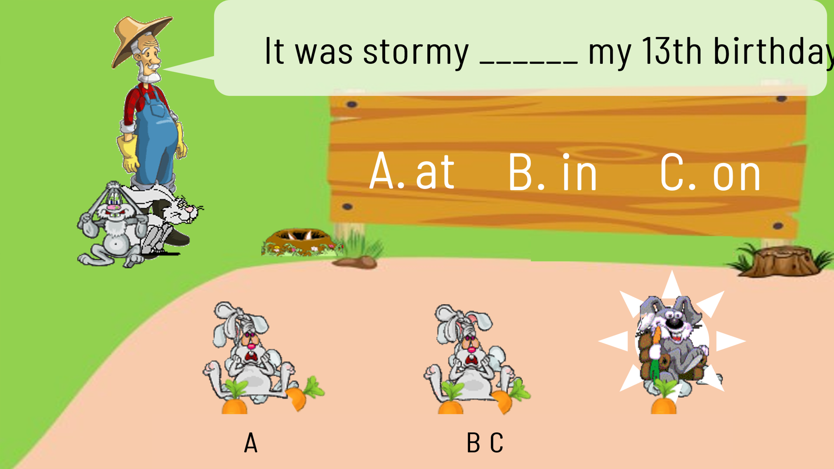
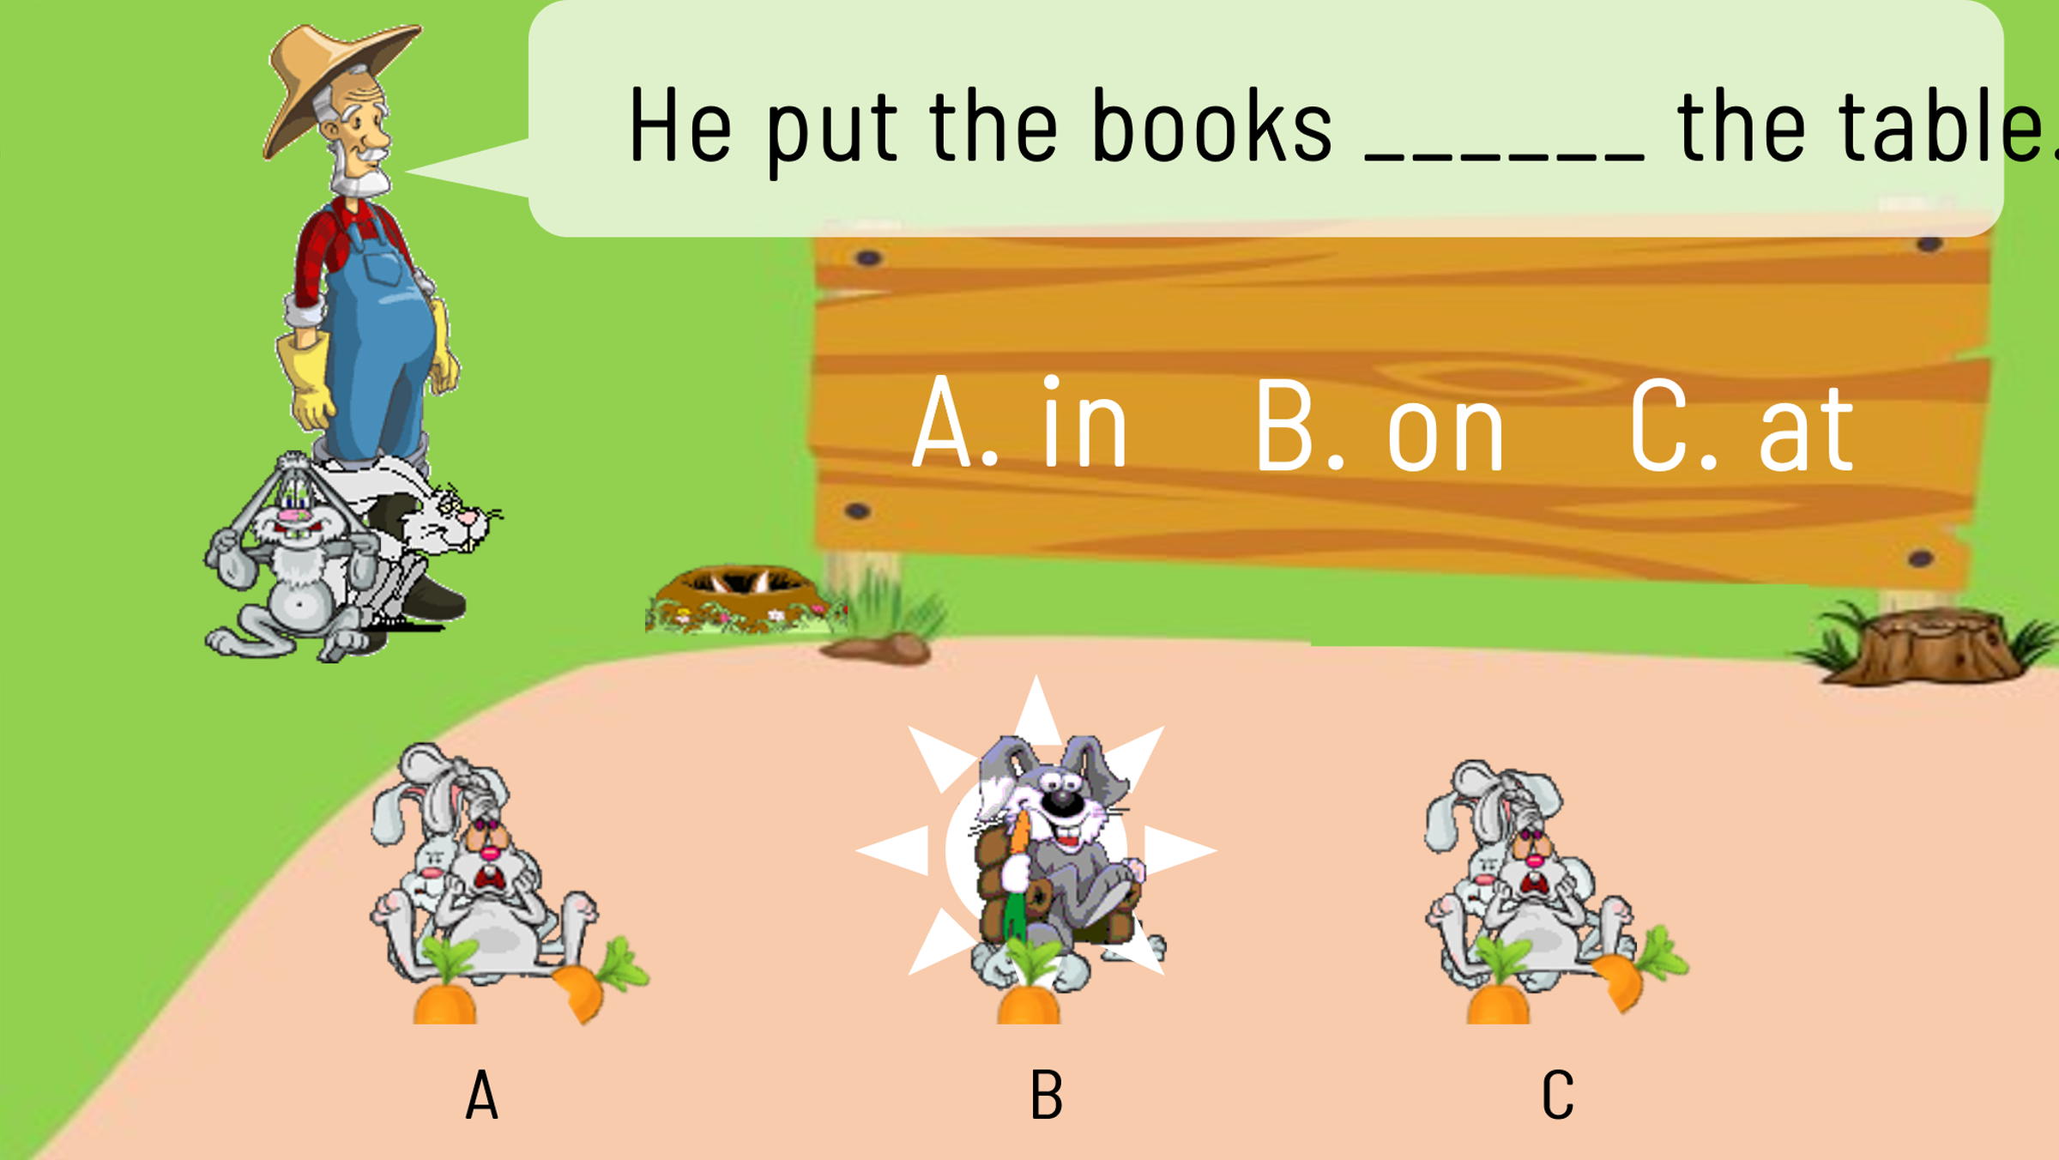 | Keys:  1. A. in  2. C. at  3. B. in  4. C. on  5. B. on

- Ask Ss to open their book and introduce what they are going to study….
Let’s study!!!
Do you know why the above game has prepositions of time and place?
- How can you show your visit to a famous school to your friends and how to give a presentation about your school?
I. Pre-Speaking
1. Everyday English
Listen and read the conversation. Pay attention to the highlighted sentence (task 1)
- Teacher plays the recording for Ss to listen and read the dialogue between Mi and Tom.
- Students pay attention to the highlighted parts.
- Teacher emphasizes asking for details and how to give the answers.
Mi: Are you doing anything this Sunday?
Phong: Not really.
Mi: Would you like to go with us to Binh Minh Lower Secondary School?
Phong: Sounds great! Can you tell me more?
Mi: We’ll leave at 7 a.m. My friends David and Nick are coming too.
- Teacher asks Ss to give the sample sentenses to ask for details
Can you tell me more? / Can you tell me why?/ Can you tell me how?
- Teacher asks Ss to practice the coversation in pairs. Then calls some pairs to practice the conversation in front of the class.
II. While- speaking: Task 2
Task 2: Work in pairs. Ask and answer questions about your visit to a famous school. Use “Can you tell me more?/ Can you tell me why?/ Can you tell me how?”
- Teacher asks Ss to work in pairs to make similar conversations, using the sample sentenses to ask for details.
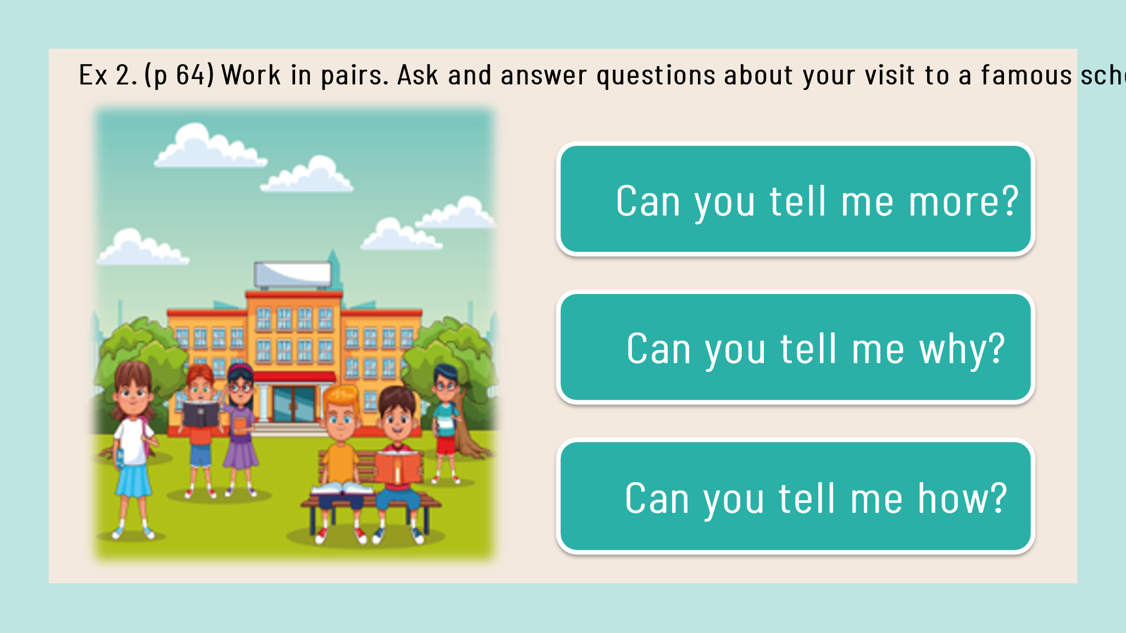

- T moves around to observe and provide help. Call some pairs to practice in front of the class. Comment on their performance.
Task 3: Imagine that some overseas friends are planning to visit your school. Make a list of what you want to show them, then fill in the note.
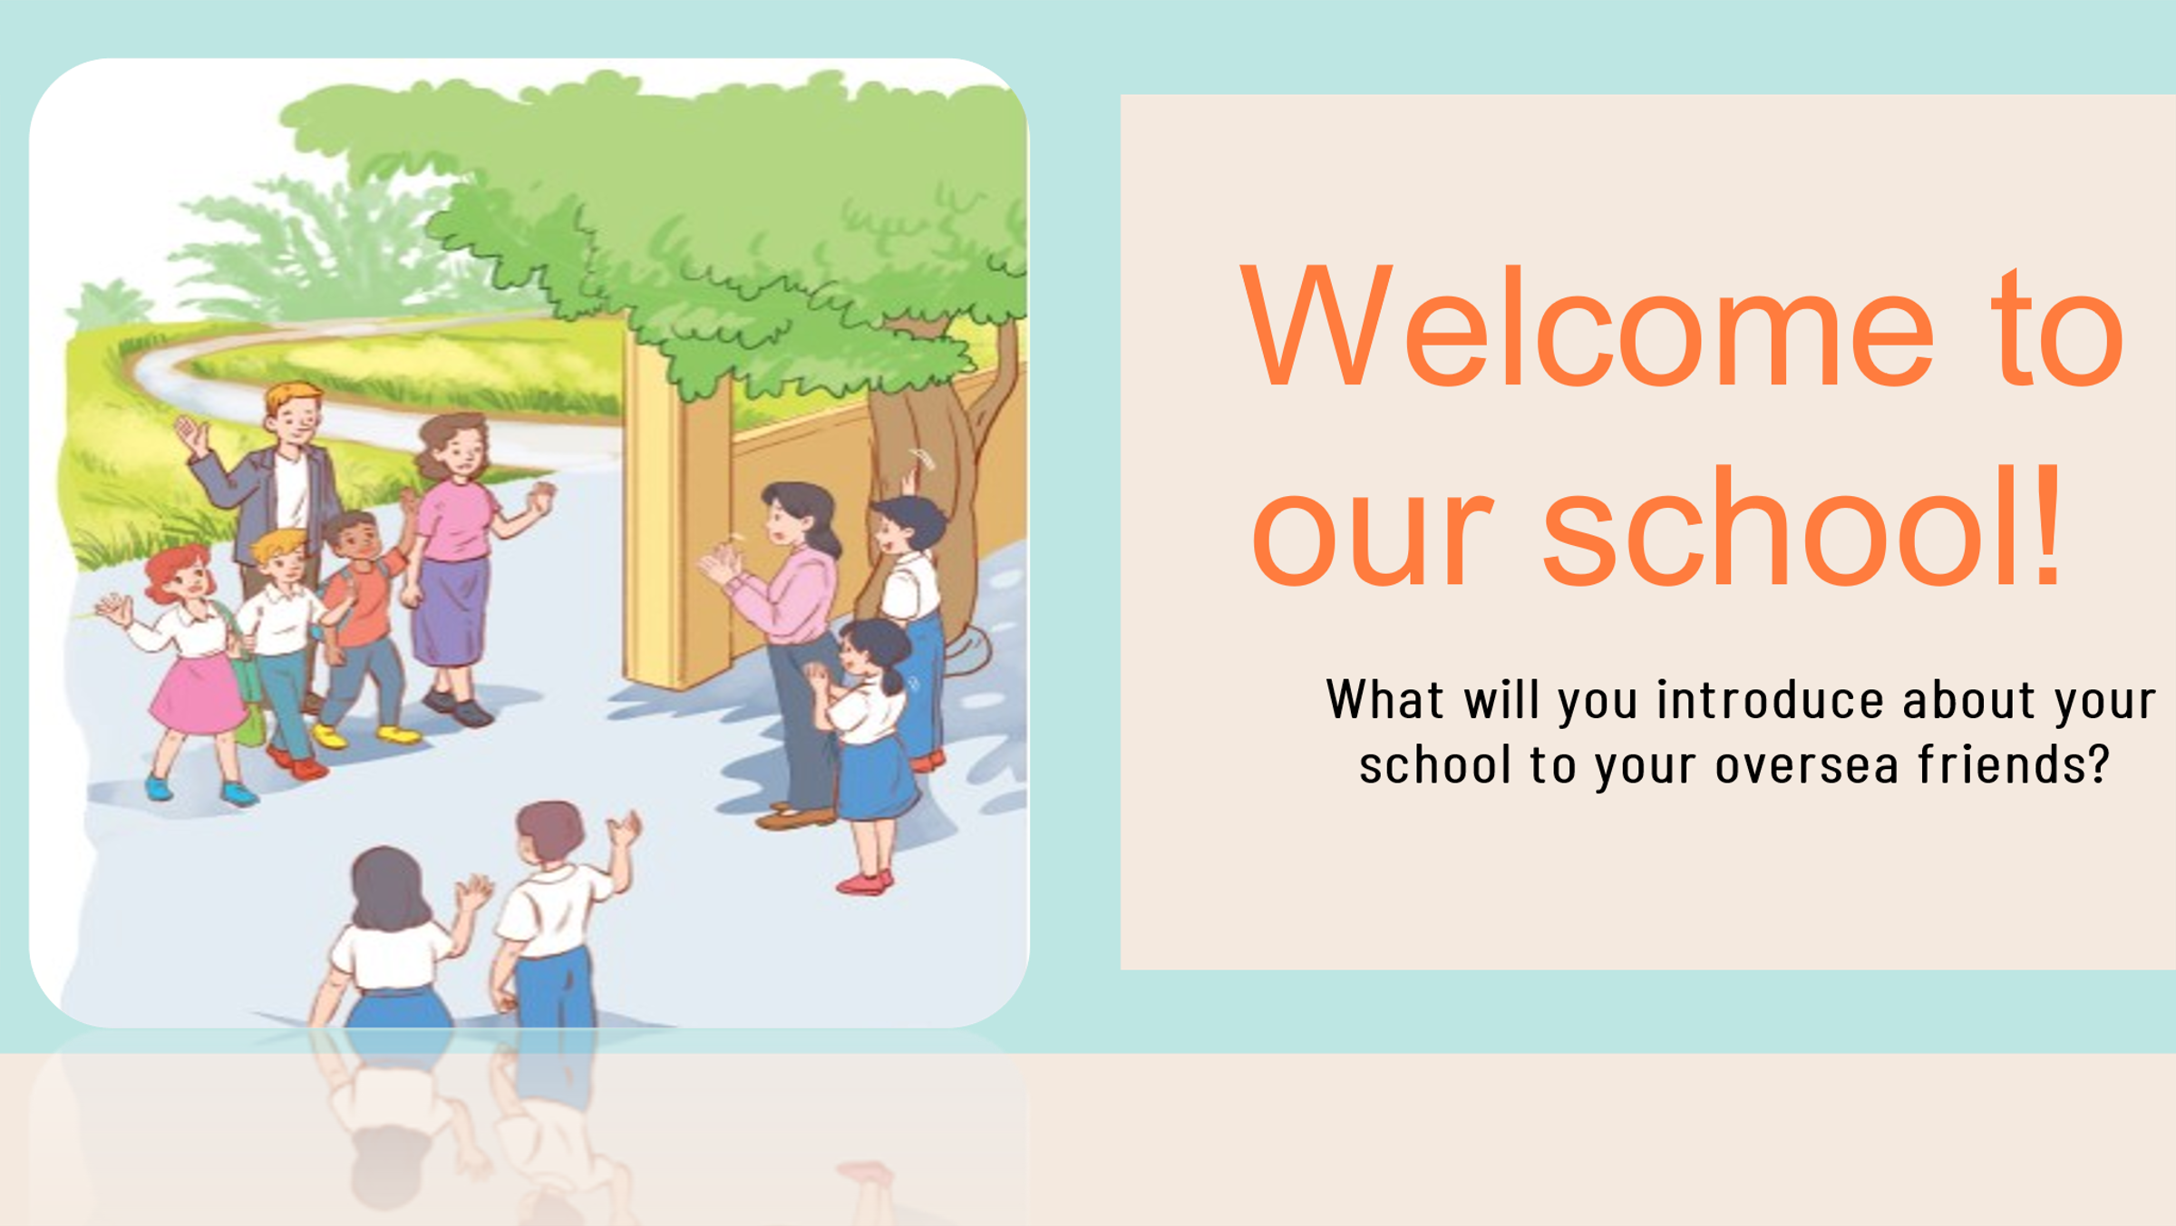
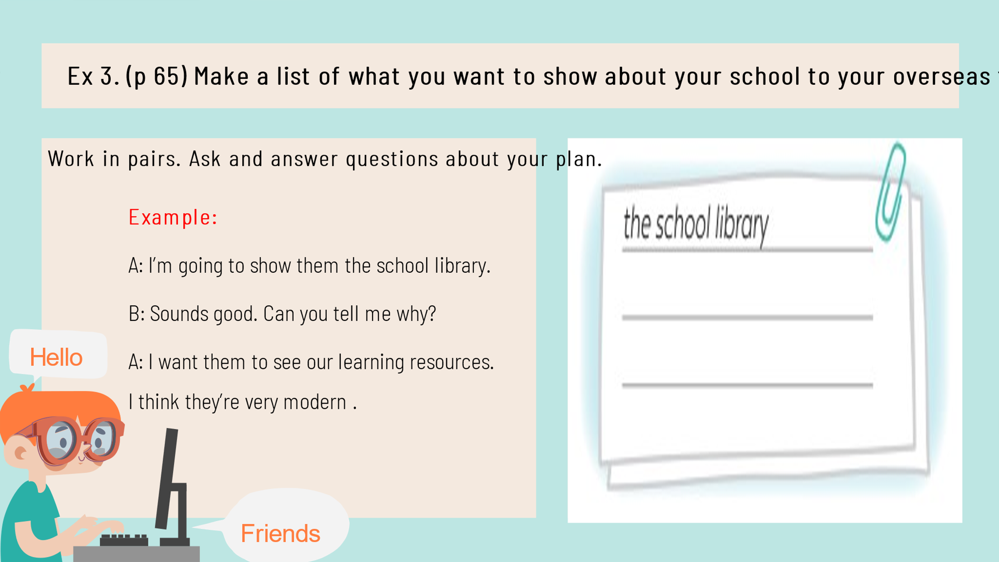
- T asks Ss to fill in the note a list of what they want to show overseas friends.
- T asks some pairs to read the example to know how to start and end the coversation: Example:
A: I’m going to show them the school library.
B: Sounds good. Can you tell me why?
A: I want them to see our learning resources. I think they’re very modern.
- T asks Ss to work in pairs: one student in each pair says what he/ she is going to do and the other asks the reason why. T goes around and offer help if necessary.
- T asks a few pairs to act out the coversations in front of the class.
- T and other Ss comment.
III. Post - Speaking: Task 4
1. Work in groups. Work in groups. Read the passage and complete the table about a high school in the UK. Then discuss and fill in the information about your school.
- T asks Ss to read the passage and fill in the information from the passage in the column of Wilson High School.

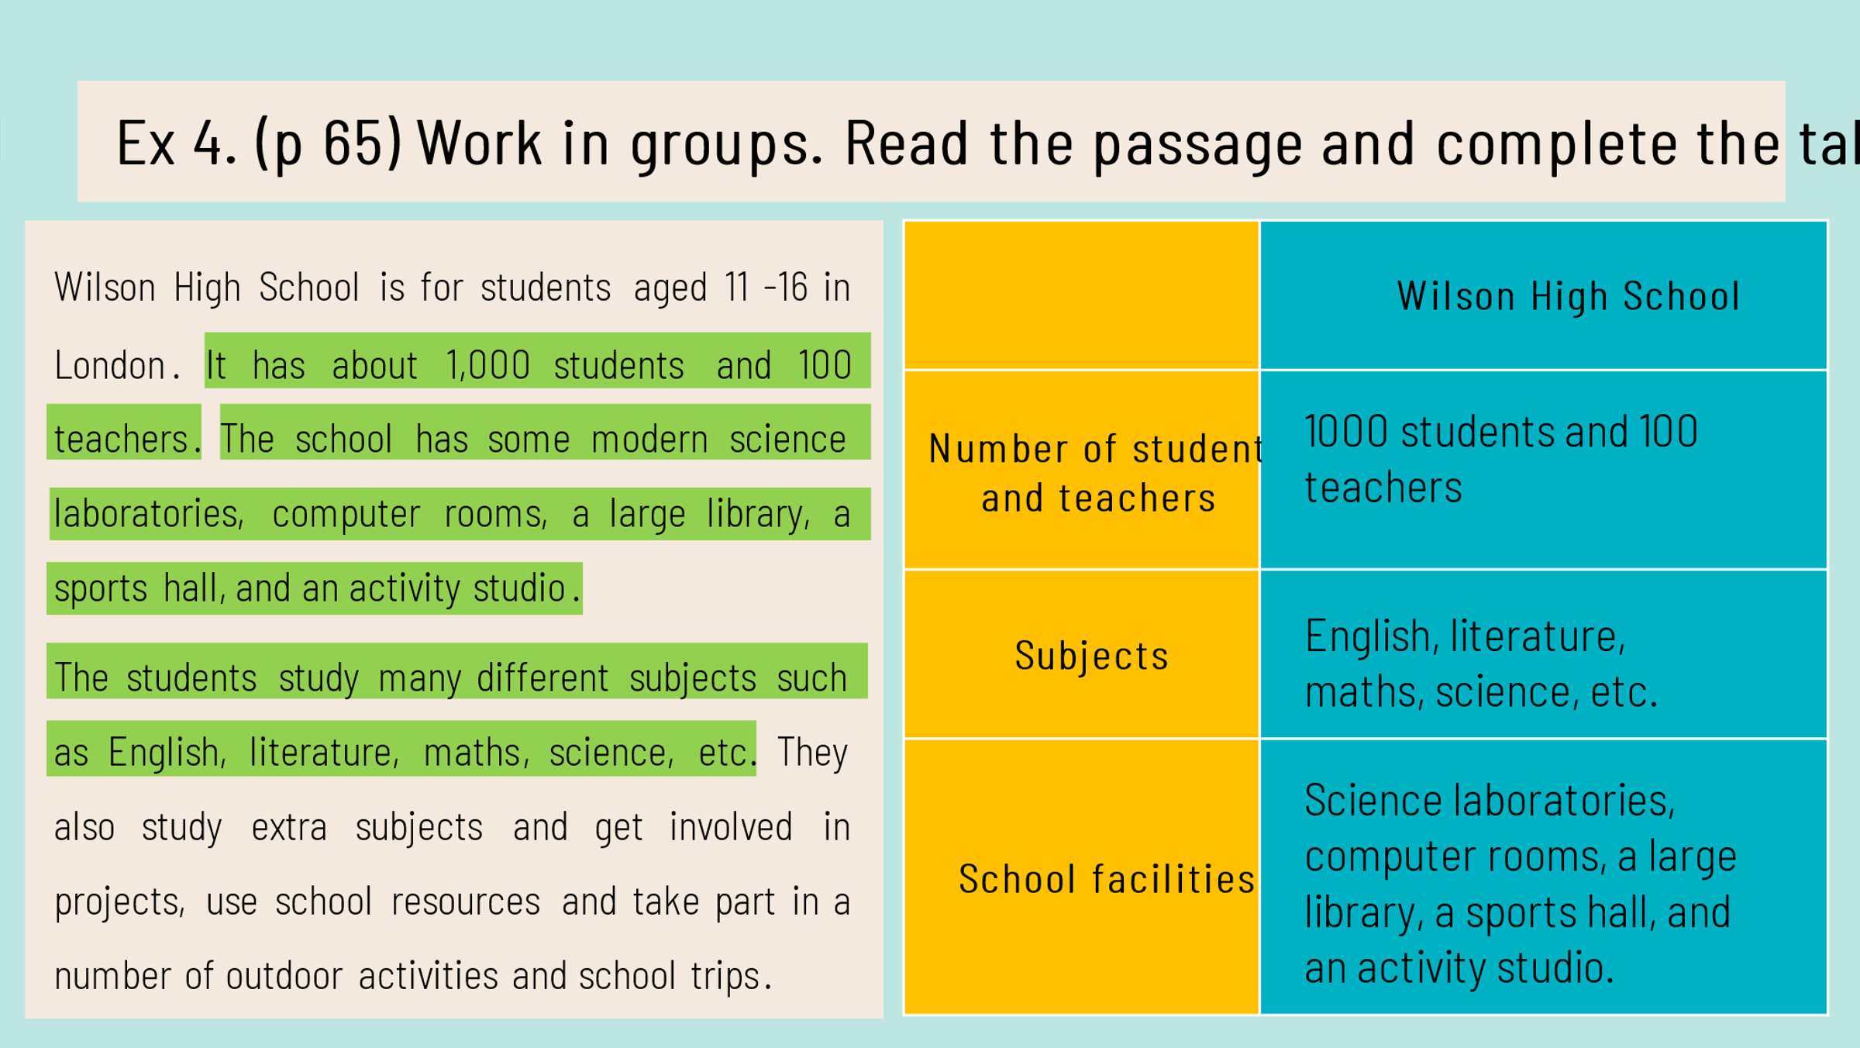
- T asks Ss to pay more attention to the important information such as: the number of students and teachers, the subjects they study and the facilities the school has.
- T ask Ss to work in groups, discuss and fill the column of Your school with information about their school. T goes around and offer support to those Ss who find it difficult to do the task.

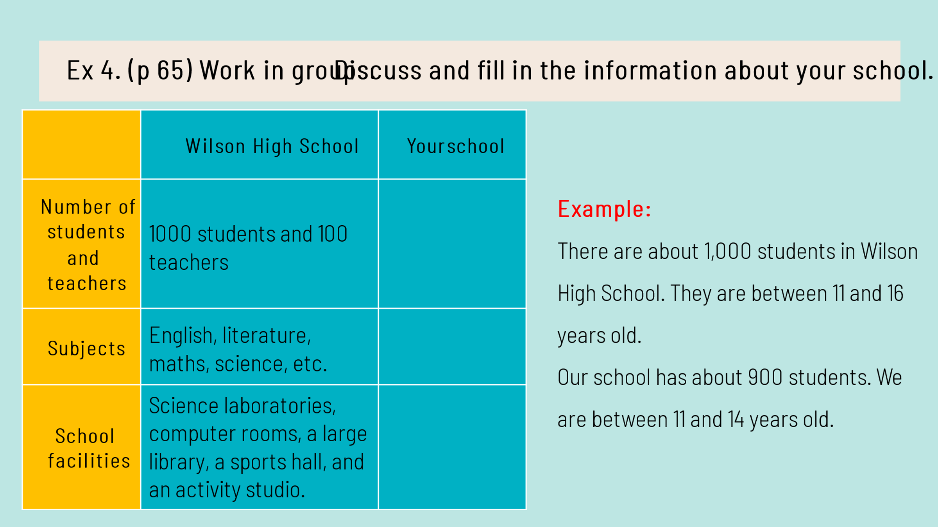
- When the students have finished the task, T asks Ss to present their school..
IV. Wrap – up
- Teacher asks Ss to summarise what they have learnt in the lesson.

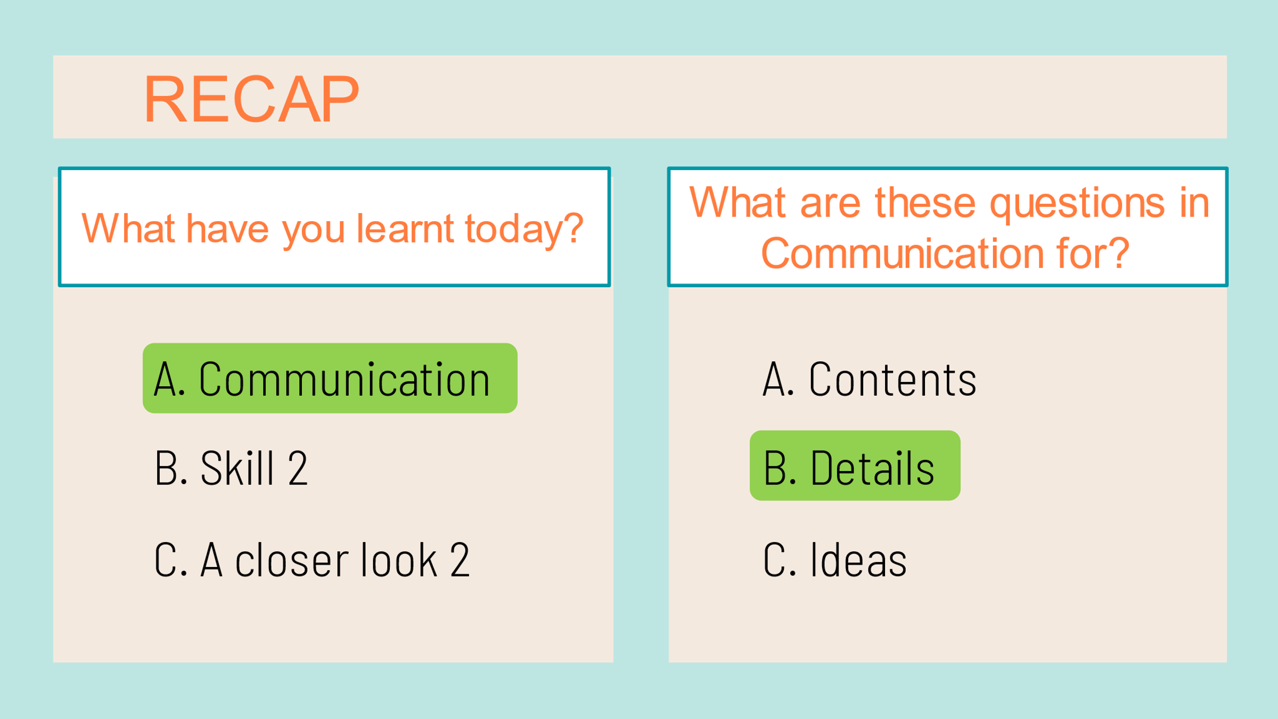
- Teacher asks some Ss to talk about their school freely.
V. Homework:
- Learn by heart the sample sentenses to ask for details
Can you tell me more? / Can you tell me why?/ Can you tell me how?
- Practice speaking asking for details and giving the answers.
- Do exercise part C in workbook.
- Prepare Unit 6-Skills 1

UNIT 6: A VISIT TO A SCHOOL
Period 46. Lesson 5: Skills 1

A. OBJECTIVES: By the end of this lesson, Ss will be able to:
1. Knowledge:
- Develop reading skill about a famous school
- Develop speaking skill: Talking about one’s school
2. Qualities
- Develop self-study skills
3. Competence:
- Develop communication skills and creativity
- Be collaborative and supportive in pair work and teamwork
- Develop presentation skill
- Actively join in class activities.
B. TEACHING AIDS:
- Teacher: Grade 7 text book, laptop, projector / TV/ pictures and cards.....
- Students: Text books, studying equipment….
- Computer connected to the Internet.
- Sach mem.vn
C. PROCEDURE:
Warm up:
Game: WHO IS FASTER?
- Teacher divides the class into 2 teams.
- Members from each team take turns to the board to write the correct school facilities under the posters.
- The team with more correct answers will be the winner.
- Students play the game in team mode.
- Teacher and students discuss the answers.
- Teacher confirms the answers and gives feedback.
I. Pre reading:
Task 1: Look at the picture and answer the question:
-Teacher asks students to work in pairs, look at the pictures and answer the questions. Encourage them to focus on the details / ideas of the photos (color of the buildings, locations, surroundings, …)
1. What can you see in the picture?
2. What do you know about them?
- Students work in pairs, look at the pictures and answer the questions.
- Teacher and students discuss the questions and answers.
- Teacher accepts all students’ questions.
II. While reading:
Task 2: Read the passage and answer the questions: (Ex 2, p. 66)
-Teacher asks students to open the book, read through the text and do the task. Teacher sets a time limit for Ss to read and do the task individually.
- Students read the text and do the task individually.
- Teacher allows students to share their answers in pairs before discussing as a class and encourages them to give evidence.
- Teacher calls some students to give the answer, explains which sentence gives them the information.
Answer key:
1. It’s in Hue (on the bank of the Huong River).
2. They were Ho Chi Minh, Vo Nguyen Giap, Xuan Dieu.
3. They are intelligent and hard-working.
4. It has two English labs.
Task 3: Read the passage again and complete the table. Than report it to the class (Ex 3, p. 66)
- Teacher can set a longer time limit for students to read the text again.
Teacher asks students to look at the table to understand what information they have to find in the text (e.g. the name, the location, the students, and the school facilities). Explain that this task helps them focus on the information they are going to find in the text.
- Students work in individuals to fill the table.
-Teacher allows students to compare their answers in groups before reporting to the class.
- Teacher selects one or two Ss to report the information in the table in front of the class. The class listens and comments.
Answer key:
Name | Quoc Hoc – Hue
Location | on the bank of the Huong River, in Hue
Students | intelligent and hard-working
School facilities | over 50 classrooms (with TVs, projectors, computers), a swimming pool, a library, two English labs, four computer rooms, and many other modern facilities.

III. Post reading:
Task 4: Work in pair. Answer the questions with the information in the table. (Ex 4, p. 66)
- Teacher has Ss read the instructions to identify how to do the task, then asks them to look at the table to understand what information they are going to discuss (e.g. the name, location, students, and the facilities of their school).
- Teacher asks students to work in pairs, asking and answering questions about the information in the table.
- Teacher can go around to help weaker students.
-Teacher calls on some pairs to practise in front of the class.
Task 5: Work in group. Tell about your school (Ex 5, p .66)
- Teacher has students work in groups, talk about their schools based on the information from Task 4.
- Students work in groups to do the task.
- Teacher goes around to help students.
- After finishing, teacher can call some groups to give presentations in front of the class.
-Teacher allows students to give comments for their friends and vote for the most interesting and informative presentation.
- Students give comments for their friends and vote for the most interesting and informative presentation.
-Teacher and students discuss the presentations.
-Teacher gives feedback and comments.
* Vocabulary:
1. found (v): thành lập
2. well-known (adj) nổi tiếng
3. royal (adj) hoàng gia
4. projector (n) máy chiếu
5.facility: (n) tiện nghi
IV. Wrap – up:
- Teacher asks students to talk about what they have learnt in the lesson.
V. Homework:
- Learn by heart vocabulary
- Do exercises 1,2,3 at page 46,47
- Prepare: Skills 2

