UNIT 3: COMMUNITY SERVICE
Period 19. Lesson 4: Communication
A. OBJECTIVES
- By the end of this lesson, Ss will be able to:
- know how to give compliments
- discuss and present the benefits of community activities
1. Knowledge:
- Vocabulary: vocabulary on community activities.
- Grammar: structures to give compliments.
2. Core competence:
- Develop communication skills and creativity
- Be collaborative and supportive in pair work and teamwork
- Actively join in class activities
3. Personal qualities
- Develop self-study skills
- Raise students’ awareness of the need to keep their neighbourhood green
B. MATERIALS
- Grade 7 textbook, Unit 3, A closer look 2
- Computer connected to the Internet
- Projector/ TV/ pictures and cards
- sachmem.vn
C. PROCEDURES
Warm-up(ALPHABET GAME)
- Teacher divides the class into 4 groups. Students take turns to use the past simple in a sentence. The first letter of the verbs must follow the sequence of the alphabet.
- Students work in groups to play the game. If a student from a group can’t think of one verb, he/she is out of the game. The next student from other groups continues with the next letter.
- Teacher goes around to help weaker students.
- Teacher gives compliments to the group which has the most correct answers.
- Example:
A: He asked me my name.
B: I bought a hat.
C: I came here last month.
LEAD-IN
Today we are going to learn how to give copliments
I. Pre-speaking
1. Listen and read (Ex 1, p. 32)
- Teacher plays the recording for Ss to listen and read the dialogue between Lan and Mark.
- Students pay attention to the highlighted parts.
- Teacher emphasizes the use of the compliments.
- Teacher confirms the answers and gives feedback.
2 ways to give compliments:
- Sounds like great work!
- Wonderful!
II. While-speaking
1. Making dialogue (Ex 2, p. 32)
- Teacher has students work in pairs to make similar dialogues.
- Students work in pairs to make similar dialogues, using the contexts given and the sample compliments.
- Teacher asks some pairs to practice the dialogue so that the whole class can give comments.
- Teacher gives feedback as a class.
III.Post-speaking
1. Read and write (Ex 3, p. 33)
- Teacher has students work in pairs to read the poster and asks them questions like:
- How many projects does Lending Hand offer?
- What activities can you do / join in Projects 1, 2 and 3?
- Students work in pairs to write the number of the projects (1 - 3) next to the benefits (A - E).
- Teacher asks some pairs to to read out their answers.
- Teacher gives feedback and correction (if needed).
Answer key:
1. B, E 2. C, D 3. A
IV. Consolidation
Teacher asks students to talk about what they have learnt in the lesson.
V. Homework
- Think about some environmental problems in your neighbourhood and the activities you want to do to solve those problems
- Prepare skills1
UNIT 3: COMMUNITY SERVICE
Perod 20. Lesson 5: Skills 1
I. OBJECTIVES
By the end of this lesson, students will be able to gain:
1. Knowledge:
- Vocabulary: Use words related to community activities.
- Pronunciation: Correctly pronounce the sounds: /t/, /d/, /ɪd/ in isolation and in context
2. Core competenc
- Develop communication skills and creativity
- Be collaborative and supportive in pair work and teamwork
- Actively join in class activities
3. Personal qualities
- Develop self-study skills
- Raise students’ awareness of the need to keep their neighbourhood green.
II. MATERIALS
- Grade 7 textbook, Unit 3, A closer look 1
- Computer connected to the Internet
- Projector/ TV/ Pictures and cards
- sachmem.vn
III. PROCEDURES
Warm – up : Guessing game
- Teacher has students play in two groups and explains the game rules.
- Each group will have a list of verbs and nouns. Students match the verbs they have with the correct nouns.
-Teacher and students discuss the answers. The group with the most correct answers wins.
- Teacher confirms the answers and gives feedback.
Set of word cards:
recycle | help | plant

trees | vegetables | small children | old people
books | bottles | cans | homeless children
I. Presentation
1. Vocabulary
- Teacher introduces the vocabulary.
- Teacher introduces the vocabulary by:
- providing the pictures
- providing the definition of the words.
1. exchange (v): trao đổi
2. pick up (phr. v) : nhặt lên
3. tutor (v) : dạy kèm
4. Litter (n) : Rác
-Teacher asks students to repeat.
2. Match the verbs in column A and B. (Ex 1, p. 30)
- Teacher has read aloud the verbs in A and words / phrases in B.
- Students work in pairs to match the verbs in A with words / phrases in B.
- Teacher asks them to share their answers in pairs before checking the answers as a class.
- Teacher invites students to take turns to read out their answers and corrects their pronunciation if needed.
Answer key:
1. e 2. a 3. d
4. c 5. B
3. Complete each of the sentences with a suitable word or phrase from the box . (Ex 2, p. 30)
- Teacher asks students to work individually to complete each of the sentences with a suitable word / phrase from the box. All of these words / phrases have been learnt in.
- Students do the task individually.
- Teacher allows students to swap their textbooks to peer check first.
- Teacher confirms the answers and gives feedback, if necessary.
Answer key:
1. litter 2. used paper for notebooks
3. water 4. donate 5. tutor
4. Use the phrases from the box to write full sentencss under the correct pictures. (Ex 3, p. 30)
- Teacher asks students to work individually to write full sentences, using the given phrases.
- Students read aloud the six phrases and match with the appropriate pictures.
- Teacher asks students to work in pairs to swap their answers and peer check.
- Teacher checks their answers as a class.
Answer key:
1. She’s reading books to the elderly.
2. They’re giving gifts to old people.
3. They’re exchanging used paper for notebooks.
4. They’re donating clothes to poor children.
5. She’s planting trees in the park.
II. Pronunciation
- To help students identify how to pronounce the sounds /t/, /d/ and /ɪd/.
- To help students practise pronouncing the sounds in words.
1. Listen ang repeat /t/, /d/ and /ɪd/. (Ex 4, p. 30)
- Teacher has students listen to the recording once first.
- Students listen to the recordings and read out the words.
- Teacher plays the recording for them to listen and repeat each word as a class, then as individuals.
- Teacher check students’ pronunciation if needed.
Suggested key:
/t/ | /d/ | /ɪd/
picked, booked, helped | tutored, watered, exchanged | donated, planted
2. Listen to the sentencesS (Ex 5, p. 31).
- Teacher has some students read the sentences first and asks them to pay attention to the underlined parts.
- Teacher plays the recording for Ss to listen then have them tick the appropriate sounds.
- Teacher invites some Ss to share their answers. Confirm the correct ones.
- Teacher plays the recording again and ask students to repeat each sentence after the recording. Teacher confirms the answers.
Answer key:
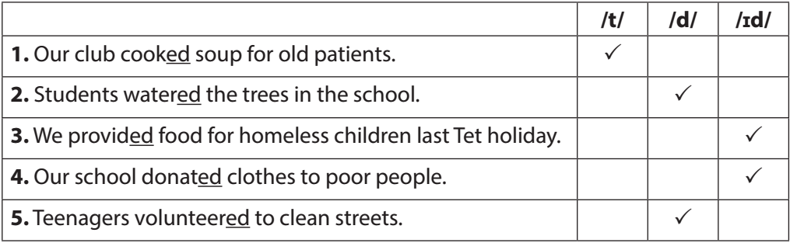
III. Homework
- Do exercise A1-2, B2
- Prepare : A close look 2
- What can you do to make your neighborhood to be a greener place? Write at least 3 activities.

Planning date:19/10/2025
UNIT 3: COMMUNITY SERVICE
Period 21. Lesson 6: Skills 2
A. OBJECTIVES
By the end of this lesson, Ss will be able to gain:
1. Knowledge:
- Understand the use of the past simple tense
- Practice using the past simple to talk about past activities
2. Core competence:
- Develop communication skills and creativity
- Be collaborative and supportive in pair work and teamwork
- Actively join in class activities
3. Personal qualities
- Develop self-study skills
- Raise students’ awareness of the need to keep their neighbourhood green.
B. MATERIALS
- Grade 7 textbook, Unit 3, A closer look 2
- Computer connected to the Internet
- Projector/ TV/ pictures and cards
- sachmem.vn
- Assumptions
C. PROCEDURES
Warm up(chatting)
- Teacher asks students some questions:
What did you do last weekend?
What did you watch yesterday?
Who did you meet two days ago?
- Students answer the questions, using the past simple.
- Teacher and students discuss the answers.
- Teacher corrects students answers if needed and confirms the use of the past simple (to talk about completed actions in the past).
Lead in: In today lesson ,we are going to learn a lesson about simple past tense
I. Presentation
1. Simple past tense
- To review students’ knowledge of the past simple tense.
- Teacher asks students to study the Grammar box.
- Teacher draws students’ attention to the meaning and use of the past simple.
- Teacher then asks some more able students to give some more examples.
Positive | S + V-(ed) /V (cột 2) + O
Negative | S + did not / didn’t +V (bare)
Questions and short answers | Did + S + V (bare) ?  - Yes, S + did.  - No, S + didn’t.
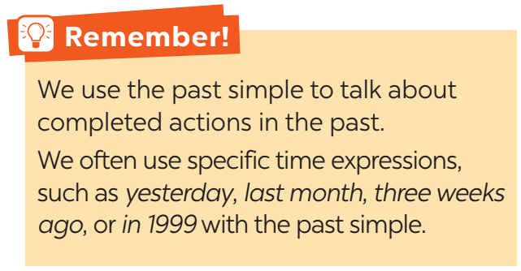
- Teacher and students discuss the answers.
- Teacher confirms the answers and gives feedback.
II. Practice
1. Circle the corect answer(Ex 1, p. 31)
- Teacher has students work individually.
- Students work individually to to complete the sentences with the past simple form of the given verbs.
- Teacher lets students work in pairs and exchange the answers before checking with the whole class (explain each sentence if necessary).
- Teacher confirms the answers and gives feedback.
Answer key:
1. B
2. C
3. B
4. A
5. C
2. Complete the sentences. (Ex 2, p. 31)
- Teacher has students work individually.
- Students work individually to complete the sentences.
- Teacher lets students work in pairs and exchange the answers before checking with the whole class (explain each sentence if necessary).
- Teacher confirms the answers and gives feedback.
Answer key:
1. took
2. Did … join
3. helped
4. sent
5. volunteered
3. Complete the sentences with the corect forms ò the verb (Ex 3, p. 31)
- Teacher asks the whole class to read aloud the verbs in the box then has students work individually to complete the sentences with the correct forms of the verbs from the box.
- Students work individually to complete the task.
- Teacher then has them work in pairs, comparing their sentences. Teacher can go around to help students.
- Teacher confirms the answers and gives feedback.
Answer key:
1. cook
2. Did … plant
3. are picking up
4. recycled
5. read
III. Production
1. Write the sentences from the pomp (Ex 4, p. 32)
- Teacher has students work independently.
- Teacher asks students to do the exercise individually.
- Teacher lets students work in pairs and exchange the answers before checking with the whole class (explain each sentence if necessary).
- Teacher confirms the answers and gives feedback.
Answer key:
1. Last year, our club donated books to children in rural areas.
2. Children sent thank-you cards to us a week ago.
3. I taught two children in grade 2 last summer.
4. Last spring, we helped the elderly in a nursing home.
5. We helped people in flooded areas last year.
IV. Consolidation
- Teacher asks students to talk about what they have learnt in the lesson
V. Homework
- Teacher asks students to do exercises A1,2 B1,2,3,4 in their work book
- Prepare communicaion

