Planning date :12/10/2025
UNIT 3: COMMUNITY SERVICE
Period 16. Lesson 1: Getting started – Sounds like great work!
I. OBJECTIVES
By the end of this lesson, Ss will be able to gain:
1. Knowledge
- An overview about the topic “Community service”
- lexical items related to community activities
2. Core competence
- Develop communication skills and enhance awareness of preserving the culture
- Be collaborative and supportive in pair work and teamwork
- Actively join in class activities
3. Personal qualities
- Develop self-study skills
- Raise students’ awareness of the need to keep their neighbourhood green
II. MATERIALS
- Grade 7 textbook, Unit 3, Getting started
- Computer connected to the Internet
- Projector/ TV/ pictures and cards
- sachmem.vn
III. PROCEDURES
Warm – up: Picture describing
- Teacher shows the picture and asks students questions:
- What can you infer from this picture?


- Students raise hands to answer the questions.
- Teacher and students discuss the questions.
- Teacher accepts all students’ questions and explains the term “Community service” (work that people do without payment to help other people).
*To lead in the topic of the lesson
-Teacher draws students’ attention to the picture in the textbook and asks them some questions about it:
- What are they doing?
I. Presentation
1. Listen to the text and guess (Ex. 2, p. 29)
- Teacher tells students to read the conversation again and work in pairs to find the answers.
- Students can underline the words and phrases about community activities then work together for one or two minutes to check the words / phrases they have underlined.
- Teacher allows students to share their answers before discussing as a class and encourages them to pronounce the words / phrases correctly.
- Teacher checks the answers as a class and gives feedback.
II. Practice
1. Listen and read. (Ex 1, p. 28)
- Teacher can play the recording more than once.
- Students listen and read.
- Teacher can invite some pairs of students to read aloud.
- Teacher check students’ pronunciation ad give feedback.
Answer key:
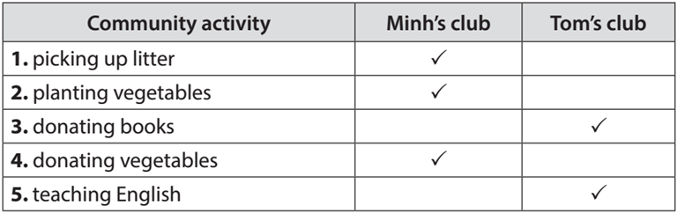
2. Complete the phrase. (Ex 3, p. 29)
- Teacher asks students to work individually to complete the phrases under the pictures with the given verbs.
- Students work individually to complete the task.
- Teacher allows students to share answers before discussing as a class.
- Teacher asks students to say the phrases aloud and makes sure they pronounce the words and phrases correctly. Teacher can ask for translation to check their understanding.
Answer key:
1. pick up 2. help 3. recycle
4. donate 5. Clean
3. Complete the sentences. (Ex 4, p. 29)
- Teacher asks students to work independently to complete each sentence with a word or phrase from the box.
- Students fill in the blanks with the most suitable words / phrases.
- Teacher allows students to share answers before discussing as a class.
- Teacher can ask students to read aloud the full sentences and correct their pronunciation if needed.
Answer key:
1. homeless children 2. litter 3. old people
4. taught 5. Planted
III. Production
Game: Pingpong game. (Ex 5, p. 29)
- Teacher instructs students to play the Vocabulary Ping-Pong game:
- Ask Ss to think of the topic Community Service.
- One student from team A shouts out a word or phrase related to the topic. Then one student from team B makes a sentence with that word or phrase. Then switch roles.
- The team that cannot give a phrase or make a correct sentence loses and the other team gets a point.
- Students play the game.
-Teacher can go around to help weaker students.
- Teacher stops the game when time is up. The team that makes the most correct sentences wins.
Example:
Team A: Litter
Team B: We often pick up litter in the park. Trees.
Team A: We plan trees in our school every year. Book.
…
IV. Vocabulary
- Teacher introduces the vocabulary.
- Teacher introduces the vocabulary by:
- providing the pictures
- eliciting the definition of the words
1. community activity (n.phr.): hoạt động cộng đồng
2. donate (v) : quyên góp, ủng hộ
3. nursing home (n.phr.) : viện dưỡng lão
4. homeless (adj) : vô gia cư
V.HOMEWORK
- Think about community activities that students can do (at least 3 activities).
- Prepare lesson : A closer look 1
UNIT 3: COMMUNITY SERVICE
Perod 17. Lesson 2: A closer look 1
I. OBJECTIVES
By the end of this lesson, students will be able to gain:
1. Knowledge:
- Vocabulary: Use words related to community activities.
- Pronunciation: Correctly pronounce the sounds: /t/, /d/, /ɪd/ in isolation and in context
2. Core competenc
- Develop communication skills and creativity
- Be collaborative and supportive in pair work and teamwork
- Actively join in class activities
3. Personal qualities
- Develop self-study skills
- Raise students’ awareness of the need to keep their neighbourhood green.
II. MATERIALS
- Grade 7 textbook, Unit 3, A closer look 1
- Computer connected to the Internet
- Projector/ TV/ Pictures and cards
- sachmem.vn
III. PROCEDURES
Warm – up : Guessing game
- Teacher has students play in two groups and explains the game rules.
- Each group will have a list of verbs and nouns. Students match the verbs they have with the correct nouns.
-Teacher and students discuss the answers. The group with the most correct answers wins.
- Teacher confirms the answers and gives feedback.
Set of word cards:
recycle | help | plant

trees | vegetables | small children | old people
books | bottles | cans | homeless children
I. Presentation
1. Vocabulary
- Teacher introduces the vocabulary.
- Teacher introduces the vocabulary by:
- providing the pictures
- providing the definition of the words.
1. exchange (v): trao đổi
2. pick up (phr. v) : nhặt lên
3. tutor (v) : dạy kèm
4. Litter (n) : Rác
-Teacher asks students to repeat.
2. Match the verbs in column A and B. (Ex 1, p. 30)
- Teacher has read aloud the verbs in A and words / phrases in B.
- Students work in pairs to match the verbs in A with words / phrases in B.
- Teacher asks them to share their answers in pairs before checking the answers as a class.
- Teacher invites students to take turns to read out their answers and corrects their pronunciation if needed.
Answer key:
1. e 2. a 3. d
4. c 5. B
3. Complete each of the sentences with a suitable word or phrase from the box . (Ex 2, p. 30)
- Teacher asks students to work individually to complete each of the sentences with a suitable word / phrase from the box. All of these words / phrases have been learnt in.
- Students do the task individually.
- Teacher allows students to swap their textbooks to peer check first.
- Teacher confirms the answers and gives feedback, if necessary.
Answer key:
1. litter 2. used paper for notebooks
3. water 4. donate 5. tutor
4. Use the phrases from the box to write full sentencss under the correct pictures. (Ex 3, p. 30)
- Teacher asks students to work individually to write full sentences, using the given phrases.
- Students read aloud the six phrases and match with the appropriate pictures.
- Teacher asks students to work in pairs to swap their answers and peer check.
- Teacher checks their answers as a class.
Answer key:
1. She’s reading books to the elderly.
2. They’re giving gifts to old people.
3. They’re exchanging used paper for notebooks.
4. They’re donating clothes to poor children.
5. She’s planting trees in the park.
II. Pronunciation
- To help students identify how to pronounce the sounds /t/, /d/ and /ɪd/.
- To help students practise pronouncing the sounds in words.
1. Listen ang repeat /t/, /d/ and /ɪd/. (Ex 4, p. 30)
- Teacher has students listen to the recording once first.
- Students listen to the recordings and read out the words.
- Teacher plays the recording for them to listen and repeat each word as a class, then as individuals.
- Teacher check students’ pronunciation if needed.
Suggested key:
/t/ | /d/ | /ɪd/
picked, booked, helped | tutored, watered, exchanged | donated, planted
2. Listen to the sentencesS (Ex 5, p. 31).
- Teacher has some students read the sentences first and asks them to pay attention to the underlined parts.
- Teacher plays the recording for Ss to listen then have them tick the appropriate sounds.
- Teacher invites some Ss to share their answers. Confirm the correct ones.
- Teacher plays the recording again and ask students to repeat each sentence after the recording. Teacher confirms the answers.
Answer key:
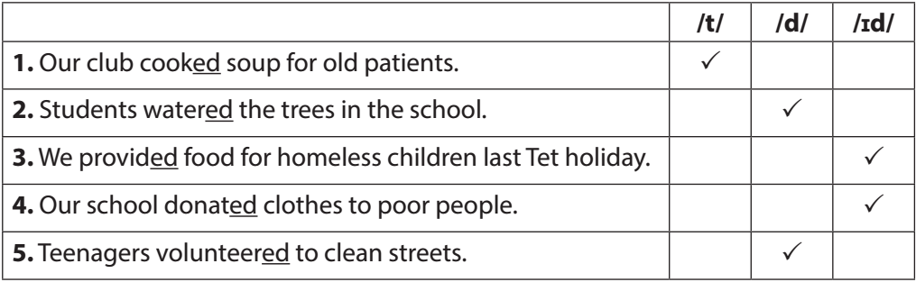
III. Homework
- Do exercise A1-2, B2
- Prepare : A close look 2
- What can you do to make your neighborhood to be a greener place? Write at least 3 activities.

UNIT 3: COMMUNITY SERVICE
Period 18. Lesson 3: A closer look 2
A. OBJECTIVES
By the end of this lesson, Ss will be able to gain:
1. Knowledge:
- Understand the use of the past simple tense
- Practice using the past simple to talk about past activities
2. Core competence:
- Develop communication skills and creativity
- Be collaborative and supportive in pair work and teamwork
- Actively join in class activities
3. Personal qualities
- Develop self-study skills
- Raise students’ awareness of the need to keep their neighbourhood green.
B. MATERIALS
- Grade 7 textbook, Unit 3, A closer look 2
- Computer connected to the Internet
- Projector/ TV/ pictures and cards
- sachmem.vn
- Assumptions
C. PROCEDURES
Warm up(chatting)
- Teacher asks students some questions:
What did you do last weekend?
What did you watch yesterday?
Who did you meet two days ago?
- Students answer the questions, using the past simple.
- Teacher and students discuss the answers.
- Teacher corrects students answers if needed and confirms the use of the past simple (to talk about completed actions in the past).
Lead in: In today lesson ,we are going to learn a lesson about simple past tense
I. Presentation
1. Simple past tense
- To review students’ knowledge of the past simple tense.
- Teacher asks students to study the Grammar box.
- Teacher draws students’ attention to the meaning and use of the past simple.
- Teacher then asks some more able students to give some more examples.
Positive | S + V-(ed) /V (cột 2) + O
Negative | S + did not / didn’t +V (bare)
Questions and short answers | Did + S + V (bare) ?  - Yes, S + did.  - No, S + didn’t.
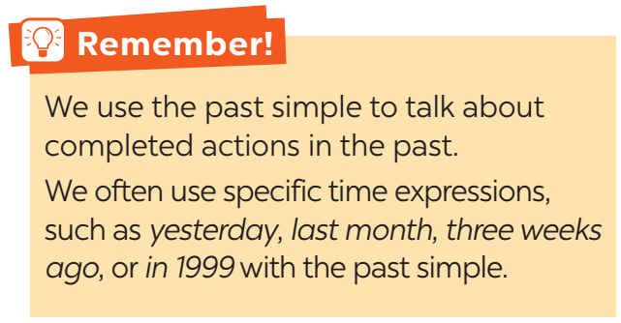
- Teacher and students discuss the answers.
- Teacher confirms the answers and gives feedback.
II. Practice
1. Circle the corect answer(Ex 1, p. 31)
- Teacher has students work individually.
- Students work individually to to complete the sentences with the past simple form of the given verbs.
- Teacher lets students work in pairs and exchange the answers before checking with the whole class (explain each sentence if necessary).
- Teacher confirms the answers and gives feedback.
Answer key:
1. B
2. C
3. B
4. A
5. C
2. Complete the sentences. (Ex 2, p. 31)
- Teacher has students work individually.
- Students work individually to complete the sentences.
- Teacher lets students work in pairs and exchange the answers before checking with the whole class (explain each sentence if necessary).
- Teacher confirms the answers and gives feedback.
Answer key:
1. took
2. Did … join
3. helped
4. sent
5. volunteered
3. Complete the sentences with the corect forms ò the verb (Ex 3, p. 31)
- Teacher asks the whole class to read aloud the verbs in the box then has students work individually to complete the sentences with the correct forms of the verbs from the box.
- Students work individually to complete the task.
- Teacher then has them work in pairs, comparing their sentences. Teacher can go around to help students.
- Teacher confirms the answers and gives feedback.
Answer key:
1. cook
2. Did … plant
3. are picking up
4. recycled
5. read
III. Production
1. Write the sentences from the pomp (Ex 4, p. 32)
- Teacher has students work independently.
- Teacher asks students to do the exercise individually.
- Teacher lets students work in pairs and exchange the answers before checking with the whole class (explain each sentence if necessary).
- Teacher confirms the answers and gives feedback.
Answer key:
1. Last year, our club donated books to children in rural areas.
2. Children sent thank-you cards to us a week ago.
3. I taught two children in grade 2 last summer.
4. Last spring, we helped the elderly in a nursing home.
5. We helped people in flooded areas last year.
IV. Consolidation
- Teacher asks students to talk about what they have learnt in the lesson
V. Homework
- Teacher asks students to do exercises A1,2 B1,2,3,4 in their work book
- Prepare communicaion

