Date :05/10/25
UNIT 2: HEALTHY LIVING
Period 13. Lesson 5: Skills 1
I. OBJECTIVES
By the end of this lesson, students will be able to gain:
1. Knowledge
+ Reading:
- read for specific information about acne
+ Speaking:
- talk about how to deal with some health problems.
2. Core competence
- Develop communication skills
- Be collaborative and supportive in pair work and team work
- Actively join in class activities
3. Personal qualities
- Be benevolent and responsible
II. MATERIALS
- Grade 7 textbook, Unit 2, Skills 1
- Computer connected to the internet
- TV/ Pictures, cards
- sachmem.vn
III. PROCEDURES
Warm up (5 mins)
To introduce the topic of reading.
GAME: HANGMAN
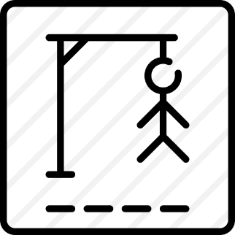

S K I N C O N D I T I O N

- Teacher divides class into 2 teams and asks them to think of the word which has 13 letters in it related the topic “health problems”.
- Ss have 1 min to think of the words related to the topic or they can discuss with their partners.
- Each member from each team turn by turn guesses the letter in the secret word.
- Teacher corrects their answers.
- The team which can find or guess the secret first will be the winner.
LEAD-IN (2 mins)
- To lead in the lesson about Skills 1. - Teacher leads students into the lesson by telling what they are going to learn: “We are going to read a passage about one of the most common “Skin condition” among teenagers.
I. Pre - reading (8mins)
- To provide students with some lexical items before reading the text.
1. Vocabulary
To introduce words related to skin conditions to Ss and help Ss have a general idea of what they are going to read.
1. disease (n): bệnh tật [explanation]
2. serious (a): nghiêm trọng [explanation]
3. take care of (phr v): quan tâm chăm sóc [symnonym]
4. pop (v): tiếng nổ lốp bốp [visual + explanation]
Concept check: Rub out and Remember.
2. Set the scene: discussion (Ex 1, p. 23)
To provide students with some lexical items before reading the text.
- Teacher asks Ss to work in pairs to look at some pictures in Ex 1 on page 23 to write each word or phrase under the correct picture and discuss with their partners “Which skin condition is the most common among teenagers”.
- Ss work in pairs.
- Teacher calls some Ss to check what they have discussed.
- Teacher corrects.
Answer keys:
1. chapped skin
2. acne
3. sunburn
II. While - reading
1. Read and match (Ex 2, p. 23)(4mins)
- To help Ss develop their reading skill for specific information (scanning) and help them focus on the problem of acne.
- Teacher has Ss read the text in detail to do the exercise and asks them how to do this kind of exercise.
- Read the beginnings in A. They all start with ‘acne’ plus the verbs (is, affects, causes).
- Locate the part of the text where they find the information. They all appear right in the first paragraph. - - Read that part and do the matching.
- Ss do the task independently
- Teacher tells Ss to compare their answers in pairs before calling some of them to check.
- Teacher confirms the correct answer and explains if necessary.
Answer key:
1. b
2. d
3. a
4. c
2. Choose the best answer (Ex 3, p. 23) (5mins)
- To provide students with some lexical items before reading the text
- Teacher asks Ss: reading each question, locating where the information appears in the text, reading that part carefully and circling the correct answer.
- Ss do the task independently.
- Teachers has Ss compare their answers in pairs and call some Ss to give their ideas.
- Teacher checks and confirms the correct answers.
Answer key:
1. A
2. C
3. B
4. B
5. A
III. Post - reading
To check students’ reading comprehension
1. Retelling
- Teacher asks Ss to work in groups and take turn to say 1 sentence which they can remember from the passage they have read about “acne”.
- Ss work in groups.
- Teacher calls some groups to check.
- Teacher corrects if necessary
VI. Pre - speaking
- To help Ss talk about how they apply the tips in the reading to themselves.
1. Read and share. (Ex 4, p. 23 )(5mins)
- Teacher asks Ss to work in pairs and tells them to focus on the tips for acne in the text to talk about which tip they can easily follow.
- Ss work in pairs. Teacher goes around and listens and gives help if necessary.
- Teacher calls on some Ss to share their answers with the class. If there is a tip they cannot follow, ask them to explain why not.
- Teacher listens and gives comment.
VII. While - speaking (7mins)
- To provide Ss an opportunity to practise giving tips for health problems.
1. Read and discuss (Ex 5, p. 23)
- Teacher has Ss work in groups and asks them to take turns to give tips for each health problem.
- Ss work in groups to do the task. Teacher goes around, listens and gives help if necessary.
- Teacher calls on some groups to share their answers with the class.
- Teacher comments.
Suggested answers:
1. Use some lip balm.
Use coconut oil or body lotion.
2. Eat less fast food, meat, and ice cream.
Eat more fruit and vegetable.
3. Get enough sleep, 7 - 8 hours a day.
Don't go to bed too late.
4. Keep warm and stay in bed.
Drink plenty of water and eat light food.
5. Avoid washing your hair every day.
Take vitamins.
VII. Post - Speaking
To help students improve next time.
- Have students give comments on their friends and vote for the most interesting and informative presentation.
- Teacher gives feedback and comments.
VIII. Consolidation
- To consolidate what students have learnt in the lesson
- Teacher asks students to talk about what they have learnt in the lesson
IX. Homework
- To prepare for the next lesson Skills 2.
- Do exercises in the workbook.

UNIT 2: HEALTHY LIVING
Period 14. Lesson 6: Skills 2
I. OBJECTIVES
By the end of this lesson, students will be able to:
1. Knowledge
+ Listening
- use the lexical items related to the topic Healthy living
- listen for specific information about some advice about healthy habits
+ Writing: write some advice to avoid viruses.
2. Core competence
- Develop communication skills
- Be collaborative and supportive in pair work and team work
- Actively join in class activities
3. Personal qualities
- Be benevolent and responsible
II. MATERIALS
- Grade 7 textbook, Unit 2, Skills 2
- Computer connected to the internet
- Pictures
- sachmem.vn
III. PROCEDURES
Warm – up: Chatting
- Teacher writes on the board the word “Healthy habits” and asks Ss some questions:
+ What does this word mean?
+ What do we do to have “healthy habits”?
+ Can you name some “healthy habits?”
- Ss think of these questions and discuss with their partners if needed.
- Teacher calls some students to give their answers.
- Teacher listens and give comments.
Lead in (1 min)
- Teacher introduces students the content of the lesson: “In the lesson today, we are going to listen to the professor talking about healthy habits”.
A. Listening
I. Pre - listening
1. Discuss and tick (Ex 1, p. 24)
- Teacher asks Ss to work in pairs to discuss if these sentences are good or bad for their health.
- Ss work with their partner to do the task.
- Teacher calls on some Ss to answer.
- Teacher gives comments and leads Ss to task 2.
Suggested answers:
- Good for health: 2, 3
- To help Ss develop their skill of listening for specific information.
2. Listen and tick (Ex 2, p. 24)
- Teacher has students guess if these habits are mentioned in the listening text. If they say yes for a habit, put a tick next to the word. Then, teacher plays the recording once for students to check their guesses.
- Ss work independently to guess then listen to the recording once to check their guess.
- Teacher calls on some students to give the answers the have listened.
II. While - listening
1. Listen and tick the habit mentioned (Ex 2, p. 24 - continue)
- Teacher plays the recording again and confirms the correct answers for their prediction.
Answer key:
- Habits mentioned in the listening text: 1, 3, 4, 6
Audio script – Tracks 12 + 13:
“Healthy habits help us keep fit and avoid disease. Here is some advice. Eat more fruit and vegetable, especially coloured ones like carrots and tomatoes. They provide a lot of vitamins. Eat meat, eggs, and cheese, but not too much. You may put on weight. Drink enough water, but not soft drinks. Be active and exercise every day. Do outdoor activities like cycling, swimming, or playing sports. They keep you fit. Go to bed early and get about 8 hours of sleep daily, so you will not feel tired. Keep your room tidy and clean. Open windows to let in fresh air and sunshine on fine days.”
- To help Ss further develop their skill of listening for specific information.
2. Listen and answer the question (Ex 3, p. 25)
- Teacher has Ss read the questions and determine what information they need for answering the questions. Remind them answer the questions with no more than THREE words. Then, teacher plays the recording once or twice more for Ss to do the exercise.
- Ss work independently to listen again and determine what information they need. After that, Ss can share their answers in pairs.
- Teacher calls on some pairs to give answers.
- Teacher confirms the correct ones and plays the recording again if needed, stopping at the places where students are having difficulties.
Suggested answers:
1. disease
2. (lots of) vitamins
3. 8 / eight hours
4. tidy and clean
B. Writing
I. Pre - writing
1. Discuss and make notes(Ex 4, p. 25)
- Teacher tells Ss to work in groups to discuss and make notes of the tips and write in full sentences.
e.g. Don’t eat too much meat and cheese.
- Ss work in groups. Teacher moves around and offers help if needed.
- Teacher invites some Ss to share their answers.
- Teacher confirms the correct answers.
To help Ss prepare ideas to write a passage.
2. Discus and brainstorm ideas
- Teacher writes on the board “Covid-19” and asks Ss to give ideas on what they have known about it and asks them to look at the pictures and explains if needed
- Ss think of it and can discuss with their partners.
- Teacher calls on some Ss to raise their ideas.
- Teacher listens and confirms.
Suggested answers: happened in 2019, it caused by virus, many people died of it, …
II. While - writing
1. Write a passage (Ex 5, p. 25)
- Teacher tells Ss that they are going to write a passage to give advice on how to avoid viruses
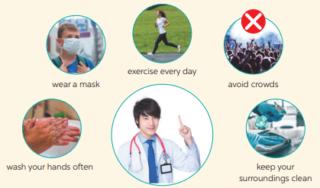
- Ss work independently to do the task and try to add more tips if they can.
Teacher goes around and help if necessary.
III. Post - writing
1. Write a passage (Ex 5, p. 25 - continue)
- Teacher asks Ss to share their writing with their partners. Then, call on some Ss to show their writing in front of the class.
- Teacher checks ideas, grammar, vocabulary and gives comments.
Suggested answers:
We can do a lot of things to avoid viruses. First, always keep your surroundings clean. Sweep your house, clean your furniture, and change your pillow covers and bedsheets often. Remember to take a bath daily. Wash your hands with soap regularly. Drink a lot of water and eat more fruit and vegetable. Exercise three times a day for at least 15 minutes each time. When you go out, wear a mask and avoid crowds.
C. Consolidation
- To consolidate what students have learnt in the lesson.
- Teacher asks students to talk about what they have learnt in the lesson.
D. Homework
- To allow students finalize their passage after being checked by friends and the teacher.
- Rewrite the passage on the notebook.
- Do ex Writing in exercise book

UNIT 2: HEALTHY LIVING

Period 15. Lesson 7: Looking back & Project
A. OBJECTIVES
By the end of this lesson, students will be able to:
1. Knowledge
- review the vocabulary and grammar of Unit 2
- apply what they have learnt (vocabulary and grammar) into practice through a project.
2. Core competence
- Develop communication skills and creativity
- Be collaborative and supportive in pair work and team work
- Actively join in class activities
3. Personal qualities
- Be benevolent and responsible
- Develop self-study skills
B. MATERIALS
- Grade 7 textbook, Unit 2, Looking back & Project
- Computer connected to the internet
- TV/ Pictures, A0 paper
C. PROCEDURES
Warm up: Brainstorming
- To help students revise the vocabulary items they have learnt in the unit.
- To enhance students’ skills of cooperating with team mates.
- Teacher asks Ss to think of what they have learnt already in Unit 2.
- Ss work in pairs to do the task.
- Teacher calls some students to retell.
Go cycling
running
HEALTH ACTIVITIES

I. Looking back
1. Complete the sentences with the verbs below. ( Ex 1, p. 26)
- Teacher has Ss work individually read the verbs in the box and see if they still remember their meanings.
- Ss do this activity individually, then compare their answers with their partners.
- Teacher asks for Ss’ answers.
- Teacher confirms the correct ones
Answer key:
1. keep 2. affects
3. avoid 4. are 5. exercise
2. Write the words below next to their definitions (Ex 2, p. 26)
- Teacher has Ss work individually read the adjectives in the box and see if they still remember their meanings.
- Ss do this activity individually, then compare their answers with their partners.
- Teacher asks for Ss’ answers.
- Teacher confirms the correct ones.
Answer key:
1. active
2. healthy
3. tidy
4. fit
5. dirty
3. Tick the simple sentences. (Ex 3,p. 26)
- Teacher asks Ss again What is a simple sentence? and tell them to do Ex 3 in the workbook.
- Ss do the exercise individually and swap with their partners.
- Teacher calls some Ss to check their answer.
- Teacher confirms the correct answer.
Answer key:
Simple sentences: 2, 3, 5
4. Change the following sentences into simple ones.(Ex 4, p. 26)
- Teacher asks Ss to write a simple sentence by identifying the main parts of the new sentence.
- Ss work individually to do the task.
- Teacher calls 1 - 2 Ss to write on the board.
- Teacher checks and confirms their answer.
Answer key:
1. Both you and your brother are active.
2. Your room looks dark and untidy.
3. The Japanese work hard and exercise regularly.
4. My mother eats a lot of fruit and vegetable.
II. Project
1. Posters exhibition
- Ask Ss to read the instructions again (T has already assigned the project since the first lesson of the Unit and check their progress after each lesson). Let students have some time to check their posters for the final time and make any adjustments if neccessary.
- T has groups show their posters and present the hobbies to the class. Remember to have the “show and tell” session and vote for the best poster.
- Students vote for the best poster.
- Teacher gives feedback.
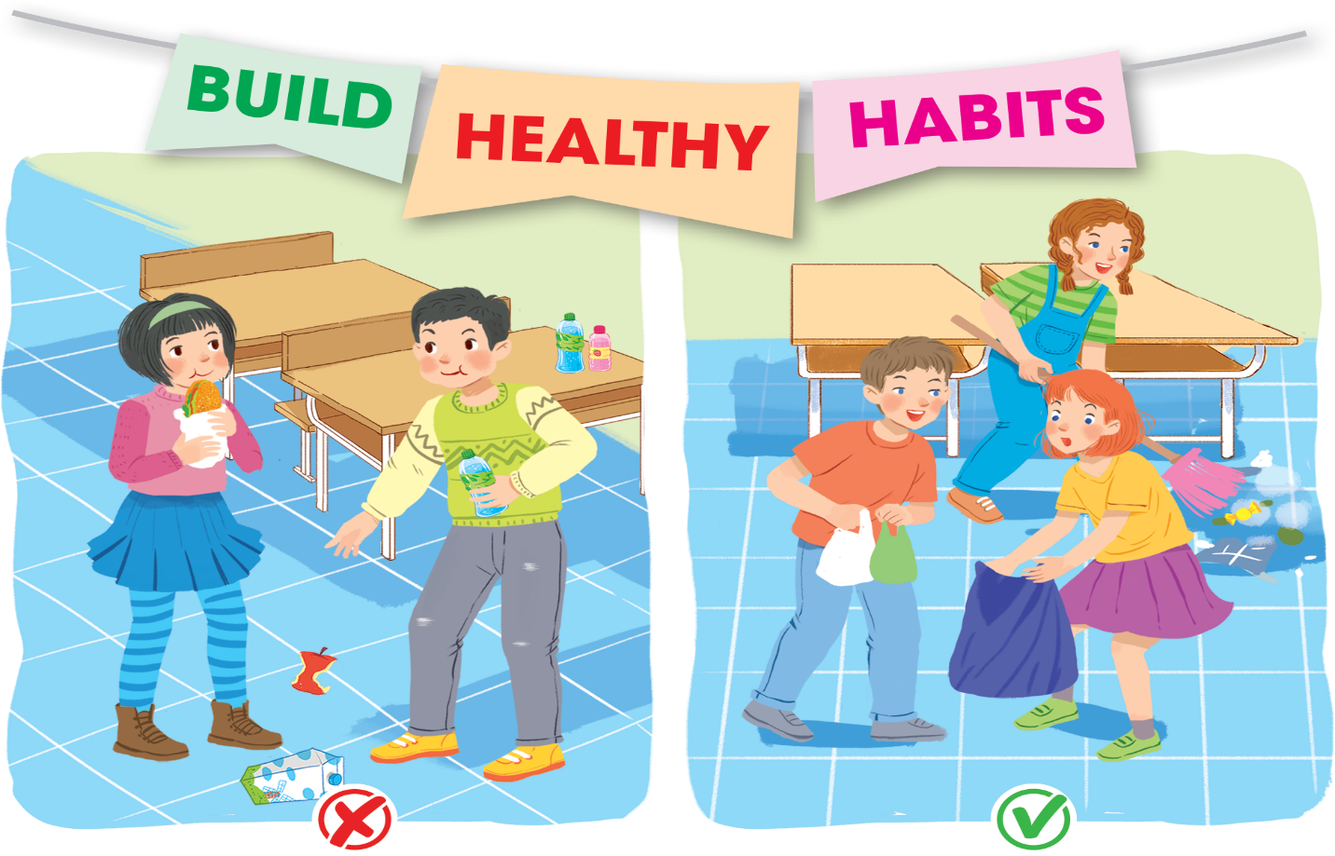
III. Consolidation
- Teacher asks students to talk about what they have learnt in the lesson
IV. Homework
- Prepare for the next lesson: Unit 3 – Getting started.

