Planning date 28/9/2025
UNIT 2: HEALTHY LIVING

Period 10. Lesson 2: A closer look 1
I. OBJECTIVES
By the end of this lesson, students will be able to:
1. Knowledge
- Vocabulary:
+ use the lexical items related to the topic Healthy living
+ use the words about healthy activities and health problems
- Pronunciation: pronounce and recognize the sounds /f/ and /v/ in isolation and in context
2. Core competence
- Develop communication skills
- Be collaborative and supportive in pair work and teamwork
- Actively join in class activities
3. Personal qualities
- Be ready to know the words about healthy activities and health problems
- Develop self-study skills
II. MATERIALS
- Grade 7 textbook, Unit 2, A closer look 1
- Computer connected to the Internet
- TV/ Projector/ Pictures/ Cards
- sachmem.vn
III. PROCEDURES
Warm up
Game: Face to face
- Teacher divides class into 2 teams: Cats and Dogs.
- Teacher asks students to think of words or phrases related to “Healthy activities” which they have learnt in the previous lesson or words they may know already.
- Ss have 3 minutes to think of the topic
- Students in each team turn by turn stand up and say 1 word or phrase related to the topic.
- In 90 seconds, the team has more right answers will be the winner, and the team repeat the word which is mentioned already or cannot give a word will be the loser.
Suggested answer:
- Going cycling/ swimming
- Walking
- Boating
- Eating breakfast
- Doing yoga/ aerobics
- Playing sports
- ….
Lead in
In today lesson, we are going to learn more words to talk about Health problems and
two sounds /f/ and /v/
I. Presentation
1. Vocabulary
1. dim light (n): [visual + explanation]
2. lip balm (n): [visual + explanation]
3. chapped lips (n): [visual + explanation]
4. coloured vegetables (n): [visual + explanation]
5. red spots (n): [visual + explanation]
- Ss say the words.
- Other Ss correct if the previous answers are incorrect.
- Teacher shows and says the words aloud and asks Ss to repeat them
2. Present the tasks
- T ask ss open the book at page 20 and ask ss to read out loud the exercise 1.
II. Practice
1. Matching (Ex 1, p. 20)
- Teacher asks students to work independently to do matching.
- Ss work individually.
- Teacher has students to check their work with their partner.
- Then, teacher call one student to do matching in front of the class and give correct answer.
Answer keys: 1. C, 2. E, 3. D, 4. A, 5. B
2. Complete the sentencs. (Ex 2, p. 20)
- Teacher asks students to read the words and phrases provided aloud and give them their meaning if necessary.
- Teacher asks Ss to work individually.
- Then, teacher calls some students to check and asks them to explain their answers.
- Teacher checks students ‘answers as a class.
Answer key:
1. coloured vegetables
2. Soft drinks
3. fit
4. skin condition
5. sunburn
3. Discussion (Ex 3, p. 20)
- First, teacher asks students to read all the sentences in the table and find out any words are new to them.
- Then, teacher has students work in group of 4 - 6 to discuss whether each activity is healthy or unhealthy.
- Ss work in groups.
- Finally, teacher calls out some group to give and explain their answers as a class.
- Teacher listens and correct their answers.
Suggested answers:
Healthy: 1, 3, 4
Unhealthy: 2, 5
III. Pronunciation (10mins)
1. Presentation
- Teacher writes on the board two words “fit” and “vegetables”.
- Then, teacher has students focus on the underlined letters “f” and “v”.
- Ss practice saying the word individually.
- Teacher calls some students to read aloud.
- Teacher corrects if necessary.
- After that, teacher says “In this lesson we are going to learn how to pronounce two sounds f and v”.
-Teacher asks Ss to watch Tiếng Anh 7 - Pronunciation video Unit 2
https://www.youtube.com/watch?v=zCHLaZzTQjc
- Ss imitate and practice the two sounds together.
- Teacher explains if necessary.
2. Practice
Task 4. Listen and repeat (Ex 4, p. 20)
- Teacher has students read out the words first.
- Ss practice saying the words independently
- Teacher asks students to listen and try to repeat the words as a class, a group, and individually.
- Teacher may play the recording as many times as necessary and correct their pronunciation
Task 5: Listen and repeat full sentences.(Ex 5, p. 20)
- Teacher has students read the sentences and tell them to pay attention to the underlined words with sounds /f/ and /v/.
- Ss read and underline the words
- Teacher plays the recording for students to listen and repeat each sentence.
- Teacher corrects their pronunciation if necessary.
- Teacher calls on some students to read the sentences individually.
IV. Production(5mins)
Game: Tongue Twister
1. Victoria fried some fresh fish.
2. Van fried the fish in half a vat of fat.
- Teacher asks students to focus on 2 sentences on the board and try to say it.
- Teacher models, then call some students to read and correct pronunciation if necessary.
- Ss practice saying the sentences.
- Teacher has students try to read the whole sentence as quick as possible without making any mistakes.
- Teacher corrects if necessary.
V. Consolidation
- Teacher asks students to talk about what they have learnt in the lesson.
VI. Homework
- Find 5 more words with the sound /f/ and 5 more words with the sound /v/.
- Write them down and practice pronouncing the words.

UNIT 2: HEALTHY LIVING

Period 11. Lesson 3: A closer look 2
I. OBJECTIVES
By the end of this lesson, students will be able to:
1. Knowledge
- Know how to recognize and write simple sentences.
2. Core competence
- Develop communication skills
- Be collaborative and supportive in pair work and team work
- Actively join in class activities
3. Personal qualities
- Be responsible and hard working
B. MATERIALS
- Grade 7 textbook, Unit 2, A closer look 2
- Computer connected to the internet
- TV/ Projector/Pictures, sets of word cards
- sachmem.vn
C. PROCEDURES
Warm up: game Shark attack
_ _ _ _ _ _ _ _ _ _ _ _ _ _ _ (simple sentences)
Lead in: Today we ares going to learn a lesson about “simple sentences”.
I. Presentation
1. Simple sentences
- Teacher writes 1 more example, then underlines the main parts of each sentence.
It rained.
S V
I read science books.
S V O
I watched T.V last night.
S V O A
- Ss look at the board and listen to the teacher’s questions to identify each part of a sentences.
- Teacher tells Ss that a simple sentence has only one subject and one verb, some simple sentences also have an object, some simple sentences also have an adverb.
III. Practice
1. Tick the simple sentences. (Ex 1, p. 21)
- Teacher asks students to do the exercise individually and then compare their answers with a classmate.
- Teacher confirms the correct answers.
Answer key:
Simple sentences: 1, 2, 4
2. Underline and write S for the subject and V for the verb in each simple sentence below. (Ex 2, p. 21)
- Ss read each sentence carefully to look for the two main parts.
- Ss do the task individually.
Answer key:
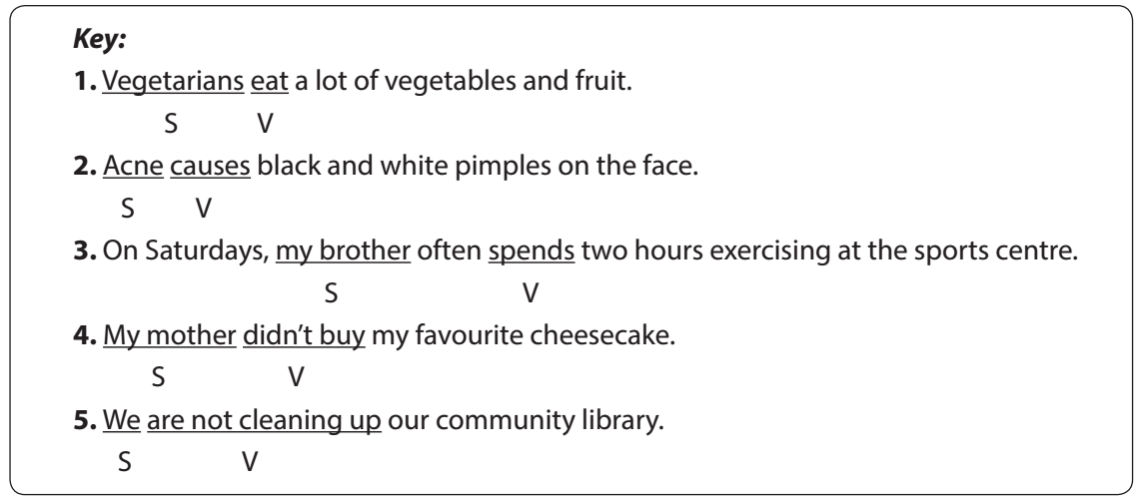

3. Rearrange the words and phrases to make similar sentences. (Ex 3, p. 21)
- Ss work in pairs to do the task.
- Teacher calls on Ss to read aloud the complete sentences.
Answer key:
1. My sister never drinks soft drinks.
2. Acne aﬀects 80% of young people.
3. He has bread and eggs for breakfast.
4. We don’t eat much fast food.
5. Fruit and vegetables have a lot of vitamins.
IV. Production
1. Write complete sentences from the prompts. You may have to change the words or add some. (Ex 4, p. 21)
- Teacher asks Ss to look at the prompts of each sentence and decide the two main parts of the sentence.
- Call on some students to read out their answers.
- Choose some typical errors and correct as a whole class without nominating the students’ names.
Answer key:
1. Tofu is healthy.
2. Many Vietnamese drink green tea.
3. She does not use suncream.
4. My father does not exercise every morning.
5. Most children have chapped lips and skin in winter.
2. Discuss and write a simple sentence from the two given sentences. (Ex 5, p. 21)
(At home for weak class or not enough time).
- Teacher asks Ss to work in pairs to read the two separate sentences, discuss and determine the two main parts for the new sentence.
- Call on some Ss to write the sentences on the board.
- Choose some typical errors and correct as a whole class without nominating the students’ names.
Answer key:
1. We avoid sweetened food and soft drinks.
2. My dad and I love outdoor activities.
3. You should wear a hat and suncream.
4. My mother read and downloaded the health tips.
V. Consolidation
Teacher asks students to talk about what they have learnt in the lesson.
VI. Homework
- Do exercises B 5,6 P. 12,13 in the workbook.
- Prepare vocabulary for Lesson 4: Communication

UNIT 2: HEALTHY LIVING

Period 12. Lesson 4: Communication
A. OBJECTIVES
By the end of this lesson, students will be able to:
1. Knowledge
- learn how to ask for and give health tips
- practise using some grammar points and vocabulary related to the topic.
2. Core competence
- Develop communication skills
- Be collaborative and supportive in pair work and team work
- Actively join in class activities
3. Personal qualities
- Be benevolent and responsible
B. MATERIALS
- Grade 7 textbook, Unit 2, Communication
- Computer connected to the internet
- TV/ Pictures/ Projector
- sachmem.vn
C. PROCEDURES
Warm up: Brainstorming

Sunburn acne
Suggested answers:
Asthma, a backache, a broken leg, a cold, a cough, an earache, a headache, a sore throat, a toothache, sunburn, etc.
Lead in
To day, We are going to learn how to give tips for health problems
I. Pre – speaking
1. Listen and read the dialogue. (Ex 1, p. 22)
- Teacher plays the record for SS to listen and read the conversation about health problem.
- Teacher corrects pronunciation if necessary.
- Teacher asks Ss to pay attention to the highlighted parts and asks them some questions to elicit the new structure:
- What do these sentences mean?
- When do we use these sentences?
- …
- Ss answer teacher’s questions to find out new structure to give tips for health problems.
- Some students give the new structure to the teacher.
- Teacher corrects and writes on the board:
Structure: to give advice:
- You should/ shouldn’t …
- You can …
2. Make similar dialoguage. (Ex 2, p. 22)
- Teacher has Ss look at the situation in Ex 2 to make similar dialogue:
1. I’m tired.
2. I have acne.
3. My hands are chapped.
- Ss work in pairs to make similar dialogue.
- Teacher calls some pairs to present it in front of the class.
- Teacher gives feedback and some comments.
Suggested answers:
A: I am tired.
B: You can drink some milk.
A: Yes.
B: And you should have a nap.
A: Thank you.
II. While - speaking
1. Read the passage and choose the correct title for it. (Ex 3, p, 22)
- Teacher asks Ss to read the passage independently and choose the correct answer of the main idea.
- Ss so the task individually.
- Teacher calls some Ss to give their answer and explain it.
- Teacher confirms the correct answers.
Answer key: A
2. Discuss and make a list for the tips which help the japanese live long lives. (Ex 4, p. 22)
- Teacher has students work in groups to discuss and takes notes of the tips for a long life that they find in the text.
- Ss work in groups.
- Teacher confirms and corrects if necessary.
Suggested answers:
(1) They eat a lot of fish and vegetable.
(2) They cook fish with little cooking oil.
(3) They also eat a lot of tofu.
(4) The Japanese work hard and do a lot of outdoor activities.
IV. Post - speaking
1. Discuss and make a list for the tips that the Vietnamese can do to live longer. (Ex 5, p. 22) (At home for weak class or not enough time).
- Teacher asks students to work in groups of 4- 5 to discuss and come up with some tips for how the Vietnamese can live longer.
- Some groups share ideas with the whole class and other groups listen and add more their ideas.
- Teacher listens and corrects if necessary.
Suggested answers:
1. avoid overeating
2. do more outdoor activities.
3. drink enough water
4. sleep before 10 p.m
5. eat more nuts.
6. do more exercises.
7. …
V. Consolidation
Teacher asks students to talk about what they have learnt in the lesson.
VI. Homework
- Do exercises C1,2,3. P. 12,13 in the workbook.
- Prepare vocabulary for Lesson 5: Skills 1

