Planning date: 14/9/2025

Period 4: UNIT 1: HOBBIES
Lesson 3: A closer look 2
A. OBJECTIVES
By the end of this lesson, Ss will be able to:
1. Knowledge
- Review the knowledge on present simple tense
2. Core competence
- Develop communication skills
- Be collaborative and supportive in pair work and team work
- Actively join in class activities
3. Personal qualities
- Be encouraged to know more about their classmate’s hobbies
- Develop self-study skills
B. TEACHING AIDS
- Grade 7 textbook, Unit 1, A closer look 2
- Computer connected to the internet
- Projector/ TV/ pictures and cards
- sachmem.vn
C. PROCEDURES
1. WARM-UP
Game: Guessing game
- T divides the class into 4 teams.
- T calls on a S from each team to go to the board in turn. That S thinks of a hobby and says the keywords out loud.
The other teams try to guess What the hobby is. They will get 1 point for each correct answer. The team with the most points is the winner.
- Teacher and students discuss as a class.
- Teacher asks students to say the words aloud and makes sure they pronounce the words correctly. Teacher can ask for translation to check their understanding.
Example:
A: water, grow, flowers, vegetable.
B: Is it gardening?
A: Yes, it is.
* Lead-in.
- To introduce the targeted grammar, T draws Ss’ attention to the form of the sentences created in the game and asks them whether they know the target tense.
2. PRESENTATION.
THE PRESENT SIMPLE: REVIEW
- T has the Ss review the forms and use of present simple before doing the exercises.
- Ss retell the form and the uses of the tense: The present simple.
Present simple tense | Form | Example
Present simple tense | S + Vinf/ V(s/es) + … | I usually collect bottles after use.
Present simple tense | S + don’t/ doesn’t + Vinf + … | She doesn’t like swimming.
Present simple tense | Do/ Does + S + Vinf + …? | Do you like playing board games?
Present simple tense | W/H + do/does + S + Vinf + …? | What do you often do when you have free time?

- T comments and explains again.
- T shows each of the examples in the Remember box on the slide or have Ss read the examples in the book. T highlights the present simple form. Explain each use.
- T has Ss read the orange box in the book again to help them understand better the uses of the present simple.
- T asks Ss what signal words help them identify the verb tense. Elicit answers from Ss. (Signal words are adverbs of frequency and verbs such as start, etc.)
- Teacher checks their answers as a class.
3. PRACTICE.
Activity 1: MATCH THE SENTENCES (1 – 5) TO THE CORRECT USES (A – C).
(Ex 1, p. 11)
- T asks Ss to do the exercise individually and then check their answers in pairs.
- Ss do the exercise individually.
- T invites some Ss to share their answers.
- Confirm the correct answers.
Answer key:
1. b
2. a
3. c
4. a
5. b
Activity 2: COMPLETE THE SENTENCES. USE THE PRESENT SIMPLE FORM OF THE VERBS. (Ex 2, p. 12)
- T has Ss do this exercise individually and then compare their answers with a partner.
- T asks some Ss to write their answers on the board.
- T checks the answers with the whole class. Ask Ss to explain the use of the tense in each sentence.
- T confirms the correct answers.
Answer key:
1. make
2. does … do
3. have
4. doesn’t like
5. Does … start
Activity 3: FILL IN EACH BLANK WITH THE CORRECT FORM OF THE VERB IN BRACKETS. (Ex 3, p. 12)
- T has Ss do this exercise in pairs and then compare the answers with another pair.
- T asks some Ss to write their answers on the board.
- T checks the answers with the whole class. T asks Ss to explain the use of the tense in each sentence.
- T confirms the correct answers.
Answer keys:
1. enjoys
2. spends
3. don’t like / do not like
4. go
5. begins
6. don’t enjoy / do not enjoy
Activity 4: WRITE COMPLETE SENTENCES, USING THE GIVEN WORDS AND PHRASES. YOU MAY HAVE TO CHANGE THE WORDS OR ADD SOME. (Ex 4, p. 12)
- T has Ss work in groups to write the sentences. Give each group a
large-size sheet of paper to write.
- Ss work in groups to write the sentences.
- T has groups cross-check.
- T sticks some sheets on the board. Comment and confirm the correct answers.
Answer key:
1. The sun sets in the west every evening.
2. Do Trang and Minh play basketball every day after school?
3. The ﬂight from Ho Chi Minh City doesn’t arrive at 10:30.
4. Our science teacher starts our lessons at 1 p.m. on Fridays.
5. Do you make models at the weekend / at weekends?
4. PRODUCTION. GAME: SENTENCE RACE (Ex 5, p. 12)
* Process:
- T divides Ss into groups. Assign a group leader.
- T writes a verb on the board and have Ss make a sentence with the verb, using the present simple form.
- The group leader records his / her group’s points.
- T invites group leaders to read aloud the sentences.
- T comments and announces the winners.
5. CONSOLIDATION.
- To consolidate what Ss have learnt in the lesson, T asks Ss to talk about what they have learnt in the lesson.
6. HOMEWORK.
- To reactivate & consolidate the knowledge learnt in the lesson, Make 3 sentences in the present simple tense.
- Complete the exercises in the Workbook.

Period 5: UNIT 1: HOBBIES
Lesson 4: Communication

A. OBJECTIVES
By the end of this lesson, Ss will be able to describe and give opinions about hobbies.
1. Knowledge
- Use the lexical items related to the topic Hobbies
- Talk about likes and dislikes
- Ask and answer about hobbies.
2. Core competence
- Develop creativity and communication skills
- Be collaborative and supportive in pair work and team work
- Actively join in class activities
3. Personal qualities
- Be ready to describe and give opinions about hobbies.
- Be interested more about new hobbies.
B. TEACHING AIDS
- Grade 7 textbook, Unit 1, Communication
- Computer connected to the internet
- Projector/ TV/ pictures and cards
- sachmem.vn
Assumptions
C. PROCEDURES
1. Warm up:
GAME: ARRANGE THE FOLLOWING VERBS OF LIKING IN DESCENDING ORDER OF PREFERENCE.
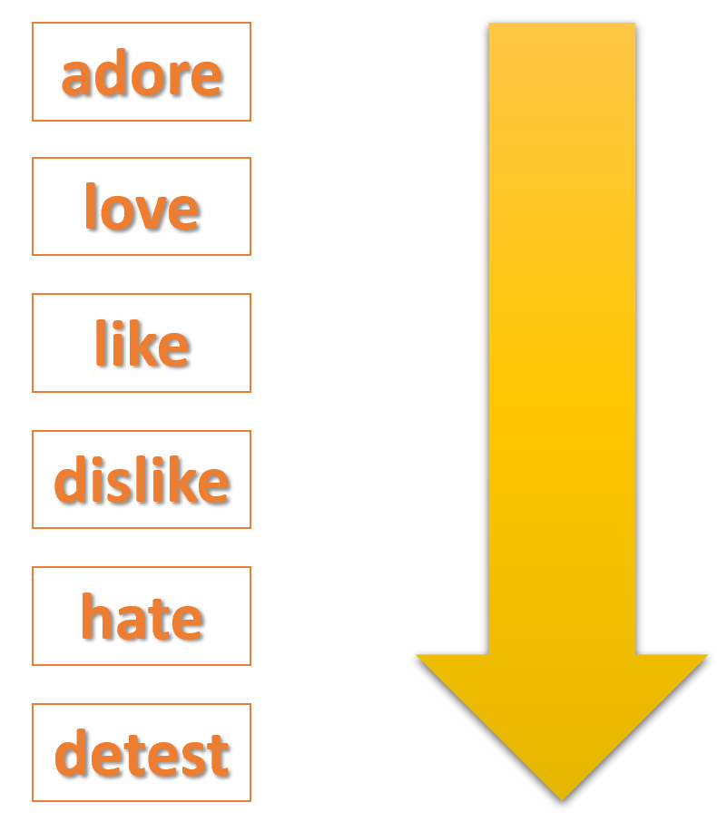
* Lead-in:
- To lead in the targeted vocabulary and pronunciation, T asks some Ss to make sentences about themselves, using the verbs of liking / disliking.
- T introduces the objectives of the lesson: learning how to talk about likes / dislikes and about their hobbies.
Let’s find out more ways to give your opinion about something in this lesson.
2. EVERYDAY ENGLISH.
Example: I like going to the cinema.
She hates cleaning the floors.
Activity 1+2: LISTEN AND READ THE DIALOGUE BELOW. PAY ATTENTION TO THE QUESTIONS AND ANSWERS. WORK IN PAIRS. ASK AND ANSWER QUESTIONS ABOUT WHAT YOU LIKE AND DON’T LIKE DOING. (Ex 1, 2, p. 13)
- Play the recording for Ss to listen and read the dialogue between Mi and Ann at the same time.
- Ask Ss to pay attention to the questions and answers.
- Have Ss practise the dialogue in pairs.
- T calls on some Ss to give examples.
- Teacher and students discuss the answers.
- Teacher confirms the answers and gives feedback.
Activity 3: All about your hobbies: ANSWER THE QUESTIONS. FILL IN COLUMN A WITH YOUR ANSWERS. (Ex 3, p. 13)
- T asks Ss to work individually and fill in column A
- Ss work individually to do the task.
- T invites some Ss to share their answers before checking with the whole class.
- T gives feedback and comments.
Answer key:
Student’s opinions.
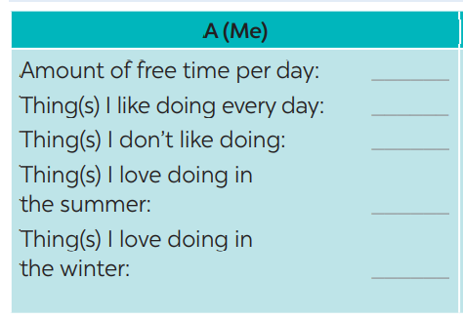
Activity 4: NOW INTERVIEW YOUR FRIEND, USING THE QUESTIONS IN 3. WRITE HIS / HER ANSWERS IN COLUMN B. (Ex 4, p. 13)
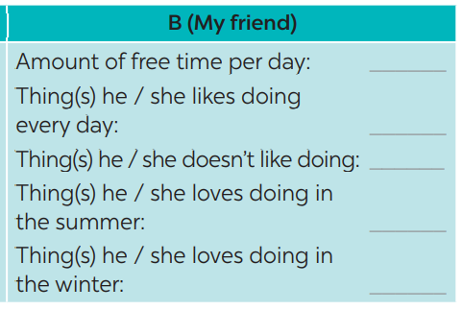
- T asks Ss to take turns being the person who asks the questions. This S has to note down his/ her partner’s answers to report to the class later.
- Ss work in pairs to do the task.
- T calls on some Ss to report the answers to the class.
- T and other Ss give comments.
3. FURTHER PRACTICE
Activity 5. COMPARE YOUR ANSWERS WITH YOUR FRIEND’S. THEN PRESENT THEM TO THE CLASS. (Ex 5, p. 13)
Example:
I have one hour of free time a day, but my friend Lan has only about 30 minutes.
I like listening to music every day, and Lan likes it too. I don’t like exercising,
but Lan does.
- T asks Ss to read the example to understand how to report the answers.
- Ss work in pairs again to compare the answers and prepare a short presentation.
- T invites some Ss to present their work.
- T and other Ss give comments.
4. CONSOLIDATION
- To consolidate what Ss have learnt in the lesson, T asks Ss to talk about what they have learnt and ticked the objectives they can do in the lesson.
5. HOMEWORK.
- Brainstorm some interesting and easy-to-do hobbies.
- Do Unit 1-part C in WB
- Prepare for : Unit 1- Skills1

Period 6: UNIT 1: HOBBIES

Lesson 5: Skills 1
A. OBJECTIVES
By the end of this lesson, Ss will be able to:
1. Knowledge
- Develop reading skill for general and specific information about Gardening.
- Talk about their hobbies and the benefits of them.
2. Core competence
- Develop communication skills and creativity
- Be collaborative and supportive in pair work and team work
- Develop presentation skill
- Actively join in class activities
3. Personal qualities
- Understand more about their preference of different types of hobbies
- Develop self-study skills
B. TEACHING AIDS
- Grade 7 textbook, Unit 1, Skills 1
- Computer connected to the Internet
- Projector/ TV/ pictures and cards
- sachmem.vn
Language analysis
C. PROCEDURES
I. WARM-UP:
LIST OUT AS MANY HOBBIES AS POSSIBLE
- T introduces the objectives of the lesson and asks Ss to list out as many hobbies as possible within 1 minute.
- Ss work in groups to brainstorm hobbies.
- Which teams can list out more correct answers wins.
- T confirms answers as a class.

II. PRE - READING.
Activity 1: WORK IN PAIRS. LOOK AT THE PICTURE AND DISCUSS THE QUESTIONS BELOW.
- T has Ss look at the picture in the book or show the picture in the book on a slide.
- Ask Ss who they see in the picture and what they are doing.
- T has Ss work in pairs to discuss the two questions.
- T invites some Ss to share their answers.
- Tell Ss that they are going to read a text about gardening.

III. WHILE - READING.
Activity 2: READ THE TEXT ABOUT GARDENING. MATCH EACH WORD IN COLUMN A WITH ITS DEFINITION IN COLUMN B. (Ex 2, p. 14)
- T tells Ss what they are going to do.
- T asks Ss how to do the exercise. Elicit answers from Ss.
- If needed, T will tell them to follow these steps:
+ Read the words in column A.
+ Locate each word in the text.
+ Read around the word to get the general meaning.
+ Read the definitions in column B, find the suitable meaning to match each word.
- T asks Ss to repeat the steps (they can speak in Vietnamese).
- Ss do the exercise individually and then check answers in pairs.
- T invites some Ss to share their answers.
- Confirm the correct answers.
Answer key:
1. b
2. e
3. c
4. a
5. d
Activity 3: READ THE TEXT AGAIN. COMPLETE EACH SENTENCE WITH NO MORE THAN THREE WORDS. (Ex 3, p. 14)
- T asks Ss what they are going to do.
– T has Ss share how to do this exercise.
– T briefly tells them the steps: read the sentences, underline the key words in the sentences, locate the key words in the text and find the words to complete the sentences.
– T asks Ss to repeat the steps (they can speak in Vietnamese).
- T asks Ss to do the exercise individually and then check their answers in pairs.
- T invites some Ss to share their answers. Have them explain their answers.
- Confirm the correct answers.
– T asks Ss to tell the class the benefits of gardening as mentioned in the text.
Answer key:
1. doing things
2. insects and bugs
3. patient
4. join in
5. an hour
* Vocabulary ( Matching)
- outdoor (adj) ngoài trời
- patient (adj) kiên nhẫn
- responsibility (n) trách nhiệm
- maturity (adj) sự trưởng thành
- valuable (adj) quý giá, quan trọng, hữu ích
IV. PRE – SPEAKING.
Activity 4: WORK IN PAIRS. MATCH EACH HOBBY WITH ITS BENEFIT(S). ONE HOBBY MAY HAVE MORE THAN ONE BENEFIT. (Ex 4, p. 14)
- T introduces some structures to talk about the benefits of hobbies:
+ to develop sth
+ to make sb + adj
+ to reduce sth
+ to help sb / sth do sth
– Give some examples.
- Ss work in pairs to match the hobby with its benefit(s). Check as the whole class.
– T asks Ss to name other benefits of these hobbies.
- Invite some Ss to share their answers.
- Confirm the answers.
Answer key:
1. c, d
2. b, c
3. a, c, d, e
V. WHILE - SPEAKING.
Activity 5: WORK IN GROUPS. ASK ONE ANOTHER THE FOLLOWING QUESTIONS. THEN PRESENT YOUR PARTNERS’ ANSWERS TO THE CLASS. (Ex 5, p. 14)
- Have Ss work in groups to ask and answer the two questions.
- Model the answers to the two questions if needed.
- Ss work in groups to ask and answer the two questions.
- Invite some Ss to share their partner’s answers to the questions.
- Invite other Ss to comment on the answers.
- Comment on Ss’ answers.
VI. POST – READING AND SPEAKING.
- T allows Ss to give comments for their friends and vote for the most interesting and informative presentation.
- Ss do as required.
- T calls Ss to share answer.
- T gives feedback and comments.
VII. CONSOLIDATION.
- To consolidate what Ss have learnt in the lesson, T asks Ss to talk about what they have learnt in the lesson.
VIII. HOMEWORK.
- T asks Ss to write down their opinion about carving eggshells.
- T asks Ss to search for more information about this unique hobby.
- Learn by heart vocabulary
- Do Unit 1-part D in WB
- Prepare for : Unit 1- Skills2

