Date of planning: 12/10/2025
Period 16: UNIT 3: TEENAGERS
Lesson 1: Getting started – It’s great to see you again!
A. Aims: By the end of this lesson, Ss will be able to:
1. Knowledge:
- Gain an overview about the topic Teenagers
- Gain vocabulary to talk about teenagers.
2. Competences:
- Develop communication skills and creativity
- Be collaborative and supportive in pair work and teamwork
- Actively join in class activities
3. Personal qualities:
- Love talking about themselves and their problems
B. Teaching aids: TV, laptop
C. Procedure:
*Warmer: I.N.I.T.I.A.L Game
- T divides the class into 2 teams.
- T shows 9 different pictures
- Students are shown different pictures and they need to take the first letter from each picture to form the mystery word.
- Which team finds the mystery word first will become the winner.

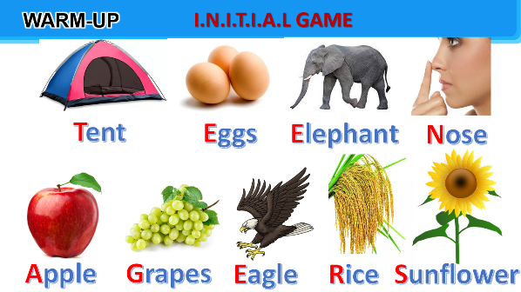
*Mystery word: TEENAGERS
- T leads to the new unit. Write the unit title Teenagers on the board. Ask Ss to guess what they are going to learn about in this unit.

I. Pre-reading:
- Teacher asks Ss to look at the pictures in the book and answer the questions:
+ Who are the people?
+ What might they be talking about?

- Ss answer the questions in pairs.
*Suggested answers:
- They are teacher and students.
- They are in a class meeting.
- They are discussing their class forum, club activities to participate in, and their problems.
II. While-reading:
1. Listen and read:
- Teacher plays the recording twice - Ss listen and read.
- Teacher checks Ss’ prediction.
- T calls 4 Ss to read the conversation aloud in pairs.
2. True/False statements:
- Ask Ss to work in pairs to read the conversation again.
- Ask them to underline the key words and phrases in the statements. Then have pairs work together for one or two minutes to do the task.
- Have Ss read out the statements and say if the statements are true or false.
- Make sure they pronounce the words correctly.
- Teacher checks the answers as a class and gives feedback.
*Answer key: 1. F 2. T 3. T 4. F 5. T
III. Post-reading:
1. Write a word or phrase from the box under the correct picture.
- Ask Ss to work in pairs to match the pictures with the words or phrases.
- Ask Ss to say the words / phrases aloud. Make sure they pronounce the words and phrases correctly.
- Teacher checks the answers as a class and gives feedback.
*Answer key:
1. language club
2. pressure
3. arts and crafts club
4. forum
5. sports club
6. chess club
2. Complete each of the sentences with a word or phrase in 3. There is one extra word or phrase.
- Ask Ss to work independently to complete each sentence with a word or phrase in 3.
- Allow Ss to refer to the pictures, the words and phrases in 3, and the conversation if needed.
- Check the answers as a class.
- Ask several Ss to read aloud the full sentences. Correct Ss’ pronunciation if needed.
*Answer key:
1. arts and crafts club
2. forum
3. language club
4. pressure
5. sports club
3. Ask and answer the questions below. Report your friend’s answers to the class.
- Ask Ss to work in pairs to ask and answer questions.
Questions:
1. What types of social media do you have?
2. What kind of pressure do you have?
3. What clubs do you participate in?
4. Why do you choose to participate in that club?
- Encourage Ss to provide their partners with as much information as possible, using vocabulary they have learnt when they answer the questions.
- Ask some Ss to report information about their partners
IV. Wrap-up:
*Vocabulary:
1. forum (n) : diễn đàn
2. stress (n) : sự/tâm trạng căng thẳng
3. stressful (adj) : gây ra căng thẳng
4. pressure (n) : áp lực
5. user-friendly (adj) : dễ sử dụng/thân thiện với người dùng
6. midterm (adj) : giữa kỳ
- Refer to the unit title again, then together with Ss, orally list the issues that the teacher and students discuss in their class meeting.
- Ask Ss to add any other issues relevant to teenagers which are not mentioned in the conversation.
- Ask Ss to name several school clubs, pressure, and social media.
V. Homework:
- Name a list of school clubs and pressures.
- Do exercises …. in the workbook.
- Start preparing for the Project of the unit:
Teacher randomly puts Ss in groups of 4 or 5 and asks them to brainstorm about the club they would like to have at school and make a poster about it. Students will show and present their posters in Lesson 7 – Looking back and Project. (Teacher should check the progress of students’ preparation after each lesson.)

Date of planning:12/10/2025
Period 17: UNIT 3: TEENAGERS
Lesson 2: A closer look 1
A. Aims: By the end of this lesson, Ss will be able to:
1. Knowledge:
- Identify the combination of some verbs and verb phrases that are often used when teens talk about using social media.
- Distinguish two sounds /ʊə/ and /ɔɪ/ correctly
2. Competences:
- Develop competences of communication, cooperation and self-management.
- Be collaborative and supportive in pair work and teamwork
- Actively join in class activities
3. Personal qualities:
- Raise ss’ awareness of social media
- Have good attitude to school pressure
B. Teaching aids: TV, laptop
C. Procedure:
*Warmer: Game: Word puzzles
- Give Ss a few minutes to play a game. Have Ss play in two groups.
- Ask ss to find 6 meaningful words in the puzzles
- The team with the more correct answers wins.
- T leads in the new lesson.

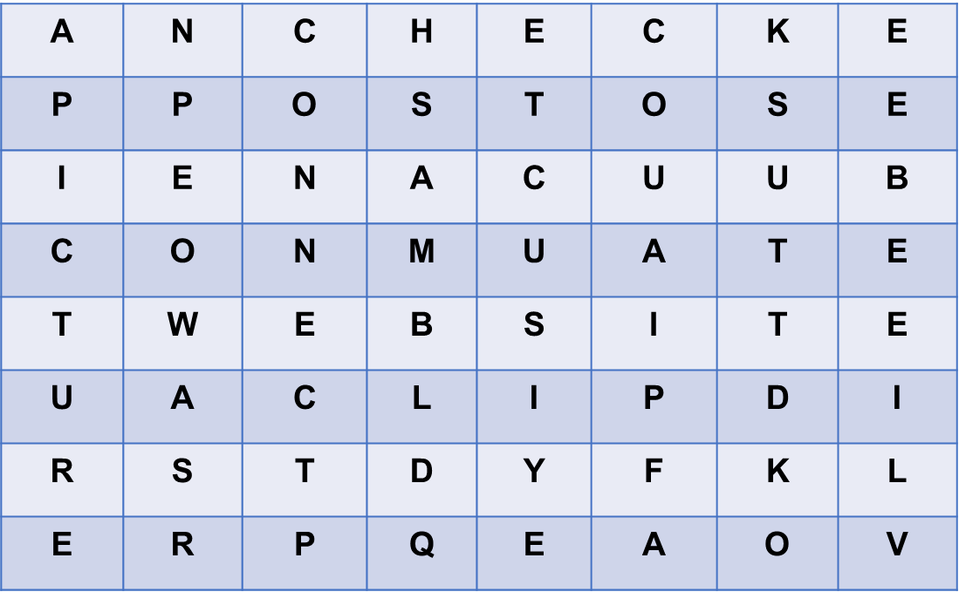

*Answer key: CHECK; POST; WEBSITE; CLIP; PICTURE; CONNECT
I. Vocabulary:
1. Presentation:
Task 1: Circle the correct options to complete the phrases.
- Have Ss read aloud the verbs and the word / phrases given.
- Ask Ss to work in pairs to circle the correct options to complete the phrases.
- Explain the meaning of the new verb phrases by using pictures or synonyms or even their mother tongue
- Invite Ss to take turns to read out their answers. Correct their pronunciation if needed.
- Check the answers as a class.
- T can also ask Ss to add more words / phrases to the verbs to make other phrases. This way, T can broaden Ss’ vocabulary if they are ready.
*Answer key: 1. A 2. A 3. B 4. B 5. B
*New words:
1. upload (v) = to copy or move programs or information to a larger computer system or to the internet : tải lên
2. browse (v) = to look at things / check over sth : đọc lướt, tìm
3. notifications (n) : thông báo
4. log on (to) (v) : đăng nhập
5. check (v) : kiểm tra
6. account (n) : tài khoản
2. Practice:
Task 2: Use the correct form of the verbs in 1 to complete the sentences
- Ask Ss to work individually to complete each of the sentences with a suitable verb from 1.
- Check the answers as a class.
- Have some Ss read aloud the complete sentences.
- Correct Ss’ pronunciation if necessary.
*Answer key: 1. browsed 2. uploaded 3. connects 4. checked 5. logs on
Task 3: Choose the correct answer A, B, or C
- T asks Ss to work individually to choose the correct answer for each sentence.
- Ss swap their answers with their partners.
- T check the answers as a class.
- T can also ask some Ss to read out their answers. Then have Ss read the sentences aloud as a class.
- Correct Ss’ pronunciation if necessary.
*Answer key: 1. B 2. C 3. A 4. A 5. B
II. Pronunciation: /ʊə/ and /ɔɪ/
1. Presentation:
- Show Ss two pictures

Boy tourguide
/ɔɪ/ /ʊə/
- T models the two sounds first
Or let Ss watch the videos from the links
https://www.youtube.com/watch?v=lFRrEI85IcM
https://www.youtube.com/watch?v=nHSqluHrD-U
- Ask Ss to give some words containing the sounds
2. Practice:
Task 4: Listen and repeat the words. Pay attention to the sounds /ʊə/ and /ɔɪ/. Then put the words into the correct columns.
- Have Ss listen to the recording once first. Then ask Ss to read out the words.
- Play the recording for them to listen again and repeat each word as a class, then as individuals.
- Play the recording as many times as possible.
- Have Ss complete the task. Check answers as a class.
*Answer key:
/ʊə/: tourist, ensure, sure, tournament
/ɔɪ/: boy, toy, avoid, choice
Task 5: Listen and practise the sentences. Underline the words with /ʊə/ and circle the words with /ɔɪ/.
- Have some Ss read the sentences first.
- Play the recording for Ss to listen to, then repeat each sentence after the recording.
- Play the recording as many times as necessary.
- Ask them to underline the words with the sound /ʊə/ and circle the words with the sound /ɔɪ/.
- Check the answers as a class.
- Call some Ss to read the sentences individually.
Answer key:
1. She is a noisy and curious girl.

2. They joined a full-day city tour.

3. I found it enjoyable to watch the tournament.
4. She’ll record our voices during the interview.

5. He is not acting very mature and is starting to annoy me.

III. Further practice: Slap the board
- T writes on the board 15 words with the sounds /ʊə/ and /ɔɪ/.
- Teacher divides students into 2 teams.
- When T reads out word by word, one student will run to the board and slap on the correct word with the correct sound.
- The team with more correct answers will be the winner.
- Students play the game.
- Teacher invites the winner to read aloud their sentences.
- Teacher gives feedback.
1. noisy  2. toy  3. tourist  4. tour  5. avoid  6. sure  7. boy  8. soil | 9. mature  10. annoy  11. voice  12. enjoy  13. tournament  14. ensure  15. choice
IV. Wrap-up:
- Ask Ss to summarise what they have learned in the lesson.
- Ask them to list some verb phrases learned in the lesson.
- Ask them to list some other learned words/ phrases related to teenagers’ activities or pressure, paying attention to their pronunciation.
- Ask ss to give 2 sounds learned in the lessons and give examples.
V. Homework:
- Learn by heart vocabulary
- Do exercises part A in the workbook
- Get ready for Unit 3. A closer look 2

Period 18 Date of planning:12/10/2025

UNIT 3: TEENAGERS
Lesson 3: A closer look 2

A. OBJECTIVES: By the end of this lesson, Ss will be able to:
1. Knowledge
- review the knowledge of simple sentences
- distinguish between simple sentences and compound sentences
- identify words that connect independent clauses
- apply the coordinating conjunctions or conjunctive adverbs to combine two sentences
2. Competences
- Develop competencies of communication, cooperation, and self-management.
- Be collaborative and supportive in pair work and teamwork
- Actively join in class activities
3. Personal qualities
- Raise ss’ awareness of social media
- Have a good attitude to school pressure
B. MATERIALS
- Grade 8 textbook, Unit 3, A closer look 2
- Computer connected to the Internet
- Projector / TV
- hoclieu.vn
C. PROCEDURES
I. WARM-UP : - Game: Board race
- Give Ss a few minutes to revise the simple sentences.
- Ss work in two teams.
- Ss receive slips of paper with simple sentences or compound sentences.
- Pick out all the simple sentences and run as fast as possible to stick them on the board,
1. She is a noisy and curious girl.

2. They joined a full-day city tour.

3. I found it enjoyable to watch the tournament.

4. She’ll record our voices during the interview.

5. Minh has some problems with his schoolwork.

6. Mark is hard-working; therefore, he usually gets high scores on exams.
7. Mai bought many books, for she likes reading.
8. He is a club member, but he never participates in any of the activities.
- Then underline the subjects and circle the verbs of those simple sentences.
- The team with the more correct answers will be the winner
+ Ask each team to read out loud the sentences they have selected. Correct their pronunciation if necessary.
+ The team with the most correct sentences wins.
+ T checks ss’ answers and gives feedback.
- Ask Ss to look at A CLOSER LOOK 2 on page 31.
II. PRESENTATION
1.ACTIVITY 1:
- Review simple sentences
- Recall the form of the simple sentences
- Learn how a compound sentence is formed and conjunctions
Grammar: Simple sentences and compound sentences.
- T gives 2 sentences and asks ss to find their subject and verb.
Eg1: Minh has some problems with his schoolwork.
S V
Eg2: Mark is hard-working; therefore, he usually gets high scores on exams.
S1 V1 connectors S2 V2
- Ask them to check how many subjects and verbs are in each of the sentences.
- Tell them to read the Remember! box in pairs before giving further explanation.
- Then T explains to ss what a simple sentence or a compound sentence is.
* A simple sentence is made up of one independent clause.
* A compound sentence is made up of two or more independent clauses
* Connectors
- coordinating conjunctions: for, and, but, or, so
- conjunctive adverbs: however, therefore, otherwise.
- Then ask Ss to underline the two independent clauses in Eg 2, circle the words in between the two independent clauses. Tell them that there are words other than and and but we use to connect two independent clauses in compound sentences.
- Ask Ss to read aloud as a class the words for, and, but, or, so, however, therefore, otherwise.
- Explain the meanings of these words if necessary. Tell Ss that they can also call these words connectors.
- Remind Ss to use a semicolon (;) before however, therefore, and otherwise, and the other connectors are followed by a comma (,)
- Teacher listens to students’ answers and gives feedback.
2. ACTIVITY 2: PRACTICE
- Task 1: Tick the simple sentences.
- Ask Ss to work individually to tick the simple sentences.
- Ask Ss to take turns to give their answers.
- Check the answers as a class.
- Then T asks some Ss to underline the subjects and circle the verbs of simple sentences.
- Ask several Ss to read aloud the full sentences. Correct their pronunciation if necessary.
Answer key: 1, 2, 4
- Task 2: Write S for simple sentences and C for compound sentences.
- Have Ss work in pairs to write S for simple sentences and C for compound sentences.
- Ask some Ss to read out the sentences and say S or C.
- Correct their pronunciation mistakes if necessary.
- Check the answers as a class.
Answer key:
1. S
2. S
3. C
4. S
5. C
- Task 3: Choose the correct answer A, B, or C.
- Have Ss work individually to choose the correct answer A, B, or C.
- Remind them of the meanings of the connectors and the punctuation (the comma and semicolon) for the connectors.
- Ask some Ss to read out the complete sentences.
- Check the answers as a class.
Answer key:
1. C
2. B
3. A
4. A
5. C
- Task 4: Combine the two sentences to make compound sentences, using the words from the box.
- Have Ss work in groups of four for five minutes to write on their posters complete compound sentences using the words in the box.
- Remind them to use commas and semicolons when necessary. Then ask them to swap answers with other groups.
- Check the answers as a class.
- Have the class read out the sentences. Correct their spelling and grammar mistakes when necessary.
Answer key:
1. Phong has to study harder; otherwise, he may fail the exam.
2. She is very sensitive, so don’t comment on her new hairstyle. / She is very sensitive; therefore, don’t comment on her new hairstyle.
3. Mi wants to have more friends, but she doesn’t connect well with others.
4. Students can work in groups, or they can work in pairs.
5. My friend likes showing off her new things; therefore, she often posts pictures on social media. / My friend likes showing off her new things, so she often posts pictures on social media.
- Students do peer correction.
- Teacher checks students’ answers as a class and gives feedback.
3. ACTIVITY 3: PRODUCTION
Task 5. GAME: Which group has the most sentences?
Work in groups. Each group makes as many compound sentences as possible. The group with the most correct sentence is the winner.
- Instruct Ss to play the game in groups.
- Have Ss work for two minutes to write compound sentences using given words on their strips of paper (the words on the slips of paper given to Ss can be for, and, but, or, so, however, therefore, otherwise). T may instruct Ss to write their compound sentences on A1-size paper.
- Invite groups to read out their compound sentences or to stick the A2-size paper with compound sentences they have written on the board.
- The group with the most correct sentences is the winner.
- T corrects any grammar and pronunciation mistakes if necessary.
4. CONSOLIDATION
a. Wrap-up
- Ask Ss to summarise what they have learnt in the lesson.
- Have them say out loud the connectors (coordinating conjunctions and conjunctive adverbs) they learnt in the lesson.
- Have them talk about the meanings of the connectors and how to use commas and semicolons with connectors.
b. Homework
- Do exercises part C in the Workbook.
- Learn by heart grammar point
- Prepare U3: communication

