Planning date: 29/9/2025

UNIT 2: MY HOUSE
Period 10/ Lesson 2: A closer look 1

A. Aims:
1. Knowledge:
By the end of the lesson, ss will be able to: use the lexical items related to the topic My house; use the vocabulary and structures to talk about the names of rooms and furniture pieces in the house; and pronounce and recognize the sounds /s/ and /z/.
2. Qualities: show their love to their home, talking about their house with positive attitudes.
3. Competences: enhance self-learning capability, group work, pair work, linguistic competence, cooperative learning and communicative competence.
B. Teaching aids:
- laptop, loudspeaker, TV/ projector.
C. Procedure:
* Warm up: * Jumbled words
- T asks students to work independently to rearrange letters to find out the correct word, the ask them to write the correct words on the board.
- T corrects and confirms the answers.
Answer key:
1. tchekin 1. kitchen
2. thraobom 2. bathroom
3. rodeomb 3. bedroom
4. lngivi moro 4. living room
5. lahl 5. hall
- T leads students into the lesson by telling them that “In today lesson, we are going to learn more words to describes rooms and furniture and two sounds /s/ and /z/.”
I. Vocabulary:
1. Presentation
* Matching (Task 1)
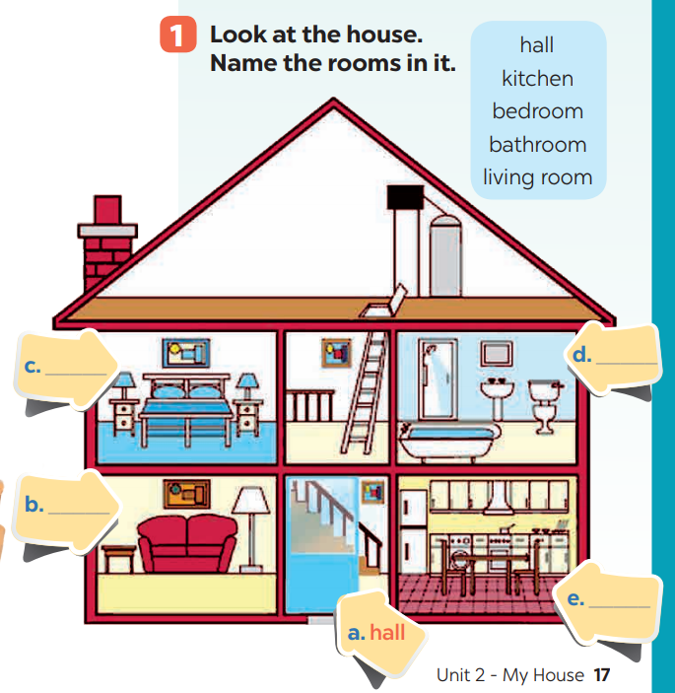- T asks Ss to look at the picture and then
match the word with the picture.
- T tells students to compare their answers
with their partners.
- Answer key:
a. hall
b. living room
c. bedroom
d. bathroom
e. kitchen
  - 2. Name the things in each room in Ex. 1 (Task 2).
- T asks students to work in pairs to do this activity.
- T writes the names of the rooms on the board in different places, then calls on students from different pairs to go to the board and write the name of the furniture under these rooms.
- T remind students that one piece of furniture can belong to more than one room.
- T asks other students to comment and asks them if they can add some more things to each room.
Suggested answers:
- Bedroom: lamp, picture, chest of drawers
- Living room: lamp, sofa, picture
- Hall: picture
- Kitchen: fridge, cupboard, dishwasher, sink
- Bathroom: shower, sink, toilet
Other words: chair, fan, air conditioner, cooker, etc.
2. Practice: Guessing game (Task 3)
- T models this activity with a student.
- T asks students to work in pairs: one student thinks of a room in his / her house; the other asks questions to guess the room.
- T calls some pairs to practise in front of the class.
- T comments on their performance.
Example:
Ss 1: What’s in your room?
Ss 2: A lamp and a chest of drawers.
Ss 1: Is it the bedroom?
Ss 2: Yes.
2. New words:
- chest of drawers (n): tủ có ngăn kéo
- sink (n): bồn rửa
- dish washer (n): máy rửa chén
- cupboard (n): tủ chén
- air conditioner (n): điều hòa không khí
- T shows the English words on the board
- T asks ss to give the Vietnamese meanings of the words.
- T writes on the board.
II. Pronunciation:
- 1. Presentation:
- T introduces 2 sounds s/ and /z/ to students and lets them listen and repeat the words in Ex. 4 (p. 18).
- T has students comment on how to pronounce these two sounds at the end of the words.
- T quickly explains the rules:
+ Final –s is pronounced /s/ after voiceless sounds (/t/, /p/, /k/, /f/, /θ/).
+ Final –s is pronounced /z/ after voiced sounds (/b/, /d/, /g/, /n/, /m/, /l/, etc.) and any vowel sounds.
- T asks students to give some words they know containing these sounds.
Suggested answers:
- /s/: cats, lamps, books, months
/z/: beds, dogs, cans, rooms, videos, cookers, bees+ Final –s is pronounced /s/ after voiceless sounds (/t/, /p/, /k/, /f/, /θ/).
+ Final –s is pronounced /z/ after voiced sounds (/b/, /d/, /g/, /n/, /m/, /l/, etc.) and any vowel sounds.
- Teacher asks students to give some words they know containing these sounds.
2. Practice: *Listen and write the words in the correct column. (Task 4)
- T asks students to read and listen again the words, then put them in the correct column.
- Ss work individually.
- T plays the recording for students to listen, repeat and check their answers.
Answer key:
/s/ | /z/
lamps, sinks, flats, toilets, | cupboards, sofas, kitchens, rooms
  - * Listen to the conversation. Underline the final “s” in the words and put them into the correct column. (Task 5)
- Have students quickly read the conversation and underline the final “s” in the words. Now play the recording for students to listen to the conversation and write /s/ or /z/ under each “s” that they have underlined.
- Tell them to put the words with the final “s” in the correct column according to the sound of “s”. Have them work in pairs to compare their answers. Check students’ answers. Ask them to explain their answers.
Answer key:
/s/: chopsticks, lamps
/z/: bowls, things, homes
Play the recording again for students to repeat each line of the conversation. Ask students to work in pairs to practice the conversation. Call some pairs to practise the conversation. Comment on their pronunciation of the final “s”.
III. Production: Game: Whispering
- Teacher divides the class into 4 big groups and asks students to stand in four lines.
- The member in the last place will make a sentence containing at least a word and a sound they have learnt; then, whisper the sentence to the next member of the group. They will continue until the member in the first place and this member will say the sentence aloud.
- The fastest group will win the game.
Suggested sentences:
- There are two bedrooms in my house.
- My living room has a TV, two lamps, some pictures and a sofa.
IV. Wrap – up
- T asks students to talk about what they have learnt in the lesson.
V. Homework:
- Learn by heart the new words.
- Find 5 more words with the sound /s/ and 5 more words with the sound /z/. Write them down and practice pronouncing the words.
- Do exercise part A in workbook.
- Prepare Unit 2- A closer look 2

