Planning date: 21/9/2025
Period 9
Unit 2: MY HOUSE
Lesson 1: GETTING STARTED
A look inside

A. Aims:
1. Knowledge: By the end of the lesson, students will be able to understand the content of conversation about the topic ‘My house” and know some vocabulary about the lexical items related to the topic My house; ask and answer about where someone lives.
2. Qualities: Students will be able to enhance their love for their homes, their responsibility for study, their industriousness.
2. Competences: Students will be able to practise listening skill, reading skill, communicate and cooperate, solve problems and develop creativity.
B. Teaching aids:
Textbook, computer, projector/ TV, cassette.
C. Procedure:
I. Warm up: Game: Networking
- T divides the class into two teams, then writes the topic “Types of house” on the board and gives them two minutes to discuss.
- After that time, a student from each team one by one runs to the board and writes one word.
The team which has more correct answers is the winner.
Suggested answers:
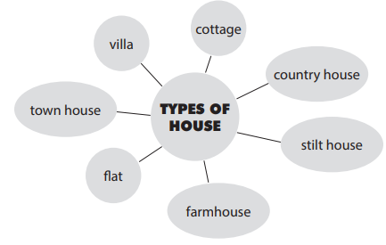

- T checks, gives feedback and leads to the new lesson.
- T leads in the lesson
- T draws students’ attention to the pictures in the textbook and asks them some questions about the pictures.
- What are Nick and Mi doing?
- What might they talk about?
Suggested answers:
- They are talking to / discussing with each other through the Internet.
(Students’answers)
I. Pre-reading:
* Put a tick: Which family member does Mi talk about? (Task 2)
- T asks students “Which family members does Mi talk about?” without reading the conversation.
- Ss guess.
II. While – reading:
1. Listen and read (Task 1)
- T plays the recording, asks students to pay attetion to the words related to the topic My house. (Teacher may check the meaning of some words if necessary.)
- T can play the recording more than once.
- Ss listen and read.
- T can invite some pairs of students to read aloud.
- T allows students to share their answers before discussing as a class and encourages them to give evidence.
Then, T confirms the correct answer:
Answer key:
1 | Parents | V
2 | Sister
3 | Brother | V
4 | Aunt | V
5 | cousin | V
2. Gap- fill: Game: Puzzle pieces (trò chơi lật mảnh ghép) (task 3)
- T asks Ss to work independently to fill each blank with the right word.
- T divides class into 2 groups and Ss in turn to unturn the pieces to find the hint ( a picture of a town house).
- T confirms the right answers and writes on the board.
Answer key:
1. sister
2. TV
3. town
4. country
5. three
III. Post – reading:
1. Vocabulary:
- town house (n): nhà phố
- country house(n): nhà ở quê

- flat (n): căn hộ
- T shows the English words on the board
- T asks ss to give the Vietnamese meanings of the words.
- T writes on the board.
2. Survey
- T asks students to work in groups of 4 or 6 to take turns to ask and answer about where they live.
- T can model with one student.
- T moves around to observe and offer help when needed.
- By the end of the activity, one student from each group can stand up and report to the class.
Suggested answers:
In my group, Linh lives in a flat, Lan and Huong live in a country house, etc….
3. Wrap up:
- T consolidates the knowledge of the lesson.
IV. Homework:
- Learn the new words by heart
- Do exercise part B in workbook
- Get ready for “A closer look 1”

