Week 3
Period 11 Teaching date: September, 25th, 2024

Unit 2: Time and daily routines
Lesson 1 (1, 2, 3)
A. OBJECTIVES:
By the end of the lesson, Ss will be able to:
1. Knowledge:
- understand and correctly repeat the sentences in two communicative contexts focusing on asking and telling the time.
- correctly say the phrases and use What time is it? – It’s …….. to ask and tell the time.
- enhance the correct use of What time is it? – It’s ………. to ask and tell the time in a freer context.
- Vocabulary: o’clock, thirty, forty five.
- Skills: speaking and listening
2. Competences:
- Oral Communication: speak about names, ask and answer the questions
- Co-operation: ready to help friends in pair work/ group work.
- Sociability: Talk to each other, say good words to others.
3. Attitude/ Qualities:
- Kindness: Help partners to complete learning tasks.
- Honesty: tell the truth about feelings and emotions
- Diligence: complete learning tasks
B. TEACHING AIDS:
- Teacher: Teacher’s guide Pages 30,31,32, audio Tracks 16,17, website hoclieu.vn, posters, laptop, pictures, textbook, lesson plan, TV or projector.
- Students: Pupil’s book Page 16, notebooks, workbooks, school things.
C. PROCEDURES:
Teacher’s activities | Students’ activities
1.Warm- up: (3’)  Game: Slap the board (with numbers)  *Aims: to create a friendly and active atmosphere in the class to beginning the lesson.  *Procedure:  - Divide the class into 3 teams. For each turn, invite 1 member from each team.  - Teacher says the numbers for the pupils to slap and say aloud.  - Give points to the pupils with the correct choice and encourage them.  - Sum up and lead in to the lesson.  - Say “Open your book page 16” and look at “Unit 2, Lesson 1 (1,2,3)”.  2. Presentation (16’)  Activity 1. Vocabulary.  *Aims: Ss will be able to know the vocabulary in the new lesson.  *Procedure:  -T elicits the new words  + o’clock : giờ đúng (translation)  + thirty : số 30 (picture)  + forty five : số 45 (picture)  + time : thời gian, giờ (translation)  - T models (3 times).  - T writes the words on the board.  - Checking: Rub out and remember  Activity 2. Look, listen and repeat:  *Aims: Ss will be able to understand and correctly repeat the sentences in two communicative contexts focusing on asking and telling the time.  *Procedure:  - Have pupils look at Pictures a and b and identify the characters in the pictures.  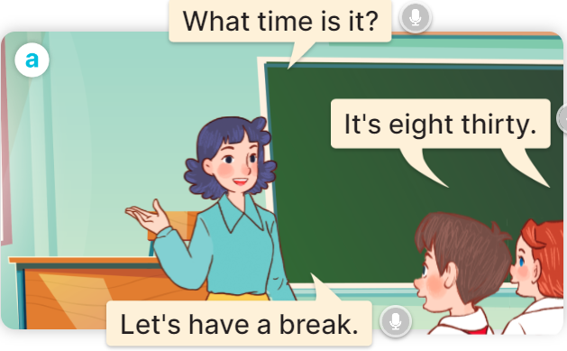  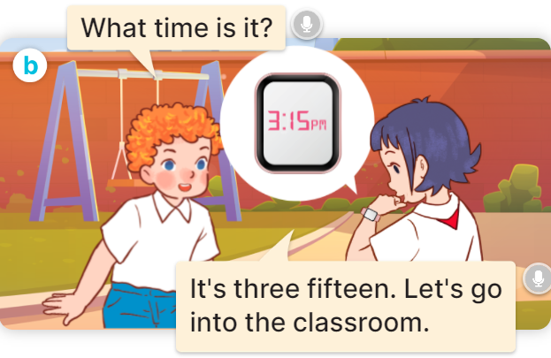  - Play the audio twice (sentence by sentence). Correct their pronunciation where necessary.  - Have Ss to practice the dialogue  - T invites a few pairs to the front of the class to practice.  - T checks pronunciation for ss.  Activity 3 Listen, point and say.  *Aims: Ss will be able to correctly say the phrases and use What time is it? – It’s …… to ask and tell the time.  *Procedure:  * Model sentences:  - T asks Ss look at picture a and helps Ss know the structure from the dialogue.  - T introduces new structure for Ss.  - T explains, models and gives meaning.  - Have Ss repeat the model sentences.  A: What time is it?  B: It’s six o’clock.  * Note:  - a.m. is used to tell the time in the morning, from 00:00 to 12:00;  - p.m. is used to tell the time in the afternoon and evening (afternoon is from 12:00:01 to 17:00 or 18:00, and evening is from 17:00 or 18:00 to 23:59:59).  3.Practice: (7’)  *Drill pictures  - Elicit and check comprehension to tell the time  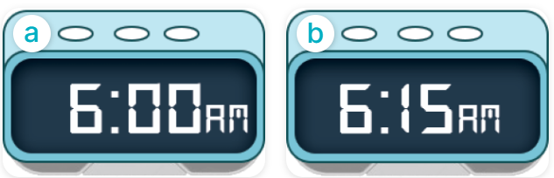  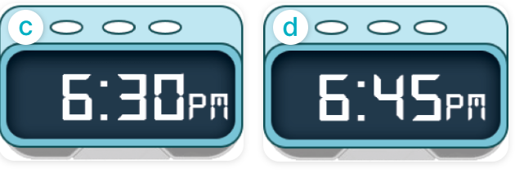  - Run through all the pictures.  - Run through model sentences.  + Run through the questions.  + Run through the answers.  - Have Ss to practise:  + T asks the first – Ss answer (change role).  + Ss – Ss (change role).  - Ask Ss to work in pairs to ask and answer the question What time is it? It’s…….  - T controls and corrects.  - Invite a few pairs to the front of the class to take turns pointing at the pictures and saying the questions and answers.  - Encourage Ss to practise speaking English.  - T gives feedbacks.  4.Production: (7’)  Activity 4. Let’s talk.  *Aims: Ss will be able to enhance the correct use of What time is it? – It’……. to ask and tell the time in a freer context.  *Procedure:  - T asks ss look at the two speech bubbles and ask:  +Who are they?  + What are they talking about?  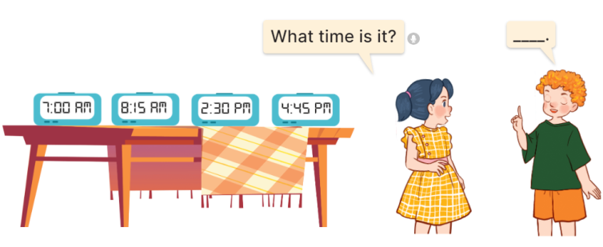  - Get Ss to repeat the question and the answer several times in pairs: It’s seven o’clock.  - T models: Go around the classroom, pointing to Ss and asking What time is it?  - Ask Ss ask and answer about their own names in pairs.  - Invite some groups to perform in front of the class.  - Give feedbacks  *Consolidation  *Aims: Ss will be able consolidate and wrap up the content of the lesson.  *Procedure:  - T asks ss to answer the following questions:  + What have you learnt from the lesson today?  +What are the core values of the lesson? (if the teacher can take from the lesson).  - T review the vocabulary and model sentences.  - T praises some Ss who are hardworking / active/ good…. as well as encourage others to try more.  5. Homework. (2’)  - Learn the vocabulary and model sentences by heart  - Prepare the new lesson: Unit 2, Lesson 1 (4,5,6). | - Ss listen.  -Ss look at the board  - Ss play the game  - Ss listen and clap their hands  - Ss open their books  -Ss listen and answer  - - Ss listen and repeat  + Choral repetition (3 times).  + Individual repetition (3 ss)  - Ss take note  - Ss look, remember and write  -Look at the pictures and get to know the characters in the pictures.  + In picture a: Ms Hoa asks: What time is it?  Class answer: It’s eight thirty.  Ms Hoa says: Let’s have a break.  + In pucture b: Bill asks: What time is it?  Linh answers: It’s three fifteen. Let’s go into the classroom.  -Ss listen and repeat in chorus (twice)  -Ss work in pairs to practice  -Ss practice the dialogue  -Ss listen  -Ss look at the picture and answer.  -Ss listen  -Ss listen and repeat  -Ss repeat to the introduce and respond to greetings.  - Ss look, listen and repeat  -Ss practice in chorus  -Ss practice in chorus  - Ss point at the pictures and repeat the time a few times.  -Ss work in pairs to practice  -Ss point and ask and answer  -Ss listen.  -Ss listen  -Ss look at the picture and answer  + Two pupils ask and tell the time shown on different clocks: 7:00 AM, 8:15 AM, 2:30 PM and 4:45 PM.  -Ss listen and say  - Ss answer  -Ss work in pairs  -Ss perform in front of the class.  - Ss listen  -Ss answer the questions  - Ss listen  -Ss listen and clap their hands  -Ss listen and take note
D. ADJUSTMENTS (if necessary):
………………………………………………………………………………………….…..……………………………………………………………………………...………………………………………….…..………………………………………………………….

