*Planning date: October 22nd, 2024*

**PERIOD 22: UNIT 3: COMMUNITY SERVCIE**

**Lesson 7: Looking back & Project**

A. AIMS

By the end of this lesson, Ss will be able to:

**1. Knowledge**

- Review the vocabulary and grammar of Unit 3

- Apply what they have learnt (vocabulary and grammar) into practice through a project

**2. Core competence**

- Develop communication skills and creativity

- Develop presentation skill

- Develop critical thinking skill

- Be collaborative and supportive in pair work and team work

- Actively join in class activities

**3. Personal qualities**

- Be more creative when doing the project

- Develop self-study skills

- Raise students’ awareness of the need to keep their neighbourhood green.

**B. MATERIALS**

- Grade 7 textbook, Unit 3, Looking back & Project

- Computer connected to the Internet

- Pictures, A0 paper

- Projector / TV

- sachmem.vn

**C. PROCEDURE:**

**MATCHING GAME:** *(Ex 1, p. 36)*

* Teacher has students play in two groups and explains the game rules.

** Each group will have a list of verbs and nouns. Students match the verbs they have with the correct nouns.

Teacher and students discuss the answers. The group with the most correct answers wins.

Teacher confirms the answers and gives feedback.

***Set of word cards:***

|  |  |  |
| --- | --- | --- |
| Help | Pick up | Donate |

|  |  |  |  |
| --- | --- | --- | --- |
| Homeless children | Clothes | small children | Litter |
| Food | bottles | The elderly | Books |

**I.VOCABULARY:**

**TASK 2: COMPLETE EACH SENTENCE WITH ONE PHRASE FROM TASK 1. REMEMBER TO USE THE CORRECT FORMS OF THE VERBS.** *(Ex 2, p. 36)*

1.The club to some poor farmers last week.

2.Yesterday, we around our area and recycled them.

3.We do the cleaning last summer.

4.Last month, our club to the community library.

5.In our recent project, we learn to read and write.



Teacher asks students to complete the task individually.

Students do the task individually to put the correct phrases in the blanks.

Students exchange their textbooks with their partners.

Teacher gives feedback as a class discussion.

***Answer key***:

*1. donated food*

*2. picked up bottles*

*3. helped the elderly*

*4. donated books*

*5. helped homeless children*

**II.GRAMMAR:**

**TASK 3: USE THE CORRECT FORM OF THE VERBS FROM THE BOX TO COMPLETE THE PASSAGE.** *(Ex 3, p. 36)*

Teacher encourages students to complete the task individually.

Students complete the passage using the correct forms of the verbs in the box.

Students exchange their textbooks with their partners.

Teacher gives feedback as a class discussion.

***Answer key:***

1. had

2. collected

3. sold

4. donated

5. went

**TASK 4: WRITE FULL SENTENCES ABOUT THE ACTIVITIES THE STUDENTS DID TO HELP THEIR COMMUNITY LAST YEAR.** *(Ex 4, p. 36)*

Teacher asks students to do individually first.

Students complete the task individually.

Teacher then asks them to check their answers with a partner before discussing the answers as a class.

Teacher confirms the answers and corrects students’ pronunciation if necessary.

***Answer key***:

*1. Mi sang and danced for the elderly at a nursing home.*

*2. Mark and his friends collected books and set up a community library.*

*3. Lan and Mai grew and donated vegetables to a primary school.*

*4. Minh and his friends gave food to young patients in a hospital.*

*5. Tom made and sent postcards to the elderly at Christmas.*

**III.PROJECT:**

* Teacher has students work in groups and gives instructions to students as follow:

- discuss some environmental problems their neighbourhood is facing and how you are going to solve the problems.

- look at the pictures as clues to brainstorm ideas.

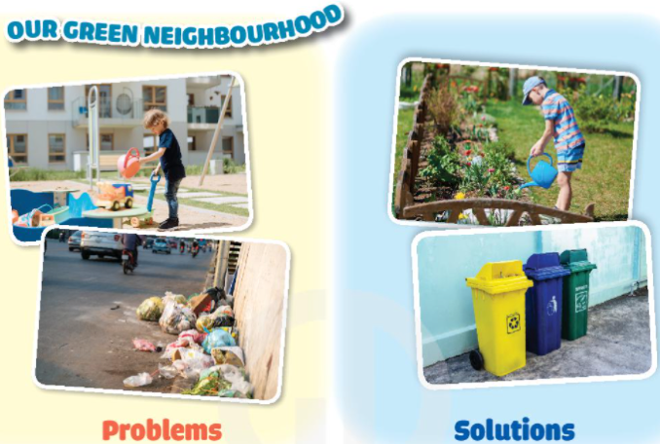

* Students discuss in groups then present the environmental problem to the class.

**

*** Students vote for the best performance.

**** Teacher gives feedback.

 -T consolidates the knowledge of the lesson (T writes the knowlegde on the board: vocabulary + grammar).

**solution**(n): giải pháp

**environmental problems** (n.phr): vấn đề môi trường

**solve**/sɒlv/ (v): giải quyết

**IV-WRAP-UP&HOMEWORK:**

-Teacher asks students to talk about what they have learnt in the lesson and T writes on the board.

-Prepare for the next lesson: Review 1(Language)

*Planning date: October 22nd, 2024*

**REVIEW 1 (Units 1-2-3)**

**Period 23: Lesson 1: Language**

**A. AIMS:**

By the end of this review, students will be able to revise the language they have learnt and the skills they have practised in Units 1-2-3.

**1. Knowledge:**

**- Vocabulary**: Revise the words related to hobbies and verbs of liking and disliking; healthy activities and health problems; and words related to community activities; Pronounce the sounds /ə/, /ɜ:/, /f/, /v/, /t/, /d/, /ɪd/ correctly in isolation and in context;

**- Grammar:** Revise the present simple tense, past simple to talk about past activities; Revise how to ask for and give health tips; how to give compliments.

**2. Skills:** Reading, speaking and Writing

**3. Attitude:** To teach Ss life skills and love their health, hobbies, community

**4. Competences:** Ss can be collaborative and supportive in pair work and teamwork**;** Raise students’ awareness of the need to keep their neighbourhood green.

**B. Teaching aids**

- Textbook, computer, projector/ TV, cassette.

**C. Procedures**

**Game: Finding key words**

- T shows 3 sets of pictures (taken from Project lessons of Unit 1-2-3) and asks students to find a keyword for each set of pictures.

- T asks Ss discuss the answers.

- T checks the answers as a class.

|  |  |  |
| --- | --- | --- |
| **Set 1: HOBBIES** | | |
| **Set 2**: **HEALTHY LIVING**  (bad habits, good habits)  **Set 3: COMMUNITY SERVICES** |  | | |  |
|  |  | | |  |
|  | |  | | |
|  | |  | | |

**I. Pronunciation**

**Circle the word with the difference stress pattern. Listen, check and repeat the words (task 1)**

- T writes the sounds /ə/ and /ɜː/; /t/, /d/ and /ɪd/; /f/ and /v/ on the board.

- T writes one word containing the sound below each of them.

- T asks Ss to read the words aloud.

- Ss do the task by reading aloud each group and circling the odd one out.

- T can invite some pairs of students to read aloud.

- T check students’ pronunciation ad give feedback.

***Answer key:***

*1. A 2. C 3.* *B 4. A 5. B*

**II. Vocabulary**

**1. Put the phrases in the corect column (Task 2)**

- T tells students to read the phrases carefully and make sure they remember their meanings.

- T asks Ss do this exercise individually by categorising the activities as they do them for their own sake or for the benefit of the community.

- T allows students to share their answers before discussing as a class and encourages them to pronounce the words / phrases correctly.

- T checks the answers as a class and gives feedback.

***Answer key:***

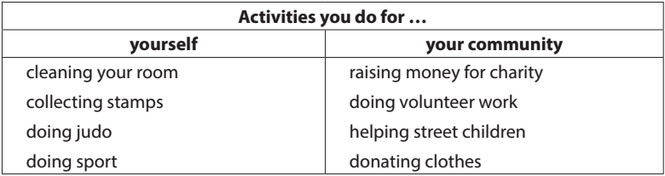

**2. Complete the sentences (Task 3)**

- T asks students to work individually to complete the sentences with the given words and phrases.

- T has Ss to work individually to complete the task.

- T allows students to share answers before discussing as a class.

- T asks students to say the sentences aloud and makes sure they pronounce the words and phrases correctly. Teacher can ask for translation to check their understanding.

***Answer key:***

*1. coloured vegetables*

*2. mountainous areas*

*3. hobby*

*4. chapped lips*

*5. community*

*6. taking photos*

**III. Grammar**

**1. Put the correct tenses of verbs**

**Game: lucky hobbies**

- T asks Ss to work independently to fill in the blanks with the correct tense of the verbs in brackets.

- T asks Ss to read the sentences first and underline the clues that help them decide if the verbs are used in the present or past simple tense.

- T reminds Ss to use the correct forms of the verbs (positive/ negative statements, or questions) as requested in each sentence then allows them to share answers before discussing as a class.

- T can ask Ss to read aloud the full sentences and correct their pronunciation if necessary.

***Answer key:***

*1. reads*

*2. Do … do*

*3. need*

*4. could not / couldn’t*

*5. did not / didn’t volunteer*

*6. joined*

**2. Turn the sentences into negative statements or questions**

- T asks Ss to read the sentences first and underline the verb in each sentence, then look at each verb and note if it is used in the present simple or past simple tense.

- T has Ss to do the task individually.

- T reminds Ss to pay attention to the request of each sentence (change it into a negative statement or a question) then allows them to share answers before discussing as a class.

- T can ask students to read aloud the full sentences and correct their pronunciation if necessary.

***Answer key:***

*1. She didn’t like exercising.*

*2. My family doesn’t always spend time doing housework together on Sundays.*

*3. I didn’t use a lot of suncream during my holiday.*

*4. Did your community organise a fair to raise money for the homeless last week?*

*5. Does Tim make beautiful pieces of art from dry leaves and sticks?*

**IV. Wrap -up**

Teacher asks students to talk about what they have learnt in the lesson.

- Pronunciation: review the sounds /ə/, /ɜ:/, /f/, /v/, /t/, /d/, /ɪd/

- Vocabulary: Revise the words related to hobbies and verbs of liking and disliking; healthy activities and health problems; and community activities

- Grammar: Revise the present simple tense, past simple

**V. Homework**

- Revise old lesson and to do exercises 1, 2, 3, 4, 5 in test youself pages 24, 25 in workbook.

- Prepare for the next lesson: Review 1: skills

*Planning date: October 26th, 2024*

**REVIEW 1 (Units 1-2-3)**

**Period 24: Lesson 2: Skills**

**A. AIMS:** By the end of the lesson students will be able to:

**1. Knowledge:**

- Skills: reading for general and specific information about a healthy life; speaking about things related to community service; listening for specific information about a hobby; writing complete sentences from the prompts provided

- Vocabulary: review words and phrases about hobbies; healthy living; community services

- Grammar: review present simple; past simple.

**2. Competences:** self-learning capability, group work, independent working, pair work, linguistic competence, cooperative learning and communicative competence.

**3. Qualities:** Raise students’ awareness of the need to keep their neighbourhood green, be industriousness, responsibility, honesty, cooperative; sociable; good communication.

**B. TEACHING AIDS**

**-** Textbooks, lesson plan, laptop, loudspeaker, TV/ projector

**C. PROCEDURE**

**Warm up: Game: Name the pictures**

- T shows pictures and asks students to discuss the ways to get a healthy life.

- T asks Ss discuss the answers.

- T checks the answers as a class

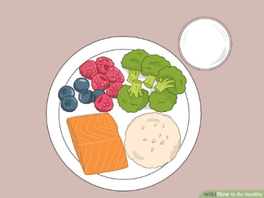 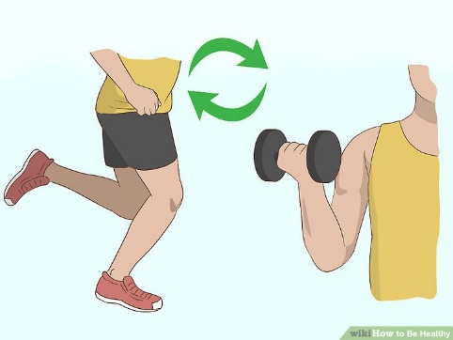

***Have a healthy diet Have a healthy exercise plan***

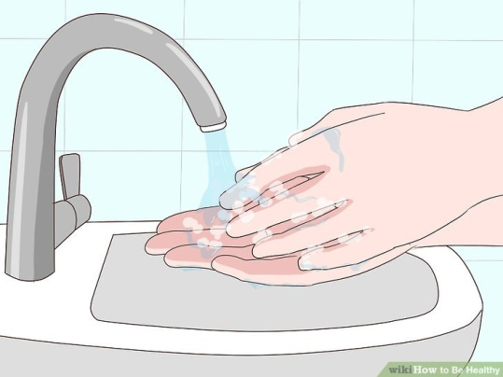 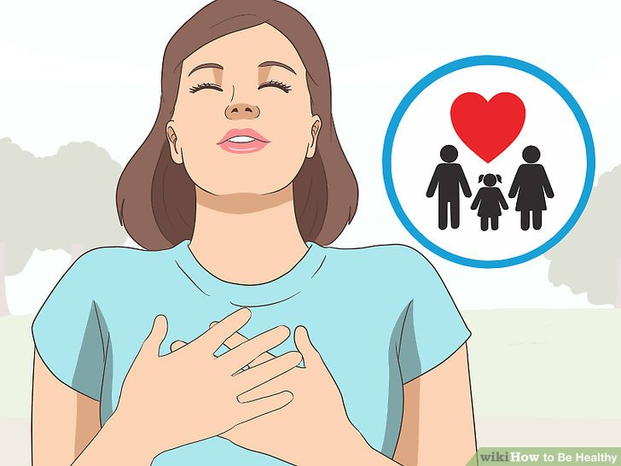

***Maintain your personal hygiene Be happy***

- T leads to the new lesson: let’s read about what can make you happy?

**I. Reading: Game Mystery box**

**Rules of game:**

- Divide the class into 2 groups

- A student of a team answers one question. If this student doesn´t know the answer, another one can help but then BOTH are excluded from their turn. They must wait for all the students of their team to answer a question so that their turn will come.

- The student who has answered correctly must decide whether to open the mystery box OR give it to another team he/she chooses.The box may contain several lucky gifts ( extra points, they may double their score etc) OR many bad gifts ( elimination of all points, multiplying them by -1 etc).There are neutral gifts too ( exchanging scores, playing rock-paper-scissors to trade the scores etc) - The team with an incorrect answer gets -5 points and another team can answer the question without opening the mystery box yet. Do not open the mystery box if someone has answered incorrectly. Let the other team fight for the mystery box.

**Read the passage and choose the correct answer: (Task 1)**

- T guides Ss by asking them to read the questions first and decide where to look for the information to answer the questions.

- T asks ss read the text fully and choose the correct answers.

- T confirms the answers as a class.

Answer key:

1. B 2. C 3. C 4. A 5. A

**II. Speaking**

**Listen and complete each sentences with one word (Task 3)**

- T has Ss read the questions first to get an overall idea of what they are going to listen to and decide what information they need to complete the sentences.

- T asks Ss to work individually to complete the task.

- T tells Ss to read the sentences carefully.

- T plays the recording for the ­first time to complete the notes. Ss listen and fill each blank with ONE word.

- T plays the recording a second times for Ss to check their answers. If Ss listen to the answer and say "stop" T will pause the tape and elicit the answers from Ss and write them on the board.

***Answer key:***

*1. games*

*2. sandcastles*

*3. open*

*4. computer*

*5. (Any of the following): food, water, compass, sleeping bag, insect cream*

***Audio script:***

*Camping can be lots of fun. When we go camping, there is plenty of time for games with friends. If we camp near a beach, we can build sandcastles, go swimming, or play beach volleyball. In other places, we can do other activities like playing football, cycling, bush walking, listening to music or drawing. In the evening, we can have dinner by an open fire. It’s a good time to enjoy the fresh air, tell stories and laugh with friends. While we go camping, there is no television or computer. But don’t worry. You’ll have a great time. Don’t forget to bring important things, like food and water, a sleeping bag, a compass, and some insect cream.*

**III. Speaking**

**Interview: community service (Task 2)**

- T asks students to work in pairs and take notes of their answers

- T calls on some pairs to report their answers for the class. Each pair may answer just one question to allow room for more pairs.

- T checks the answers and add more information if necessary.

***Suggested answer:***

*1. Anybody.*

*2. Street children, old and sick people, abandoned / street animals, etc*

*3. (It can be any tasks like) cooking / shopping for the old / the sick; collecting books / clothes for street children; opening classes to teach street children; adopting a dog / a cat; cleaning the neighbourhood / beach; painting walls at / decorating public places; reading to the people in*

*hospitals / nursing homes ...*

**IV. Writing**

**Complete the sentences (Task 4)**

- T asks Ss to work individually to make a passage describing community activities.

- T has Ss to read all the six sentences first to help them see the connection among them and decide which tense should be used for each sentence, and which word(s) is / are missing from the sentence.

- T allows Ss to share answers before discussing as a class.

- T can ask Ss to read aloud the full sentences and correct their pronunciation if needed.

***Answer key:***

*1. We join community activities once a month.*

*2. Last month we planted (some) trees in the park.*

*3. We dug some holes to put the young trees in.*

*4. Then we watered them for two or three weeks.*

*5. Now the trees are growing very well.*

*6. They will make the park greener and the air fresher*

**V. Wrap-up**

- T reminds the lesson Ss have just learned: Today we have read about tips for happiness, listened about going camping and know how to write a short passage about comminity activities.

**VI. Homework**

- Complete Test yourself in your workbook

- Write a passage about activites you can do to help community.

- Prepare for Unit 4 – Getting started