*Planning date: October 10th, 2024*

**Period 16: UNIT 3: COMMUNITY SERVICE**

**Lesson 1: Getting started- Sound like great work!**

1. AIMS

By the end of the unit, students will be able to:

-Use the words related to community activities.

- Pronounce the sounds /t/, /d/and /id/ correctly.

- Use the past simple to talk about past activities.

- Give compliments.

- Read for specific information about community activities at school.

- Talk about the reason why students join different community activities.

- Listen for the specific information about some community activities and their benefits.

- Write an email about community activities one did last summer.

I. AIMS

By the end of this lesson, Ss will be able to gain:

**1. Knowledge**

- An overview about the topic “Community service”

- lexical items related to community activities

**2. Core competence**

- Develop communication skills and enhance awareness of preserving the culture

- Be collaborative and supportive in pair work and teamwork

- Actively join in class activities

**3. Personal qualities**

- Develop self-study skills

- Raise students’ awareness of the need to keep their neighbourhood green

**II. MATERIALS**

- Grade 7 textbook, Unit 3, Getting started

- Computer connected to the Internet

- Projector/ TV/ pictures and cards

- sachmem.vn

**C. PROCEDURES**

**\* Warm up**: **\* *Picture describing***

- Teacher shows the picture and asks students questions:

*Teacher: What can you infer from this picture?*



- Students raise hands to answer the questions.

- Teacher and students discuss the questions.

- Teacher accepts all students’ questions and explains the term *“Community service”* (work that people do without payment to help other people).

**🡪Lead in:**

- Teacher introduces the topic of the lesson.

*Today we are going to learn about “Community service”*

- Teacher draws students’ attention to the picture in the textbook and asks them some questions about it:” *What are they doing?”*

- Students raise hands to answer the questions.

- Teacher and students discuss the questions.

- Teacher confirms the answers and indicates that they are doing “**community activities**”.

**I. PRE-READING:**

* Tick the appropriate box (Task 2)

- Teacher shows the two pictures of Minh and Tom in the textbook and says:

+ This is Minh and this is Tom

+ They are talking about community activities at their school clubs.

- Before reading the conversation between them, you have to guess what activities does Minh’s club and Tom’s do.

| **Community activity** | **Minh’s club** | **Tom’s club** |
| --- | --- | --- |
| 1. Picking up litter |  |  |
| 1. Planting vegetables |  |  |
| 1. Donating books |  |  |
| 1. Donating vegetables |  |  |
| 1. Teaching English |  |  |

- Students guess by tick the appropriate box.

**II. WHILE-READING**

1. **Listen and read**.(Task 1)

- Teacher asks students to read the conversation again and work in pairs to find the answers.

- Students can underline the words and phrases about community activities then work together for one or two minutes to check the words / phrases they have underlined.

- Have pairs tick the appropriate boxes. Ask pairs to say the answers aloud: Mirth's club picks up litter; Tom's club donates books, etc.

Make sure they pronounce the words / phrases correctly.

- Check the answers as a class.

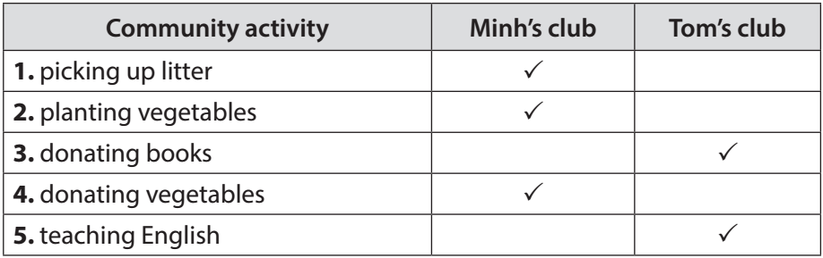

**2.** **Complete the phrases under the pictures with the verbs below.(Task 3).**

- Teacher asks students to work individually to complete the phrases under the pictures with the given verbs.

- Students work individually to complete the task.

- Teacher allows students to share answers before discussing as a class.

- Teacher asks students to say the phrases aloud and makes sure they pronounce the words and phrases correctly. Teacher can ask for translation to check their understanding.

***Answer key:***

*1. pick up 2. help 3. recycle 4. donate 5. Clean*

**III. POST-READING**

**1. Vocabulary:**

1. community activity (n.phr.) : Hoạt động cộng đồng

2. donate (v) : tặng, quyên góp

3. nursing home (n.phr.) : Viện dưỡng lão

4. homeless (adj) : Vô gia cư

- T shows the English words on the board

- T asks ss to give the Vietnamese meanings of the words.

- T writes on the board.

**2.** **Complete the sentences with the correct words or phrases below. (Task 4)**

- Teacher asks students to work independently to complete each sentence with a word or phrase from the box.

- Students fill in the blanks with the most suitable words / phrases.

- Teacher allows students to share answers before discussing as a class.

- Teacher can ask students to read aloud the full sentences and correct their pronunciation if needed.

***Answer key:***

*1. homeless children 2. litter 3. old people*

*4. taught 5. planted*

**3. Wrap up:**

- T consolidates the knowledge of the lesson.

**IV. Homework:**

- Learn the new words by heart

- Do exercise part B in workbook

- Get ready for “A closer look 1”

*Planning date: October 10th, 2024*

**Period 17: UNIT 3: COMMUNITY SERVICE**

**Lesson 2: A closer look 1**

A. AIMS

By the end of this lesson, students will be able to gain:

**1. Knowledge:**

- Vocabulary: Use words related to community activities.

- Pronunciation: Correctly pronounce the sounds: /t/, /d/, /ɪd/ in isolation and in context

**2. Core competenc**

- Develop communication skills and creativity

- Be collaborative and supportive in pair work and teamwork

- Actively join in class activities

**3. Personal qualities**

- Develop self-study skills

- Raise students’ awareness of the need to keep their neighbourhood green.

**B. MATERIALS**

- Grade 7 textbook, Unit 3, A closer look 1

- Computer connected to the Internet

- Projector/ TV/ Pictures and cards

- sachmem.vn

**C. PROCEDURES**

**\* Warm up : MATCHING GAME:**

- Teacher has students play in two groups and explains the game rules.

+ Each group will have a list of verbs and nouns. Students match the verbs they have with the correct nouns.

- Teacher and students discuss the answers. The group with the most correct answers wins.

- Teacher confirms the answers and gives feedback.

| recycle | help | plant |
| --- | --- | --- |

***Set of word cards:***

| trees | vegetables | small children | old people |
| --- | --- | --- | --- |
| books | bottles | cans | homeless children |

1. **PRESENTATION : VOCABULARY**

***\* Matching (Task 1)***

- Teacher introduces the vocabulary.

- Teacher introduces the vocabulary by:

* providing the pictures
* providing the definition of the words.

| **A** | **B** |
| --- | --- |
| 1. Donate 2. Exchange 3. Water 4. Pick up 5. tutor | 1. Use paper for notebooks 2. Primary students 3. Litter 4. Plants 5. books |

- Teacher asks students to repeat.

- Teacher rubs out and checks

- Teacher has read aloud the verbs in A and words / phrases in B.

- Students work in pairs to match the verbs in A with words / phrases in B.

- Teacher asks them to share their answers in pairs before checking the answers as a class.

- Teacher invites students to take turns to read out their answers and corrects their pronunciation if needed.

***Answer key:***

1. e 2. a 3. d 4. c 5. b

**II. PRACTICE**

**1. Complete each of the sentences with a suitable word or phrase from the box.(Task 2)**

| **Tutor litter water donate used paper for notebooks** |
| --- |

**-** Teacher asks students to work individually to complete each of the sentences with a suitable word / phrase from the box. All of these words / phrases have been learnt in.

- Students do the task individually.

- Teacher allows students to swap their textbooks to peer check first.

- Teacher confirms the answers and gives feedback, if necessary.

***Answer key:***

*1. litter 2. used paper for notebooks 3. water 4. donate 5. Tutor*

**2. Use the phrases from the box to write full sentences under the correct pictures.(Task 3)**

- Teacher asks students to work individually to write full sentences, using the given phrases.

- Students read aloud the six phrases and match with the appropriate pictures.

- Teacher asks students to work in pairs to swap their answers and peer check.

- Teacher checks their answers as a class.

***Answer key:***

*1. She’s reading books to the elderly.*

*2. They’re giving gifts to old people.*

*3. They’re exchanging used paper for notebooks.*

*4. They’re donating clothes to poor children.*

*5. She’s planting trees in the park.*

**II. PRODUCTION : PRONUNCIATION**

1. **Presentation: Listen and repeat.Pay attention to the sounds /t/, /d/and /ɪd/. (Task 4)**

* T introduces 3 sounds /t/, /d/, /ɪd/ to students and lets them listen and repeat the words task 4

| **/t/** | **/d/** | **/id/** |
| --- | --- | --- |
| **Cooked** | **Watered** | **Collected** |
| **Passed** | **Cleaned** | **Donated** |
| **helped** | **volunteered** | **provided** |

* Teacher has students listen to the recording once first.
* Students listen to the recordings and read out the words.
* Teacher plays the recording for them to listen and repeat each word as a class, then as individuals.
* Teacher check students’ pronunciation if needed.

1. **Practice: Listen to the sentences and pay attention to the underlined parts. Tick the appropriate sounds …(Task 5)**

* Teacher has some students read the sentences first and asks them to pay attention to the underlined parts.
* Teacher plays the recording for Ss to listen then have them tick the appropriate sounds.
* Teacher invites some Ss to share their answers. Confirm the correct ones.
* Teacher plays the recording again and ask students to repeat each sentence after the recording. Teacher confirms the answers.

***Answer key:***

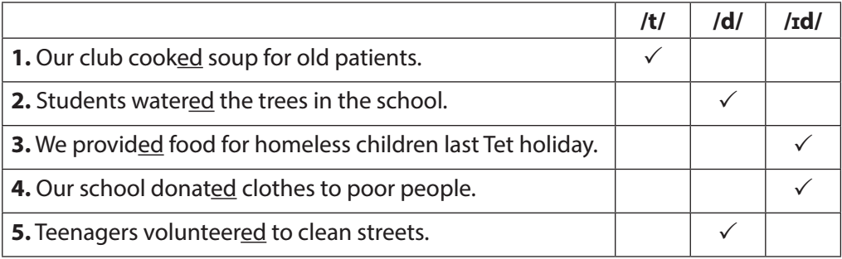

**IV. Wrap – up**

- T asks students to talk about what they have learnt in the lesson.

**V. Homework**:

* Learn by heart the new words.
* Find 5 more words with the sound /t/ , 5 more words with the sound /d/ and 5 more words with the sound /id/ . Write them down and practice pronouncing the words.
* Do exercise part A in workbook.
* Prepare Unit 3- A closer look 2

*Planning date:October 12th, 2024*

**Period 18: UNIT 3: COMMUNITY SERVICE**

**Lesson 3: A closer look 2**

1. AIMS

By the end of this lesson, Ss will be able to gain:

**1. Knowledge:**

- Understand the use of the past simple tense

- Practice using the past simple to talk about past activities

**2. Core competence:**

- Develop communication skills and creativity

- Be collaborative and supportive in pair work and teamwork

- Actively join in class activities

**3. Personal qualities**

- Develop self-study skills

- Raise students’ awareness of the need to keep their neighbourhood green.

**B. MATERIALS**

- Grade 7 textbook, Unit 3, A closer look 2

- Computer connected to the Internet

- Projector/ TV/ pictures and cards

- sachmem.vn

**C. PROCEDURES**

**\* Warm-up: CHATTING**

* Teacher asks students some questions:

*What did you do last weekend?*

*What did you watch yesterday?*

*Who did you meet two days ago?*

- Students answer the questions, using the past simple.

- Teacher and students discuss the answers.

- Teacher corrects students answers if needed and confirms the use of the past simple (to talk about completed actions in the past).

**I. PRESENTATION**

- Teacher asks students to study the Grammar box.

- Teacher draws students’ attention to the meaning and use of the past simple.

- Teacher then asks some more able students to give some more examples.

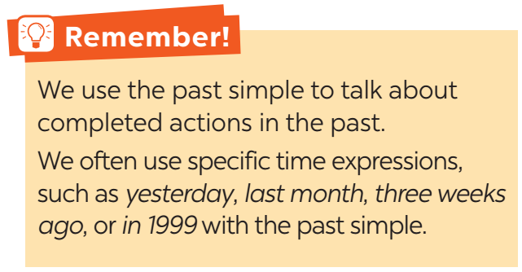

- Teacher and students discuss the answers.

- Teacher confirms the answers and gives feedback.

**II. PRACTICE**

1. **Circle the best answer A,B or C to complete each sentence. (Task 1)**

- Teacher has students work individually.

- Students work individually to to complete the sentences with the past simple form of the given verbs.

- Teacher lets students work in pairs and exchange the answers before checking with the whole class (explain each sentence if necessary).

- Teacher confirms the answers and gives feedback.

***Answer key:***

*1. B 2. C 3. B 4. A 5. C*

**2. Complete the sentences with the past form of the given verbs. (Task 2)**

- Teacher has students work individually.

- Students work individually to complete the sentences.

- Teacher lets students work in pairs and exchange the answers before checking with the whole class (explain each sentence if necessary).

- Teacher confirms the answers and gives feedback.

***Answer key***:

*1. took 2. Did … join 3. helped 4. sent 5. Volunteered*

**3. Complete the sentences with the correct form of the verbs from the box. (Task 3)**

| **Plant read cook recycle pick up** |
| --- |

- Teacher asks the whole class to read aloud the verbs in the box then has students work individually to complete the sentences with the correct forms of the verbs from the box.

- Students work individually to complete the task.

- Teacher then has them work in pairs, comparing their sentences. Teacher can go around to help students.

- Teacher confirms the answers and gives feedback.

***Answer key***:

1. cook 2. Did … plant 3. are picking up 4. recycled 5. read

**III. PRODUCTION**

**1. Write complete sentences from the prompts. (Task 4)**

- Teacher has students work independently.

- Teacher asks students to do the exercise individually.

- Teacher lets students work in pairs and exchange the answers before checking with the whole class (explain each sentence if necessary).

- Teacher confirms the answers and gives feedback.

***Answer key***:

*1. Last year, our club donated books to children in rural areas.*

*2. Children sent thank-you cards to us a week ago.*

*3. I taught two children in grade 2 last summer.*

*4. Last spring, we helped the elderly in a nursing home.*

*5. We helped people in flooded areas last year.*

***2****.* **Work in groups. Tom is from the Red Cross. Look at the fact sheet and ask Tom about his projects in 2016 and 2020.(Task 5)**

- Teacher introduces the Red Cross projects and activities in 2016 and 2020 and has students work in pairs for 5 minutes to practise asking and answering questions based on the fact sheet.

- Students use the past simple when they ask and answer questions about the past activities.

- Teacher invites some pairs to make short conversations as an example.

- Teacher corrects any grammar and pronunciation mistakes if necessary.

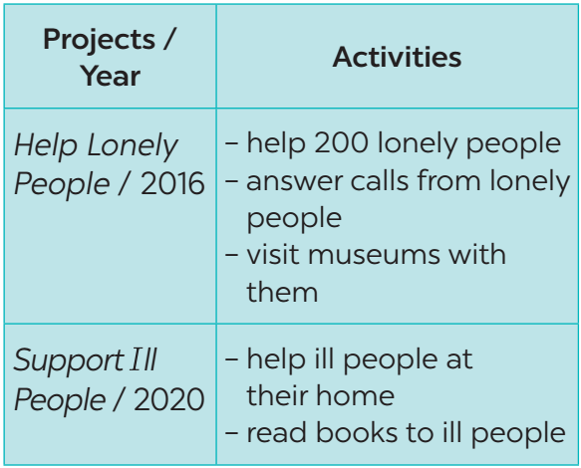

***Example***:

*Tom: I’m from the Red Cross. I worked on the Help Lonely People project in 2016.*

*Lan: What did you do?*

*Tom: We helped 200 lonely people…*

**IV. Wrap - up:**

- Teacher asks students to summarise what they have learnt in the lesson.

- Teacher has them say out loud the past forms of the verbs they have learnt.

**V. Homework:**

- Revise the past simple tense

- Do Ex 4,5,6 part B in work book on page 18

- Prepare: Communication.