*Planning date: September 9th, 2024*

**UNIT 1: HOBBIES**

**Period 4: Lesson 3: A closer look 2**

**A. Aims:**

**1. Knowledge:** Students will be able to use the present simple tense.

**2. Qualities:** Students will be able to know more about their classmate’s hobbies, their responsibility for study, their industriousness.

**4. Competences:** Students will be able to practice speaking and writing, communicate and co-operate, solve problems and develop creativity.

**B. Teaching aids:** Text book, computer, projector/ TV, cassette

**C. Procedure**

**\* Warm up: Game: Guessing game**

- T divides the class into 4 teams.

- T calls on a S from each team to go to the board in turn. That S thinks of a hobby and says the keywords out loud.

- The other teams try to guess “What the hobby is ?”. They will get 1 point for each correct answer. The team with the most points is the winner.

- T asks Ss to say the words aloud and makes sure they pronounce the words correctly. Teacher can ask for translation to check their understanding.

***Example:***

*A: water, grow, flowers, vegetable.*

*B: Is it gardening?*

*A: Yes, it is.*

**I. Presentation:**

T draws Ss’ attention to the form of the sentences created in the game and asks them whether they know the target tense.

**THE PRESENT SIMPLE: REVIEW**

- T has the Ss review the forms and use of present simple before doing the exercises.

- Ss retell the form and the uses of the tense: The present simple.

- T comments and explains again.

- T shows each of the examples in the Remember box on the slide or have Ss read the examples in the book. T highlights the present simple form. Explain each use.

- T has Ss read the orange box in the book again to help them understand better the uses of the present simple.

- T asks Ss what signal words help them identify the verb tense. Elicit answers from Ss. (Signal words are adverbs of frequency and verbs such as start, etc.)

- T checks their answers as a class.

- T elicits and writes the knowledge “**Present simple tense**” on the board:

1. Form

|  |  |
| --- | --- |
| Present simple tense | **Form** |
| S + Vinf/ V(s/es) + … |
| S + don’t/ doesn’t + Vinf + … |
| Do/ Does + S + Vinf + …? |
| W/H + do/does + S + Vinf + …? |

**2. Use**

**We use present simple for:**

- A timbale/ programme

- A regular action

- A general truth

**II. Practice:**

**1. Matching (Task 1)**

- T asks Ss to do the exercise individually and then check their answers in pairs.

- T asks Ss do the exercise individually.

- T invites some Ss to share their answers.

- T confirms the correct answers.

**Answer key:**

1. b 2. a 3. c 4. a 5. b

**2. Complete the sentences (Task 2) Football game**

- T has Ss do this exercise individually and then compare their answers with a partner.

- T asks some Ss to write their answers on the board.

- T checks the answers with the whole class. Ask Ss to explain the use of the tense in each sentence.

- T confirms the correct answers.

***Answer key:***

*1. make 2. does … do 3. have*

*4. doesn’t like 5. Does … start*

**3. Complete the paragraph**

- T has Ss do this exercise in pairs and then compare the answers with another pair.

- T asks some Ss to write their answers on the board.

- T checks the answers with the whole class. T asks Ss to explain the use of the tense in each sentence.

- T confirms the correct answers.

***Answer keys:***

1. enjoys 2. spends 3. don’t like / do not like

4. go 5. begins 6. don’t enjoy / do not enjoy

**4. Write complete sentences (Task 4) Game: Help the chick**

- T has Ss work in groups to write the sentences. Give each group a   
large-size sheet of paper to write.

- Ss work in groups to write the sentences.

- T has groups cross-check.

- T sticks some sheets on the board. Comment and confirm the correct answers.

***Answer key:***

1. The sun sets in the west every evening.

2. Do Trang and Minh play basketball every day after school?

3. The ﬂight from Ho Chi Minh City doesn’t arrive at 10:30.

4. Our science teacher starts our lessons at 1 p.m. on Fridays.

5. Do you make models at the weekend / at weekends?

**III. Production: Speaking**

**Game: Sentence race (Task 5)**

-T divides Ss into groups. Assign a group leader.

- T writes a verb on the board and have Ss make a sentence with the verb, using the present simple form.

Verbs: have, do, write, play, enjoy, start

- The group leader records his / her group’s points.

- T invites group leaders to read aloud the sentences.

- T comments and announces the winners.

**IV. Wrap-up**

T asks Ss to talk about what they have learnt in the lesson:

- Review present simple tense

**V. Homework**

- Make 3 sentences in the present simple tense.

- Complete the exercises in the Workbook B 4, 5; D 1, 2

*Planning date: September 9th, 2024*

**UNIT 1: HOBBIES**

**Period 5: Lesson 4: Communication**

**A. Aims**

**1. Knowledge:** By the end of the lesson ss will be able to use the lexical items related to the topic hobbies, talk about likes and dislikes, ask and answer about hobbies

**2. Qualities:** Students will be able to describe and give opinions about hobbies and be interested more about new hobbies.

**3. Competence:** Students will be able to revise and learn how to use and form present simple tense. Talking about likes and dislikes.

**B. Teaching aids:**

-Textbook, computer, smart TV

- Sachmem.vn

**C. Procedure**

**Warm up: Revision**

- T shows some pictures of the hobbies that Ss learnt in the previous lessons.

- Ask some Ss to make sentences about themselves, using the verbs of liking / disliking.

- T introduce the objectives of the lesson: learning how to talk about likes / dislikes and about their hobbies

**I. Pre-listening**

**\* Everyday English**

**1. Listen and read the dialogue below (task 1 + 2)**

- T plays the recording for Ss to listen and read the conversation at the same time

- T has Ss practice the conversations in pairs.

- T calls on some pairs to practice the conversations in front of the class.

- T asks Ss to pay attention to the sentences and phrases practice talking about likes and dislikes

- T calls on some Ss to give examples.

- Teacher and students discuss the answers.

- Teacher confirms the answers and gives feedback.

**II. While- speaking**

**1. Answer the questions, fill in column a with your answer (task 3)**

- T asks Ss to work individually and fill in column A

- Ss work individually to do the task.

- T invites some Ss to share their answers before checking with the whole class.

- T gives feedback and comments.

***Suggested answers:***

* How much free time do you have a day?

The amount of free time per day I have is a hour

* What do you like doing every day?

I like watching movies everyday

* What do you not like doing?

I don’t like running

* What do you love doing in the summer?

I like swimming in the summer

* What do you love doing in the winter?

I like ice skating in the winter

***2.* Now interview your friend, using the questions in 3. Write his/her answer in column B (task 4)**

- To let students further practice asking and answering about hobbies

- T asks Ss to take turns being the person who asks the questions. This S has to note down his/ her partner’s answers to report to the class later.

- Ss work in pairs to do the task.

- T calls on some Ss to report the answers to the class.

- T and other Ss give comments.

**III. Post -speaking**

**Compare your answer with your friend’s then present them to the class (task 5)**

- T asks ss to underline the words that can be used to make comparisons in the example (but, too).

- Introduce some other ways to express.

comparison, such as: both (*we both have one hour of free time every day)*; more(*I have more free time than her); etc.*

- Ask Ss to work in pairs again to compare the answers and prepare a short presentation.

- Invite some Ss to present their work.

- Comment on their answers.

***Example:***

I have one hour of free time a day, but my friend Lan has only about 30 minutes.

I like listening to music every day, and Lan likes it too. I don’t like exercising,

but Lan does.

**IV. Wrap up:**

- Teacher asks students to talk about what they have learnt in the lesson: Talk about hobbies

**V. Homework**:

- Learn by heart ways asking and answering about hobbies

- Do exercises C1,2 (P12,13 in WB)

- Get ready for “Skills 1

*Planning date: September 9th, 2024*

**UNIT 1: HOBBIES**

**Period 6: Lesson 5: Skills 1**

**A. Aims**

By the end of this lesson, Ss will be able to:

**1. Knowledge:** Ss will be able to developreading skill for general and specific information about Gardening and talk about their hobbies and the benefits of them.

**2. Qualities:** Ss will be able tounderstand more about their preference of different types of hobbies**,** develop self-study skills

**3.Competence:** Students will be able to practice listening skill, reading skill, communicate and cooperate, solve problems and develop creativity

**B. Teaching aids:**

-Textbook, computer, smart TV

- Sachmem.vn

**C. Procedure**

**Warm up: Brainstorming**

- T asks Ss to list out as many hobbies as possible within 1 minute.

- Ss work in groups to brainstorm hobbies.

- Which teams can list out more correct answers wins.

- T confirms answers as a class.

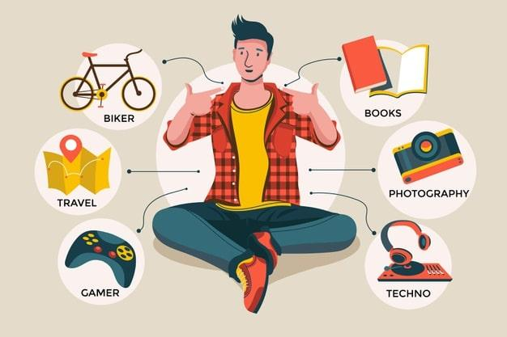

- Ask some Ss what their hobbies are and who in the family they share their hobbies with.

- Ask them about the good things of sharing a hobby with a family member.

- Elicit answers from Ss.

**I. Pre-reading**

**1. Look at the picture and discuss the question (Task 1)**

- T has Ss look at the picture in the book or show the picture in the book on a slide.

- Ask Ss who they see in the picture and what they are doing.

- T has Ss work in pairs to discuss the two questions.

- T invites some Ss to share their answers.

- Tell Ss that they are going to read a text about gardening.

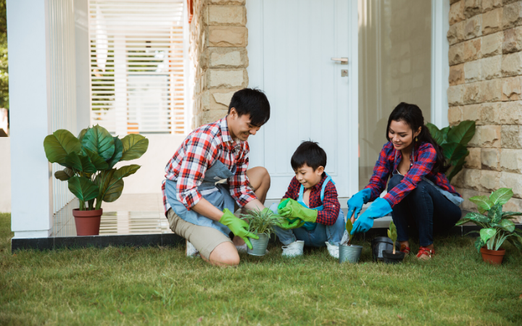

**II. While-reading**

**1. Read the text about gardening, match each word in column A with its definition in column B (task 2)**

T asks ss to read the words in column A.

+ Locate each word in the text.

+ Read around the word to get the general meaning.

+ Read the definitions in column B, find the suitable meaning to match each word.

- T asks Ss to repeat the steps (they can speak in Vietnamese).

- Ss do the exercise individually and then check answers in pairs.

- T invites some Ss to share their answers.

- Confirm the correct answers.

***Answer key:***

*1. b 2. e 3. c 4. a 5. d*

**2.Read the text again. Complete each sentence with no more than three words (task 3)**

**Game: Typhoon**

Rule of game:

- T divides whole class into two teams

- Each team takes turn to choose the number. If the answer is correct, the team will open one of three boxes (your points, steal points, blow points)

- Which team has more points will be the winner

- T has Ss work individually to complete each sentence

- T asks ss to read the sentences, underline the key words in the sentences, locate the key words in the text and find the words to complete the sentences.

- T asks Ss to do the exercise individually

- T explains the meaning of some words if necessary.

- T checks the answers as a class and gives feedback.

***Answer key:***

*1. doing things 2. insects and bugs 3. patient*

*4. join in 5. an hour*

**3.Vocabulary:**

gardening (v, n) : làm vườn

belong to (v): thuộc về

insect (n) : côn trùng

bug (n) : con bọ

patient (adj) : kiên nhẫn

responsibility (n): trách nhiệm, chịu trách nhiệm.

maturity (n) : sự trưởng thành

valuable (adj): quý giá, quan trọng, hữu ích

- T shows the English words on the board

- T asks ss to give the Vietnamese meanings of the words.

- T writes on the board.

**III. Post-reading**

**1. Match Each hobby with its benefits. One hobby has more than one benefit (task 4)**

* T introduces some structures to talk about the benefits of hobbies:

+ to develop sth

+ to make sb + adj

+ to reduce sth

+ to help sb / sth do sth

- Give some examples.

- Ss work in pairs to match the hobby with its benefit(s).

- T asks Ss to name other benefits of these hobbies.

- Invite some Ss to share their answers.

- Confirm the answers.

***Answer key*:**

*1. c, d 2. b, c 3. a, c, d, e*

**2. Work in group. Ask one another the following questions. Then present your partner’s to the class (task 5)**

- Have Ss work in groups to ask and answer the two questions.

1. What is your favorite hobby?

2. What are its benefits?

- Model the answers to the two questions if needed.

- Ss work in groups to ask and answer the two questions.

- Invite some Ss to share their partner’s answers to the questions.

- Invite other Ss to comment on the answers.

**Example:** My friend Mi’s favourite hobby is collecting stamps. It helps her be more patient....

**IV. Wrap up:**

- Teacher asks students to talk about what they have learnt in the lesson.

**V. Homework:**

- Learn by heart vocabulary

- Do exercise D 1, 2,3 in WB

- Prepare the next lesson Unit 2: Skills 2.